Email signature guidance

Use this template and instructions to update your email signature. Please note it’s aimed at PC users. If you use a Mac, we provide separate instructions for you to follow.

Step 1 – Create your signature

Your new signature should look like this:

Andrea Jenaro (she/her)
Creative Design Manager

Content and Brand team
Marketing and Communications
Queen Mary University of London
Dept W, 81 Mile End Rd, London E1 4UJ
Tel: +44 (0)20 7882 3000
Email: a.jenaro@qmul.ac.uk





Copy the example above and amend to reflect your own details, or use the following structure:

[Name] [Pronouns]
[Job title]

[Academic school, Centre, Institute or professional services team]
[Faculty or Directorate]
Queen Mary University of London
[Building, Street, City, Postcode]
Tel: [Telephone number]
Mob: [if applicable]
Email: [email name@qmul.ac.uk]

My working hours are: [if applicable]

Pronouns
A pronoun is a word used to refer to a person instead of their name. The most common pronouns are she/her and he/him, but many people choose to use different gender-neutral pronouns such as they/them. The practice of including pronouns in your email signature normalises the idea that gender shouldn’t be assumed, and demonstrates the University’s commitment to recognising diverse identities and gender expressions. For these reasons we’d recommend you include your pronouns in your email signature if you feel comfortable doing so. Read Queen Mary’s Pronouns Matter Leaflet to learn more.

Social Media
If you would like to link to your own social media accounts, rather than the university’s primary accounts, first right-click the icon you would like to edit and select Edit Link:

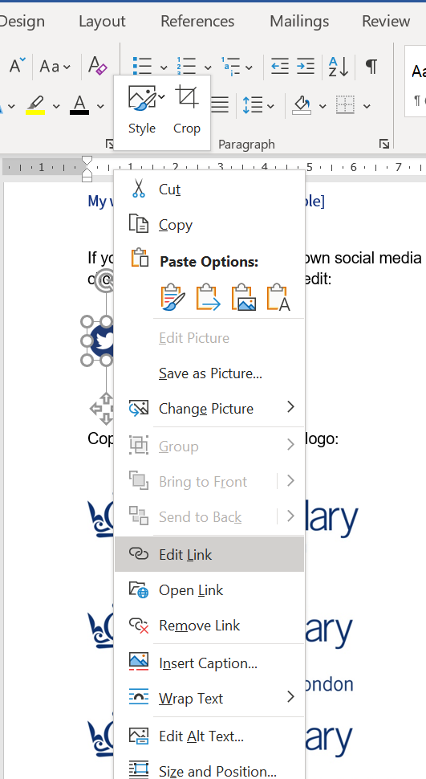

Enter the new URL into the Address bar and click OK:

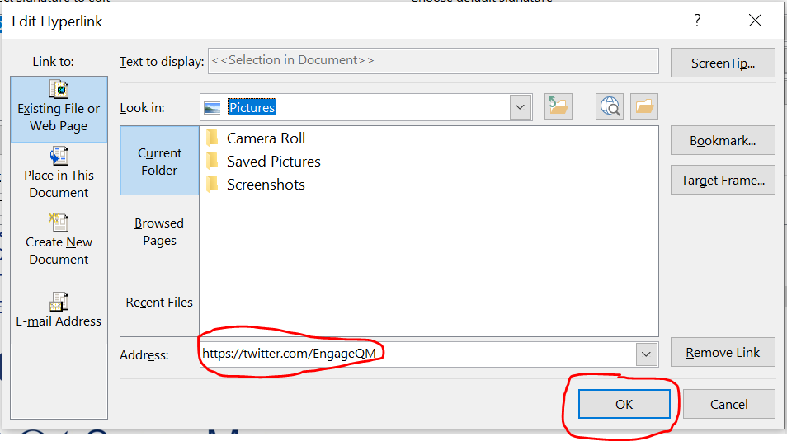

Step 2 – Install your new signature

To set up a new signature on Outlook, click New Email in the top left-hand corner:
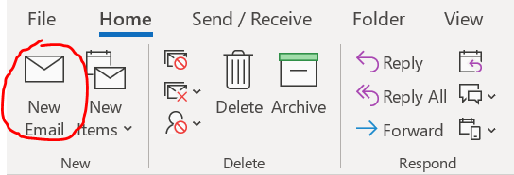

Once the new email box opens, go to the Signature option on the tool bar and choose Signatures… from the mini drop-down menu:
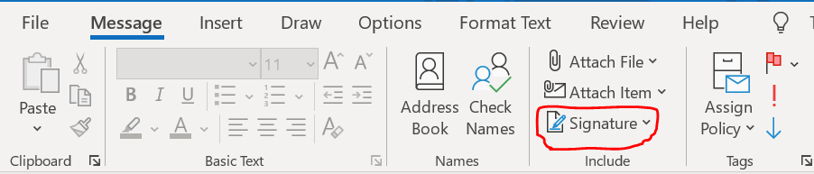

A new box titled Signatures and Stationery should open up. Choose New and type a name for the signature:

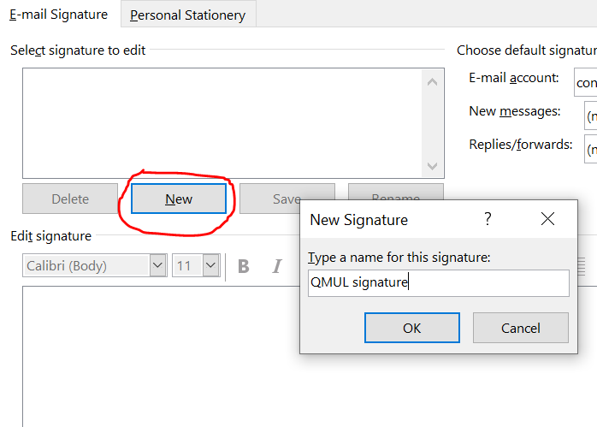

Copy and paste your new signature into the box below and click OK:

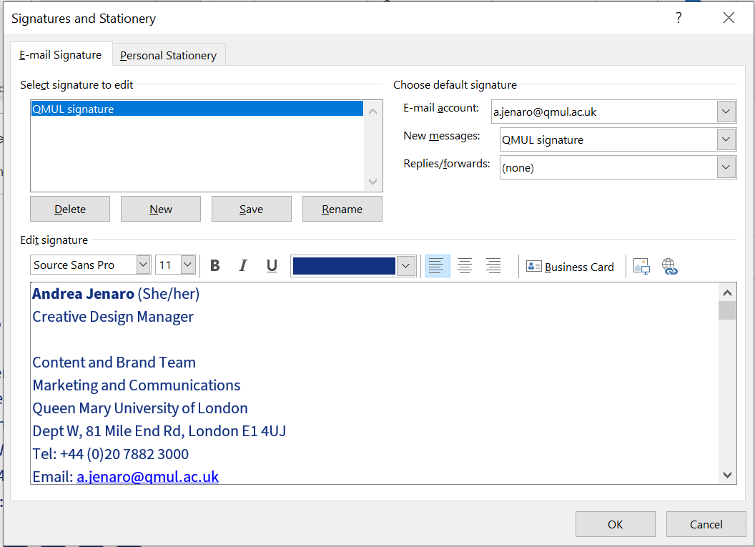
Your new signature should be ready when you open a new email.

If you have any problems or questions, please contact the Content and Brand team at content@qmul.ac.uk

