1. Click on your Task menu indicated by a Tick Symbol top-right of your screen (the number in the box relates to the total number of tasks you need to action). Select Req approval (costc) in the list displayed which will open your requisition task(s).

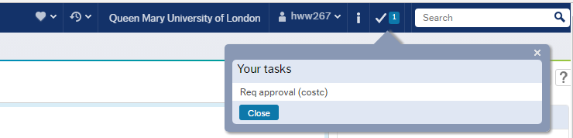

2. All requisition details will appear as shown below.

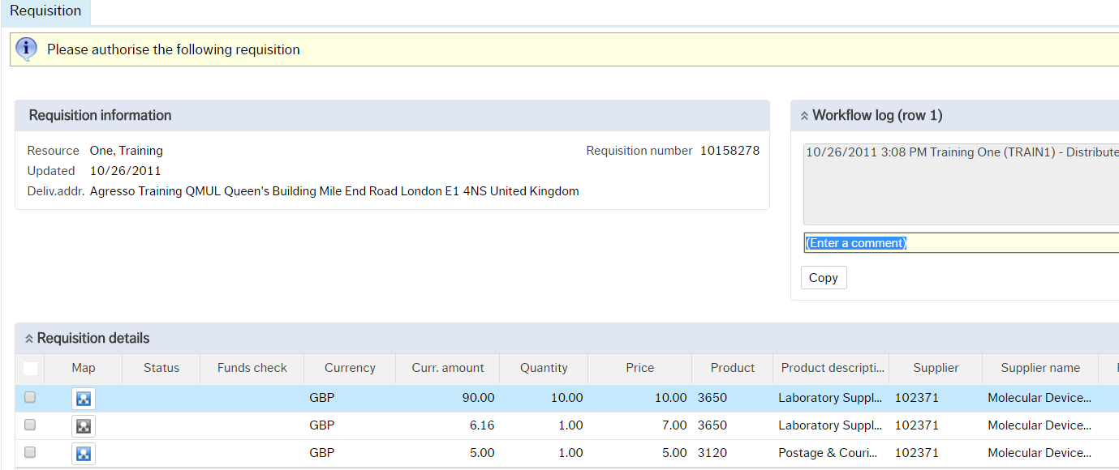

3. Select your action from the bottom of the screen.

If you approve requisition, it will disappear from your task menu.

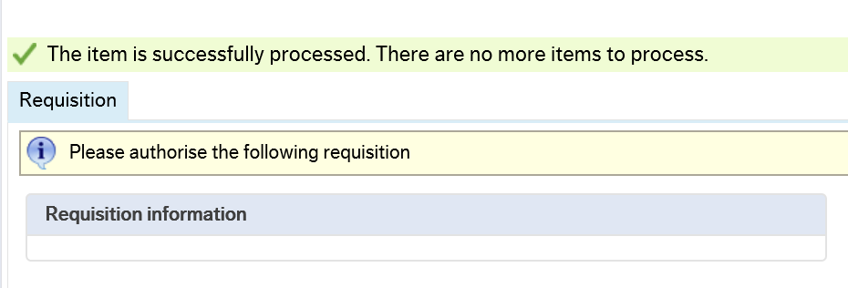

If Reject is selected, you must enter your reason(s) in the Comment field. This information will be returned to the person who raised the requisition.

