Import Duty and VAT guidance QMUL
Please read this document in conjunction with the QMUL procurement guidance on imports and exports

Imports and Customs

For overseas physical goods purchases, VAT and/or Customs Duty may be charged at the point of entry. Our procurement guidance is available here:
- General Import & Export Guidance
- Imports to the UK

Some (but not all) items may be eligible for customs duty relief due to QMUL’s charitable status. In certain cases, HMRC National Import Relief Unit (NIRU) certificate may be required—though often this is not needed for UK universities. Please note that some shipping agents may be unaware of this exemption. If duty payable is higher than 0% finance-tax-manager@qmul.ac.uk can check if customs duty relief is available.

Customs duty rates vary based on the commodity’s classification. You can check applicable tariffs using HMRC’s trade tariff lookup: HMRC Trade Tariff Tool, this Harmonised System (HS) code, also known as tariff or Commodity Code may be given to you by the supplier and/or the shipping agent, and it is often stated on the invoice and/or shipping documents.

The shipping agent must apply the correct Customs Procedure Code (CPC) to claim any applicable VAT and/or customs duty relief. Incorrect use of CPC codes can result in HMRC penalties, which will be charged to your project.

If you provide tax team with the HS code and intended use of the goods, we can assist in determining the appropriate CPC. finance-tax-manager@qmul.ac.uk

QMUL does not operate Postponed VAT Accounting and does not have deferment account, hence VAT and/or Duty must be paid by the shipping agent at the port of entry. The agent then invoices QMUL for reimbursement and charges administrative fee for this service. All the levies and fees must be budget for as they will be recharged to the purchasing department.

IMPORTANT Postponed VAT accounting (PVA)

Under no circumstances the shipping agent should be informed to use Postponed VAT Accounting (PVA) as QMUL does not operate under PVA. If any staff instructs agents to apply PVA and HMRC imposes penalties as a result, those costs will be recharged to the relevant department.

General Information – Medical Research Purchases -Zero rate VAT

QMUL is not generally exempt from VAT. However, as a registered charity, we can receive zero-rating VAT on some qualifying only items used for approved qualifying purposes, such as medical research, training, diagnosis, or treatment.

Please see the internal guidance document via Zero VAT Guidance – medical equipment QMUL outlining which types of equipment and substances may qualify, and when. Additional guidance is available from HMRC here (see Section 4): HMRC Guidance on Charity-Funded Equipment

HMRC definition of medical research:
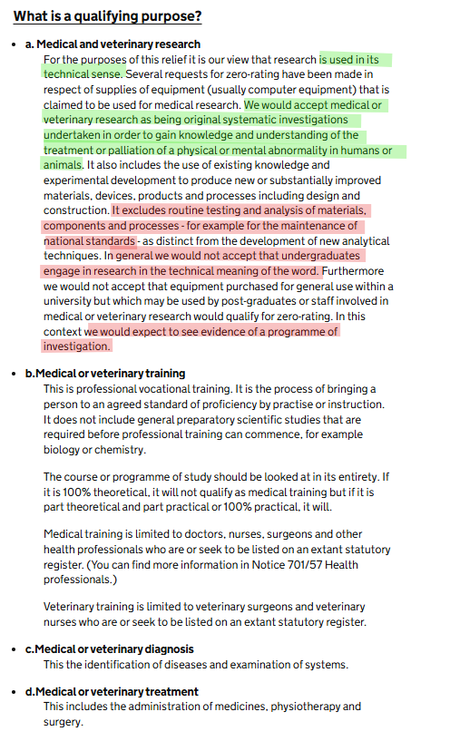
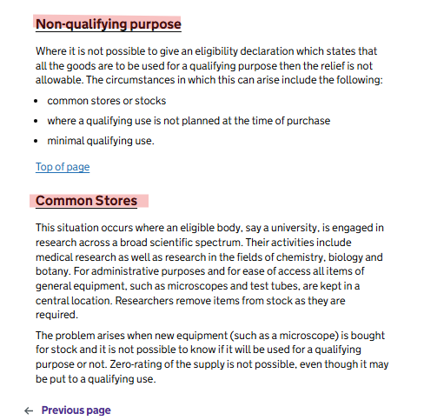

If you are eligible to claim zero-rated VAT, please ensure the supplier and shipping agent receives a copy of the fully completed certificate and understands that no VAT should be applied. If VAT is incorrectly charged, it is generally non-recoverable because QMUL cannot recover most VAT as majority purchases are for our exempt education or non- business purposes (publicly funded research etc).

Zero rate VAT Certificates – Medical use

If you are confident that both, the item, and its intended use qualify under HMRC guidelines, a VAT exemption certificate should be issued.

Generating VAT Certificates on Unit4

When raising a purchase order (PO):
- Select the appropriate product code from the VAT-codes list.
- Change the tax code to “P3” to trigger automatic certificate generation.

These certificates are typically only partially pre-populated and must be completed by the purchaser. This includes:
- Selecting the relevant category by ticking the appropriate boxes (based on the nature of the qualifying item and purpose).
- Dating and signing the form.
- Sending one copy to the supplier and/or shipping agent.
- Retaining a copy with the supplier documentation (Accounts Payable can assist with this) for audit purposes.

The below is an example of pre-populated zero rate VAT certificate. The areas circled in red should be completed by the purchasing department as appropriate.

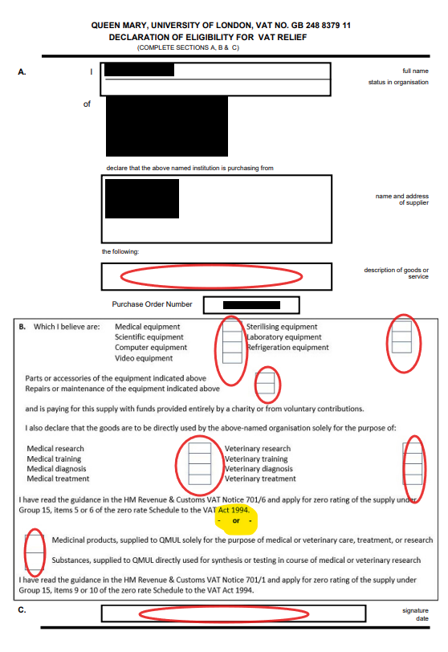

EORI and most common CPC codes

QMUL EORI Number: GB248837911000

This can be used only if QMUL is importing (acting as the Importer of the record). It is not appropriate for QMUL to import on behalf of someone else and then just recharge costs, even if you are jointly employed by Barts NHS trust, unless you have a specific confirmation from finance-tax-manager@qmul.ac.uk .

QMUL and NHS Barts are two separate legal entities with different VAT exemptions and recoveries hence we cannot mix-and-match purchases and then just recharge costs with no VAT.

CPC codes – most common QMUL use

40 00 000 - where UK VAT and applicable duty will be charged on import, please use this if you are NOT eligible to use medical Zero rate VAT certificate and the duty is 0%, or you are happy that the duty is payable as there is no appropriate relief.
- equipment that is not a scientific instrument and apparatus used in education or research,
- substances that will NOT be directly used for testing, or for mixing with other substances in the course of medical research

40 00 1RV - where applicable customs duty will be charged on import, please use this only if you ARE eligible to use medical Zero rate VAT certificate and the duty is 0%, or you are happy that the duty is payable as there is no appropriate duty relief. E.g. therapeutic substances of human origin (blood, tissue etc.)

40 00 C13 - when buying scientific instruments and apparatus for non-commercial scientific research or educational purposes. UK VAT would be payable at the import. Use this only if customs duty is more than 0%. If customs duty is 0%, please use 40 00 000.
If using C13 code, you will be required to provide a certificate issued by the National Imports Relief Unit (NIRU) please contact finance-tax-manager@qmul.ac.uk to provide the certificate.

40 00 C13 +Special Procedure code F45 - when buying scientific instruments and apparatus for non-commercial scientific research or educational purposes and the goods fulfil the HMRC qualifying item definition for Zero Rate UK VAT and so you are eligible to use medical Zero rate VAT certificate.
Apart from the Zero rate VAT certificate, if using C13 code, you will be required to provide a certificate issued by the National Imports Relief Unit (NIRU) please contact finance-tax-manager@qmul.ac.uk to provide the certificate .

40 00 C15 +Special Procedure code F45 – when buying certain tariff headings from biological and chemical substances for non-commercial scientific research or educational purposes.
You may need to request a certificate issued by the National Imports Relief Unit (NIRU) from finance-tax-manager@qmul.ac.uk if requested by the shipping agent.
You should check if your goods are strictly controlled and if you will need an import licence.

40 00 C16 +Special Procedure code F45 – when buying Therapeutic substances of human origin, blood grouping reagents and tissue-typing exclusively for non-commercial medical or scientific purposes for which relief from Customs Duty and VAT is claimed.
This CPC should only be used to claim relief on goods liable to a positive (non-zero) rate of Customs Duty, or to claim VAT relief. If 0% duty and no VAT relief use 40 00 000.

You may need to request a certificate issued by the National Imports Relief Unit (NIRU) from finance-tax-manager@qmul.ac.uk if requested by the shipping agent.
You should check if your goods are strictly controlled and if you will need an import licence.

Other Import Duty Reliefs

There may be some other duty reliefs available. Please review the below only if the duty is more than 0%. The shipping agent will tell you that duty is payable even if the duty % is 0, hence it is important that you know that it is payable at more than 0%.

Please inform the tax manager if you are importing any of the below:
Animals for scientific research
Therapeutic substances - please also see above point 5. CPC code 40 00 C16
Donated medical equipment
Goods that will undergo examination/analysis/testing (but not you are testing with)
Museum and gallery exhibits
Scientific instruments and apparatus – please also see above point 5. CPC 40 00 C13
Biological and chemical substances certain tariff headings only – please also see above point 5. CPC 40 00 C15
Visual and auditory goods

Temporary Imports and Exports

Most imports will be of new goods. At the point that the import declaration is completed and import duty and VAT paid, the goods are in “free circulation”. Goods are also in free circulation when they originate from the UK.

However, universities often send goods out of the UK and reimport them, for example after:
- use on field trips
- use in research projects
- repair or servicing
- exhibition
- loan to a third party

It is important that you establish if an item is being reimported, to avoid incurring unnecessary import VAT and duty costs.

Alternatively, you may import goods temporarily, for example, when on loan from a third party or for exhibition, that will be subsequently exported.

A correct CPC codes must be supplied for export and re-import to benefit from any of these reliefs. If a correct procedure is not followed you will incur duties and VAT, they may not be recoverable and so additional cost to you. Please contact tax manager well in advance of exporting and re-importing!

Reliefs available

The following reliefs are available at the point that the goods are reimported or imported with the intention that they will be exported. Please note that these reliefs may require advanced authorisation and/or some form of financial guarantee being in place with HMRC before use. The ones that are most relevant to universities are:

- ATA Carnet
known as a “passport for goods” is an international customs and temporary export-import document. It is used to clear customs in 87 countries and territories without paying duties and import taxes on goods that will be re-exported within 12 months. ATA can be costly, and these costs must be paid by the importing department.

- Returned Goods Relief
Examples of use: Goods returned after being on exhibition or loan, or after use in a field trip or research project.
Returned Goods Relief applies where the goods are of UK origin or have been in free circulation and have been exported from the UK. No import duty or VAT will be payable provided that certain conditions are met. Please contact tax manager for more information before you export the goods. If the goods have not been exported correctly the return goods relief cannot be used.

- Outward Processing Relief
Example of use: goods being returned to the UK following repair or service.
Outward Processing Relief applies where the goods are of UK origin or have been in free circulation and have been exported from the UK for processing. Import VAT and duty will only be payable on the “added value” of the goods, usually the cost of the repair or service, provided that certain conditions are met. Please contact tax manager as HMRC authorisation may be required.

- Inward Processing Relief
Example of use: goods coming into the UK for process or repair
Inward Processing Relief applies where the goods are being imported into the UK are for process or repair and are then being re-exported. No import duty or VAT will be payable provided that certain conditions are met. Please contact tax manager as HMRC authorisation may be required.

- Temporary Admission
Temporary Admission applies where certain goods are imported temporarily and returned unaltered, for example samples, professional equipment, items for auction, exhibition goods, demonstration goods. This HMRC document includes list of eligible items for temporary admission relief
A full audit trail that links the import declaration to the export declaration, by quoting the import declaration reference on the export declaration will be mandatory requirement. Please contact tax manager as HMRC authorisation or guarantee account may be required.

- Merchandise in Baggage
See point 8. Below

For more information, please contact finance-tax-manager@qmul.ac.uk.

Taking goods out of or bringing goods into Great Britain in your baggage

Please note that separate online declarations may be required for the journey from and to the UK.

There are subtle differences between:
- Trips when you are taking normal business assets with you such as a laptop
The value of all business assets must be under £1,500 and weigh no more than 1,000kg. This guidance does not include alcohol, tobacco or fuel or controlled and restricted goods.
For this type of activity, you need to refer to:
- declare commercial goods you are taking out of GB in your baggage or small vehicles
- declare commercial goods you are bringing into GB in your baggage or small vehicles

- Trips where you are taking samples or materials for research
For this type of activity, you need to refer to:
- taking commercial goods out of GB in your baggage
- bringing commercial goods into GB in your baggage

Country of Origin

The Country of Origin is important because preferential duty rates may apply to goods originating from a particular country if the UK has a trade agreement with that country.

The Country of Origin of the goods is where they have been grown, produced, or manufactured. It may not be the country the goods are sent from.

It is necessary to declare in the import declaration that you hold proof of origin. The proof of origin must be kept for 4 years. The supplier should provide you with proof of origin. This can be in the form of a Certificate of Origin (“CO”) or by the inclusion of a declaration or statement on any sales invoice.

HMRC refer to two main categories of goods for the Country of Origin:
- goods wholly obtained or produced in a single country
- goods whose production involved materials from more than one country

The Country of Origin of goods that are in the second of these categories will be determined by detailed rules contained in:

- the trade agreement with the EU or
- the trade agreement with the relevant non-EU country or
- the Generalised Scheme of Preferences, which is used for some developing nations.

Import licences

There are special rules, and you may need to obtain and provide licences or certificates, if you are importing certain articles. Please check below:

There are special rules, and you may need to get licences or certificates if you are importing any of the following:
- animals and animal products
- plants and plant products
- high risk food
- veterinary medicines
- human medicine
- controlled drugs
- tissues and cells for human application
- waste shipments
- products containing F gas
- precursor chemicals
- hazardous chemicals
- nuclear material (on the Office for Nuclear Regulation website)
- guns, knives, swords and other weapons
- weapons and goods that could be used for torture or capital punishment

From January 1, 2022, all products of animal origin (POAO) and certain animal by-products imported from the EU into Great Britain require the same level of veterinary certificates and pre-notification as those from the rest of the world. This applies to a wide range of products, including not just food items but also substances like blood samples and genetic material.
For detailed guidance and specific forms, you should visit the GOV.UK website

Documentation required and its retention

Once the goods have entered the UK, the Customs agent and/or Supplier will need to provide the following to the university. You must retain these documents for 6 years:

- airway bill/bill of lading,
- C88 (official Customs evidence),
- delivery note,
- commercial invoice
- any other relevant information (such as evidence of Country of Origin)

Please email imports-exports@qmul.ac.uk with copies of your documentation, as HMRC frequently carry out audits and it will make it easier to track the imports where information is being sought.

