Guidance on maintaining professionalism during workplace discussions
At Queen Mary University of London (QMUL), we are committed to conduct that reflects our core values: Inclusive, Proud, Ambitious, Collegial, and Ethical. These values help define how we behave towards colleagues, students, patients, and the wider community.

Epstein and Hundert (2002) defined the professional competence as “the habitual and judicious use of communication, knowledge, technical skills, clinical reasoning, emotions, values, and reflection in daily practice for the benefit of the individual and community being served”.

All staff and students are expected to model and promote professionalism and kindness during interactions. This not only enhances teamwork and morale, but also directly impacts on the quality of student learning experience, patient care, and organisational integrity. These are areas we aim to keep at the heart of everything we do.

Purpose. To ensure that all communication between staff members and between staff members and students upholds the highest standards of professionalism, respect, and collaboration in a supportive way.

This is important during discussions in person, online or via e-mail involving patient care, students and learning, or team matters. Sensitive in person discussions should not be in a clinical setting where others may be present such as patients, students or colleagues, instead, these should take place in an appropriate private setting.

1. Respectful Communication
- Interaction with all colleagues, students regardless of role or seniority should be both courteous and professional.
- Avoid sarcasm, aggressive tone, or personal remarks in any setting.
- Maintain calm and constructive dialogue, even during disagreement or high-pressure situations.
- Use polite, positive and supportive language.
- Respect cultural, gender, and personal differences without bias or judgment.
- Acknowledge emotions without judgement, creating a sense of psychological safety.
- Respectful and constructive interactions are important in assessment settings especially during staff–student interactions i.e., OSCEs, SCRs, between colleagues during examiner briefings, calibration meetings, and feedback sessions, and interactions with Quality Assurance team and external examiners.
- Professional and respectful communication in these contexts underpins fairness, transparency, and the integrity of the assessment process.

2. Active Listening
- Allow others to speak without interruption.
- Demonstrate that you are listening by using eye contact and appropriate responses.
- Avoid dismissive gestures such as eye-rolling, cynical smiles, sarcastic remarks, smirking or exaggerated sighing during in person conversations/at meetings (online/in person).
- Seek to understand each person’s perspective, ensuring communication and actions are respectful and considerate.

3. Issue-Focused Discussions
- Keep the conversation centred on the topic, not the person.
- Give feedback that is clear, respectful, supportive and based on observable facts or actions.
- Avoid blaming, shaming, or making assumptions about others’ intentions.
- Demonstrate courtesy, patience, and fairness in all interactions.

4. Team Collaboration
- Support each other by being approachable, dependable, and cooperative.
- Acknowledge others’ contributions and offer help when needed, whilst still ensuring credit is maintained appropriately.
- Resolve conflicts constructively, only escalate issues through the proper channels if necessary, and only after an attempt to resolve between individuals.
- Build each other up rather than compete in ways that divide.
- Maintain honesty, transparency and learning from challenges, while pursuing ambitious goals.

5. Inclusive Participation
- Encourage contributions from all team members i.e., including e-mail discussions.
- Value the input of others and create a safe space for open and honest dialogue without any prejudices and potential retaliation in future.
- Do not dominate discussions or disregard input based on job title/experience level.

6. Managing Conflict Professionally
- Address disagreements calmly, privately where appropriate i.e., always avoid clinical setting/laboratory settings i.e., Research/Clinical Skills, Haptics where there is a need for discussion.
- Focus on resolving the issue constructively rather than being the “winning” party and subsequently, gossiping about the issue.
- Focus on resolving the issue constructively and concentrate to the current situation.
- If needed, seek the support of a manager and/or EDI representative to mediate. See the flowchart for further guidance on raising concerns about exclusion, professionalism, bullying and harassment:
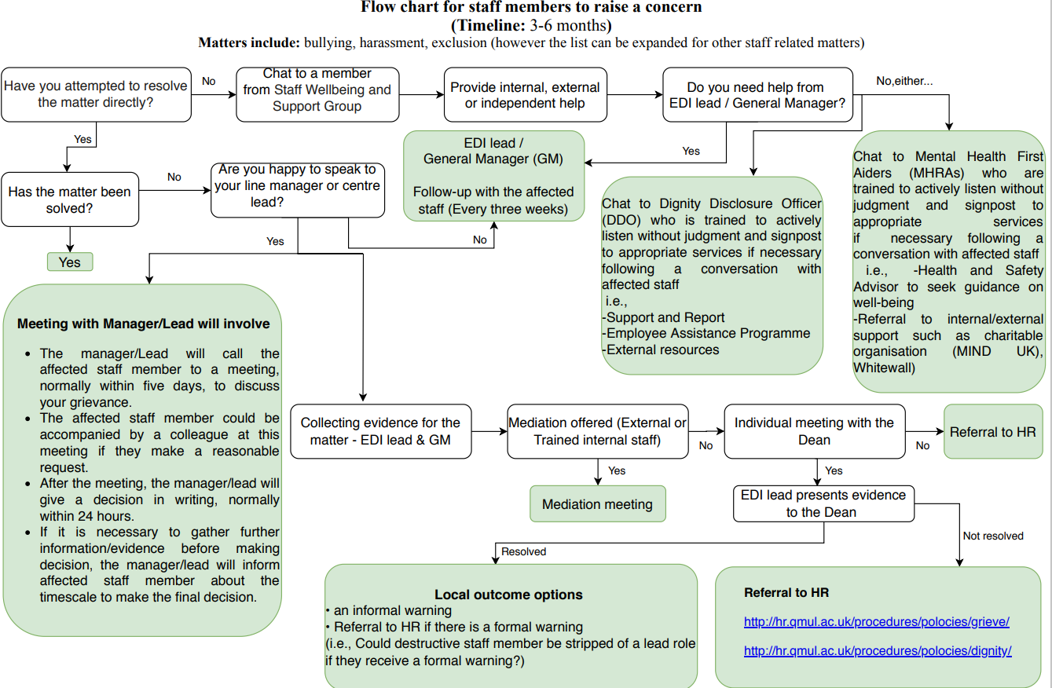

7. Tone and Body Language
- Be aware of your tone, volume, and non-verbal cues.
- Maintain open and respectful posture and expressions.
- What you don’t say can be just as powerful as what you do.

8. Confidentiality and Professional Boundaries
- Discussions involving sensitive or confidential information should be held in appropriate settings such as not in front of students/patients/staff members who are not part of the discussion.

- Never share private student, staff or patient information informally or without permission.
- Avoid informal gossip or inappropriate jokes at the workplace.
- Avoid looking for mistakes/errors/failures and exposing these to others in order to belittle a colleague.
- Confidentiality in assessments and exam boards is important since these interactions involve sensitive student information, which need to remain private and be shared only with those directly involved.

Summary:
Professional excellence by adhering to the QMUL’s core values is strengthened when empathy guides our understanding, recognition uplifts the teams, and kindness shapes the daily actions. These qualities foster trust, collaboration and a culture of respect with a shared commitment to the well-being of the entire community.

References
Epstein RM, Hundert EM. Defining and assessing professional competence. JAMA. 2002;287(2):226–235. doi: 10.1001/jama.287.2.226. [DOI] [PubMed] [Google Scholar]
Dignity-at-Work-and-Study-General-Guidance-May-2021.pdf
Written by FMD EDI Strategy Group

