 Risk Assessment Form for New or Expectant Mothers
QMUL_HS_201_March 2019 V2: Issued by the QMUL Health & Safety Directorate and Occupational Health
(supercedes QMUL form V1 issued in Jan 2007)
Instructions and guidance for the new or expectant mother (employee): This assessment will be treated in the strictest of confidence. It is to be used to discuss your work activities with your manager so that measures can be taken to safeguard you and your unborn child or new born child’s health and safety. You should provide to your line manager any medical advice received that is necessary for the risk assessment. The form is to be completed jointly by the new or expectant mother and manager.
In extreme circumstances if you are unable to complete the form with your manager, you can approach QMUL Occupational Health, QMUL Health & Safety Directorate or QMUL Human Resources in confidence and an initial risk assessment can be carried out. Please note if a change in working practice is required to prevent a risk, such a change will, inevitably, need your manager to be informed.
See page 7 of http://hr.qmul.ac.uk/media/hr/docs/pay/Employee-Guide-to-Maternity-Leave-2012.pdf
Instructions and guidance for the manager: In Health & Safety law, workplace risk assessments should already consider any risks to female employees of childbearing age and, in particular, risks to new and expectant mothers (for example, from working conditions, or the use of physical, chemical or biological agents). The risks to their unborn children and the children of a woman who is still breastfeeding must be included in the assessment. At QMUL, this responsibility is devolved to line managers. At QMUL, risk assessments must be reviewed at least once every 3 years, and annually where there is residual medium to high risk. See page 12, point 7.5.4 of http://www.hsd.qmul.ac.uk/media/hsd/documents/standards-and-guidance/QMUL_HS_042-Risk-Assessment-Policy_V3_26NOV2018.pdf
If you are notified that an employee is pregnant, breastfeeding or has given birth within the last six months, you should check your workplace risk assessments to see if any new risks have arisen. You would need to take medical advice given to the new and expectant mother into account (this will be informed to you by the new or expectant mother). If risks are identified during the pregnancy, in the first six months after birth or while the employee is still breastfeeding, you must take appropriate, sensible action to reduce, remove or control them.
QMUL has instigated a specialist risk assessment template below to help you decide if any additional action needs to be taken to minimise risks for the new or expectant mother and their unborn children. The form is to be completed jointly by the new or expectant mother and manager.
Identifying a hazard does not necessarily mean you have to stop working with it but if risk/s to the health of the new or expectant mother and their unborn children are identified, you must identify and implement the preventative and protective measures to reduce, remove or control them.
What the manager and employee need to do:
- To identify hazards which may cause health & safety risk/s for the new or expectant mother or their unborn or new born children
- Discuss together the new or expectant mother’s working conditions
- Include risks which might arise when the employee is performing their own duties and other activities in their department
- If needs be, take advice as follows -
(a) On medical issues - from the QMUL Occupational Health http://hr.qmul.ac.uk/about-us/
(b) On the risk assessment, workplace hazards and risk controls and on ionising radiation risks from the QMUL Health & Safety Directorate http://www.hsd.qmul.ac.uk/ (see topic page for new or expectant mothers and other relevant A-Z pages)
(c) As applicable, on local working conditions involving ionising radiation risks from the Departmental Radiation Protection Supervisor.
(d) Information and guidance can also be obtained from the Health & Safety Executive online at http://www.hse.gov.uk/mothers/
- Please keep a copy on file and send by sealed internal post marked CONFIDENTIAL to Occupational Health, Geography Building, Mile End Campus or email to oh-surveillance@qmul.ac.uk
- This assessment should be regularly reviewed and if necessary updated, particularly if there is a change in health or circumstances.
Note – this form is not appropriate for non QMUL employees but if used, the QMUL responsible person for the new and expectant mother takes on the responsibility of the line manager.
(A) DETAILS OF NEW or EXPECTANT MOTHER
Surname:
First name
Date of birth (optional):
Job title:
Category: | Staff Student (on payroll)  Full time Part-time
Campus: | - Mile End Whitechapel Charterhouse Square  Other:
School/Institute/Directorate:
Locations of work activities (e.g. building name/s, outdoors, multiple campuses, abroad):
QMUL email address:
Contact number:
Status: | Pregnant (expectant mother)
Status: | Has given birth in the last six months (new mother)
Status: | Breastfeeding
Date the baby is due/was born:

(B) DETAILS OF MANAGER
Surname:
First name:
QMUL email address:
Contact number: | 0207 882

(C) CURRENT STATE OF HEALTH/WELL-BEING OF NEW or EXPECTANT MOTHER
This information will help identify the appropriate control measures needed for your work activities, which can be then made specific to your needs)
Are you suffering from any of the following: | Yes | No
Morning sickness
State specific times of sickness, if possible:
Swollen feet
Backache
Other (please specify):

Are you doing anything to alleviate any of the above? If so, please state what below:

(D) BRIEF SUMMARY OF WORK PROCESSES:

(E) WORKING CONDITIONS
Does your work contain/involve the following: | Yes | No
Display screen equipment
Working alone
Travelling during working hours (i.e. during the day between campuses for work)
Night work
Shift work
Stressful situations (e.g. high pressure work due to customer facing role or volume of work)
Other (please specify:

(F) EXPOSURE TO PHYSICAL AGENTS
Does your work expose you to the following: | Yes | No
Manual handling of loads
Physical fatigue i.e. sitting or standing for extended periods of time
Extremes of cold and heat
Lasers
Radiation Sources (ionising and/or non-ionising radiation)
Ionising radiation sources: x-ray, alpha, gamma, beta – identify appropriate:

Non ionising radiation sources: electromagnetic frequency, UV, solar, microwave– identify appropriate:

Other (please specify):

Vibration
Hand-arm, whole body – identify appropriate:

Noise
Awkward spaces
Confined spaces
Other (please specify):

(G) EXPOSURE TO HAZARDOUS CHEMICAL AGENTS
Does your work expose you to the following:  (categories in bold below may impact new or expectant mother / child health adversely if exposure occurs) |  | For those categories ticked, please provide the following information:  - Name of agent/s  - Route/s of exposure (e.g. inhalation, absorption etc.)  - Length of exposure (e.g. 2 hours a day) | Yes | No
 | Skin Irritant  Sensitizer  Hazardous to ozone layer
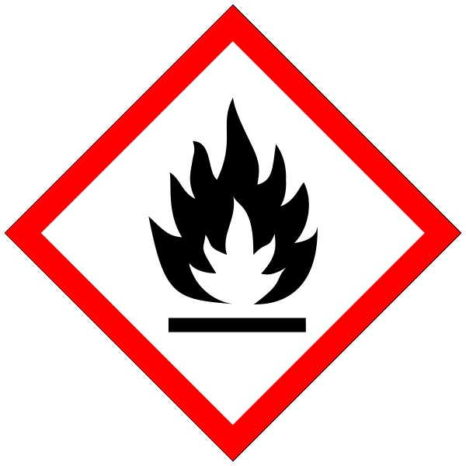 | Flammables
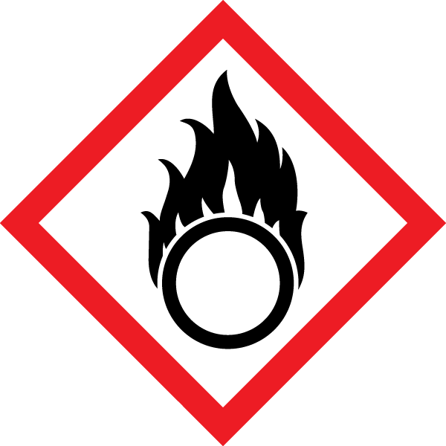 | Oxidisers
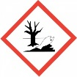 | Environmental (aquatic) Toxicity
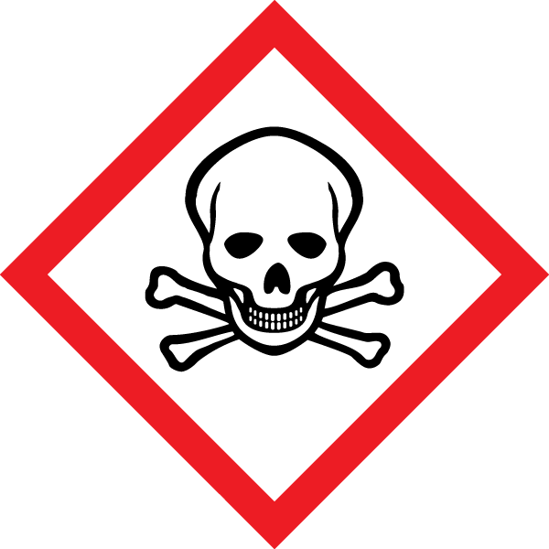 | Acute Toxicity  including
(a) | Cytotoxic drugs (also known as antineoplastic drugs) e.g. compounds utilised in for cancer and other treatments by pharmacy, nursing, research laboratories, veterinary or animal facilities
(b) | Mercury or mercury derivatives
(c) | Lead or lead derivatives
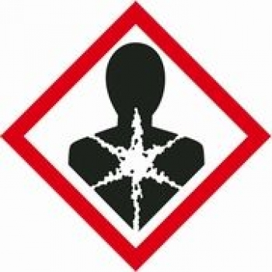 | Health Hazard  Carcinogenic  Mutagenic  Reproductive Toxicity  Respiratory Sensitizer
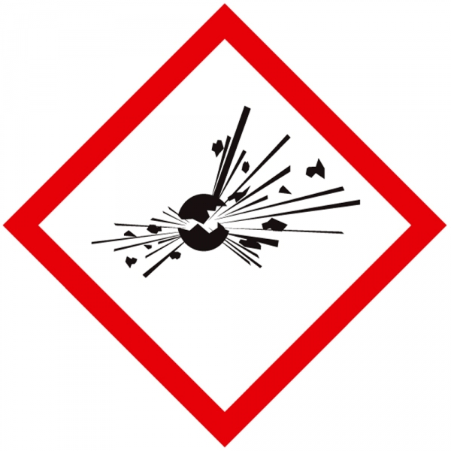 | Explosives
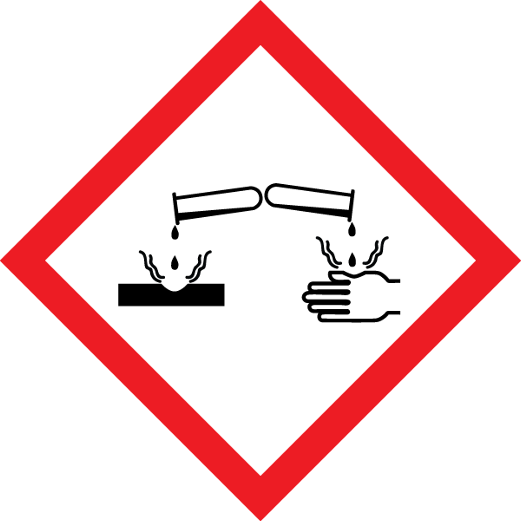 | Corrosives
 | Gases under Pressure
Carbon monoxide
Other (please specify):

SECTION FOUR: EXPOSURE TO BIOLOGICAL AGENTS
Does your work expose you to the following: | For those ticked, please provide the following information:  - Name of agent/s  - Route of exposure (e.g. inhalation, absorption etc.)  - Length of exposure (e.g. 2 hours a day) | Yes | No
Blood / body fluids
Human tissues / clinical specimens
Animal allergens (if working in veterinary or animal facilities)
Blood borne viruses e.g. HIV, Hepatitis B,C
Other infectious viruses e.g. Hepatitis A, cytomegalovirus, parvovirus, Rubella
Toxoplasma gondii (causative agent of toxoplasmosis)
Chlamydia psittaci
Listeria
Work with other ACDP Hazard Group 2 or above biological agents or Genetically Modified Organisms Class 2 or above:
Other (please specify):

SECTION FIVE: EXTERNAL FACTORS
Provide details on factors outside of the workplace, if you wish for it to be considered in this assessment (e.g. stressful situations at home):

 | SECTION SIX: CONTROLS AND ACTIONS
If you ticked yes in any of the above sections, please use this section to identify the controls that need to be put into place, to safeguard you and your unborn / new born child’s health and safety whilst carrying out your work activities/duties. Extend the table if required.
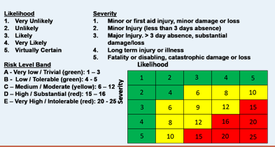
No. | Hazard identified | Assessment of risks  (Likelihood x severity=risk level / band) | Further health and safety controls identified and actions required (identify who should complete the action and deadline) | Residual risk level / band (once controls in place)

Please keep a copy on file and send by sealed internal post marked CONFIDENTIAL to Occupational Health, Geography Building, Mile End Campus or email to oh-surveillance@qmul.ac.uk
Employee’s signature: | Date:
Manager’s signature: | Date:
QMUL Occupational Health Use Only:

