**Professorial Review 2024-25**

**Guidelines**

**Contents**

1. Introduction page 1
2. Eligibility page 2
3. Principles page 2
4. Step 1 – Individual Professorial Submission page 3
5. Step 2 – Head of School / Institute Director Commentary page 3
6. Step 3 – Faculty Review and Moderation page 5
7. Step 4 – University-wide Review / Validation by Senior Executive Team page 5

Appendix 1: Timetable

Appendix 2: Sample wording from the Academic Careers Framework at Professorial level

Appendix 3: Assessing the scale of contributions

Appendix 4: Bonus criteria

**1. Introduction**

Each year, Queen Mary conducts a review of the progress, achievements, and contribution of Professors, individually and collectively. A Professorial title is increasingly the academic career norm and individuals may hold the title for 30 years of active career; in recognising this, the Professorial Review process aims to facilitate the ongoing development of the professoriate, collectively and individually.

There are four steps in this review process:

* Each individual professor’s own submission
* Review/commentary by the Head of School / Institute Director
* Faculty review/moderation by the Faculty Vice-Principal and Faculty Deans, working with Faculty Strategic HR Partners
* University-wide review/validation by the Senior Executive Team (SET)

In addition to this annual review of the progress, achievements, and contributions of Professors, there is a review of the School/Institute recommendations on professorial pay or bonus. Faculty Vice-Principals make recommendations which are subject to overall review and moderation by SET. Bonus recommendations are also subject to overall review by a University-wide Bonus Calibration process.

The documentation for the Professorial Review aims to ensure:

* A clear link is made between performance outcomes/outputs aligned to Queen Mary Strategy (e.g. grant success, scholarly impact, or university/national/international academic leadership profile) and any reward decisions on professorial pay
* The outcomes/outputs are aligned to the standards of professorial excellence set out in the Academic Careers Framework (e.g. appendix 2 contains sample wording at Professorial level from the ‘Research’ and ‘Scholarship’ sections) with the expectation that all professors are role-modelling the Values
* The outcomes/outputs are measured/assessed in line with the ‘scale of contributions’ in appendix 3

As part of their individual submission, professors should summarise their contribution and how it meets the standards of professorial excellence set out in the Academic Careers Framework.

Heads/Directors are expected to be able to review/assess how each individual’s performance meets both the standards of professorial excellence set out in the Academic Careers Framework and the outcomes in Appendix 3 ‘scale of contribution’.

Queen Mary aims to value, recognise and reward contributions in a range of activities such as: impactful output (scholarly, research or professional practice), industrial engagement/spin-offs, research/scholarly/professional practice leadership (e.g. driving forward Queen Mary visibility/reputation globally, leading/coordinating large scale projects, reviewing/setting national and international research policies), and success in attracting research grants.

Queen Mary professors also have significant teaching and student responsibilities as an integral part of their roles; the Professorial Review therefore also provides the opportunity to assess individual performance and reward exceptional contribution against the agreed targets set by Heads of School / Institute Directors.

**2. Eligibility**

You are invited to make a submission to the Professorial Review 2024-25 if:

* you are a non-clinical Professor with a contract of employment with Queen Mary, and
* you have at least one year’s continuous service as a Professor with Queen Mary as at 1 January 2025, and
* you have completed all the mandatory training required for your role by the due dates.

You are invited to make a submission irrespective of your contractual working arrangements. This includes those who are currently on paid sabbatical leave and those who, through flexible retirement, are both working and receiving a pension.

**3. Principles**

**Link between the annual appraisal process and the Professorial Review**

The annual appraisal window runs to November. The focus of the Appraisal and Development discussion is on personal and career development.

The aims of the appraisal process are to:

* Ensure a shared understanding of individual objectives, aligned with Queen Mary’s strategic aims and operational requirements;
* Celebrate successes, identify and address any obstacles to achieving objectives;
* Identify strengths/development needs and enable discussion of career aspirations.

The Professorial Review submission builds on the annual appraisal. The Professorial Review form includes the option for appraisal objectives and commentary to be lifted directly and inserted, if individuals are satisfied the appraisal appropriately captures their achievements and contribution. Individuals can also add further achievements/contributions, if they wish.

**Areas of contribution**

The Professorial Review is aligned to the Academic Careers Framework. The Framework is designed to support every type of academic career path (Teaching & Research, Teaching & Scholarship, and Teaching & Professional Practice) and ensure that individual contribution is valued and measured consistently across the University. It is designed to be used to help plan and support career development and to recognise individual achievements.

There are six Areas of Contribution. It is anticipated that no more than three or four Areas will apply to each academic role, based on the academic’s career path (e.g. Teaching & Research, Teaching & Scholarship) and the specific expectations of the role, e.g. as set out in their job plan:

* Education
* Research
* Scholarship
* Citizenship & Inclusion
* External Engagement & Enterprise
* Professional Practice

**Assessment and decision-making**

The scale of contributions in appendix 3 provides a framework for Heads/Directors and the Faculty to ensure the consistent assessment of the evidence. This framework aims to differentiate between the levels of reach or impact of contributions, as well as to their size and complexity.

The Heads/Directors are asked to give an assessment of their professoriate and the levels of contribution at individual level, with input and oversight from the Faculty Vice-Principal and Faculty Deans. This assessment helps to inform the overall Faculty decision-making on professorial development and reward.

**4. Step 1: Individual Professorial Submission**

The submission should be concise and cover achievements over the last 12-month period. It may also be relevant to cover work in progress and contributions that span over a longer time period such as those not noted in detail in previous submissions. CVs should not be submitted.

* The first part of the Professorial Review Form enables individuals, if they wish, to lift text directly from their appraisal and to provide details of up to six achievements/contributions (which probably originated as objectives in the appraisal) together with comments against each one, which can then be built on with additional commentary as appropriate.
* It is not necessary to record six achievements/contributions if, in practice, a smaller number of objectives were agreed. Conversely, where more than six objectives were agreed, please combine and/or prioritise to a maximum of six.
* There is a side-column to indicate to which of the Areas of Contribution (see the Academic Careers Framework) applies. It may be that a specific achievement contributes to more than one area, and therefore it is appropriate to tick multiple boxes.
* Below each contribution, please provide a commentary on the achievement or its progress. Again, this may be based on/drawn from the comments in your appraisal documentation.
* The subsequent text box asks about plans for your ongoing personal development and for comments on progress against these plans. This, again, may be drawn from your appraisal.
* There is an opportunity to note the impact of personal circumstances, to put your contribution into context. Examples are the impact of having reduced your working hours during the year, or having a disability, or experiencing a long-term absence (such as maternity, paternity or shared parental leave), or having caring responsibilities that may have had a work impact. The circumstances may be permanent or temporary. There is no need to provide specific personal details, only a summary of the type of circumstance and the impact on your work.

**5. Step 2: Head of School / Institute Director Commentary**

The Head of School / Institute Director writes a two-part School/Institute commentary on the professoriate in their School/Institute.

The first part focuses on individuals, and each is written on the individual professor’s submission.

* Heads / Directors may ask for contributions to these commentaries within the School/Institute (e.g. from Heads of Departments/Centres), however reward (pay/bonus) recommendations should be only provided by Heads of School / Institute Directors themselves.
* For transparency, any comments should be in line with discussions with the individuals, e.g. at appraisal meetings. Heads / Directors’ comments may also form the basis of subsequent feedback; do not write what has not been, or cannot be, shared with the individual.

The Head / Director provides an assessment of the contribution of each individual professor:

* Assess each “Achievement / contribution / objective” outlined in the individual submission forms and use the scale of contributions outlined in appendix 3 to help complete the matrix “Assessment of contribution”*.*
* Give an assessment of the professor’s contribution to each of the Areas of Contribution by checking High, Medium or Low in each area. Tick the appropriate boxes to indicate what your evaluation is based on e.g. the size / complexity of what they have done, the breadth of impact etc. Please also refer to the standards set out in the Academic Careers Framework.
* Provide summary comments and highlight any areas of strength or development. Under “areas of strength”, there is the opportunity to indicate where there is an area of outstanding strength. Keep comments brief – a couple of sentences per textbox are usually sufficient.
* Based on the above, make a pay or bonus recommendation. Pay recommendations are made on the basis of an individual’s contribution over the longer-term (not just the past year) and take into account an appropriate pay comparator (i.e. appropriate market median or internal comparator data). Bonus recommendations are based on the bonus criteria in appendix 4. The Reward team provide relevant data to Heads / Directors in confidence on current salaries for those Professors within their School / Institute, relevant analysis (e.g. average salary, gender / BAME ratios etc.) and data on previous awards.

The second part of the report addresses the organisational profile of the School / Institute’s professoriate and support the Faculty / School / Institute enabling plans. It focuses attention on the collective strengths and development needs of the School / Institute at professorial level. Whilst a Head / Director may take soundings in the preparation of this, it is important the views are theirs.

The headings for commentary are:

* The **pay profile** for the professoriate within the School / Institute: are there any gender / BAME pay gaps or apparent pay anomalies between peers that cannot be objectively justified?
* **Areas of organisational strength**, for example particular departments within the School / Institute or specialties within the discipline (or inter-disciplinary) where there is strength in depth or particular achievements relative to the professoriate as a whole?
* **Areas for** **organisational development** aligned with the trajectory of the discipline or School / Institute enabling plans.
* **Leadership development:** plans for the development of the professoriate in the coming year, with a focus on creating leadership capability as well as academic, and developing senior leaders at School / Institute and Faculty levels.
* Individuals at **risk** **of departure**, together with proposed School / Institute strategies.
* The **future** of the professoriate: rising academics currently below the level of Professor; the **succession plans** to enable both the renewal of the professorial pool within a School / Institute and future leadership roles.

**6. Step 3: Faculty Review / moderation by the Faculty Vice-Principal and Faculty Deans**

The Faculty Vice-Principal and Faculty Deans, working with Faculty Strategic HR Partners and Heads of School / Institute Directors, will agree appropriate peer comparators for the Professors in their Faculty, based upon levels of contribution, to establish appropriate internal pay relativities.

On the basis of the above discussions, the Faculty Vice-Principal, Faculty Deans and Faculty Strategic HR Partners will review / endorse pay recommendations (in line with an indicative budget) and subject to final oversight / review by SET.

The Faculty Vice-Principal will prepare a brief overview of Faculty pay recommendations for the SET Review process, based on the Faculty level discussions and moderations. This overview will also focus on the strengths, achievements, development areas, retention risks, the current professorial profile and future rising academics.

**7. Step 4: University wide review / validation by the Senior Executive Team (SET)**

SET will be provided with Faculty overview reports and a summary report from HR covering overall pay and bonus recommendations, diversity data analysis and any relevant benchmarking data. They may hold a two-part conversation: individual reward and organisational development.

**Individual reward:**

* What is the overall affordability of recommendations?
* Where do gender / BAME pay gaps continue to exist?

The group may also seek more information and / or moderate pay recommendations.

**Organisational development:**

* Endorsement of Faculty summary review and development plans for professoriate: agreement on areas of strength and where to best target interventions.
* Endorsement of risk management responses regarding any Professors at risk of leaving.
* Review of the spread of the areas of contribution / career paths across the Faculties; for example, is there the right mix of Scholarship, Research and Professional Practice?

**Appendix 1: Timetable**

| **Timetable** | |
| --- | --- |
| Launch of 2022/23 Professorial Review | Tuesday 21 January 2025 |
| Completed applicants’ Professorial Review form to be emailed to their Head of School / Institute Director by: | Friday 14 February 2025 |
| Heads of School / Institute Directors to meet with their Vice Principals to review individual submissions: | Monday 17 February 2025 – Wednesday 26 March 2025 (inclusive) |
| Heads of School / Institute Directors to return their completed submission decision forms to the Reward and Benefits team by: | Friday 28 March 2025 |
| Faculty Panels chaired by Vice-Principals to review submissions from their Faculty ahead of the SET Review | April 2025 |
| SET Review (and Bonus Calibration Panel) | May 2025 |
| Decisions and reward outcomes communicated | May/June 2025 |

**Appendix 2: Sample wording from the Academic Careers Framework**

The Academic Careers Framework sets out the standards of excellence for delivery, development and leadership in all areas of contribution at professorial level: Education, Research, Scholarship, Citizenship & Inclusion, External Engagement & Enterprise, and Professional Practice.

The sample wording below is from the sections on ‘Research’ and ‘Scholarship’ in the Academic Careers Framework and sets out examples of the standards of excellence expected. Please refer to the Academic Careers Framework for the full complement of standards of excellence.

# **Research**

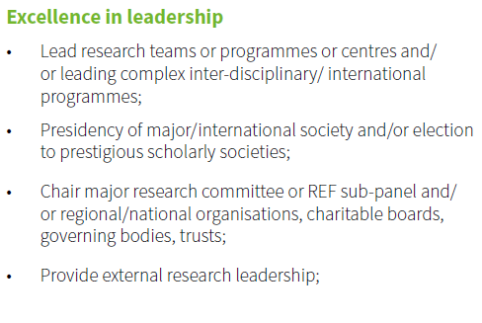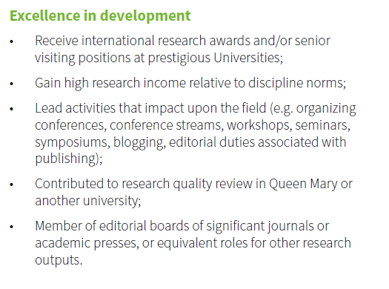

# **Scholarship**

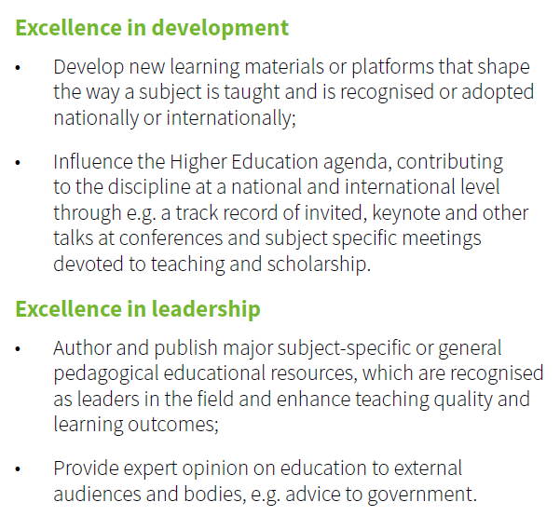

**Appendix 3: Assessing the scale of contributions**

|  |  |
| --- | --- |
| **Size/complexity** | * How big were the projects or programmes of work being described? * How complex was the work e.g. budgets, multiple territories or multiple interest groups? |
| **Sustained individual contribution aligned to the Queen Mary Values, Strategy and standards of excellence** | * To what extent has individual contribution at professorial level been maintained and continually improved in line with the Values? * To what extent is the individual contributing to the University’s Mission and Strategy? * How does the contribution align to the standards of professorial excellence that are set out in the Academic Careers Framework? |
| **Measurable outcomes** | Use measurable outcomes to quantify the outcomes of the work being described. Examples of quantification would include:   * Completion rates * Satisfaction ratings * Volume / amount * Frequency |
| **Breadth of impact** | How wide-ranging was the impact of the work? Some of the categories to consider for assessing impact would be:   * The breadth of their impact on the work itself. What role were they playing? Examples include: Initiating / Leading / Advising / Consulting / Participating * Their discipline: the extent of their impact upon their discipline. * HE sector: to what extent did they impact at School/Institute / Faculty / University / Sector levels? * Territories: to what extent have they had an impact which was national / international? * People: who has been impacted by their work? For example:   + Students (u/g or p/g)   + Colleagues in / outside Queen Mary   + Practitioners within the discipline   + Wider public |
| **Partner profile** | How influential or distinguished are the organisations or bodies with whom or for whom the work was done? What sort of national/international reach do they have? This is a wide-ranging group, which would include:   * Other HEIs * Journals * Learned societies * Social enterprises / Charities * Government bodies / Parliamentary bodies * Industrial or commercial organisations * Research committees * Conferences * National/international media |
| **Recognition** | How has the professor been recognised?   * Assessor / Reviewer * Visiting positions (for named lecture) * Awards / Election to distinguished body (e.g. FRS, FBA) |

**Appendix 4: Bonus Criteria**

| **Criteria – How? (Values)** | **Criteria – What?** | **Impact of what has been delivered (Measures)** |
| --- | --- | --- |
| * Inclusive * Proud * Ambitious * Collegial * Ethical | * Development and delivery of innovative or creative new solutions that have impact * Exceptional personal responsibility/impact either as an individual or by a team as an example of good citizenship, inclusivity, or environmental sustainability * Delivery of work output(s), project(s) or initiative(s) that impacts beyond the usual scope of their role/grade or their area of responsibility | * Legacy of initiative or contribution or cross-functional collaboration will be greater than one year * Demonstrable reduction in wastage or efficiency gains * Number of staff or students supported or benefiting from the activity * Financial savings or income generation * Risk mitigation accomplished * Scale and significance of activity is beyond usual area of responsibility * Duration of contribution e.g. 3+ months * Extent/scale of cross-organisational/team working with other parts of the organisation * Long-term upskilling of team that has an impact on future ways of working/projects |