Apply for your Student immigration permission outside the UK

This guide is for Queen Mary University of London students who are applying for a Student Visa from outside the UK to come to study in the UK at Queen Mary University of London.
In summary, you will need to complete the Student Visa application form and pay the visa application fee and Immigration Health Surcharge (IHS) online.
The date you pay the IHS charge and application fee is the date you have made your visa application. Please ensure that your documents (if applicable) meet the Student visa requirements on this date.
Before you apply for your student visa, you should check that you meet all the requirements, and you have all the relevant documents for your visa application.
Every applicant for a Student Visa will need to have been issued with a Confirmation of Acceptance for Studies by Queen Mary University of London for your course of study, and you will need your valid passport or travel document.
For some Student Visa applications, you will need to check if you need to provide:
- ATAS clearance – required for some course
- TB Clearance Certificate – required for some applications from listed countries
- Evidence of qualifications listed on your CAS – for some applicants
- Evidence of your finances – for some applicants
- Any other evidence relevant to your application – for some applicants

For further information, including on the above documents please carefully read all the information on our website on Applying for Student Immigration Permission
*The application form may be subject to change. If you notice any changes, please let us know and we will update our guidance*

This guidance document has 23 sections:

1. Where you planning to live 3
2. Do you have an EU,EEA or Swiss passport? 3
3. Select a county to provide your biometrics 4
4. Start application 4
5. Register an email and telephone number 5
6. Marshall, Chevening or Commonwealth Scholarships 6
7. Providing Confirmation of Acceptance for Studies 6
8. Personal Details Section 7
9. English Language Section 9
10. Your Family Section 12
11. Travel and Residence in the UK section 13
12. Date you plan to arrive in the UK: 15
13. Immigration History and problems section 16
14. Sponsor Details (Sponsor Licence Details) 17
15. Course Information section 18
16. Additional information 21
17. Checking Your Application 21
18. Documents 22
19. Conditions and Declaration 22
20. Immigration Health Surcharge (IHS) 23
21. BRP (Biometric Residence Permit) collection 24
22. Final submission of and paying for your Student Visa Application 25
23. After You Submit and Pay for your Student Visa Application 25

Where you planning to live

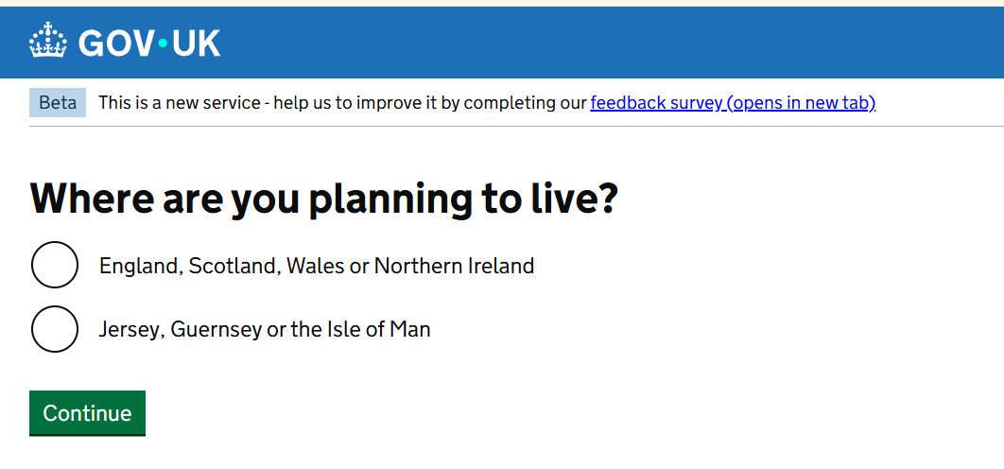

The first question asks if you are planning to live in either:

- England, Scotland, Wales or Northern Ireland
- Jersey, Guernsey or the Isle of Man

If you planning to live in England, which includes London, then the first option would be to correct one to choose.

Do you have an EU,EEA or Swiss passport?

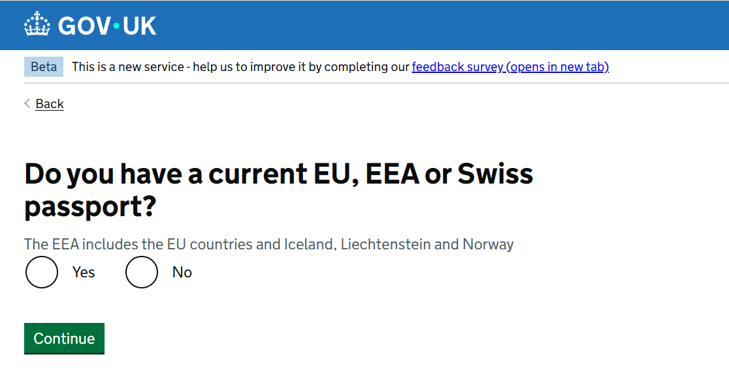

The next question you will see asks if you have an EU, EEA, or Swiss passport. If you are not an EU,
EEA or Swiss citizen answer “No” to this question and move on to the next stage of the application.
This is because there is a different way of applying for the student visa available to EU, EEA and Swiss citizens. To confirm your identity, you can use the free UK Immigration: ID Check app to scan your passport with a biometric chip and upload a photo of yourself. If you answer “Yes” the form will provide separate questions checking if you have a biometric passport and prompting you to download an app.
EU, EEA, and Swiss citizens who are able to use the UK Immigration: ID Check app, will not need to visit a Visa Application Centre as part of the Student Visa application. The visa application process may look slightly different to how it is explained in this document, but the application form questions should still be the same.

Select a county to provide your biometrics
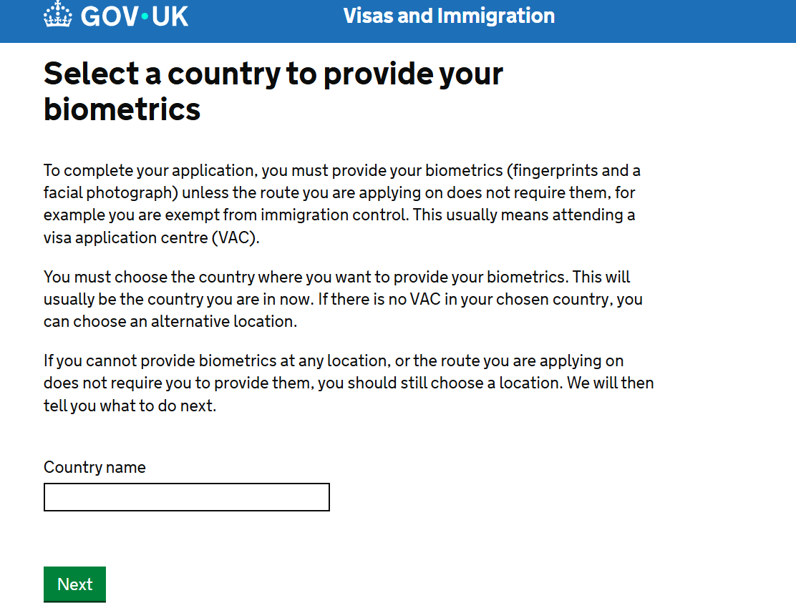

If you cannot use the UK Immigration: ID check app, you will need to attend a visa application centre to provide your biometric information. You will be asked to declare a country you intend to apply from.

The immigration rules require that you apply from the country of your nationality or a country you are “living in”, for example if you have residency rights for. The immigration rules do not typically allow you to apply from a country you are just there as a visitor our tourist.

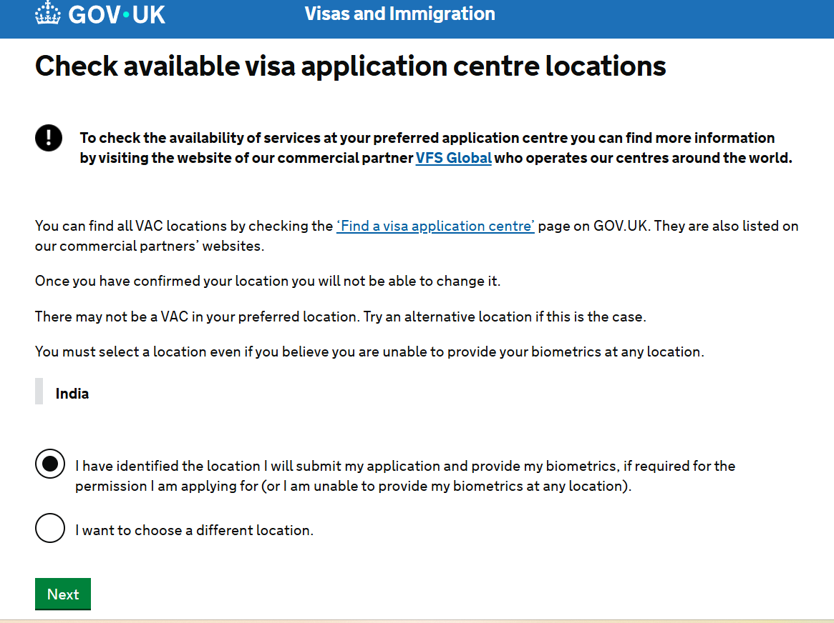

The form will then direct you to the find a visa application centre page, to check you have a centre you can attend from your chosen location.

Start application
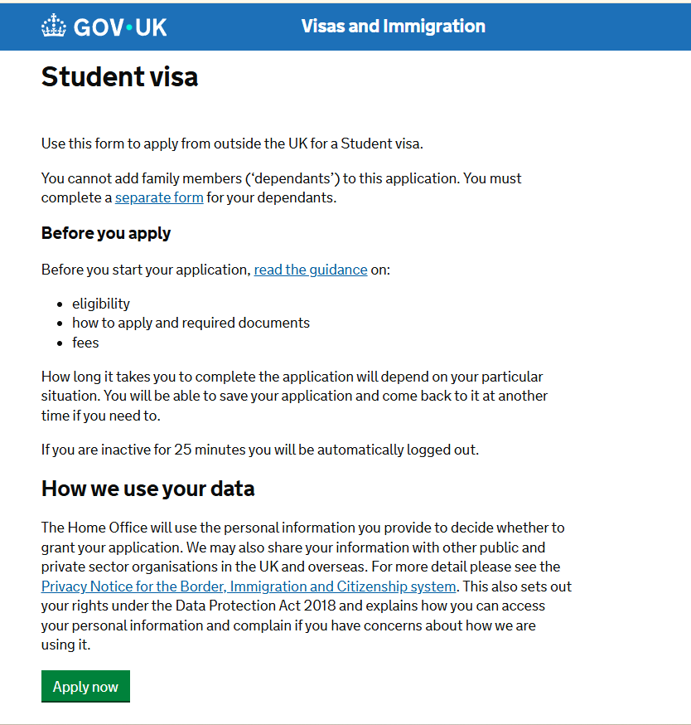
You will be taken to a webpage in which you can select the “Apply now” button to start your application.

Register an email and telephone number
Please read the information carefully and create an account
- Register your email - you should use the email account which you use most frequently.
- Create a secure password following the instructions and save and continue
- Confirm that you can be contacted by email
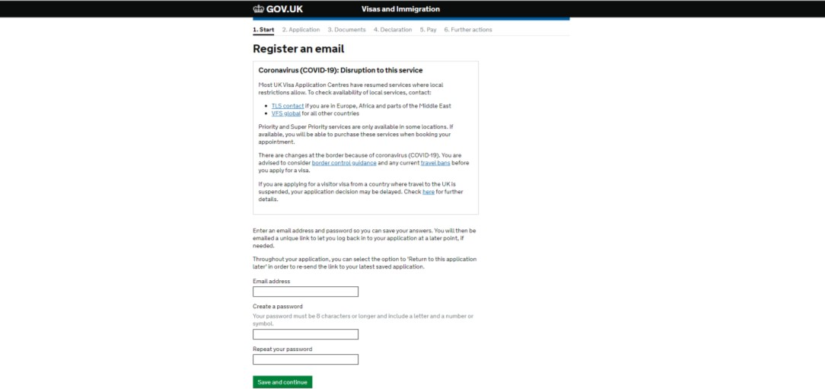

Note: Regularly check your email inbox - and also the junk/ spam mail folder in case any correspondence from the UK Government (UKVI/ the Home Office) is filtered through to junk.

Telephone number:
Provide details of any telephone numbers that you can be contacted on.

Marshall, Chevening or Commonwealth Scholarships
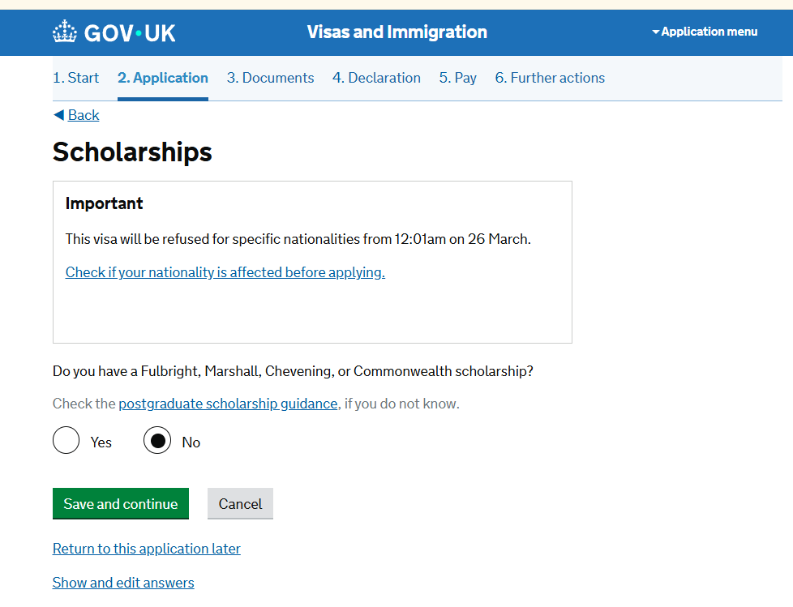
Do you have a Marshall, Chevening or commonwealth scholarship? Answer ‘Yes’ if you do and ‘No’ if
you do not, you can read the guidance notes if you are not sure.

Providing Confirmation of Acceptance for Studies

You need a CAS in order to apply for your visa. Copy the details from your CAS.
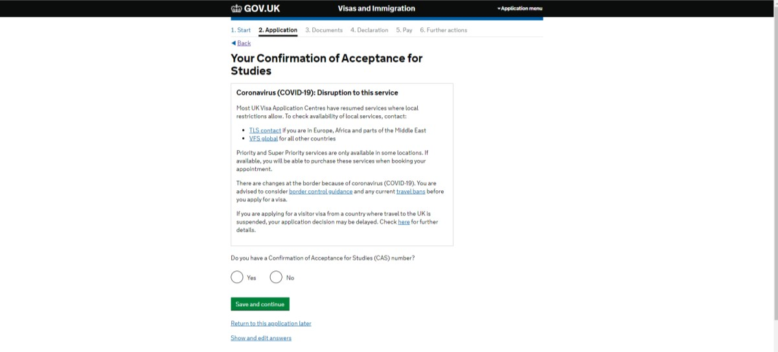
Note: You should not use the same CAS number that you have used previously. Any Student Visa application you make needs a new CAS number, even if you are applying for a student visa to continue the same course as previously.
See our website information for more information on the CAS.
The Form will ask you for the start date and end date for your course. Copy the course start and date directly from your CAS information.

Personal Details Section

Your name:
Please complete the details as your name is spelt on your passport.
If you have any other names, you will be asked to complete further questions. You should copy the details as they are spelt on any official documents.
You should also provide details of any other names that you are known or have been known by including any different spelling that you have used for your name(s).

Your Gender and relationship status:
For gender select one of the options: Male, female or unspecified.
For relationship status, choose one of the options in the drop-down selection.

Your Address:
This will normally be your normal residence in your home country or where you are currently living and should be the address where you can receive correspondence about your application.

If you cannot receive correspondence at your address, you can provide an alternative address where you can receive correspondence in this section of the application form.

About this property:
You are asked how long you have lived there. If you are not completely sure, you should choose the number of years or months that is closest to what you believe.
You are also asked the status of the property where you live: if you own or rent the property or the status is other.
If, for example, you live in your parents or other family members home, you can choose “Other” and in the free text box that appear, you can explain in one sentence that you live with that family member who owns or rents the property themselves.

Other addresses in the past two years:
If you have been living at your address for less than 2 years, you will be asked to complete the questions with details of all the other addresses that you have lived at in the past 2 years. These should be places you genuinely resided in for living/study/work etc.

Your Passport:
Enter the passport details of your current, valid passport that you intend to submit with your immigration application. This should match the passport number in your CAS statement. If it does not match, please contact cas-admissions@qmul.ac.uk before proceeding with your immigration application.
Note: As long as your passport is valid at the time of your application and intended travel date to the UK, there is no minimum period of validity required for your passport.

Identity card:
If you have a national identity card (an official identity document issued by your country), please complete the details in this section. This includes identity cards, issued from non-UK governments. This does not include driving licences. If you have an internal passport, provide the details here.
If you do not have a national identity card, you can answer “no” and move to the next section.

Your nationality, country and date of birth:
Enter your country of nationality or citizenship as shown on your passport.
If you have more than one nationality and more than one passport, you may wish to consider which nationality and passport it would be advantageous to apply with (for example applying under the differentiation arrangements is possible).
You will still need to provide details of all your nationalities in your visa application and you must inform the International Admissions team of your nationalities.

Other nationalities:
If you have previously or still hold another nationality, then select ‘yes’ and complete the following
details. If you have not, please select ‘No’ and continue.

Applying for a Student Visa in a country not of your nationality:
You normally need to apply for your student visa in the country of your residence. This will normally be the country of your nationality. However, in some cases if you are a temporary resident (e.g.: on a student visa) or a permanent resident in another country, you can apply there.
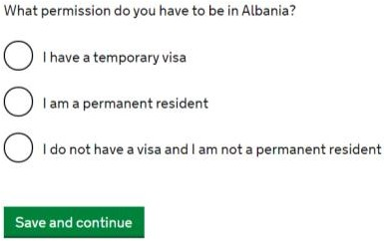

If you are in another country of which you are not a national as a visitor or a tourist, you cannot normally apply from there and must return to your country of normal residence to apply for your Student visa.

English Language Section

Nationals of Majority English Speaking Countries:
If you are a national of a majority English speaking country (e.g.: Australia, Barbados, Canada, Jamaica New Zealand or USA and a few others), your Student Visa application form should not ask you questions about your English language ability and you will be directed to the next section of the Student Visa application form.
You can find a current list of majority English speaking country nationalities on the UK Government website https://www.gov.uk/student-visa/knowledge-of-english

Nationals not considered Majority English Speaking Countries
Most other QMUL students (nationals of countries which are not majority English speaking) applying for a Student Visa for a course at degree level or above, will be able to prove their English language ability either through having previously met the English Language requirements in a previous visa application or because QMUL, as a Higher Education Provider with a Track Record of Compliance, has stated on your CAS that the institution has assessed your English language and you meet the minimum B2 requirements in all four components.
Some other students, mainly those studying at below degree level, may have to prove English language ability through one of the other possible options

Evidence of English Language Ability provided in a previous visa application

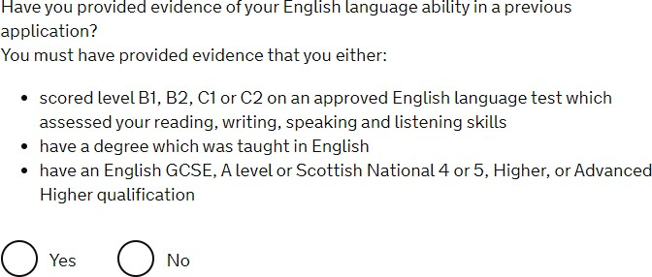

You can check your CAS to see how your English language ability was assessed.
If your CAS says that your English language has been assessed in another way, select NO and answer the following questions according to your situation.
You should only answer “Yes” here if you have previously provided evidence of your English
language ability at the required level in a previous UK visa application.
If you answer “Yes” here, you will not be asked any further questions about English language and will
be taken to the next section of the application form.

Spoken language preference:
This is in case UKVI need to speak to you about your application. You can either select English or Other. It would be advisable to choose English.

English Qualification from an English School
In most cases, QMUL students studying at degree level or above will not need to provide evidence of their English language as your CAS should state that QMUL has assessed your English language ability.
However, in case QMUL has not made its own assessment if you have an English language or literature qualification from a UK school you attended when you were under 18, you can provide your exam certificate. You can use a GCSE, A level, National 4 or 5, Higher, or Advanced Higher qualification.

If you answer “Yes” here, you will not be asked any further questions about English language and will be taken to the next section of the application form.

English Language Assessment
In most cases, QMUL students studying at degree level or above will not need to provide evidence of their English language as your CAS should state that QMUL has assessed your English language ability.
If this is the case as stated on your CAS, you can answer “Yes” to the question “Are you coming to the UK to study at a higher education provider with a track record of compliance?”
In the follow up question “Does your Confirmation of Acceptance for Studies (CAS) statement indicate that your English language ability was assessed by your institution or that you are a ‘gifted’ student?
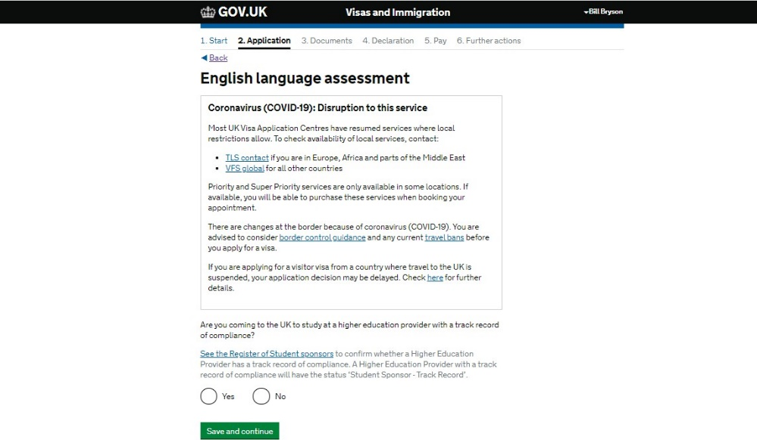

If you answer “Yes” to both questions here, you will not be asked any further questions about
English language and will be taken to the next section of the application form.

Short Term Study
In most cases, QMUL students studying at degree level or above will not need to provide evidence of their English language as your CAS should state that QMUL has assessed your English language ability.
You should only answer “Yes” here if you are attending a short-term study abroad programme at QMUL as part of a university course you are attending in the USA.
If you answer “Yes” here, you will not be asked any further questions about English language and will
be taken to the next section of the application form.

Studying English as a Foreign Language
In most cases, QMUL students studying at degree level or above will not need to provide evidence of their English language as your CAS should state that QMUL has assessed your English language ability.
Unless you are studying English as a Foreign Language (not pre-sessional English), you can answer
“No” to this question if it appears in the application form.

Degree Taught in English
In most cases, QMUL students studying at degree level or above will not need to provide evidence of their English language as your CAS should state that QMUL has assessed your English language ability.
However, in case QMUL has not made its own assessment and you have a degree taught in English, you may be able to rely on your degree taught in English as evidence of your English language ability.

English Language Test
In most cases, QMUL students studying at degree level or above will not need to provide evidence of their English language as your CAS should state that QMUL has assessed your English language ability.
However, in case QMUL has not made its own assessment (for example because you will be studying below degree level) and you have passed an approved English Language Test in the last 2 years, you may be able to rely on your English Language Test as evidence of your English language ability.
More information on the acceptable English Language Tests can be found on the government website https://www.gov.uk/guidance/prove-your-english-language-abilities-with-a-secure-english- language-test-selt

English Language Test Exemption
In most cases, QMUL students studying at degree level or above will not need to provide evidence of their English language as your CAS should state that QMUL has assessed your English language ability.
However, in case QMUL has not made its own assessment of your English language ability, if you believe that you are exempt because a medical condition prevents you from taking a test, you will need to provide a letter from your doctor confirming this.

Your Family Section

People financially dependent on you:
If you are bringing children or relatives who are financially dependent on you to the UK or if they are remaining in your home country, then you should answer ‘yes’. If you do not have anyone who is financially dependent on you then you can select ‘no.’
A financial dependant is anyone who relies on you financially for things like money, clothes, or food. This might include children, spouses, or other relatives.
If you select ‘Yes’ you will be asked to complete questions about the people financially dependent on you.

Give details about your parents:
You will be asked to provide details of your first parent. It does not matter which parent you choose. Please complete their details as they would appear on their passport or travel document.
You will then be asked to complete the details of your second parent.
If you do not have their details, you can select ‘What if I do not have my parents’ details?’

Family in the UK:
If you have any family that live in the UK, you can select ‘Yes’ otherwise you can select ‘No’. If you
answer ‘Yes’ you will be asked further details about your relative.
You will also be asked to provide their passport number and information about their status in the UK if they are not a British or Irish citizen such as whether they are permanent residents in the UK or have a temporary visa.
If you have more than one relative living in the UK, you can then add information about additional relatives.

Travel and Residence in the UK section

Travelling as part of an organised group:
If you will be coming to the UK as part of an organised group which includes travel companies, sports, work, or study groups you should select ‘Yes.’ You will then be asked for the name of the company or group name.
If you will be travelling on your own or with a friend or family members you should select ‘No.’

Travelling with another person:
If you are travelling with someone who is not a dependant, spouse, or partner (e.g. with a parent or a friend) select ‘Yes’ and complete their details as requested.
Otherwise please select ‘No’

Staying in the UK with family:
If you answered yes to the question about family members in the UK, you will be asked if you plan to stay with your family members.
If you will be staying with (one of) your family members in the UK, you can select the family member you have provided details for in answer to this question.
If you will not be staying with your family member in the UK, you can click on “save and continue”
without selecting the family member, you have provided details for in your application form. If you do not have any family members in the UK, you will not be asked this question.

Where will you stay in the UK:
If you have already arranged your accommodation, select ‘Yes’ and complete the details of the
address of the accommodation.
If you have not yet arranged your accommodation, you can select ‘No’ and you will be prompted to
give details about where you will be staying (your accommodation plans in the UK).
You could write something like "not yet confirmed" or “to be confirmed once my visa is granted.” If you plan to stay in private accommodation, you can write: ‘private accommodation.’ If you will be staying in QMUL accommodation, you can write: ‘University halls of residence.
When you have arranged your accommodation, you should let the Home Office know that your details have changed. You can do this online: http://www.gov.uk/change-circumstances-visa-brp

Other places you will stay while in the UK: Answer honestly based on your situation. For example, if you are staying in a hotel or with a friend when you first arrive in the UK before moving into your accommodation, you can answer ‘Yes’ and you will be asked for further details of where you will stay.
If, as far as you know, you will not be staying any other places you can answer ‘No’

UK Travel history:
If you have not been to the UK in the last 10 years you can select ‘No’

If you have been to the UK please select ‘Yes’ you will then be asked details of how many times you visited and you will be asked details about the purpose of your visit and the length of your stay of your 3 most recent times that you have been in the UK.
Depending on how you answer this question, some of the following questions may or may not appear in your student visa application.

Medical Treatment in the UK
This question will only appear if you have stated that you have previously travelled to the UK.
If you have ever received medical treatment in the UK (including for example, if you visited a doctor, clinic or hospital, this counts as having medical treatment), you should answer “yes” here and provide the additional details requested.
If you have never received any medical treatment in the UK at all, you can answer “no” here.

UK Visa applications
This question will only appear if you have stated that you have never travelled to the UK. If you have not been issued a visa for the UK in the past 10 years you can select ‘No’.
If you have been issued a visa for the UK, then please select ‘Yes’ and complete the following details.

Leave to remain in the UK:
This question will only appear if you have stated that you have previously travelled to the UK.
If you have not been issued a visa extension for leave to remain the UK in the past 10 years you can
select ‘No’
If you have applied for leave to remain in the UK, then please select ‘Yes’ and complete the following
details.

National Insurance Number:
This question will only appear if you have stated that you have previously travelled to the UK. Answer Yes or No if you have a UK National Insurance number.
If you answer yes because you have a UK National Insurance number, you will be asked to provide the National Insurance number.

UK Driving Licence:
This question will only appear if you have stated that you have previously travelled to the UK. Answer Yes or No if you have a UK driving licence.
If you answer yes because you have a UK driving licence, you will be asked to provide the driving licence number.

Finance – UK Public Funds:
This question will only appear if you have stated that you have previously travelled to the UK. Answer Yes or No if you have ever received UK public funds (government benefits).
If you answer yes because you have received UK public funds, you will be asked to provide details of the public funds you received.

Travel to Australia, Canada, New Zealand, USA, Switzerland or the European Economic Area:
Answer yes if you have ever travelled to any of these countries (Australia, Canada, New Zealand, USA or a European Economic Area member state) complete the details.
If you have visited these countries in the past 10 years you will be asked to provide information about your visits.
If you have not, then you can select ‘No’.
You will be able to provide details of more than one visit. However, if the application form does not allow you to enter all your previous trips to these countries, you can provide details in the Additional Information section at the end of the application form.

World travel history:
If you have not visited any other countries (apart from the UK, Australia, Canada, New Zealand, USA or a European Economic Area member state) in the past 10 years then you can select ‘No’
If you have and you select ‘Yes’, then you will be asked for details about your trips.
You will be able to provide details of more than one visit. However, if the application form does not allow you to enter all your previous trips to these countries, you can provide details in the Additional Information section at the end of the application form.

Date you plan to arrive in the UK:

Important: Choosing the date you put here will affect the start date of your visa and when you can arrive in the UK. It is important that you read the information below and understand the rules on visa validity.

If you are undertaking a course which is at least six months long - or a pre-sessional course, you will be allowed to travel to the UK up to one month before the date in the "Course start date" field in your CAS statement, or one week before your intended travel date, whichever is later.
If you are coming to the UK for 6 months or longer, you will be issued with an Entry Clearance vignette (sticker) in your passport which is valid for 90 days. You must enter the UK before the end of this 90-day period.
(EU, EEA and Swiss citizens who apply using the UK Immigration: ID check app won’t be issued with an Entry Clearance vignette but instead will be issued a digital status and an email confirming grant of your student visa with valid from and valid to dates.
The 90 days will start from one week before the date you intend to travel to the UK or one month before the start date of your course as stated on your CAS, whichever is later.
If you do not travel to the UK during this 90-day period your entry clearance will expire and you will need to apply for a replacement entry clearance (visa transfer) if you still wish to travel to the UK.
If your course is less than six months and is not a pre-sessional course, then you will be allowed to travel to the UK up to 7 days before the date in the "Course start date" field in your CAS statement.
Please note: If you intend to travel after the course start date, you should check your CAS statement to see the latest date you can arrive in the UK to enrol at QMUL.

Immigration History and problems section

Immigration history:
Please complete the details. If you have not been subject to any of the actions listed (such as refused a visa or deported) in relation to any country, then select ‘No.’
If you have then select ‘Yes’ and answer the following questions.
If you answer yes to this question, you should contact the International Student Advisers in the Advice and Counselling service at QMUL for advice or referral to a specialist immigration advice service.

Breach of UK immigration law:
Please complete the details. If you have not breached UK immigration law (breaching the conditions of your visa – such as illegal working or staying in the UK beyond your visa validity without making a visa application before the expiry), then select ‘No.’
If you have breached UK immigration law, you should select ‘Yes’ and provide the details requested.
If you answer yes to this question, you should contact the International Student Advisers in the Advice and Counselling service at QMUL for advice or referral to a specialist immigration advice service.

Convictions and other penalties:
You will need to select if any of the list of convictions or penalties applies to you. If not, you can
select the final option which is “No, I have never had any of these”

If you answer ‘Yes’ to any of this set of questions on convictions and other penalties, you will be asked to provide details.
If you answer yes to any of this set of questions, you should contact the International Student Advisers in the Advice and Counselling service at QMUL for advice or referral to a specialist immigration advice service.

War crimes:
Please complete the question answering ‘Yes’ or ‘No’. There is guidance to help with your understanding of war crimes, which you will need to confirm that you have read.

Terrorist activities, organisations and views:
Please complete the question answering ‘Yes’ or ‘No’. There is guidance to help with your understanding of terrorist activities, organisations and views, which you will need to confirm that you have read.

Extremist organisation and view:
Please complete the question answering ‘Yes’ or ‘No’. There is guidance to help with your understanding of extremist organisation and views, which you will need to confirm that you have read.

Person of good character:
Please complete the question answering ‘Yes’ or ‘No’. If you select ‘yes’ you will have to provide
more details.
If you answer yes to any of this set of questions, you should contact the International Student Advisers in the Advice and Counselling service at QMUL for advice or referral to a specialist immigration advice service.

Your employment history:
You will need to select if any of the list of employment applies to you (for example, if you have ever worked for the armed forces or intelligence services).
If not, you can select the final option which is “I have not worked in any of the jobs listed above.” If you have worked in any of the listed jobs, you will be requested to provide more information.

Sponsor Details (Sponsor Licence Details)

What is your sponsor licence number?
Write: 11W8K9Y63

Sponsor’s address
Write: Queen Mary University of London, 327 Mile End Road, London, E1 4NS Place of Study
Select Higher education institution with a track record of compliance (note this is important so please pay close attention to select this choice)

Primary site of study:
It should give the main address of Queen Mary which you entered in the question about the Sponsor’s address.
If this will not be where you have most of your studies, you may answer ‘No’ and you will have to
provide your primary place of study. This will be stated on your CAS.

UCAS details:
If you applied through UCAS you can answer ‘Yes’ and then you will need to provide your UCAS number.
Most undergraduate students will likely have applied through UCAS, but most postgraduate students will not.
If you did not you can select ‘No.’

Academic Technology Approval Scheme (ATAS):
Your CAS will state if you need ATAS clearance. If you need an ATAS certificate, you should include it with your Student visa supporting documents. You can find out more about how to get an ATAS in our advice guide.

If you require ATAS clearance, you will need to obtain this before you make your Student Visa application. You will need to provide the ATAS reference number in your application.

Future official sponsor:
You should only answer "Yes" here if you are receiving money (a scholarship or bursary, but not a loan) from the British Government, the government in your home country, the British Council, an international organisation, an international company, a university (this could be Queen Mary University of London) or an independent school.
If you are receiving financial sponsorship, you will need to confirm how you will prove this. If you are being only partly sponsored financially, you may need to demonstrate that you have sufficient funds to meet the outstanding financial requirements for your Student Visa.
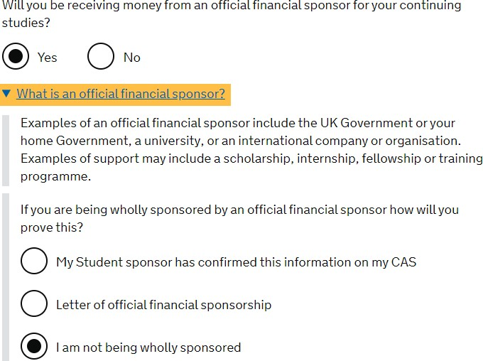

Course Information section

Name of Sponsor:
Write here: Queen Mary University of London

Course name:
This is the title of the course you are taking at QMUL. Copy this information from your CAS – as it is written on your CAS.

Qualification You Will Get:
Note for the qualification you will get you can copy this from your CAS. This is the RQF level of your course (RQF is the same as NQF).
Most undergraduate courses are RQF (NQF) level 6, most postgraduate (PG Cert, PG Dip and Masters) are RQF level 7 and most doctorate courses (e.g.: PhD) are RQF level 8.

Student Union Sabbatical Officer:
You should answer this question “No” unless you have been elected as a sabbatical officer for Queen Mary University of London Student’s Union and you require a Student Visa to undertake or complete your role.

Course dates:
The Course start date and the course end dates should match the information that is stated on your CAS. Copy this information exactly as it is on your CAS.

Accommodation payments:
Have you or your parent(s)/legal guardian(s) already paid any money to your sponsor for accommodation?
If you will be living in Queen Mary University of London or University of London halls of residence and you have already paid some money for your accommodation, you should select "Yes".
If you are staying in private accommodation, choose ‘no’ for this question
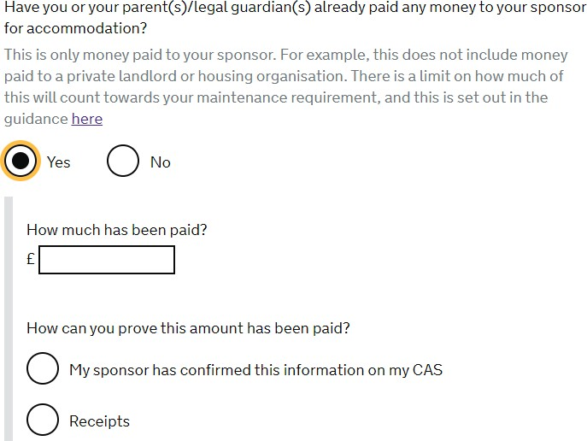

If you will be living in QMUL halls of residences, you can deduct a maximum of £1,334 of the money you have paid for housing. This will be shown on your CAS so you can select ‘My sponsor has
confirmed this information on my CAS.’
If the CAS is not up to date with payments that you have made, you should contact the International Admissions team CAS-Admissions@qmul.ac.uk with information of additional payments and a request to update your CAS.
Please note: The £300 accommodation holding deposit required by QMUL is not counted as fees paid towards your accommodation and will not be reflected on your CAS or deductible from your living expenses.

Course fees:
The course fees you state on your student visa application should match the information of your course fees stated on your CAS. Copy this from the "1st Yr Crs fees" field in your CAS statement.
Have you or your parent(s) or legal guardian(s) already paid any of your course fees? Select "Yes" if your CAS is showing any amount of tuition fee here as having been paid. You will then need to answer the following supplementary questions:
- How much has been paid? - This is listed in the "Crs fees paid to date" field in your CAS statement.
- How can you prove this has been paid? – Select ‘My sponsor has confirmed this information on my CAS’
If you have paid tuition fees since your CAS was issued, contact the QMUL Admissions team by email at cas-admissions@qmul.ac.uk to ask them to update your CAS.
Note: Even if you have an official financial sponsor who will pay your fees, you should still answer this question to match the information stated on your CAS.

Student loan:
If you will be receiving any of your tuition fees or living expenses maintenance from a student loan
you should select ‘Yes’ you will then be asked if you have already received the money. If not, you should answer ‘No’
Check our guidance about Student Loans

Maintenance funds:
Are all of the maintenance funds required for this application in a bank account with your name on it?
If the funds you need to hold as evidence of your finances (tuition fees minus any paid and living costs minus up to a maximum of £1334 paid to QMUL accommodation) are in a bank account in your own name, then you can answer ‘Yes’.
If you are receiving official financial sponsorship, you can also answer ‘Yes’ to this question.

If you are showing your funds held in accounts from your parent’s/legal guardian, you will select ‘No’ and answer the remaining questions confirming that you have the consent of your parent(s) to use their bank account and you can prove your relationship to your parent (e.g.: birth certificate)

Additional information

This section allows you to add additional information for the Entry Clearance Officer to consider. You may need to add additional information if you need to explain anything that might not be clear from your application or where there wasn’t the space or opportunity to provide details elsewhere in the application.
For example, in the circumstances of a previous UK immigration problem (e.g. if you have applied before and your immigration application was refused), you may be able to use this section to explain in more detail what happened.
If you have had a previous immigration problem, you may wish to seek advice from a Welfare Adviser at the Advice and Counselling Service at QMUL or another regulated immigration adviser before proceeding with your immigration application. Contact details for the Advice and Counselling Service can be found here: https://www.qmul.ac.uk/welfare/about-us/contact-us/

Checking Your Application

Once you have answered all these questions, your application is nearly completed.
You can sign out and come back to your application later. You can also save or print a PDF of your application form. There are still a few more steps to take before your application is completed and considered to be submitted.
You can still check your answers and make any amendments to your application at this stage. You may not have the opportunity to do so later, so check carefully.
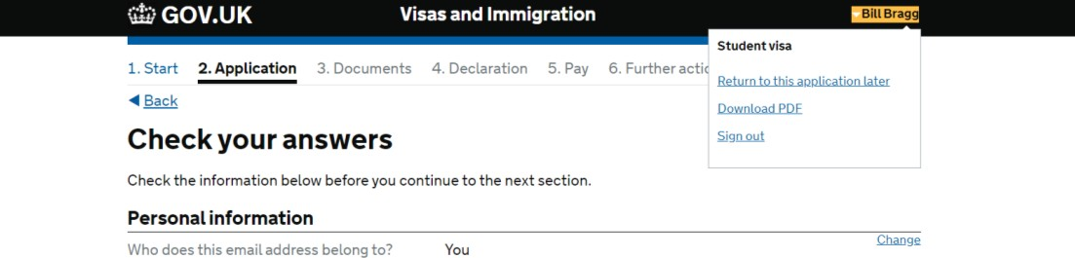

If any sections of your application are incorrect, you can change the answers by clicking on the
“Change” link on the right-hand side of your response and amending the information as appropriate.

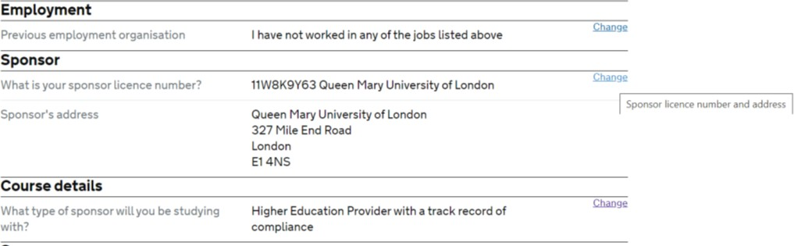

Once you are happy that your application is correct and fully completed, you can scroll to the bottom of your answers and click on continue.

Documents

All applicants will need to provide their passport as part of their application (EU, EEA and Swiss citizens can use the UK Immigration: ID check app to scan and read their passports instead of submitting the passport to a Visa Application Centre).
Depending on your application (including your nationality, the country in which you are living, your personal and financial circumstances), you may see a list of other documents which you will need to provide as part of your application. These will be listed under Other documents (if applicable to you).

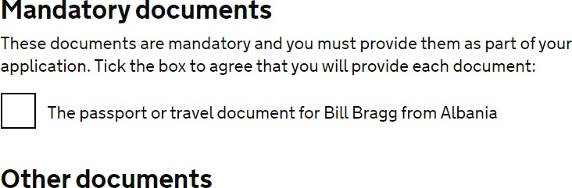

When you see the checklist of documents to be provided as part of your application, you will also see information about how to provide those documents.
Note: If you are a national of a low risk country applying under the differentiation arrangements, you must still meet the Student immigration permission requirements, but you don’t need to provide evidence of your funds and qualifications with your visa application, unless requested to do so by UKVI.

Conditions and Declaration

You will need to agree to the conditions of the application before you can submit the application.

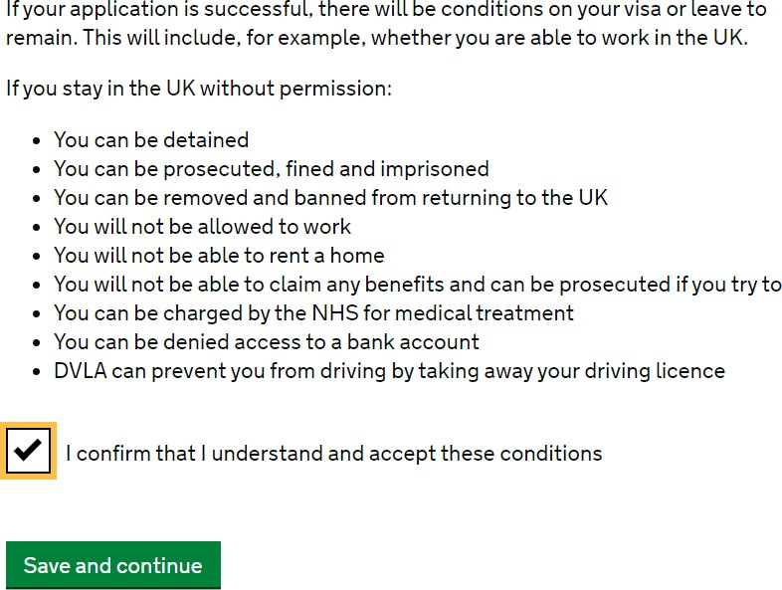

Once you have agreed to the conditions of the application, you will be directed to a declaration.
If you are the applicant and under the age of 18, you will need written consent from your parents to apply.
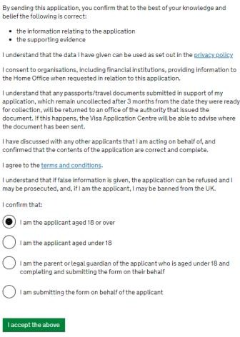

Immigration Health Surcharge (IHS)

Once you have completed the declaration, you will be directed to a separate webpage to pay the Immigration Health Surcharge.
Click on ‘Go to IHS website.’ You’ll then need to pay the IHS. You can check how much you’ll need to
pay here: www.immigrationhealth-surcharge.service.gov.uk/checker/type.

On the first IHS webpage, you will just need to read the information about the cost. Click ‘Continue’
after reading that page.

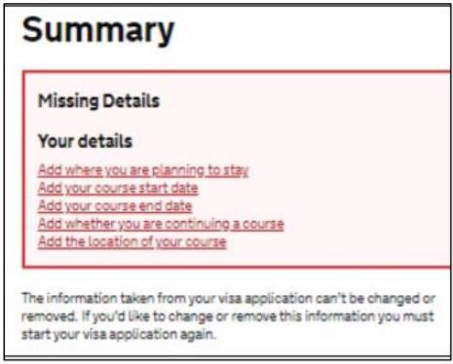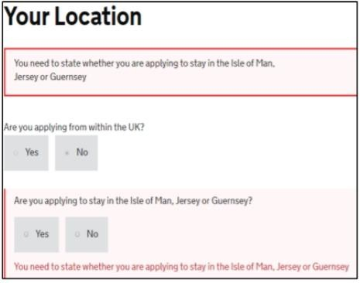

You may need to answer some additional questions about your planned stay in the UK and your course details again. This is so that the IHS can be calculated correctly.
In the question, “Are you applying from within the UK?” you can answer “no” as you are making
your visa application outside the UK.
In the question, “Are you applying to stay in the Isle of Man, Jersey or Guernsey?” you can answer “no” unless you are applying to stay in one of those islands.
Once you have completed this information, you will be able to pay by providing credit or debit card
details. The card can be in anyone’s name and it does not have to be a UK bank.
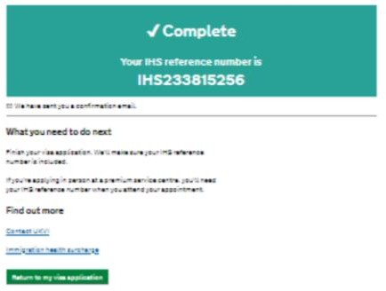

BRP (Biometric Residence Permit) collection

The final section before payment is regarding BRP collection. This will be your actual permission to stay in the UK for study (if your visa is longer than 6 months).
You must collect it from a Post Office within 10 days of arriving in the UK or before your entry clearance visa to the UK expires.

You are only eligible for a BRP if your visa will be longer than six months. If your visa is for less than 6 months, you will receive a vignette (sticker) in your passport for the full length of your visa.
Please note that you should choose to collect your BRP from a Post Office and not from an Alternative Collection Location as this is not available currently.
Check our guidance for a map of the nearest participating Post Office to the campus where you will be studying and the relevant postcodes to write on your application form.
Note: If you are an EU, EEA or Swiss citizen who applied for your student visa using the UK Immigration: ID check app, you will not be issued with a BRP and your status will be digital only.
Please see the UK Government website for more information on Viewing and Proving your status

Final submission of and paying for your Student Visa Application

Once you have paid the IHS, you will be redirected back to the student visa application form and you will be required to make another payment - for the visa application.
Please check the Student Visa application fee for a standard service in the local currency.
A standard student visa application should normally be considered within 3 weeks of submission of application.
At that stage, you may also be able to book optional services and book the visa appointment, for example if there is an option of a priority or speedy service for an additional fee, you may choose those options at this point.
We cannot provide specific guidance on the payment screens as it varies by country.
At this stage, you should be able to upload copies of any documents relevant to your application through the UK Visas and Immigration Commercial partner’s website for free (or you can take the documents to your biometric appointment to be scanned but there will be a charge).
Note: Once you have paid for your student visa application, your application is considered as submitted. However, you will still need to attend an appointment at the Visa Application Centre to provide your biometrics.
Even if you have uploaded all of your documents for your visa application, you will still need to take your original passport to the Visa Application Centre.
Note: If you are an EU, EEA or Swiss citizen who has used the UK Immigration: ID check app, you will not normally need to attend an appointment at the Visa Application Centre or submit your passport.

After You Submit and Pay for your Student Visa Application

Keep a copy of your submitted application and any evidence you submitted in support of your application and save in a secure location electronically.

Save any correspondence you receive about your visa application including automated emails and confirmation emails.
Regularly check your email (inbox and junk / spam mail folders) and your mobile phone SMS messages for the contact details you have provided for any contact about your visa application.
You may be contacted about your application, to invite you to a visa interview or to request your attendance at the Visa Application Centre for another reason by email or phone.
When your visa application is decided, you will normally be notified by email along with a Visa Decision Letter.
This letter is very important as it outlines your visa details and you will need it for when you arrive in the UK, when you register / enrol at QMUL and when you go to the Post Office to collect your BRP (if you are to be issued with a BRP).
Please see our website information on checking your student visa.

If you think you have made a mistake on your application form after you have submitted it, please contact us immediately, using the contact details at the end of this guide, so that we can advise you on the options available to you.
Some mistakes are minor and are unlikely to affect your application. However, some errors can lead to a refusal e.g. failing to declare a past refusal or an application made for a UK visa.
It may be possible to provide a cover letter to explain some errors or omissions or it may be best to withdraw or cancel the visa application and resubmit with correct information.

More information on Student Visas can be found on the Advice and Counselling Service website
- https://www.qmul.ac.uk/welfare/visas-international-advice/

To contact an International Student Adviser please see our website contact page
- https://www.qmul.ac.uk/welfare/about-us/contact-us/

