Flexible Research Fund (FRF)

The dual purposes of Flexible Research Funding is to encourage research leaders to develop strong, independent research teams by providing them with flexible funding for running their research group; and also to reward investigators for bringing overhead funding to the institution which in turn improves QMUL cost recovery on research.

General Principles
- The FRF overhead allocation is based on 20% of residual overheads awarded to overhead generating grants, once partner costs have been excluded.
- Awards activated up to 31st Jan each year will be set up and available to spend per the allocation for that academic year. Awards activated after the 31st Jan will be available from 1st Aug of the next academic year.
- Budget for awards activated after 31st Jan will be spread over the revised period 1st Aug to the award end date unless prior agreement with FRF Finance contacts.
- If total project overheads are reduced or increased during the FRF period, then the FRF budget allocation will be amended to reflect the change in total project overheads.
- The FRF account will be closed immediately if an award ceases or an award moves to a new individual or organisation.
- The FRF allocation will be allocated for each grant to specific budget code. Where there is an agreed split between PI and Co-I(s) at the point of application, additional budget codes will be set up by Finance team. Any agreed pooling of FRF funds at school/institute will be actioned post allocation upon confirmation from the project lead/team.
- FRF expenditure incurred will be grouped and funded via a faculty held budget i.e. Expenditure on FRFs will not adversely impact the delivery of an institute/schools cash generation target.
- FRF budget allocations will be spread evenly over the life of the award. Allocations need to be spent within the financial year that they relate to (i.e. expenditure to be made by 31st July). Unused allocations cannot be carried forward.
- FRF is considered internal funds allocated to academic staff to support their research and the use of these funds will need to be approved by usual process.
- Funds can be used for any activity permitted in the Queen Mary regulations, including staff, studentships, conferences, equipment, books, contributions to leverage bids for internal support etc.
- The following requirements apply for staff to be appointed using FRF funding:
- A clear business case supporting the appointment needs to be approved via the normal approval processes.
- Appointments to be on a fixed term contract, given the time limited funds and the appointment end date will be no later than the award period dates.
- If the proposal will be for a new position or extension which takes someone over 2 years’ service, the redundancy costs need to be factored into the costings and this should be explicitly mentioned in the business case.
- The line manager for the post holder is responsible for managing the role, including the fixed term contract steps that need to be taken to manage the end of the FTC effectively, and safely to avoid risk for the university.
- Proposals to use large/pooled FRF funds (over £100k) for one off capital expenditure i.e. use multiyear FRF award to fund one off equipment, infrastructure etc. in one financial year, will need the agreement of Head of School, who will then put forward a business case supporting the investment. This will need approval in principle by the Institute/School & Faculty VP and Chief Financial Officer (Capital process still to be confirmed).
- Any associated maintenance agreements required to support the capital, need to be included in the business case and funded from the FRF.
- To utilise the full funds on one off capital expenditure, the application will need be made at the outset of the FRF award. Applications part way through an award can only use current available funds i.e. cannot use any funds not utilised in previous financial years.
- Any equipment purchased via FRFs become an asset of QMUL i.e. the asset will not transfer to a new institution if an individual or award moves.

Process

- At grant set up, the JRMO Costing Officer will liaise with grant project lead/team to complete the split of overheads in split tab within Worktribe.
- At grant award, an automated email from Worktribe is sent to the grant project lead/team, to review the original overhead split (follow ‘View full details link’ within email). Any changes should be notified to the Costing Officer via the comments function to action the change.
- Faculty Finance to produce a report of the new awards activated requiring an FRF to be set up and the respective project splits each month.
- Faculty finance team to set up budget codes per the project split. Budget code to be sent to project lead/team via the comment field in Worktribe?
- Faculty finance team to set up full life budget for FRF at the project outset. Budget allocated evenly over the life of the award.
- Report detailing institute FRF’s to be included in the monthly management reporting packs
- Individual awards can be monitored by project lead/administrator via ‘insert name’ Agresso web report.

FRF Finance contacts
H&SS and S&E - Akmol Hussain - akmolh@qmul.ac.uk
SMD - Ope Oloruntoba - o.oloruntoba@qmul.ac.uk

How to calculate the 20% FRF allocation
The 20% allocation is based on 20% of the contribution to overheads (excluding partner costs).
This can be accessed via theworktribe web application. To access the specific award you need to go into either My Projects or the Assigned To Me in the Projects menu dropdown. Then select the project.
Once the project has been selected, click on the budget tab as below
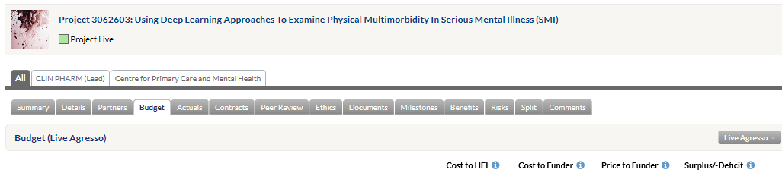
This will bring up the detailed budget information for the project. Scroll to the bottom of the budget summary and the last section shows the Budget Summary (Excluding Partner Costs) as follows
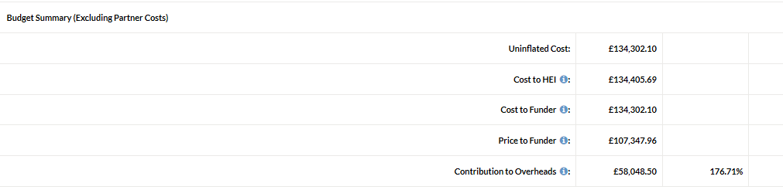
The last line of the report is the contribution to overheads of which 20% will be allocated, based on the agreed split.
The agreed split for an award is included in the Split tab and will indicate where there are multiple applicants, how the 20% FRF will be shared.

Residual overheads is the balance of grant funding less all direct costs of the research and will also need to take into consideration, where relevant, other School/Faculty support already committed/agreed at point of application.

