WOLFSON INSTITUTE OF POPULATION HEALTH
NEWSLETTER
ISSUE 40: 31 AUGUST 2023

In this issue of our Wolfson Institute of Population Health Newsletter, we celebrate the achievements and work of staff and students through August.

FROM OUR DIRECTOR
Dear All

As August draws to and end and we look towards the start of the new academic year, I hope that everyone has found some time to relax and recharge their batteries. Many will be attending conferences over the coming weeks and we wish you successful presentations and good collaborations.

The next week will be busy: there are changes ahead for the Centre for Prevention, Detection and Diagnosis, so do attend the All-Staff meeting next Tuesday (5 Sept) to find out more about this. On the following day, Wednesday 6 Sept, the Centre for Evaluation and Methods are holding their first Showcase from 2pm at ArtsTwo LT, Mile End. You’re very welcome to join us there to hear all about their exciting work.  With all best wishes  Fiona | 
MEET WIPH

MEET WIPH - Francois van Loggerenberg
(Youth Resiliance Unit, Centre for Psychiatry and Mental Health)

How would you describe your role/responsibilities?
As a Research Fellow in the YRU I have a broad range of roles, but primarily I’m responsible for managing the day-to-day activities on the Development of Emotional Resilience (DEER) study. This is a cohort of primary school children in East London that started recruiting this past year and that we will follow up for five years. I also prepare and submit grant applications for new work, currently focussing on the adaptation and testing of the psychosocial solution-focused intervention DIALOG+. We are exploring using this in HIV care in South Africa, in school children in Colombia, and in children and adolescents in mental health services in the UK. I have a small teaching commitment, and co-supervise research students.

What has been your greatest professional achievement?
I received my first grant early in my career, and used the study this funded to conduct my PhD fieldwork and data collection. It was a great experience to be able to conceptualise and fund my own PhD work, and I was awarded a Commonwealth Scholarship, which allowed me to do my PhD through a UK university. My most recent grant was for work in schools in Colombia, and I was very pleased to be awarded my first UK research grant so soon after taking up the post at QMUL.

What aspects of your role do you enjoy the most?
I have always enjoyed research management, largely because it is a good opportunity to nurture the research aspirations of newer staff working on the projects. Over the years I have had several research assistants go on to their own PhD work, or to manage their own large studies. I also enjoy any teaching I do, for much the same reason.

What would be your second choice as a profession?
My other passion in life is aviation, and if I had had more confidence in my abilities, I would have loved to have worked as a pilot.

What do you enjoy doing outside work?  Not too surprisingly, flying is a big part of my life, and spending as much time as I can up in the air in a small two-seater airplane in which I have a share is very rewarding. Otherwise I will be out running (only sensible distances) or walking in the countryside. LEGO should be prescribed on the NHS – it kept me sane over lockdown.  Something about you that most people don’t know?  I was originally a drama and English undergraduate student. I was majoring in dance and was very focussed on that, until a torn hamstring meant I had to reconsider career options. | 
FROM OUR LEADERSHIP TEAMS

Education News from Mark Freestone (Director of Education)

Congratulations to our four WIPH colleagues who have successfully completed the Queen Mary Academy’s taught CILT and PGCAP programmes and been registered for Advance HE Fellowships. CILT and PGCAP courses take a year (or more) to complete, and are a huge achievement. Well done to Celeste Damiani, Sammy Quaife, and Belinda Nedjai (Postgrad Certificate in Academic Practice – Fellows), and to Michaela Hinson-Raven (Certificate in Learning and Teaching – Associate Fellow).

Research News from Tor Kemp (Research Manager)

CHANGE TO PROCESS

Guidelines | Approval of bids to Barts Charity Funding
Following extensive discussion, FMD have now approved new guidelines underpinning bids to Barts Charity funding. These guidelines are designed to streamline internal processes and to ensure an open and transparent process that delivers on the FMD Research Strategy. Details here

OPPORTUNITIES AND EVENTS

Event | Cross-ARC Child Health and Maternity Services Implementation networking |17 October
At this networking event there will be an opportunity to hear an update from the four project teams who are supporting and researching the implementation of the evidence-based child health and maternity programmes. You will also hear about the patient and public involvement and engagement activity that has been at the core of the programme. For the afternoon session, you are invited to submit abstracts for 10 min talks on two themes of child health, and maternity services (expressions of interest to present can be submitted via the event registration). The event will take place Tues 17 October 10:00-15:00. Register (free) here

Seminar | Reverse Innovation in the NHS; a case study on Community Health and Wellbeing | 6 September
Reverse innovation (innovation developed in a low- or middle-income country which is then adopted by a high-income country) has been identified as a key emerging trend in global health systems, as these innovations do more with less, and challenge a more traditional knowledge flow from rich to poor countries. In this seminar, two leading experts will discuss their research, focusing on a case study from Brazil, and answer your questions. The seminar is on Weds 6 September 12:00-13:00. Please register (free) using this link

Fellowship | NIHR SPHR pre-doctoral and post-doctoral | 23 October
The NIHR School for Public Health Research (SPHR) is funding up to 10 pre-doctoral and post-doctoral fellowships. The fellowships are expected to begin in April 2024 and will be available across the nine members of SPHR (note: this does not include QMUL). Fellowships will be aligned to the SPHR research programmes: (i) Health inequalities; (ii) Public mental health; (iii) Healthy places, healthy planet and (iv) Children, young people & families. The closing date for applications to both schemes is 12 noon Monday 23 October 2023. Please find more details here

GENERAL INSTITUTE NEWS

Let’s Talk Differently About Medicines: Storybook collection launched
15 August (Deborah Swinglehurst, Nina Fudge, Alison Thomson. Centres for Primary Care/Prevention, Detection and Diagnosis)

Let’s Talk Differently About Medicines, a collection of 7 illustrated fictional storybooks dealing with issues around polypharmacy, has been published by Deborah Swinglehurst, Nina Fudge, and Alison Thomson. The books are based on the findings of ethnographic research including co-design work (APOLLO-MM project), and refined through user-experience testing with older people. An e-collection of the stories including audible versions is also available, at Medicines Talk. APOLLO-MM explored the lived experience of patients aged 65+ who were prescribed 10+ items of medication (‘higher risk’ polypharmacy). Let’s Talk Differently About Medicines has been created to spark conversations between patients, family, friends, and health professionals, and the authors hope that the stories will open up new avenues for discussion between clinicians and patients engaged in medication reviews. Deborah and Nina are now collaborating with several Academic Health Services Networks as they build communities of practice to tackle polypharmacy in response to the UK government’s National overprescribing review.


Call to remove packaging targeting children from high sugar food products
15 August (Action on Sugar Team, Centre for Public Health and Policy)

Following a review of sugar content in food products appealing to children, the Action on Sugar team have called for the removal of packaging that features cartoon characters, animations, vibrant colours, and familiar characters that strongly resonate with children, from unhealthy cereals and yoghurts. Nestle, Lidl, and Aldi were found to have the highest sugars on average across their cereals and yogurts targeted at children, with some products containing up to 4 teaspoons of sugar per suggested serving. While restrictions exist on advertising high sugar foods during peak viewing times for children, no regulations govern the visual appeal and design of packaging designed to influence children. | 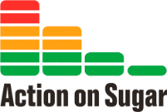  
Gestational diabetes and adverse maternal and perinatal outcomes
16 August (Elena Greco, Eleanor Barry, Matina Iliodromiti. Centre for Public Health and Policy)

 | Gestational diabetes mellitus (GDM) is associated with increased risk of adverse maternal and perinatal outcomes in both singleton and twin pregnancies, according to new research. The study also found that, in twins, GDM may have a milder impact on some adverse perinatal outcomes, and may be associated with lower risk of neonatal death. In singleton pregnancies with GDM (v those without GDM) there was increased risk of hypertensive disorders of pregnancy (RR 1.85), induction of labour (RR 1.36), caesarean delivery (RR 1.31), large for gestational age neonate (RR 1.61), preterm birth (RR 1.36), and admission to neonatal unit (RR 1.43). In twins with GDM compared with controls, there was increased risk of hypertensive disorders of pregnancy (RR 1.69), caesarean delivery (RR 1.10) large for gestational age neonate (RR 1.29), preterm birth (RR 1.19), and admission to neonatal unit (RR 1.20).
Healthier You NHS Digital Diabetes Prevention Programme
17 August (Jamie Ross. Centre for Primary Care)

A new study evaluates participant engagement with the Healthier You NHS Digital Diabetes Prevention Programme, a 9-month behavioural change intervention delivered by providers across England. Data for 12,857 participants show a median of 11 days of use, and that >94% of those enrolled engaged with the apps in the first 30 days. Use data fields were categorized into 4 intervention features: Track, Learn, Coach Interactions, and Peer Support. Observed differences in engagement with features across providers enable identification of features that are important for engagement with digital health interventions, and could inform the design of other digital behaviour change interventions. | 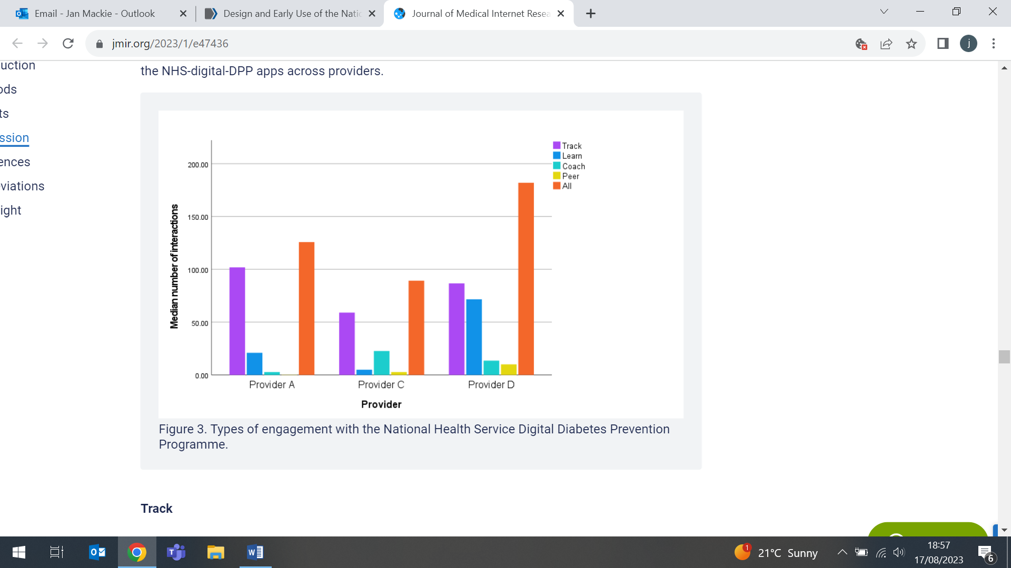
SHARING to create knowledge in a crisis
17 August (Sara Paparini, Vanessa Apea, Rosalie Hayes. Centre for Public Health and Policy)

   | A commentary on the 2022 mpox outbreak reflects on the need for collaborative academic leadership to bring clinical teams together, and the response to the outbreak mounted by the QMUL Sexual Health and HIV All East Research (SHARE) Collaborative. During the outbreak SHARE expanded, creating the SHARE-NET collaboration of researchers from 16 countries, to develop large and globally relevant case series. As well as codesigning a case report to capture key infection data, SHARE-NET produced further data series, characterising manifestations among women, and addressing the intersections between advanced HIV and mpox. It also called for international guidelines to include mpox as an opportunistic pathogen, and for this severe form of mpox to be considered an AIDS-defining condition. Authors reflect that the key to a new and unfunded global collaboration working so effectively lay in collaborative leadership that championed the power of the collective. For the next pathogen, SHARE-NET has created new ways to take us forward.
Vulnerability and TB treatment outcomes in urban areas in England
17 August (Dominik Zenner. Centre for Public Health and Policy)

Most research on TB treatment outcomes in underserved populations in England is London-centric, and may not represent the national picture to inform setting-specific prevention and care policies. A new study combines retrospective epidemiological data on 2252 TB patients from Birmingham and Leicester with qualitative data from interviews with patients and healthcare professionals. Results show that patients aged ≥55, foreign-born (Central Europe, East Asia and Sub Saharan Africa), and with multidrug resistant TB were more likely to have poor treatment outcomes. Researchers conclude that factors contributing to vulnerability to develop TB and poor treatment outcomes, including poor working/living conditions, inadequate/absent welfare protection, poor primary healthcare responsiveness, treatment duration and side effects, could be addressed by increased networking, partnership and integration between healthcare and social services, and better integration between primary and secondary healthcare.

Maternal nutrition education and childhood cognitive development in Uganda
18 August (Montasir Ahmed. Centre for Evaluation and Methods)

An analysis assessing a proven maternal nutrition education intervention for improving developmental outcomes among children aged 6–8 months shows that the intervention is cost effective compared with current practice in Uganda. From a healthcare provider perspective, the study compared current practice with large scale implementation of the intervention over 18-months. The incremental cost-effectiveness ratio (ICER) was USD 16.50 per cognitive composite score gained, with an incremental cost of USD 265.79 and an incremental cognitive composite score of 16.11. The ICER was sensitive to changes in cognitive composite score and the cost of personnel, but sensitivity analysis suggests the results are robust. Authors say that these results could also inform policymakers and stakeholders about effective resource allocation processes in other low and middle income countries. | 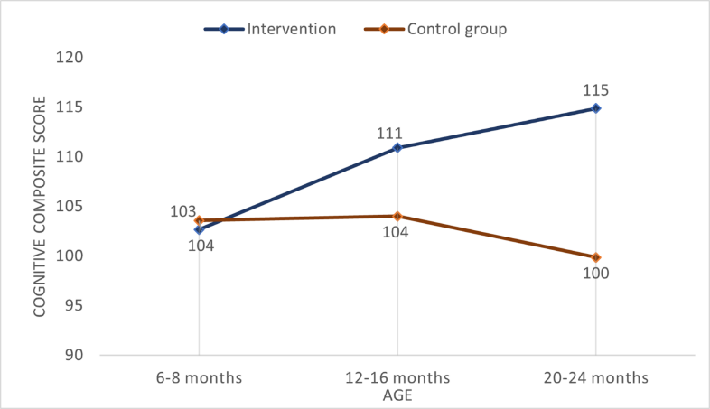
Body mapping for arts-based inquiry in mental health research
18 August (Aisling Murray, Mariana Steffen, Eleanor Keiller, Maria Turri, Jennifer Lau. Centre for Psychiatry and Mental Health)

Traditional research methods have not yielded highly effective long-term mental health treatments and might not reflect diverse lived experiences. Body mapping is an arts-based research method that involves tracing the body to produce a life-sized outline that is then filled with words, colours, and symbols reflecting embodied experiences, and has proved successful in exploring mental health and social experiences. A literature review of results from 17 body mapping studies shows that benefits included its exploration of difficult-to-access emotions and experiences, focus on strength and resilience, therapeutic effect, participatory and collaborative nature, empowerment and dissemination of participants' voices, and engagement with children and young people. Researchers conclude that body mapping holds promise for work with marginalised groups typically excluded from mental health research.
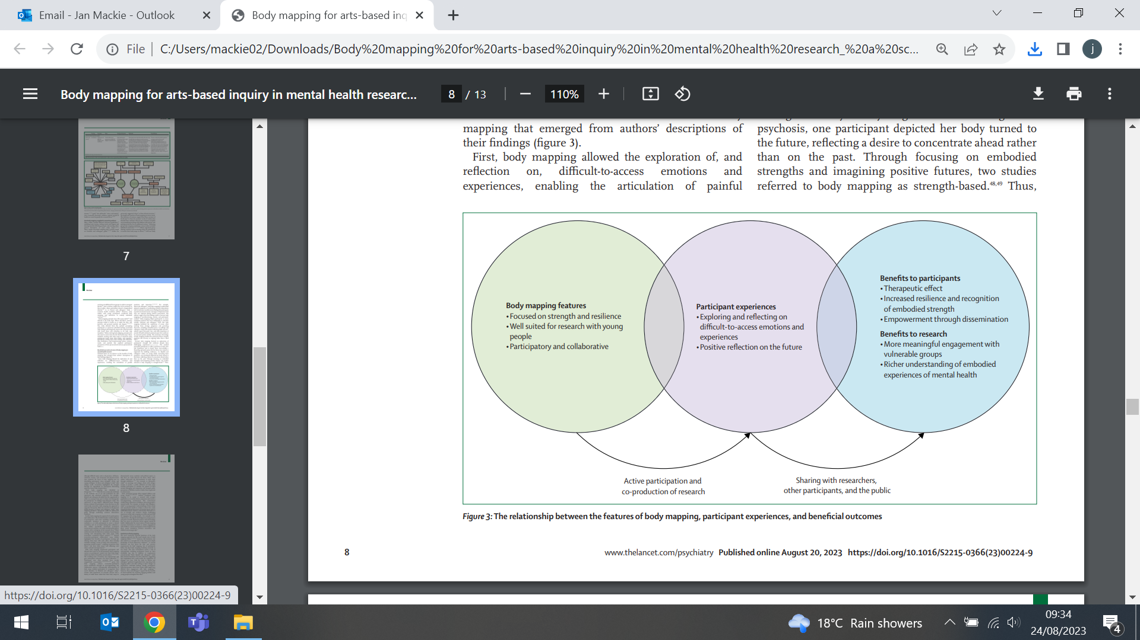
Private health providers and Universal Health Coverage in LICs
21 August (Laura Coveney, Giuliano Russo. Centre for Public Health and Policy)

From 34 papers documenting how basic health care services are provided through the private sector in countries like Uganda, Afghanistan and Somalia, researchers have found evidence that most primary care, mother, child, and malaria services are made available by non-public providers across all 27 low income countries (LICs). Results show that formal private providers mostly operate in well-served urban settings, while informal and not-for-profit providers cater for the lower end of the health market. Informal providers often provide services of suboptimal quality and fail to advance financial protection against ill health. Authors conclude that, despite their shortcomings, working with informal private providers to increase quality and financing of their services may be key to realizing universal health coverage in LICs. | 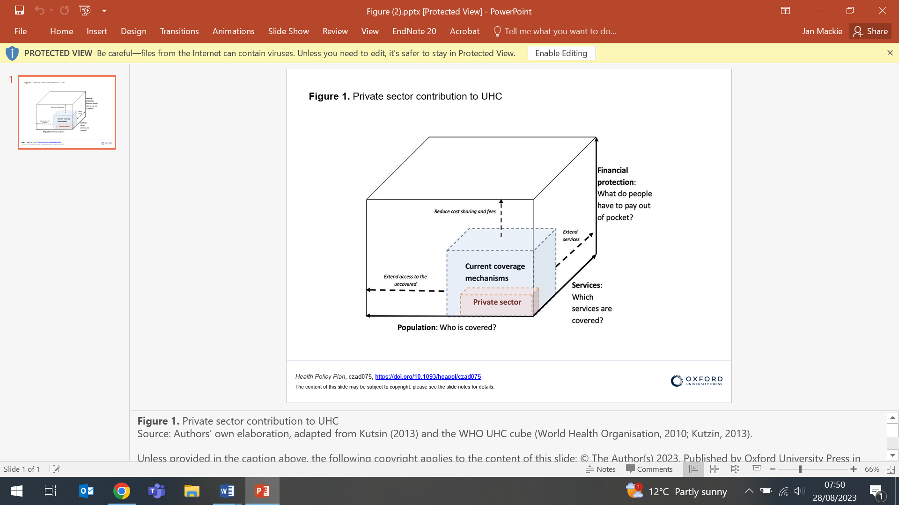
Adding Spirometry to LDCT screening to identify undiagnosed COPD
21 August (Rhian Gabe. Centre for Evaluation and Methods)

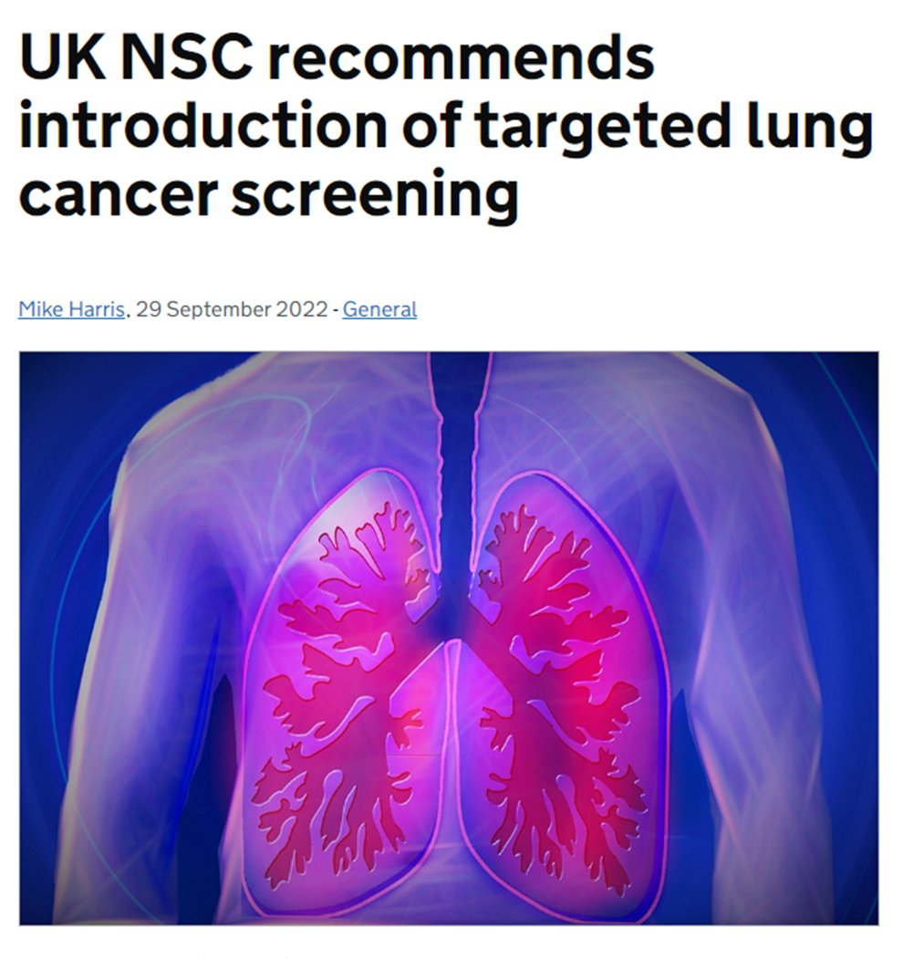 | To determine whether using spirometry alongside low dose computed tomography (LDCT) may identify un- and mis-diagnosed COPD, researchers examined data on 3920 ever-smokers at high lung cancer risk invited to the Yorkshire Lung Screening Trial. This group underwent spirometry as part of a lung health check. Results show 17% had undiagnosed airflow obstruction with respiratory symptoms, suggesting potentially undiagnosed COPD. Compared with attendees with a primary care COPD code, this group had milder symptoms, better lung function and were more likely to be current smokers. Of 836 attendees with a primary care COPD code who underwent spirometry, 19% did not have airflow obstruction, potentially representing misdiagnosed COPD. Authors conclude that spirometry offered alongside LDCT screening can potentially identify cases of both undiagnosed and misdiagnosed COPD.
Clustering by multiple long-term conditions and social care needs
23 August (Beth Stuart. Centre for Evaluation and Methods)

Using data from 9171 participants in the English Longitudinal Study of Ageing, researchers have classified people with multiple long term conditions (MLTC) and social care needs (SCN) into five distinct clusters, and quantified the association between clusters and care outcomes. Mean age was 66.3, and >70% of participants had 2+ MLTC. SCN were assessed through 13 measures of difficulty with daily living activities, 10 measures of mobility difficulties, and whether health status limited earning capacity. The highest SCN/MLTC cluster included mainly white women aged 70-79 educated to the upper secondary level, and was significantly associated with higher nursing home admission. No association was found between clusters and all-cause mortality. Authors conclude that distinct clusters of individuals with shared sociodemographic characteristics can help identify those at-risk with MLTC and SCN at primary care level. | 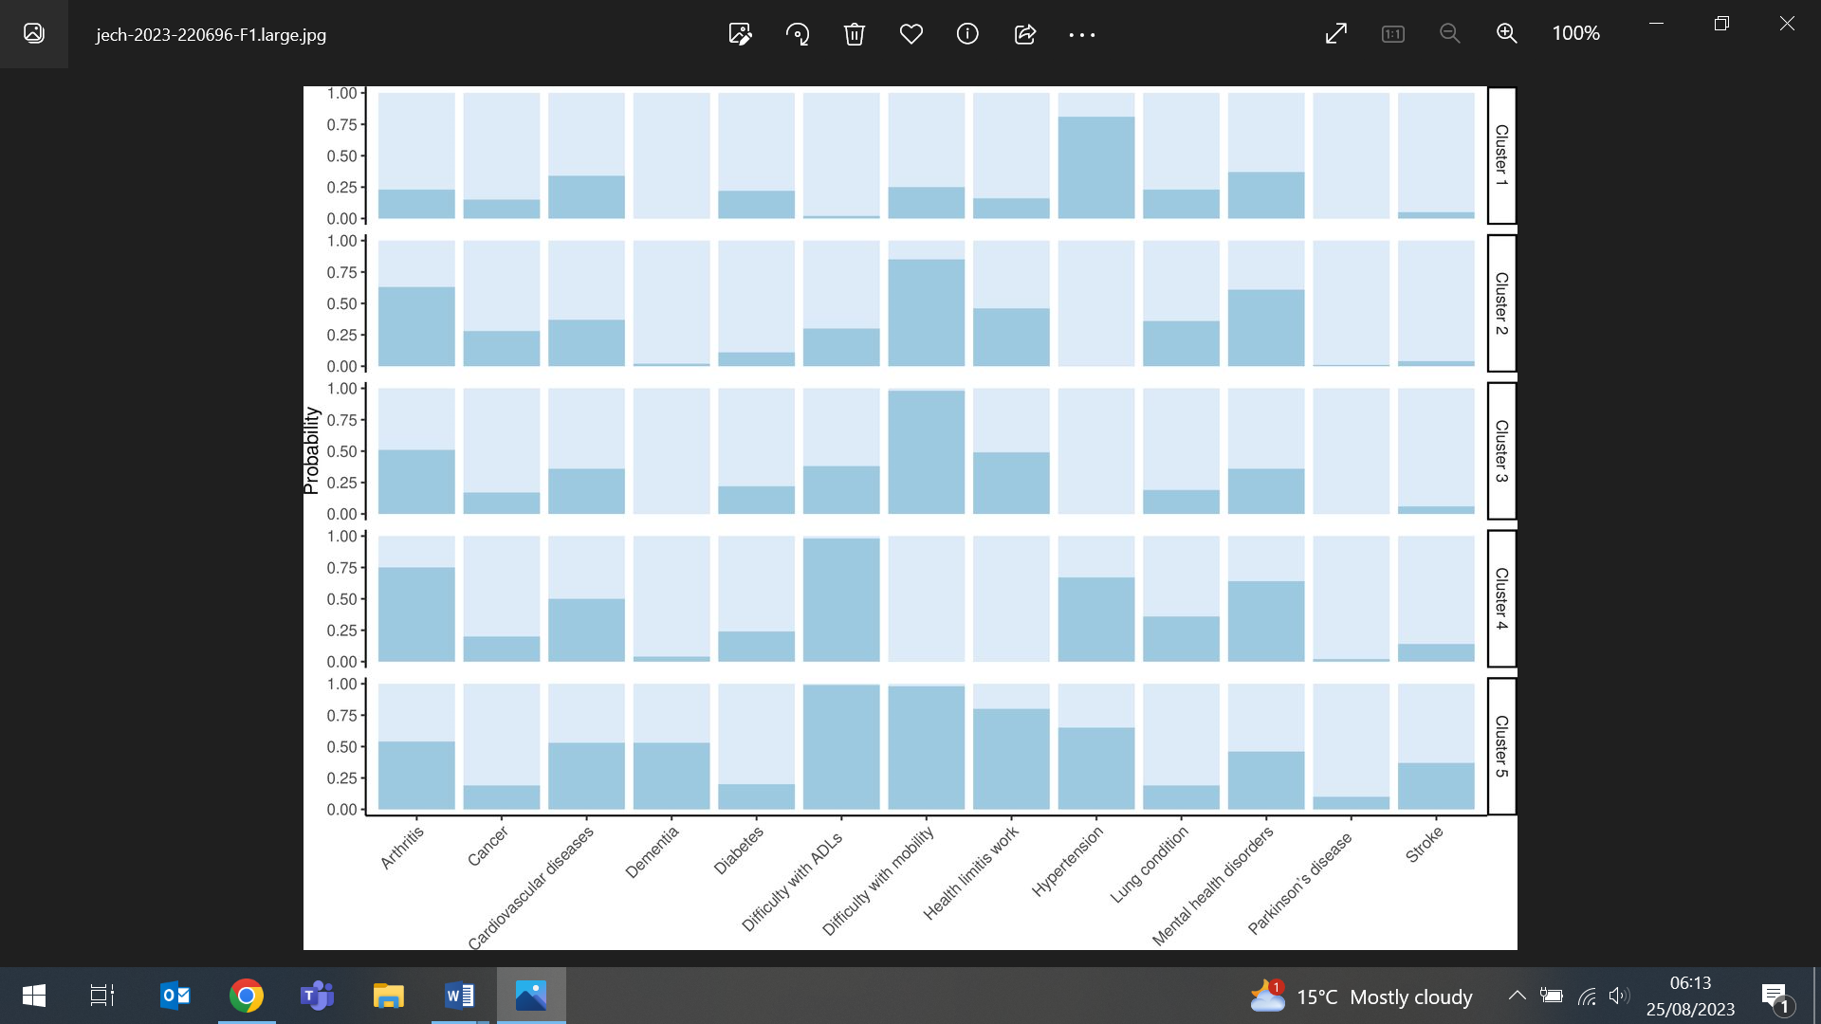
RCT shows home cook intervention for salt reduction is effective in China
24 August (Feng He, Jing Song, Graham MacGregor. Centre for Public Health and Policy)

 | An RCT in 60 communities from 6 provinces across China shows that a community based salt reduction package targeting home cooks and family members is effective in lowering salt intake and blood pressure. The intervention, received over 12 months, included supportive environment building for salt reduction, 6 salt reduction education sessions, and salt intake monitoring by 7-day weighed record of salt and salty condiments. Results from 1419 participants show that 24hr urinary sodium excretion decreased from 4368.7 to 3977mg in the intervention group and from 4418.7 to 4330.9mg in the control group, and the knowledge, attitude, and behaviours in the intervention group improved significantly. Researchers conclude that this intervention could be widely applied in China and other countries where home cooking remains a major source of salt intake.
No benefit of cognitive behavioural intervention for advanced COPD and anxiety/depression
24 August (Steph Taylor, Ratna Sohanpal, Liz Steed, Claire Chan, Richard Hooper, Moira Kelly, Stefan Priebe. Centres for Primary Care/Evaluation and Methods/Psychiatry and Mental Health)

Results from the TANDEM (Tailored psychological intervention for anxiety or depression in COPD) RCT indicate that there is no benefit from a cognitive behavioural approach intervention in people with advanced chronic obstructive pulmonary disease (COPD) and anxiety/depression. The study randomised people with COPD and moderate-very severe airways obstruction and depression scores indicating mild-moderate anxiety and/or depression to the intervention or usual care. At 6 months the intervention, delivered face-to-face by respiratory health professionals over 6-8 weeks, did not improve anxiety or depression or any secondary outcomes. Health economic analysis found the intervention highly unlikely to be cost-effective. More research is needed for these patients with high levels of unmet need. | 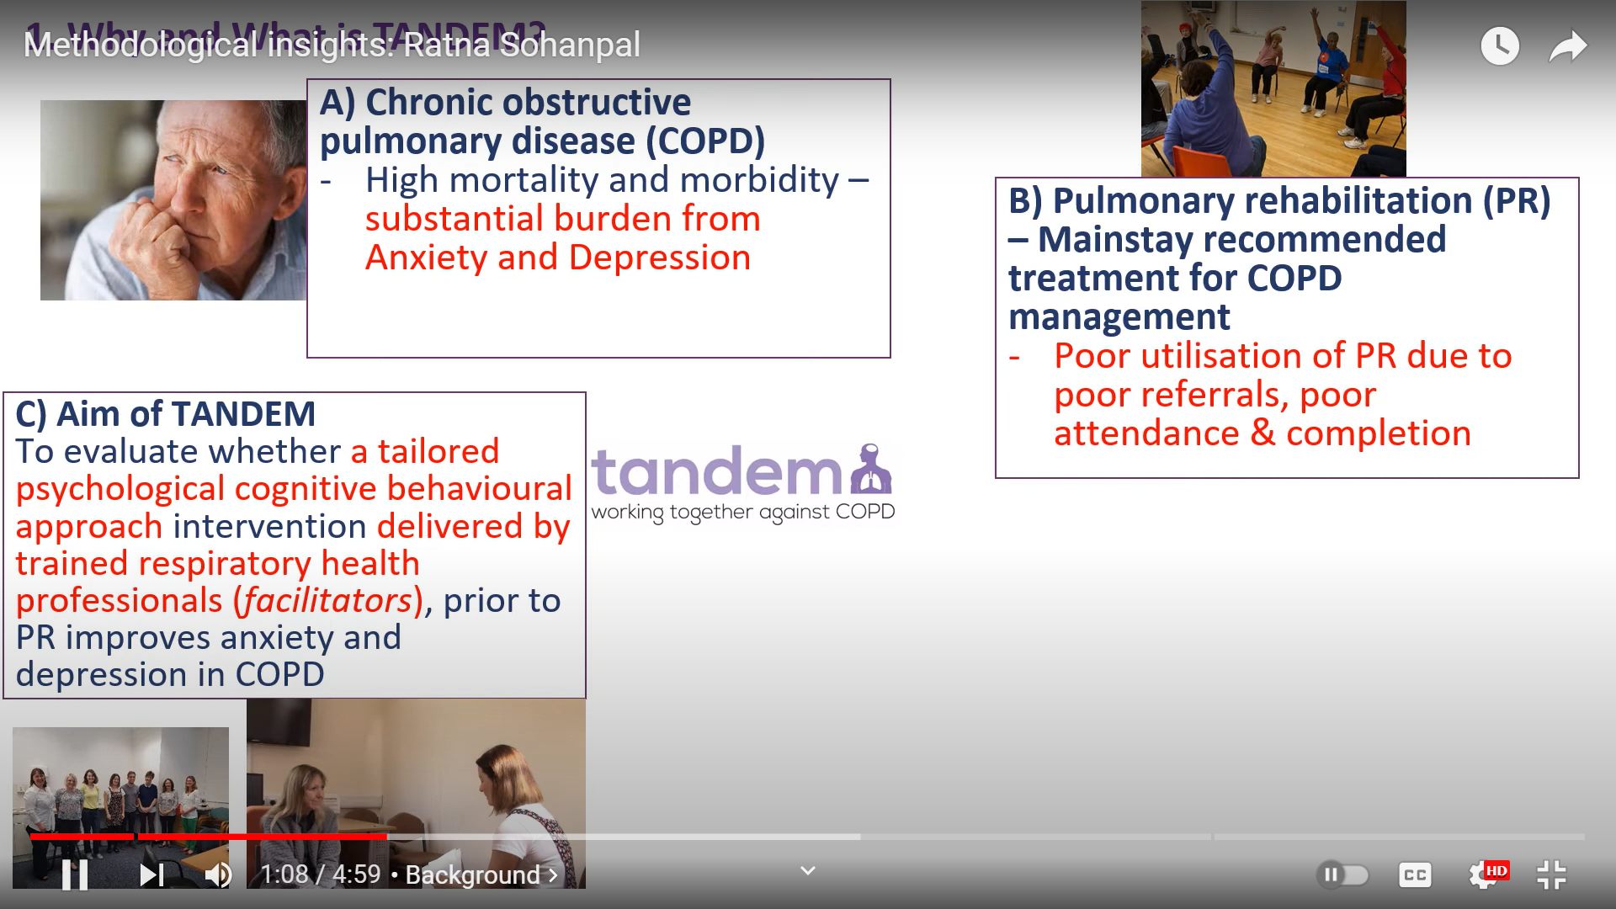  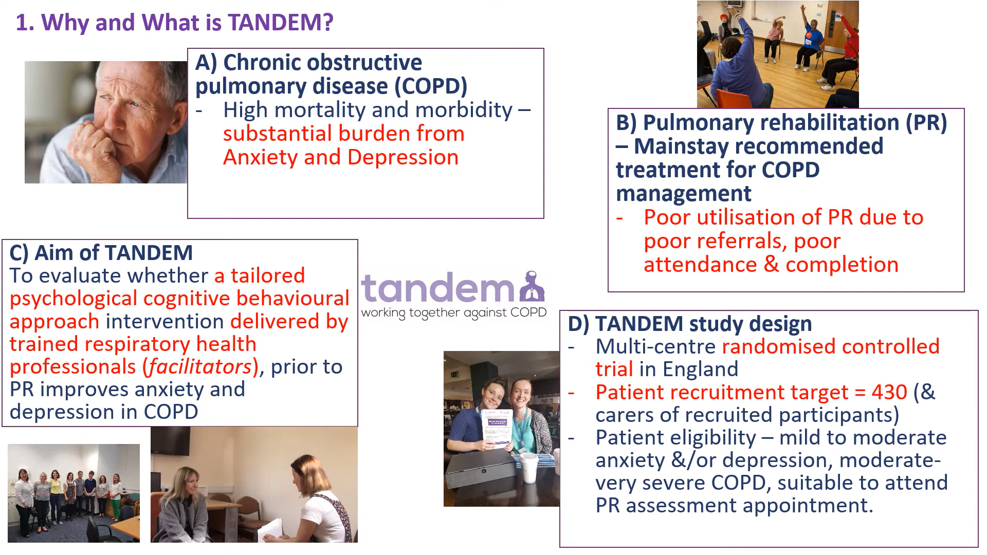
MAD-Reflux study protocol
24 August (Suzanne Scott. Centre for Prevention, Detection and Diagnosis)

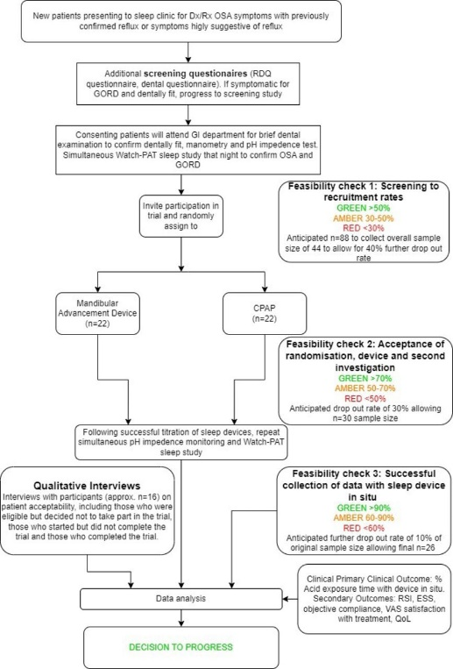 | A feasibility study protocol designed to gauge patient recruitment, acceptability, clinical efficacy and health economic outcomes has been published for the MAD-Reflux clinical trial. The proposed study will investigate if mandibular advancement device (MAD) treatment for obstructive sleep apnoea (OSA) can reduce nocturnal gastro-oesophageal reflux (GORD), and will inform a definitive trial. Continual positive airway pressure therapy is the gold standard treatment for OSA, but the impact of mandibular advancement devices on GORD has yet to be investigated. A feasibility study is needed prior to a definitive trial.
Protocol for evaluation of psychosocial interventions to prevent self-harm repetition 24 August (Dennis Ougrin. Centre for Psychiatry and Mental Health)

Researchers have published the protocol for a systematic review and network meta-analysis of RCTs testing psychosocial interventions for the prevention of self-harm repetition. Providing evidence-based psychosocial interventions to individuals presenting with self-harm is recognised as an important suicide prevention strategy. The proposed study will include RCTs in adults who presented with self-harm in the 6 months preceding enrolment in the trials, with interventions categorised according to their similarities and underpinning theoretical approaches (eg. cognitive behavioural therapy, case management). Primary efficacy outcome will be self-harm repetition, with secondary outcomes including suicide mortality, suicidal ideation and depressive symptoms. Drop-outs rates will be analysed as the main acceptability outcome. | 
Relating a self-reported indicator of financial hardship to health status
24 August (John Robson. Centre for Primary Care)

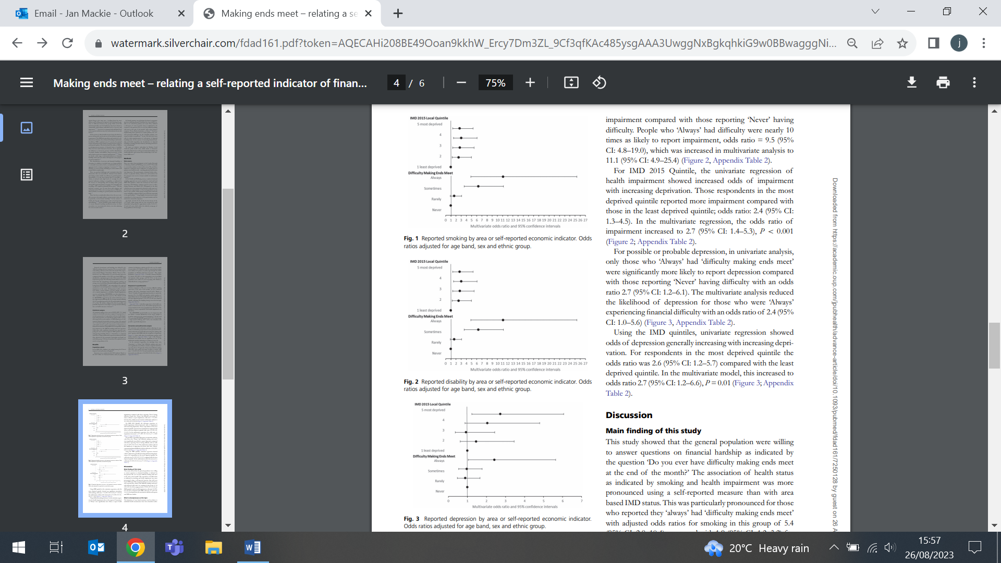 | Data from participants in the 2019 London Borough of Hackney Health and Wellbeing survey are used in a study comparing self-reports of hardship with area measures in relation to health status. From 1024 interviews, 39% reported always or sometimes ‘having difficulty making ends meet at the end of the month’. Self-reported hardship was more strongly associated with smoking compared with index of multiple deprivation scores. Health impairment and depression were also more likely with self-reported hardship, compared with the index. The paper concludes that self-reported hardship was more strongly related to health status than to area-based indicators.
COVID-19 pandemic effects on Cancer Prevention
25 August (Stephen Duffy, Tom Duffy. Centres for Prevention, Detection and Diagnosis/Evaluation and Methods)

A review of the effects of the pandemic on cancer prevention finds that prevention services were severely affected in the early months, and in places are still recovering. The study, looking at vaccination, chemoprevention, and surgical cancer prevention programmes, and at screening services for breast, colorectal, and cervical cancers, also examined how lifestyle changes (smoking, alcohol, and weight) due to the pandemic will affect future cancer rates, as future large numbers of additional or additional late stage cancers have been predicted as a result of the disruption. They conclude that how many additional predicted cancer deaths can still be avoided will depend on service recovery, noting that this message has already been taken on board by some healthcare providers. Colorectal screening programmes in several countries rapidly returned to pre-pandemic activity, and the UK NHS Breast Cancer Screening Programme is now screening 150,000 more women and detecting >3000 more cancers/yr than before the pandemic. | 
Mortality and hospitalisations after diagnosis of atrial fibrillation
25 August (Jianhua Wu. Centre for Primary Care)

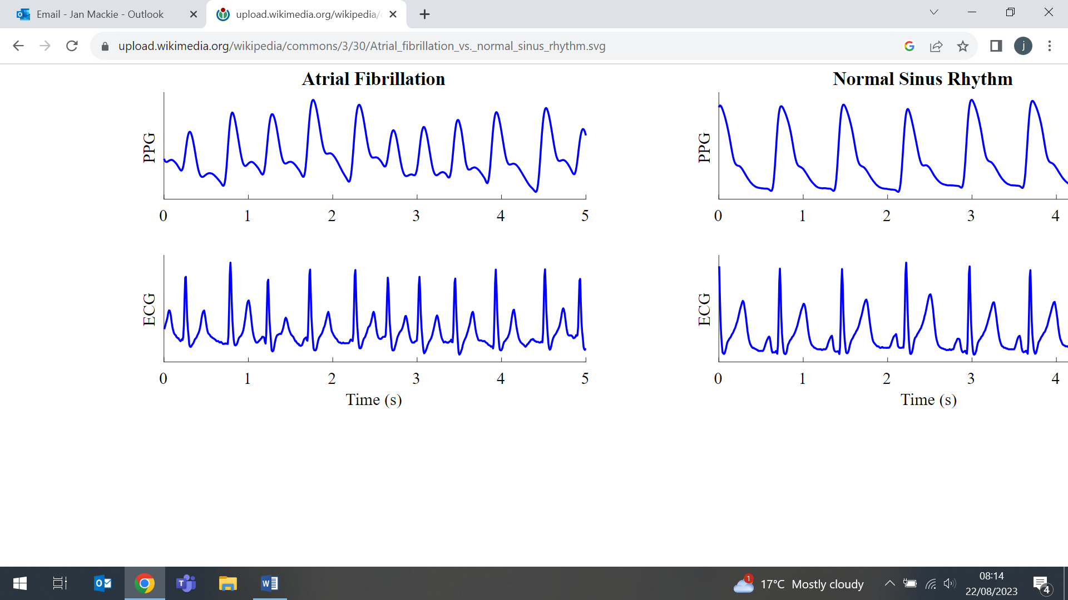 | An investigation into mortality and hospitalisations after a diagnosis of atrial fibrillation among over 72k patients in the UK examines trends over time, by cause, and by patient features. The study compared all-cause and cause-specific mortality and hospitalisation at 1-year following diagnosis for 2001/2 and 2016/17. All-cause mortality declined, with large declines for cardiovascular and cerebrovascular mortality, but not for non-cardio/cerebrovascular causes of death. By 2016/17, deaths from dementia, outstripped deaths from acute myocardial infarction, heart failure and acute stroke combined. Overall hospitalisation rates increased, especially for non-cardio/cerebrovascular causes. Older, more deprived, and hospital-diagnosed AF patients experienced higher event rates.
Process Evaluation of the CAPSAI Project
25 August (Heather McMullen. Centre for Public Health and Policy)

The CAPSAI project, measuring the impact of a family planning services intervention in Ghana and Tanzania, included a process evaluation to identify key causal pathways and better understand factors influencing contraceptive uptake and use. A study of the process evaluation describes the unique methodology, and examines outcomes including service utilisation, continuation rates, attitudes and behaviours. Qualitative methods were used to evaluate the effects of the intervention, and document review, non-participant observation, and in-depth interviews were conducted. Coding and thematic content analysis were conducted collaboratively across countries, with each country team drafting reports drawing on the 3 datasets. The study demonstrated feasibility of a process evaluation of a complex intervention across multiple countries, and was also able to yield differentiate results based on specificity in each country’s context. Similar process evaluation activities can be replicated in future work. | 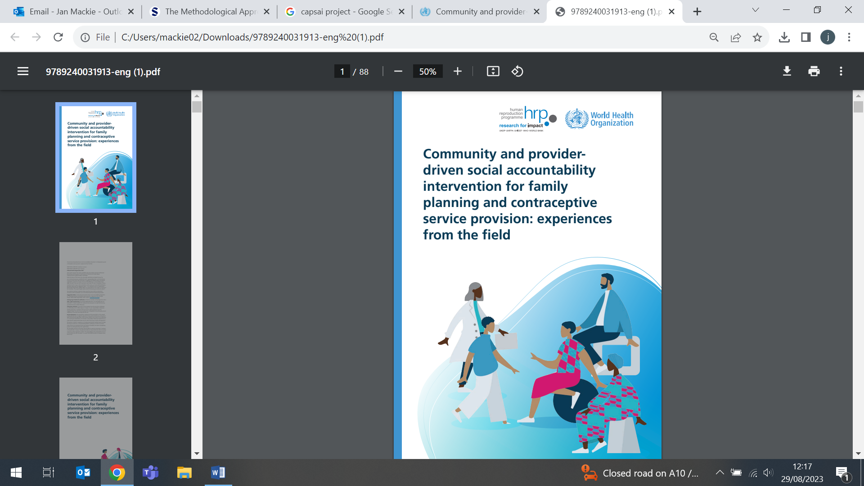
Group arts therapies v group counselling for patients with psychosis, mood,or anxiety disorders
26 August (Catherine Carr, Richard Hooper, Yan Feng, Boby Mihaylova, Stefan Priebe. Centres for Psychiatry and Mental Health/Evaluation and Methods)

 | The protocol has been published for an RCT to test whether group arts therapies (art/ dance movement/or music therapy) can reduce psychological distress for diagnostically heterogeneous patients in community mental health compared with group counselling. The study will include adult patients living in the community with a primary diagnosis of psychosis, mood, or anxiety disorder, who will be shown videos of arts therapies and asked for their preference, before randomisation either their preferred type of arts therapy or counselling. Evidence from the study will indicate whether there is an additive benefit to the use of the arts in group therapy in community mental health care.
Cost effectiveness of tests for patients with kidney stones
27 August (Hiro Farabi. Centre for Evaluation and Methods)

The prevention of recurrent kidney stones in high-risk patients requires serum and 24hr urine collection to diagnose metabolic abnormalities, but current guidelines do not incorporate cost-effectiveness. In an analysis of the usefulness of routine serum and 24hr urine tests in patients who have formed kidney stones, researchers simulate 1000 patients undergoing 22 standard laboratory tests, and use a decision tree model to evaluate the cost-effectiveness and identify the most efficient tests. Results show that urinary uric acid, citrate, and serum potassium were the most cost effective tests, and could form a simplified blood and 24hr urine metabolic evaluation. | 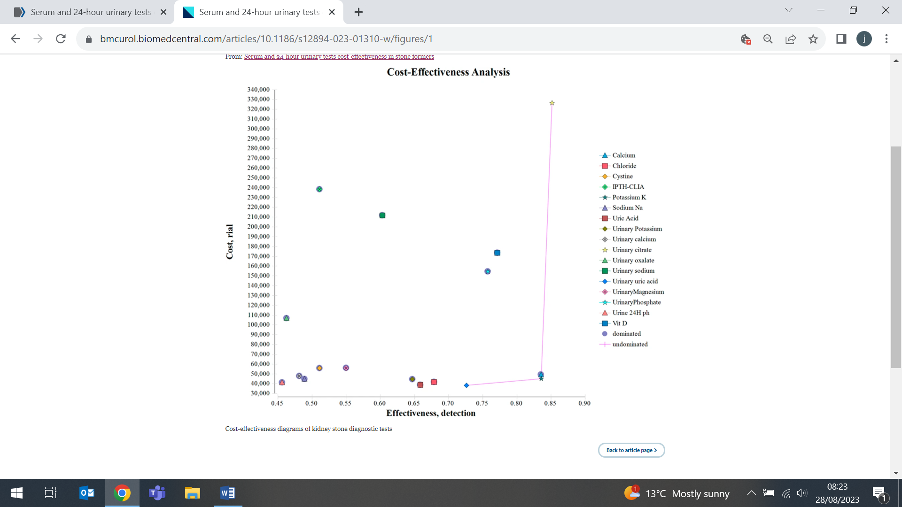
Defibrillator location and socioeconomic deprivation in Great Britain
28 August (Jianhua Wu. Centre for Primary Care)

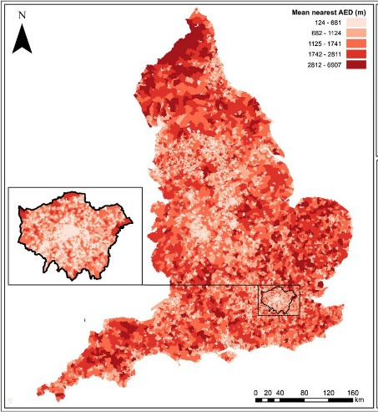  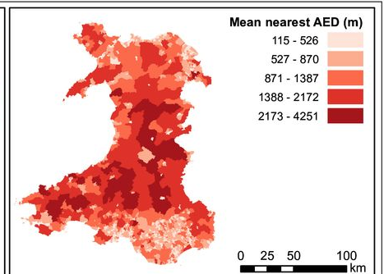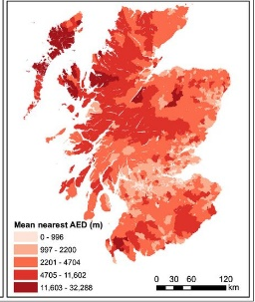 | In a study of the location of 78425 automated external defibrillators (AEDs) across GB, researchers used a multilevel linear mixed regression model to investigate associations between the distances from each postcode to the nearest AED, and Index of Multiple Deprivation. Distance to the nearest AED is shorter in England and Wales for more deprived communities, with no overall trend in Scotland. Distance to nearest 24/7 AED was nearer with increased deprivation in Wales, but greater with increased deprivation in England and Scotland, with a 24/7 AED on average respectively, 99.2m and 317.1m further away in the most deprived than in the least deprived communities.
High-grade serous ovarian cancer: Tumour stage, treatment, and survival in UKCTOCS
29 August (Ranjit Manchanda. Centre for Prevention, Detection and Diagnosis)

The UKCTOCS trial of ovarian cancer screening found a decrease in advanced stage tubo-ovarian cancer, but no reduction in deaths in the multimodal screening (MM) group v the no screening (NS) group. To understand the discrepancy, researchers examined data on women in the MM screening and NS groups who were diagnosed with high-grade serous cancer. In the MM group fewer were diagnosed with advanced stage disease, more had primary surgery, more had zero residual disease following debulking surgery, and more received treatment, including surgery and chemotherapy. No difference existed in first-line combination chemotherapy rate. At the end of follow up, survival was longer in those with high-grade serous cancer in the MM v the NS group (absolute difference in survival 6·9% at 18yrs: 21v14%). Authors say this is the first evidence that screening can detect high-grade serous cancer earlier, and lead to improved short-term treatment outcomes. Potential survival benefit for women with high-grade serous cancer was small, likely due to only modest gains in early detection and treatment improvement, and to tumour biology. Results suggest surrogate endpoints for disease-specific mortality should not currently be used in ovarian cancer screening trials. | 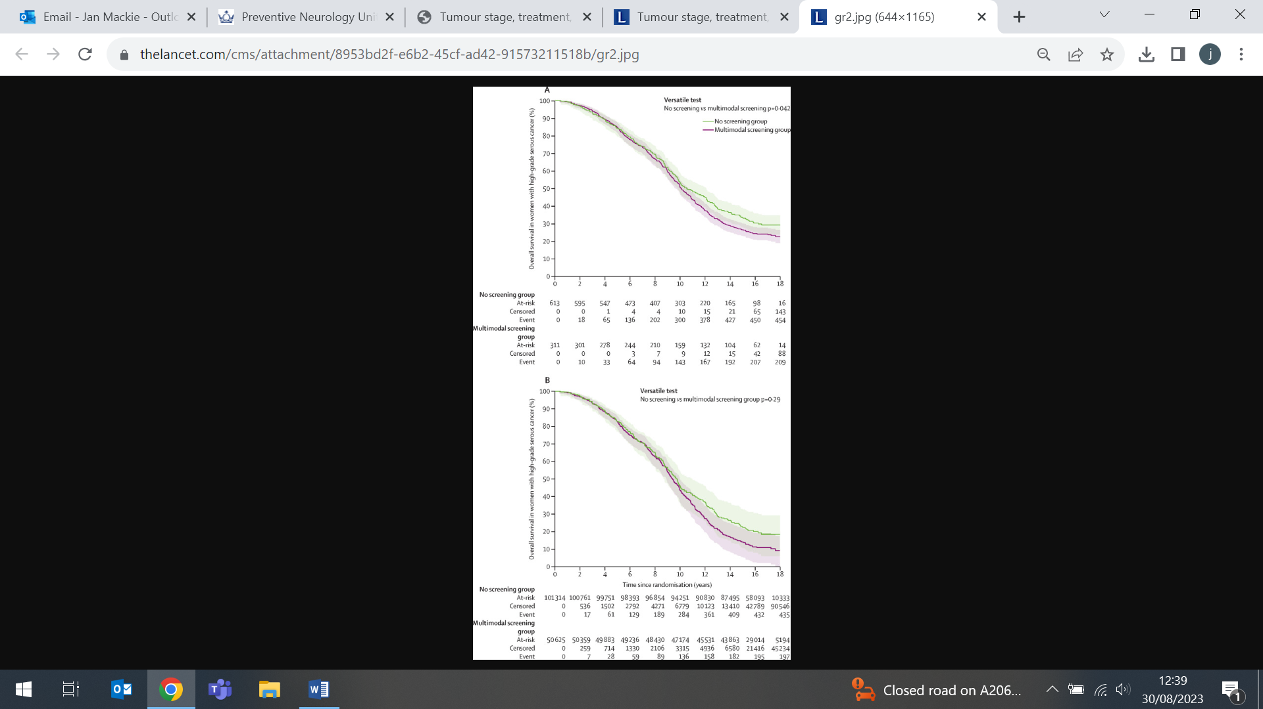
Many thanks to all who so enthusiastically contribute. Please send any news items for the next newsletter to j.a.mackie@qmul.ac.uk

