WOLFSON INSTITUTE OF POPULATION HEALTH
NEWSLETTER
ISSUE 14: 1 JUNE 2022

In this issue of our Wolfson Institute of Population Health Newsletter, we celebrate the achievements and work of staff and students in the second half of May.

FROM OUR DIRECTOR
Dear Colleagues

As we move towards the Jubilee weekend, I’d like to celebrate some highlights of the last fortnight. May 19 marked World Family Doctor Day. Despite recent news about the impact of the pandemic, staff shortages, and access issues in general practice, this was an opportunity to acknowledge the central role that primary care plays in keeping our population healthy. Thank you for all you do in contributing to research and education to improve patient care in the community.

We launched our new WIPH website in November 2021, and a recent analysis shows that
the number of visitors has averaged 3,262,597 per month This is certainly a cause for celebration!  Finally, many thanks to everyone who took the time to respond to the Staff Survey – you will see below how well we did compared with other Faculties, Schools, and Institutes.  With best wishes for a wonderful long weekend,  Fiona |  |  | 
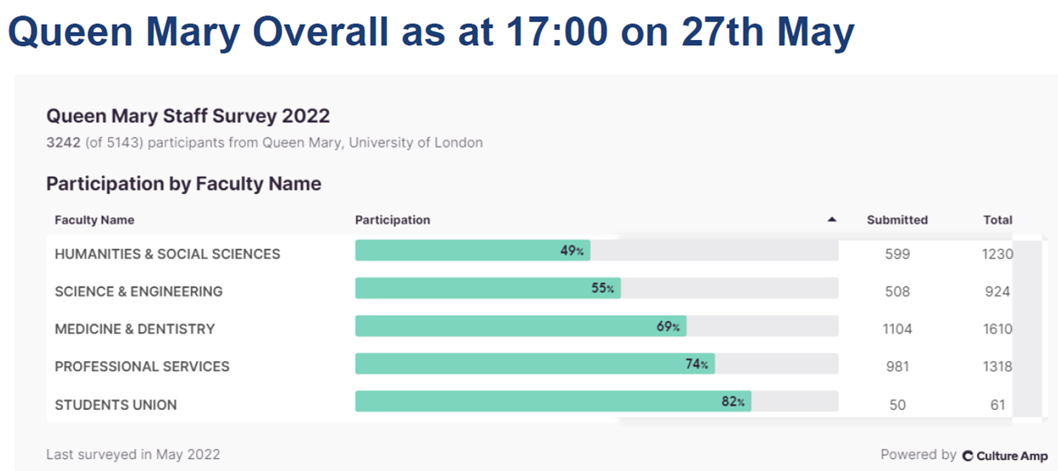

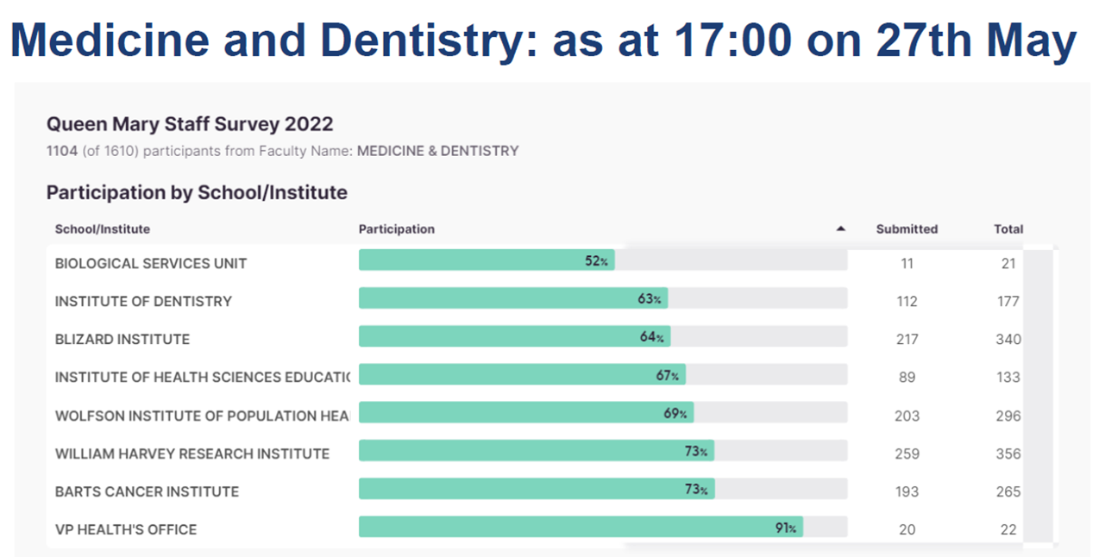

GENERAL INSTITUTE NEWS

Effects of short-term air pollution exposure on asthma steroid prescriptions
16 May (Hajar Hajmohammadi, Anna de Simoni, Jim Cole, Chris Griffiths, Sally Hull. Centre for Primary Care)

A London study using a time series regression model to determine the effects of short-term air pollution exposure shows a significant relationship between daily nitrogen oxide concentrations and the number of oral steroid courses prescribed in the next 21 days. Daily nitrogen oxide concentration measurements from 8 monitoring stations in east London and daily ambient temperatures for London City Airport were compared oral steroid prescriptions in 33,672 registered asthma patients. Nitrogen oxide concentration lags of up to 21 days were used in the modelling. Detrimental exposure impacts were distributed over the next 3 weeks, with two components, one in the first and the other during the third following week. The model also showed significant negative correlation between ambient temperature and asthma exacerbation, leading to more oral steroid prescriptions on colder days. An increase of 1 μgm⁻³ in nitrogen oxide atmospheric concentration led to an increase of about 2.7% in oral steroid course prescriptions per day. Other research has focussed on mortality or hospital admissions due to long-term air pollution exposure, but this study used clinical data to quantify less severe impacts of short-term exposure on patients with asthma. The authors hope that this evidence will help the primary care sector to better understand the pattern of asthma exacerbation related to daily air pollution exposure. | 
International consortium issues global call to action on dietary sodium
16 May (Feng He, Graham MacGregor. Centre for Public Health and Policy)

 |  | The World Hypertension League, Resolve to Save Lives, and the International Society of Hypertension have joined forces in issuing a global call to action to reduce dietary sodium. A letter and fact sheet published in the Journal of Human Hypertension is aimed at nutrition, hypertension, cardiovascular and other health care clinicians and scientists, as well as their parent organizations. The publication aims to align these audiences with the facts on the burden of disease, consistent and current recommendations for reducing dietary sodium, current sodium intake levels, cost savings from reductions, the sources of controversial opinions, and how to stay up to date on these issues. In presenting the evidence, the paper cites 14 separate references produced by WIPH Research and Action on Salt and Obesity Unit researchers.

Ductal Adenocarcinoma of the Breast

18 May (Stephen Duffy. Centre for Prevention, Detection and Diagnosis)
A highly fatal breast cancer sub-type, currently misdiagnosed as ductal carcinoma in situ, can be identified through imaging and histopathology, and should be recognised and treated as a separate cancer type: Ductal Adenocarcinoma of the Breast (DAB). In a new paper, researchers note that the hallmark of DAB, neoductgenesis, has characteristic imaging and histopathologic features. Around 20% of all breast cancer cases originate from the major lactiferous ducts. These cancers propagate intraductally and produce continuously branching neoducts, through an invasive process (neoductgenesis), which eventually forms a massive tumour burden. Co-author Stephen Duffy said “We‘ve long known that some breast cancers are more aggressive than might be expected from the traditional factors we use to assess their stage and type. This work is a step on the way to explaining this, and potentially identifying which breast cancers need aggressive therapies and which don’t.” |  | 
Annual Association of British Neurologists conference
18-20 May (Ruth Dobson, Cristina Simonet, Ben Jacobs. Centre for Prevention, Detection and Diagnosis)

  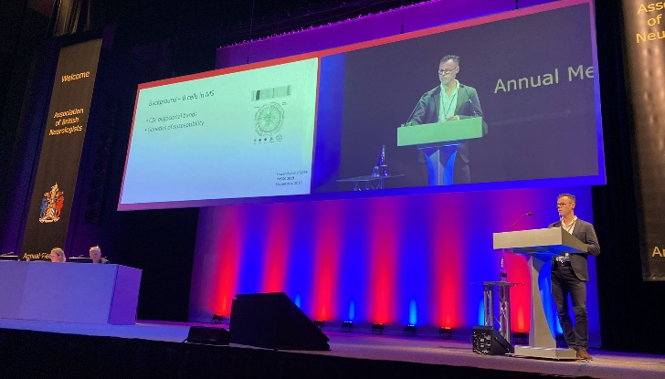 |  | Three WIPH researchers presented at the 2022 ABN conference in Harrogate. Ruth Dobson spoke on “Evaluating the feasibility of a real world pharmacovigilance study (OPTIMISE:MS)” and Cristina Simonet made two presentations: “Risk factors and Parkinson’s disease presentations in primary care in a diverse UK population” and “What, when and how should the information about neurodegenerative disease risk in iRBD be communicated?” Congratulations to Ben Jacobs, who was awarded runner-up for his oral presentation about work he is undertaking with Prof Stephen Sawcer at the University of Cambridge, using single-cell RNA sequencing to understand the pathogenesis of Multiple Sclerosis. Many other PNU team members also contributed posters.
Polygenic risk score helps predict type 2 diabetes in people of south Asian origin
19 May (Sarah Finer, Chris Griffiths. Centre for Primary Care)

An observational cohort study has shown that a polygenic risk score for type 2 diabetes could help predict disease risk and stratify distinct disease subtypes in British Pakistani and British Bangladeshi individuals, to better allocate healthcare resources. Type 2 diabetes is highly prevalent in British south Asians, who are underrepresented in research. The risk score helped identify young, otherwise healthy individuals at high risk of type 2 diabetes, 1 in 20 of whom may be wrongly labelled as low risk using current clinical tools. The work also highlights the need for greater representation of diverse ancestry groups in genetic studies of type 2 diabetes. Corresponding author Sarah Finer said: “We hope polygenic risk scores will be adopted in clinical care in the future, after careful evaluation to understand their potential to improve health outcomes cost-effectively, and with diverse populations who are at greatest need.” |  | 
Five tips for young people dealing with long COVID
20 May (Dipesh Gopal. Centre for Primary Care)

 | NIHR Fellow and GP Dipesh Gopal has shared his top tips for young people who think they might have long COVID in a piece for The Conversation. Between 3-12% of people who contract COVID develop long COVID, with those aged 35-49 most likely to experience symptoms. Dipesh advises: Recognise if your symptoms need urgent attention; Register with a GP; Contact your GP if you have symptoms; Be prepared with an idea of what you want from the appointment; and Seek out other resources. Dipesh commented: “In our clinic, people who didn’t rest while they were acutely unwell with COVID and immediately afterwards have been more likely to develop a more severe version of long COVID. So rest while you are unwell with COVID and even once you recover, especially if you can afford to do so.”
Is your boss a psychopath?
20 May (Mark Freestone. Centre for Psychiatry and Mental Health)

Mark Freestone is extensively quoted in a Newsweek article: Is your boss a psychopath? "Only about 0.6% of people meet the criteria for a true psychopath, so the likelihood is that your boss is not a psychopath. However, people in management positions are more likely than others to have psychopathic traits, so it's not an impossibility” he told the reporter. Psychopaths are good at making decisions that other people may find hard or impossible "because their bandwidth for considering other people's emotions is much more limited," but poor at estimating risk, so they'll take "very big gambles that may well pay off". Mark said "a corporate psychopath is likely to either crash and burn very early on with some unlucky decisions, or hit the jackpot and be quickly promoted," He added that many other workers will probably suffer as a result of their decisions. |   
Value of routinely collected health data to inform clinical practice (OPTIMISE:MS)
20 May (Ruth Dobson. Centre for Prevention, Detection and Diagnosis)

   | Data collected from 2112 Multiple Sclerosis (MS) patients at routine clinical visits across 13 UK Centres have been analysed to assess their usefulness in evaluating disease modifying therapy risks and benefits. The data from the OPTIMISE:MS prospective, pragmatic observational pharmacovigilance study showed 342 reported clinical events, of which 108 were infections. There was an increased risk of adverse events in people taking second/third generation disease modifying therapy, and increased incident adverse events in people taking natalizumab, ocrelizumab, and GA biosimilar, compared with no disease modifying therapy. Many clinical trials have age restrictions and routinely exclude people with significant co-morbidities, and so do not fully reflect the range of people with MS treated in routine clinical practice. Such trials are also powered to detect disease activity related endpoints, rather than rare adverse events. This early analysis was not able to detect significant numbers of rare and/or serious adverse events, but it shows that it is possible to detect significantly different risk profiles in patient populations treated with different disease modifying therapies. First author Ruth Dobson said: “Our work demonstrates the power and value of real-world data to help us understand the potential benefits and treatment-associated risks with disease modifying therapies, and hence inform the risk-benefit conversations that people with Multiple Sclerosis need.”
Campaign against Government delay on multi-buy junk food deals
21 May (Action on Sugar. Centre for Public Health and Policy)

Following the announcement from the Department of Health that plans to ban multi-buy junk food deals will be deferred for a year, Action on Sugar has featured in multiple news stories, denouncing the government decision, and joining Jamie Oliver to protest outside Downing Street. Mhairi Brown, writing in an article for the Grocer, said that the delay was a “huge blow to child health”. The team hailed the reaction from some major supermarket chains to ignore the government delay. Kat Jenner told the Sun: “It is encouraging to see that both Tesco and Sainsbury’s have shown some moral fibre”. | 
Why some people at relatively high genetic risk don’t develop Parkinson's
22 May (Jonggeol Kim, Alastair Noyce, Ben Jacobs, Isabelle Foote. Centre for Prevention, Detection and Diagnosis)

 | A study investigating why some individuals avoid developing Parkinson's disease, in spite of being at relatively high genetic risk, has used the largest datasets of individual-level genetic data available to show that a genetic resilience score can modify the effect of Parkinson’s genetic risk factors, and protect those carrying a high-risk genetic burden from developing the disease. Researchers performed a genome-wide association study meta-analysis to understand genetic variation associated with disease resistance, and then constructed a polygenic resilience score and performed MAGMA gene-based analyses and functional enrichment analyses. Although no single locus reached genome-wide significance, MAGMA gene-based analyses nominated TBCA as a putative gene.
Funding for constructing households as a unit of analysis in research
24 May (Gill Harper, Carol Dezateux, Alison Thomson. Centres for Primary Care/Prevention, Detection and Diagnosis)

An award of almost £700k has been secured from the highly competitive ESRC-ADR UK Research-Ready Data & Access Fund to develop and evaluate a method for constructing households as a unit of analysis in research. The QM team will collaborate with researchers at Swansea University and The University of Edinburgh on the project: 'Creating harmonised and scalable methods and tools for constructing households in large diverse administrative and health research datasets'. The aim is to create research-ready linked household and housing datasets from routine administrative and patient data by assigning encrypted Unique Property Reference Numbers to address data from North East London, Scotland, and Wales. They will use the ASSIGN algorithm, developed and evaluated by Gill Harper. The project will link longitudinal patient address records to datasets from the Valuation Office Agency, ONS, and Energy Performance Certificate register to analyse occupancy, household composition, floor space, over-crowding, tenure, and energy performance. Work on the 24 month project will commence in October 2022. | 
CICADA Study protocol
24 May (Ruth Dobson. Centre for Prevention, Detection and Diagnosis)

 | The protocol has been published for the Coronavirus Chronic Conditions and Disabilities Awareness (CICADA) study, an 18 month NIHR-funded UK project investigating pandemic-related issues faced by disabled people with impairments and those living with chronic conditions who come from minoritised ethnic groups. The pandemic has had inequitable impact on the experiences of both groups. While 17.2% of the UK population are recorded as disabled, they represented 59.5% of COVID-19 deaths to November 2020; similarly, 13% of the population are from minoritised ethnic backgrounds, but they represented 33% of critically ill COVID-19 patients between February-August 2020. This research focusses on understanding the interplay between being disabled and being from a minoritised ethnic group. The study aims to improve pandemic and longer-term support networks and access to and experiences of care, services, and resources for these under-served groups, both during the pandemic and longer term, reducing inequities and enhancing social, health and wellbeing outcomes.
AI technology to detect skin cancer not yet ready for use in primary care
25 May (Fiona Walter. Centre for Prevention, Detection and Diagnosis)

Artificial Intelligence (AI) to detect skin cancer is not yet ready for use in primary care settings, due to a lack of evidence in settings where the prevalence of skin cancer is low, according to a new study in Lancet Digital Health. In the first systematic review of studies of machine learning-based AI techniques to see if they could be used to enable earlier diagnosis of skin cancer in primary care, researchers emphasize that the technology demonstrates promising results in detecting skin cancer in images from specialist clinical settings, where diagnostic accuracy is high. However, from 272 relevant studies the researchers found little evidence of validation in prospective or ‘real world’ clinical settings, and no research from a health economic or patient and clinician acceptability perspective. Only a few of the algorithms described in the published research were developed using data from populations with low prevalence of skin cancer, and images of skin lesions in black and brown skin were rarely used. Widespread adoption into routine primary care clinical practice cannot yet be recommended. |   
Childhood hearing loss and mental health
25 May (Carol Dezateux. Centre for Primary Care)

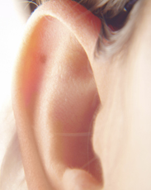 | An analysis of data from the Millenium Cohort Study shows that childhood hearing loss may predict peer victimisation (in girls), depressive symptoms, and self-harm. It is known that childhood hearing loss predicts poor mental health and is associated with a higher risk of communication difficulties, but the association with specific types of poor mental health (such as depressive symptoms or self-harm) and peer victimisation was previously unclear. Data from the Millennium Cohort Study were available on children at ages from 9 months to 14 years, and this study included 10,858 singleton children with self-reported data on peer victimisation, depressive symptoms, and self-harm at age 14. Researchers conclude that their findings highlight the need for increased support for families and children to prevent these outcomes and enable children with hearing loss to achieve good mental health.
Achieving climate justice: Child marriage and environmental crises
26 May (Heather McMullen. Centre for Public Health and Policy)

The climate crisis has a disproportionate impact on the lives of women and girls. People need control over their bodies to respond to changing environments. Sexual and reproductive rights, health, and justice are essential in building resilience, and must be considered in climate change adaptation responses. Climate justice will not be achieved if people do not have bodily autonomy. Through a partnership between the UN sexual and reproductive health agency (UNFPA) and QMUL, resources have been made available to help understand the links between climate change and sexual and reproductive rights outcomes. A scoping review explores the relationship between child marriage and climate change, with an academic paper forthcoming. The findings, summarised in an evidence brief, show that environmental changes have profound implications for women’s and girl’s bodily autonomy. The review confirms that climate change has a negative impact on almost all sexual and reproductive rights outcomes, and leaves vulnerable women and girls at higher risk of being left behind. Partnership agreement lead, Heather McMullen, said: 'Bodily autonomy is a fundamental human right, and is essential to achieve climate justice. Sexual and reproductive rights and health are too often unconsidered. We hope these briefs can help people make the connection'. | 
How can GPs get people to move more?
26 May (Dipesh Gopal. Centre for Primary Care)

 | A new analysis highlights the importance of encouraging physical activity in clinical practice, provides an overview of current physical activity guidelines, and outlines evidence-based strategies to aid physical activity promotion in primary care settings. Although the UK was among the first countries globally to set out physical activity guidelines, an estimated 23% of UK adults and 45% of children and young adults do not achieve the recommendations. General practice could provide personalised lifestyle advice, but 80% of GPs in England are unfamiliar with the guidelines. Researchers conclude that understanding the activity guidelines is essential for primary care staff to have these conversations with patients, but also that clinicians should be aware of the cultural and pragmatic barriers, such as timing during caring or working hours, and the need for women-only spaces.
Type 2 diabetes subgroups in East London: association with ethnicity and clinical outcomes 26 May (Sally Hull, Sarah Finer. Centre for Primary Care)

An observational cohort study of almost 32,000 adults with type 2 diabetes in the East London Primary Care Database over a 10-year period has shown that identifying type 2 diabetes subgroups at diagnosis in routine real-world multi-ethnic populations may offer a pragmatic means to develop stratified primary care pathways and improve healthcare resource allocation. Researchers compared three subgroups (mild age-related diabetes, mild obesity-related diabetes, and severe hyperglycaemic diabetes) and compared associations with glycaemic control, treatment initiation, and vascular outcomes, to understand how these vary by ethnicity. Subgroup differences in treatment initiation were most pronounced for the white group, and vascular complications for the black group. | 

Stockpiling behaviour among patients with asthma during the COVID-19 pandemic
30 May (Chris Griffiths, Anna De Simoni. Centre for Primary Care)

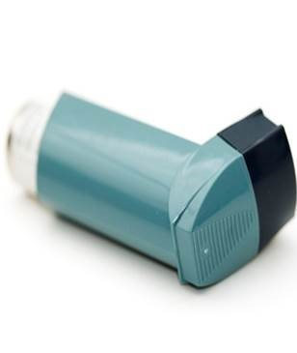 | A qualitative analysis of posts from a UK asthma online community has found that asthma patients seemed to disregard advice against stockpiling inhalers issued during the COVID-19 pandemic. Inhaler shortages were reported during the pandemic, with factors leading to increased requests including stockpiling, early ordering, realising inhalers were out-of-date, and doctors prescribing multiple medication items. Some anxieties that could lead to stockpiling were fear of asthma attacks leading to admission and acquiring COVID-19 in hospital, lack of dose counters on some inhalers, and believing a lower amount of drug is delivered in the last actuations. Corresponding author Anna De Simoni said: “We found that patients were indeed stockpiling, but there were some legitimate reasons for prescription requests (eg. finding that inhalers were out-of-date). In any future respiratory disease epidemic, advice not to stockpile could have minimal effects on inhaler demand and patient behaviour, unless patient concerns and behaviours are properly understood and addressed.”
FORTHCOMING EVENTS

Mad Hearts – The Arts and Mental Health: Masked/UnMasked 10 and 11 June 2022

This event explores productive, radical, contemporary encounters between the arts and mental health, bringing together clinical, artistic and research perspectives that offer a re-interpretation of contemporary mental health science and practice, with a view of imagining a different future. This year's theme is Masked/Unmasked – the wearing of physical masks to face the pandemic is a prompt to reflect on the metaphorical masks we wear to face the world, how we put these on to protect us from an unforgiving social world at the price of hiding the beauty of our differences. This year’s highlights include: Keynotes from acclaimed artist Dolly Sen and Senior Lecturer in Creative Arts and Mental Health and psychiatrist Dr Maria Turri. Book tickets here | 
Festival of Communities 11 and 12 June

The annual Festival of Communities celebrates everything that makes east London a fantastic place to live and work. We bring together hands-on demonstrations of local research and services, loads of fun family activities, food stalls, and games, to create two-days of fun for all ages and interests. The festival was created by QMUL in collaboration with Tower Hamlets community groups and organisations, to provide a space to get involved in our borough in ways that we may not have had the opportunity to before. Over 3500 local residents will join us over the weekend. |  | 
The 2022 Three Minute Thesis Final (We have a WIPH finalist!) 13 June, 4pm

Join us for the 2022 Queen Mary 3 Minute Thesis (3MT) competition final on 13 June, 4-5pm, followed by a drinks reception until 6pm, at the Peston LT, Graduate Centre, Mile End campus or tune in online. 3MT is a prestigious research communication competition, in which doctoral students have just three minutes to tell a non-specialist audience about their research and results. The 7 finalists were selected after Faculty Heats in April and will compete for First and Runner-up place prizes and the People’s Choice Award. Register to support our finalists and vote for your favourite pitch! The QM winner will then compete against other doctoral students from across the UK and could win a £3k or £1k public engagement grant from UKRI. More info here. |  | 
Many thanks to all who so enthusiastically contribute. Please send any news items for the next newsletter to j.a.mackie@qmul.ac.uk

