WOLFSON INSTITUTE OF POPULATION HEALTH
NEWSLETTER
ISSUE 7: 14 JANUARY 2022
In this first Wolfson Institute of Population Health Newsletter for 2022, we celebrate the achievements and work of staff and students in the latter part of December and the first half of January.

FROM OUR DIRECTOR

Welcome back to work after the holidays, and best wishes for a peaceful, healthy, and productive 2022. Despite being in the midst of the latest wave of the pandemic, and the huge strain this is placing on our already stressed health and care system, our researchers and teachers have made an impressive start to the year as you’ll read below.

Everyone able to attend the live QMUL graduation ceremony conferring our post graduate degrees on 11 January described it as a very happy and special occasion. Thanks to all involved. We now have our new Vice Principal (Health), Professor Sir Mark Caulfield, in post, and I look forward to continuing to develop our WIPH aims and strategic development with his support.  Warm wishes to all, Fiona | 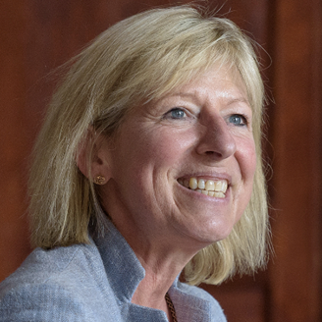

FROM OUR LEADERSHIP TEAMS AND REPRESENTATIVES

"AI-MULTIPLY" grant success
Deborah Swinglehurst. (Theme Lead: Complexity and Social Science)

AI-Multiply, a QMUL collaboration (Mike Barnes, Sarah Finer, Deborah Swinglehurst, Meg Clinch, Vanessa Apea) previously funded by an NIHR Development award, has received major funding in a £3 million NIHR Artificial Intelligence for Multiple Long-Term Conditions (AiM) Research Collaboration Award. The team will use interdisciplinary methods to study the dynamic inter-relationships between multimorbidity and polypharmacy. Using health data from multiple sources we will describe how long-term health conditions and polypharmacy interact over time, identifying possible early intervention targets prior to 'tipping points' associated with rapidly progressive ‘bursts’ of multimorbidity/polypharmacy. We will apply our findings to trial emulation and proof-of-concept clinical decision support tools to deliver future impact on health and healthcare. Using ethnographic methods, we will also examine how AI-in-healthcare collaborations proceed, and show how these working practices become inscribed in digital outputs, making explicit the assumptions that underpin their development. Our work will have a detailed focus on understanding the role of personal and social intersectional factors with the aim of reducing health inequalities, and we will embed PPI activities in partnership with Social Action for Health.

January goals for Public Advisory Panel work
Megan Clinch. (Theme Lead: Public Advisory Panel)

This month I will be working with Sarah Gifford from the QMUL Centre for Public Engagement on developing the WIPH seminar to be delivered at the end of the month. The aim of the seminar is to identify areas of possible WIPH teaching and research activity in response to the Civic University research, and to establish a process for setting up the Public Advisory Panel. I am also working with the Tower Hamlets Council for Voluntary Services and Positive East/Vanessa Apea to pilot some support we could start to provide in relation to community researcher training and workshop facilitation (in this case supporting local organisations to present community knowledge on mental health/stigma to the East London NHS Foundation Trust, and other statutory service providers).

Research News Victoria Kemp (Research Manager)

The WIPH Research Team are conducting a survey to gather information about representation on funding panels, and bid submissions to external funding bodies. Your responses will be of great value to improving knowledge exchange across WIPH. Please follow this link to fill in the survey, which is now live and will close midnight Monday 23 January.

Application for candidates to the Wellcome-funded Doctoral Training Programme for Primary Care Clinicians opened on 14 January. WIPH colleagues can put forward doctoral project ideas they would like to supervise. Projects should have secondary supervision based in a different consortium member organisation (but we can help organise this). Please contact Steph Taylor for more information on proposing a project. The scheme aims to support the most promising primary care clinicians (including representatives from all clinical disciplines working in primary care) to undertake rigorous research training, leading to the award of a PhD. The first intake of PhD Fellows under this new award will be in September 2022. More information on the scheme, including FAQs, is available here.

GENERAL INSTITUTE NEWS

Association of etiological factors for hypomanic symptoms, bipolar disorder, and other severe mental illnesses
15 December (Georgina Hosang. Centre for Psychiatry and Mental Health)

   | A cohort study using phenotypic and genetic data for 8568 twin pairs from the Swedish Child and Adolescent Twin Study has examined the shared genetic and environmental architecture of subsyndromal hypomania and bipolar disorder, schizophrenia, and major depressive disorder in young adults. Subsyndromal hypomanic symptoms are relatively common in the general population and are linked to the onset of bipolar disorder, but little is known about their etiology and whether this is shared with the etiology of bipolar disorder or other mental illnesses. This study, in JAMA Psychiatry, assessed hypomanic symptoms using the parent-rated Mood Disorders Questionnaire when the twins were aged 18. Higher heritability estimates were found for hypomania for males compared with females. Moderate genetic and non-shared environmental correlations between hypomania and bipolar disorder were detected, and hypomania was significantly associated with the polygenic risk scores for schizophrenia and major depressive disorder, but not for bipolar disorder. Lead and corresponding author Georgina Hosang said: ”Our results show that the etiology of subsyndromal hypomania overlaps with bipolar disorder, major depressive disorder, and schizophrenia, indicating that it may be a continuous trait for psychiatric disorders reflected at its extreme.”
Benefits of optimising antihypertensive and statin treatments in an ethnically diverse urban UK population
30 December (Runguo Wu, Stuart Rison, Isabel Dostal, Chris Carvalho, John Robson, Borislava Mihaylova. Centre for Evaluation and Methods/Centre for Primary Care)

A cross-sectional population study has characterised gaps in blood pressure and statin treatments among people at high cardiovascular disease (CVD) risk in a large, ethnically diverse UK population, and quantified the health and economic impacts of optimising treatment. Data for adult patients with hypertension or CVD from around 1 million people registered with all 123 primary care practices in the City and Hackney, Newham, and Tower Hamlets clinical groups (local authorities among the 10% most socially deprived in England) showed that 27% of patients with hypertension and 38% with CVD do not receive optimal treatments. Modelling to project cardiovascular events avoided, years and quality adjusted life years (QALYs) gained, and healthcare costs saved with optimised treatments showed that, per 1000 additional patients with treatment optimised over five years, hypertension treatment would prevent 25 major vascular events and 7 vascular deaths, and statin treatment would prevent 28 major vascular events and 6 vascular deaths. Among patients aged 60-69, those with uncontrolled hypertension would gain 0.64 QALYs with optimised treatment over their lifespan, and those with CVD not optimally treated with statins would gain 0.3 QALYs with optimised treatment. In both cases, hospital costs savings minus extra medication costs were about £1100 per person over the remaining lifespan. First author Runguo Wu said: These results show that optimising cardiovascular treatments can cost-effectively reduce cardiovascular risk and improve life expectancy. | 
Highlights from the four-year IMPULSE Project
31 December (Nikolina Jovanovic. Centre for Psychiatry and Mental Health)

  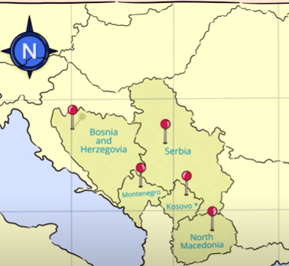 | IMPULSE (Implementation of an effective and cost-effective intervention for patients with psychotic disorders in low and middle-income countries in Southeast Europe), a four year EC-funded project coordinated by QMUL, has now completed its research activity. The collaboration by partners in Bosnia and Herzegovina, North Macedonia, Kosovo (UN Resolution), Montenegro, Serbia, and the UK, focused on psychosocial treatment of individuals with psychosis, service user involvement and stakeholder engagement, capacity in mental health research, and dissemination and public involvement. A large RCT of the DIALOG+ psychosocial intervention across five countries resulted in the intervention being implemented, improving quality of life for individuals with psychosis after four sessions. Meetings and workshops organised with mental health service users in Southeast Europe strengthened existing networks and led to setting up a new service user organisation in Montenegro. To support the focus on research capacity building >100 hours of training was delivered on trial methodology, implementation science, qualitative research, and public engagement. The project produced 19 papers and two booklets. Researchers have produced a short video to celebrate the highlights.
New Channel 4 Prison Drama: ‘Screw’
6 January (Mark Freestone. Centre for Psychiatry and Mental Health)

Mark Freestone provided extensive script advice for a new “darkly comic prison drama” television series, SCREW. All six episodes are now streaming on All4. The series is set in the intense world of a fictional men’s prison, with emotional high stakes and danger for prisoners and officers alike. Mark’s role was to provide input on the representation of drug use and mental disorder in prisons, and to offer specific guidance on how trauma, mental disorder, and violence should be portrayed together in an accurate, ethical and sympathetic way. | 
Kings Cancer Prevention Group Blog
7 January (Ranjit Manchanda. Centre for Prevention, Detection and Diagnosis)

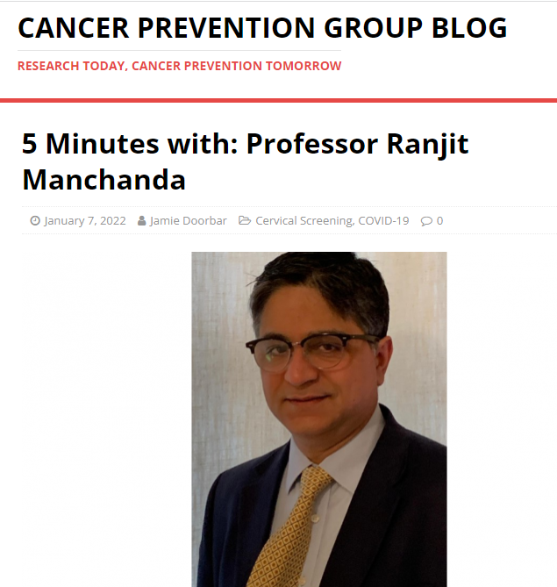 | Ranjit Manchanda has featured in a quick fire 5 minute interview on the Kings Cancer Prevention Group blog. Reflections include how to deal with a grant rejection, his prediction for the future for cancer prevention (population-based testing for risk prediction and stratification for better targeted and effective early diagnosis and preventive interventions of clinical utility), and his choice of a message for the world: “We have the technology and ability to prevent thousands more cancers than we do today. Prevention is better than cure. Come forward and get tested to see if you are at increased risk for cancer.”
PROTECTOR Study registered for Associate PI Scheme
10 January (Ranjit Manchanda. Centre for Prevention, Detection and Diagnosis)

The PROTECTOR (Preventing Ovarian Cancer through early Excision of Tubes and late Ovarian Removal) study, led by Professor Ranjit Manchanda, has now been registered for the NIHR Clinical Research Network's Associate PI scheme, and has been listed on the NIHR Associate PI Scheme Website. Applicants are now able to register to be Associate PIs for this study, having obtained approval from their local PI, using the NIHR Associate PI Scheme Form. | 
Impact of March-June 2020 lockdown on mental health: mothers in the Born in Bradford study
11 January (Trevor Sheldon. Centre for Public Health and Policy)

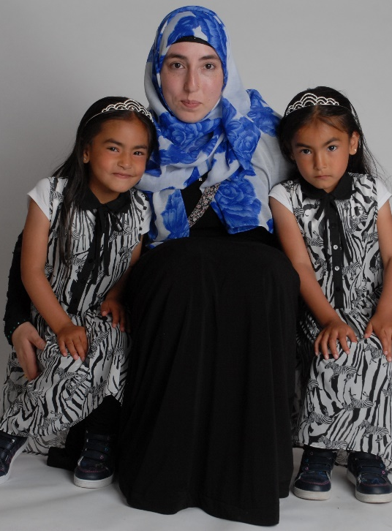   | Using survey data from 1860 mothers of children aged 0-5 or 9-13 in the Born in Bradford cohort (48% Pakistani heritage), researchers have assessed clinically important increases in depression/anxiety before and during the first UK Covid-19 2020 lockdown, and factors relating to this change, with a particular focus on ethnic differences. Only three UK studies have compared mental health in the pre-Covid-19 period with that in lockdown, but most participants were of white European origin, and the largest study was in a relatively affluent population. This new research was conducted in a highly ethnically diverse population, the majority of whom live in the most deprived centiles in the UK. The number of women reporting clinically important depression/anxiety increased from 11% to 20% and 10% to 16% respectively, with increases associated with loneliness, finances, food and housing insecurity, lack of physical activity, and a poor partner relationship. The magnitude of associations between key exposures and worsening mental health varied between ethnic groups. The complex inter-play of challenges contributing to mental ill health included acute health anxieties, the mental load of managing multiple responsibilities, loss of social support and coping strategies, pressures of financial and employment insecurity, and being unable to switch off from the pandemic. Authors conclude that mental ill health during the lockdown worsened for many, particularly among the lonely and economically insecure, and that the magnitude of associations between key exposures and worsening mental health varied between ethnic groups.
Conferment of PGT and PGR degrees for the Faculty of Medicine and Dentistry 11 January

For the first time in two years, live QMUL graduation ceremonies have been held this month. Congratulations to all the graduates of both our former Institutes, and special thanks to Alastair Noyce and Mark Freestone for volunteering their time to assist our new Vice Principal (Health), Professor Sir Mark Caulfield, at the ceremony for conferment of our post graduate degrees on 11 January. |   
ActEarly Research Consortium issues first monthly e-bulletin
11 January (Emma Doohan. Centre for Public Health and Policy)

 | ActEarly is a UK Prevention Research Partnership-funded research consortium focusing on upstream early life interventions to improve the health and opportunities for children living in two contrasting areas with high levels of child poverty: Bradford and Tower Hamlets. Trevor Sheldon is co-director of ActEarly in London, leading the different themes of work with communities, Tower Hamlets Local Authority, and researchers to understand how to help families to live healthier and more active lives. Regular news and updates are now available by signing up to the monthly e-bulletin. Click here for the first edition.
FORTHCOMING EVENTS
Talking out the stigma: power of language in mental healthcare  Seminar 20 January  Sandra Jumbe (Centre for Evaluation and Methods) will speak about her experience, observations, and challenges of researching and working on youth mental health literacy in Malawi in a forthcoming seminar hosted by the London International Development Centre. During her research, Sandra realised that the problem in Malawi is not only connected to a lack of communication about mental health, but also to a lack of words to properly describe a mental health condition in the official local language – Chichewa. The depth of this problem was especially visible during translation, as she was struggling to describe depression in Chichewa for a mental health survey needed for her project. | 
Many thanks to all who so enthusiastically contribute. Please send any news items for the next newsletter to j.a.mackie@qmul.ac.uk

