WOLFSON INSTITUTE OF POPULATION HEALTH
NEWSLETTER
ISSUE 18: 16 AUGUST 2022

In this issue of our Wolfson Institute of Population Health Newsletter, we celebrate the achievements and work of staff and students over the last few weeks.

FROM OUR DIRECTOR
Dear Colleagues

I hope everyone is enjoying the summer and the sunshine. August days are marked by far fewer meetings and events in my diary so I had hoped for more time to write and think…. getting there!

The very hot weather has really underlined the urgency of addressing climate change. It’s crucial that we act now, individually and collectively, and I’d welcome the opportunity to consider how we can increase our approaches to sustainability across the Institute. One plan is to implement more ‘planetary health’ education, but please send me any other suggestions you may have.  With best wishes to all  Fiona | 
GENERAL INSTITUTE NEWS

Preventing Multiple Sclerosis
20 July (Ruth Dobson. Centre for Prevention, Detection and Diagnosis)

In an Editorial introducing a Research Topic in the journal Neurology, Ruth Dobson writes that while the prevention of Multiple Sclerosis is a key aim, the pathogenic pathway is complex, with contributions from and interactions between genes and the environment. Despite this, she notes that the 11 papers presented in this collection show that sufficient evidence exists to support trialling prevention interventions, and that clearly defined interventions in selected high risk populations will be key to success. “Without the courage to set up studies to understand the impact of interventions, the need for prevention will remain unaddressed – this cannot continue, given the importance of this topic.” |   
Urinary Sodium and Obesity Markers
21 July (Feng He. Centre for Public Health and Policy)

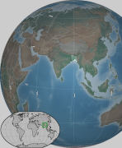 |  | Results from a study of the relationship between urinary sodium and BMI in a Bangladeshi population suggest that sodium intake is related to obesity markers. The evaluation of BMI and waist circumference in pooled data from three cohort studies found that associations between urine sodium and the 10th and 90th percentile BMI distributions were higher compared with the conditional mean models, suggesting high sodium intake could be more detrimental to underweight and obese participants. The international consortium of authors conclude that further research should explore the link between sodium intake and obesity-related markers in blood and urine, and that, given the rising obesity epidemic and high sodium among South Asians, such research would provide important clues to identify interventions to lower cardiometabolic diseases.
Antibiotic Use and Bacterial Infection in COVID-19 Patients
23 July (Beth Stuart. Centre for Evaluation and Methods)

A review of studies published from June 2020 to March 2021 shows that the global antibiotic prescribing rate for COVID-19 patients declined from 82.3% to 39.7% in comparison with the preceding six months. The overall bacterial infection rate in COVID-19 patients was 10.5%, and the most frequently reported resistant pathogen was Staphylococcus aureus, followed by Pseudomonas aeruginosa, Escherichia coli, and Klebsiella pneumoniae. The seven most frequently prescribed antibiotics were all on the "Watch" list of the WHO AWaRe antibiotics classification. Authors conclude that there is an urgent need for comprehensive, consistent guidelines in selecting appropriate antibiotics for COVID-19 patients, and that resistance data on the most frequently used antibiotics for COVID-19 patients for certain resistant pathogens should be closely monitored. | 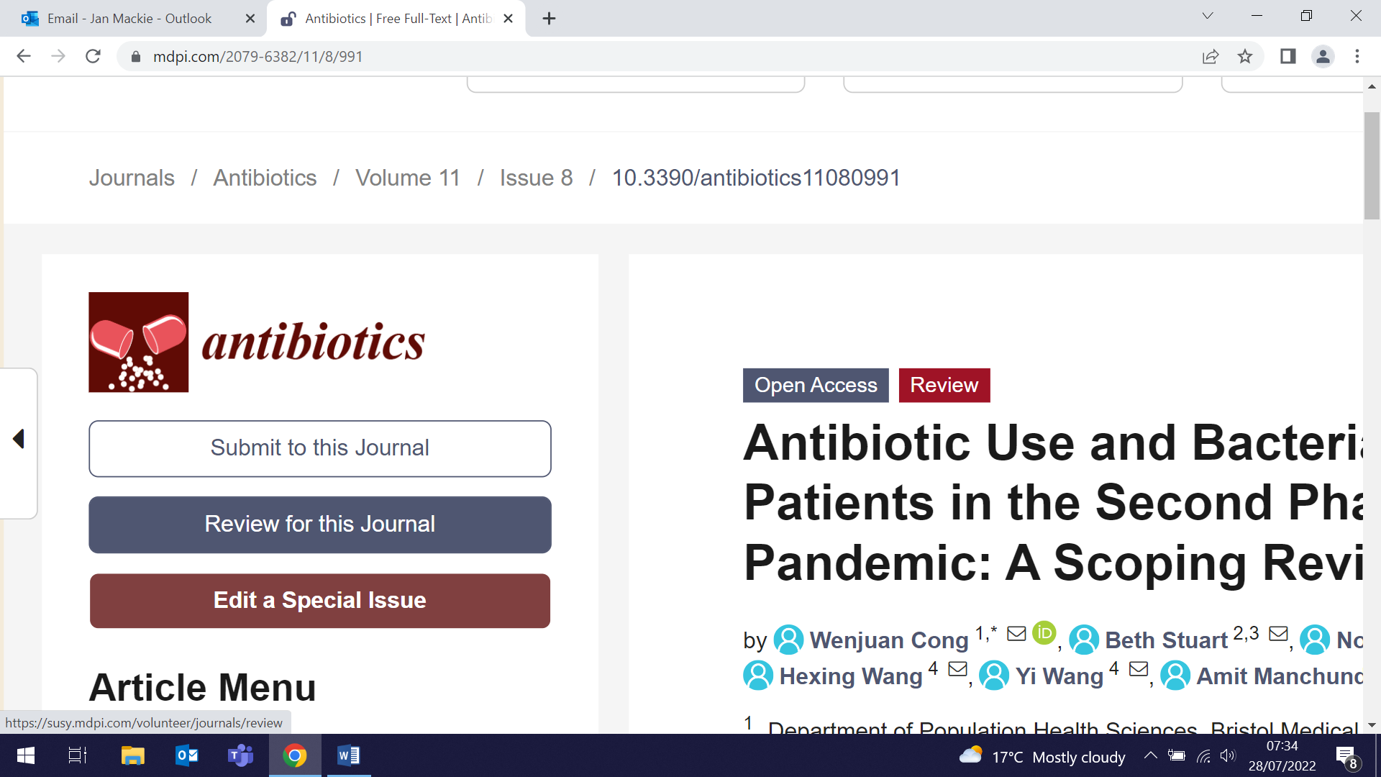
Experiences of traditional v one-stop prostate cancer diagnostic pathways
26 July. (Fiona Walter. Centre for Prevention, Detection and Diagnosis)

 | A qualitative study has compared patient and GP experiences of two prostate cancer diagnostic pathways in England: 'traditional' and 'one-stop'. Since 2019 NICE guidance has recommended prebiopsy MRI for men suspected of having prostate cancer, but significant variation exists in prostate cancer diagnostic pathways between English NHS Trusts and regions. Study results show that patients value a 'one-stop' pathway, integrating prostate MRI and diagnostic consultations with specialists and where patients undergo a prostate MRI scan, receive their MRI result and potentially undergo a prostate biopsy on the same day at a single outpatient attendance, over the traditional approach of several hospital appointments. GPs, however, remain uncertain how they can best identify patients for referral to urgent prostate cancer testing, due to the lack of accurate triage and risk assessment strategies.
Undiagnosed COPD in the SUMMIT Study Lung Cancer Screening Cohort
26 July (Samantha Quaife. Centre for Prevention, Detection and Diagnosis)

Incorporating targeted chronic obstructive pulmonary disease (COPD) case-finding into lung cancer screening programmes may be an opportunity to reach those at the highest-risk of COPD under-diagnosis and facilitate a stage shift in earlier COPD diagnosis. Estimates suggest that 71.2%-86.5% of COPD cases are undiagnosed, but COPD is a significant risk factor for lung cancer independent of smoking status, and increases lung cancer risk by four- to six-fold. Results from 16,010 current or former smokers in the SUMMIT study who attended a Lung Health Check and underwent a respiratory consultation and spirometry show that one in five met the criteria for undiagnosed COPD. The undiagnosed cases were more likely to be male (59.1% v 53.2%), current smokers (54.9% v 47.6%) and from an ethnic minority group. | 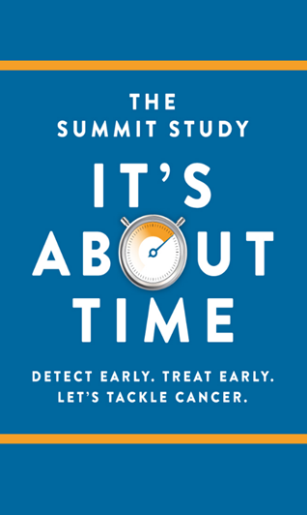
Global Food Companies called out on misleading health claims
28 July (Action on Salt Team. Centre for Public Health and Policy)

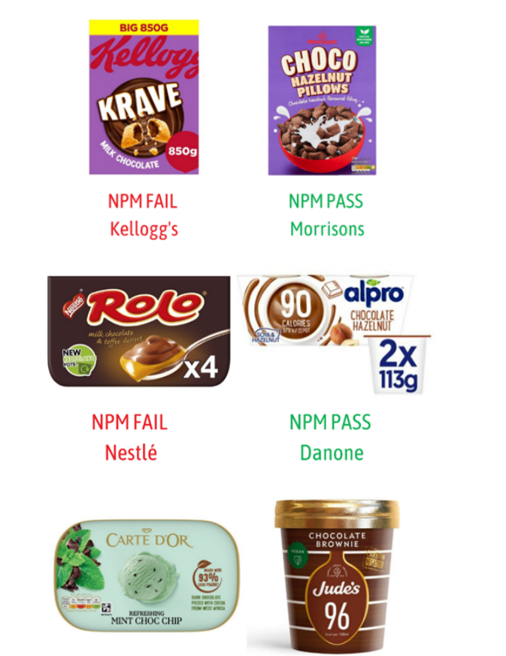  Similar products: marketing restrictions will apply to products that fail the Nutrient Profile Model (NPM) | Action on Salt has called on global food manufacturers Danone, Kellogg’s, Kraft Heinz, Nestlé, and Unilever to urgently reformulate their popular brands to improve the healthiness of their products, and to shift their marketing to champion genuinely healthier options. The call follows results from the team’s recent product analysis, showing that over 1/3 of ‘flagship’ products are high in saturates, salt and/or sugar, but display misleading nutrition and health-based claims in their product description. Of 100 key flagship products from these companies, almost half would receive a red front of pack colour-coded warning label for high salt, sugar, or saturated fat, in stark contrast to the image manufacturers strive to create as global leaders in improving the healthfulness of their food and drinks. In anticipation of the October introduction of new restrictions to limit unhealthy products being prominently promoted (eg. at checkouts), researchers urge these companies to redouble their efforts to reformulate their products responsibly, so that the restrictions would no longer apply.
Rapid Diagnosis of Drug Resistant TB
28 July (Dominik Zenner. Centre for Public Health and Policy)

Extensive use of anti-tuberculosis (TB) drugs has led to an increasing problem of extensive drug resistance (XDR). A systematic review of publications describing and assessing rapid diagnostic tests for pre-XDR/XDR TB from a point of care perspective has compared the diagnostic techniques and approaches in terms of sensitivity, specificity, laboratory complexity, and time to confirmed diagnosis. Researchers found that two rapid WHO-endorsed tests are available (Xpert MTB/XDR and GenoType MTBDRsl) and that both are presently diagnosing pre-XDR-TB with similar performance, though slightly favouring Xpert. The study concludes that Xpert MTB/XDR could be suggested at near-point-of-care settings to be used primarily as a follow-on test for laboratory-confirmed TB, complementing existing rapid tests detecting at least rifampicin-resistance. | 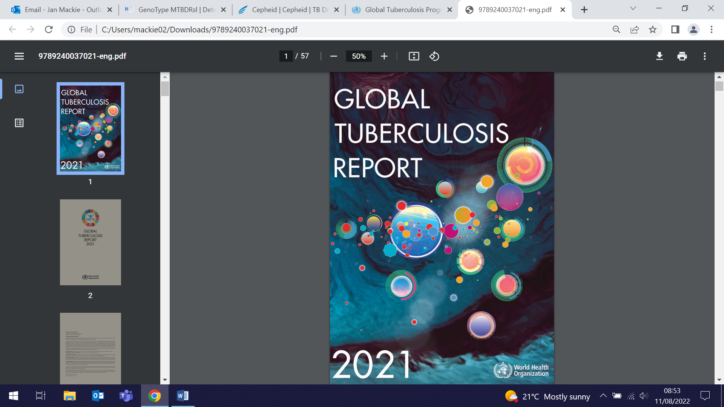
How academic social connections translate into research collaboration
29 July (Fiona Walter. Centre for Prevention, Detection and Diagnosis)

  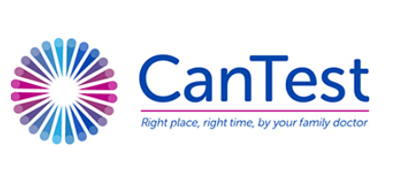 | An investigation into how getting to know other researchers translates into effective academic collaboration has found that academic social relationships stimulate research collaboration. In the CanTest collaborative, an international primary care cancer research network, surveys were used to determine who knew who (the academic network), and co-authorship was used to measure collaborative research output. Assessment of individual researcher characteristics, such as gender, seniority, and workplace revealed that academic social networking was different for male and female researchers. Results show that, although academic social networks and research collaborations do not grow at the same pace, researchers got to know each other quickly, forming a stable academic social network that was particularly encouraging towards more junior researchers.
QMUL Research Highways Project releases videos
29 July (Mhairi Brown. Centre for Public Health and Policy)

To coincide with the launch of the QMUL Research Highways project, a series of videos has been released to highlight the best research impact from across the university, including one by Mhairi Brown describing the work of the WIPH Action on Salt team. Action on Salt has comprehensively shown that reducing salt in food is one of the most cost-effective public health policies available to the government: for every £1 spent on salt reduction, £300 is saved in healthcare costs. The Research highways are five interdisciplinary research themes which bring together expertise from across Queen Mary, each representing an area with cross-faculty excellence and depth. The Highways are Sustainability, environment, energy; Digital, information, data; Lifelong health and wellbeing; Performance, communication, creative industries; and Accelerating innovation and invention. | 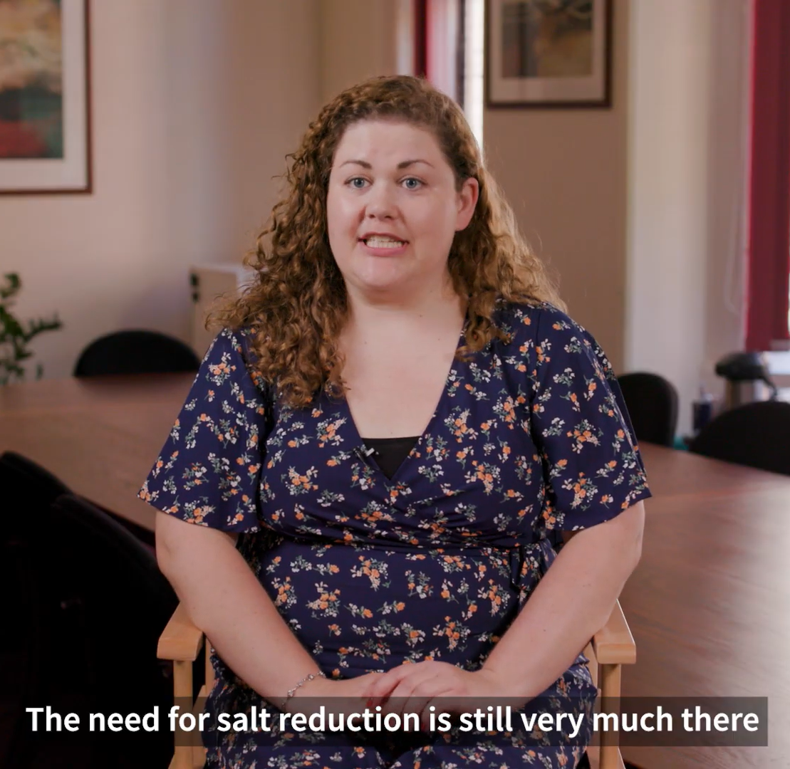  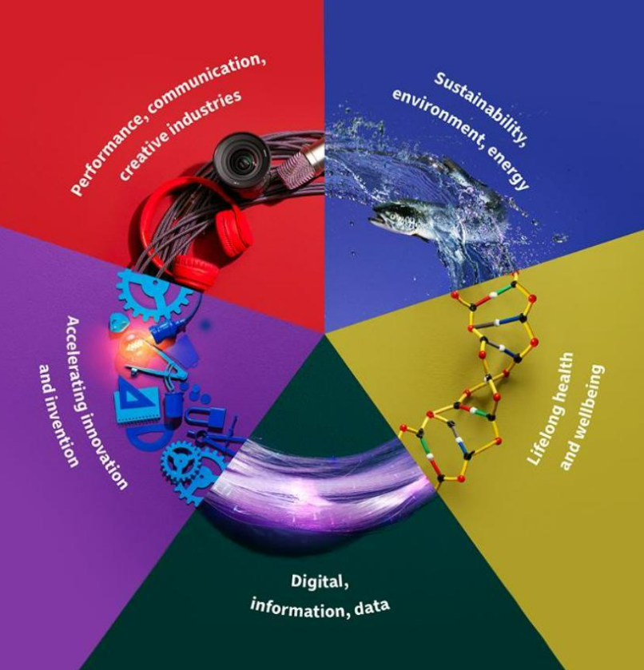
Advance HE Fellowships
29 July (Liam Arnull, Joy Li, Adam Brentnall, Dominik Zenner)

 | Four WIPH colleagues have this year successfully completed Queen Mary Academy’s taught programmes, the Certificate in Learning and Teaching, and the Postgraduate Certificate in Academic Practice, and have received Advance HE Fellowships. Congratulations to Liam Arnull and Joy Li, who have both been awarded Associate HEA Fellowships, and Adam Brentnall and Dominik Zenner, who are now HEA Fellows.
Post-vaccination anti-Spike antibody titres and protection against SARS-CoV-2 infection
30 July (David Jolliffe, Hayley Holt, Mohammad Talaei, Florence Tydeman, Seif Shaheen. Centres for Public Health and Policy/Prevention, Detection and Diagnosis)

Finding a reliable, simply determined blood marker that indicates vaccine-induced protection against covid infection has proven difficult; while neutralising antibody titres do correlate, testing for these is resource and time intensive, and they have not been evaluated in the general population, so adjusting for factors influencing risk of exposure is problematic. Research using data from 7538 subjects in the COVIDENCE UK has found that combined igG/A/M anti-Spike titres measured after SARS-CoV-2 vaccination are modestly predictive of protection against covid, but discrimination is significantly improved by adjustment for factors influencing risk of exposure, such as household overcrowding and public transport use. The authors suggest that that the limited predictive value of anti-Spike IgG/A/M titres for protection may stem from their inability to reflect protective vaccine-induced cellular responses. |   
Genetic and environmental factors and risk of Parkinson's disease
1 August (Alastair Noyce. Centre for Prevention, Detection and Diagnosis)

 | Genetic and environmental factors are known to contribute to the etiology of Parkinson’s disease, but little is known about how they interact to affect penetrance, risk, and disease severity. A new paper in Annals of Neurology provides insights into environmental modifiers of the disease, discussing precedents from other conditions, and outlining the genetic and environmental factors contributing to the disease. The authors review potential environmental modifiers of penetrance and clinical variability in monogenic and idiopathic Parkinson’s disease, highlight some potential challenges, and propose how future studies might tackle these important questions.
Updated childhood immunisation tool for GPs
3 August 2022 (Ana Gutierrez, Anna Billington, Carol Dezateux, Milena Marszalek, Isabel Dostal, Zaheer Ahmed. Centre for Primary Care)

The Centre for Primary Care Clinical Effectiveness Group has launched version 2 of its childhood immunisation tool for GPs, APL-Imms. The tool lists all children under six who are registered with a GP practice and flags those who are due or overdue for a routine immunisation. It will be particularly valuable to practice teams following the JVCI advice that all children aged 1-9 in London need to receive a polio dose now, either as an extra booster or to catch up with routine vaccinations. Version 2 incorporates several new features suggested by users, including the ability to export a prioritised list of children in a format that can be imported straight into messaging software, making it much easier to contact parents, and an additional filter to display newly-registered children. | 
Mind the Gap NIH webinar on designing stepped web trial now available online
4 August (Richard Hooper. Centre for Evaluation and Methods)

 | The Mind the Gap presentation made by Richard Hooper for the National Institutes of Health is now available online. In this talk Richard focuses on optimal solutions to three design problems for longitudinal cluster trials: (1) a parallel groups design with a prospective baseline period in both arms, (2), a stepped wedge design where each of a large number of clusters may cross over to the intervention at a different time, and (3) an incomplete stepped wedge design where he restricts recruitment to particular time intervals in particular clusters to minimize the burden of participation.
The link between childhood obesity and musculoskeletal conditions
4 August 2022 (Nicola Firman, Marta Wilk, Gill Harper, Carol Dezateux. Centre for Primary Care)

Only a small number of studies have investigated the relationship between obesity at school entry (age five) and musculoskeletal condition diagnoses made before age 20, according to a new systematic review. Four studies published from 2000-2002 were identified, but quantitative synthesis of their findings was not possible due to differences in outcomes and effect sizes reported. Children with obesity at school entry were more likely to receive diagnoses of slipped capital femoral epiphysis, back pain, fractures and musculoskeletal complaints made in primary care settings. The authors conclude that further research is needed to replicate these findings in ethnically diverse populations and to investigate whether these are causal associations. The implications of this for children’s mobility and quality of life and future musculoskeletal health warrants further assessment. | 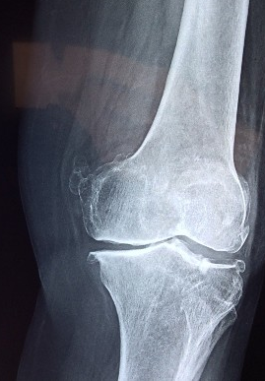
National Teaching Fellowship Award
4 August (Jennifer Randall. Centre for Public Health and Policy)

   | WIPH Senior Lecturer in Global Public Health and Student Experience Lead for Global Health, Dr Jennifer Randall, has been awarded a 2022 National Teaching Fellowship. The award has been made in recognition of her outstanding record as an educator and in enhancing the student learning experience. Over a 20-year career, Jennifer’s teaching has led to transformative and empowering learning experiences for hundreds of students. She has played a central role in the development and launch of Queen Mary’s online MSc in Global Health, and has also been key to the development of the ‘Stepping Stones’ and ‘Get Ahead’ programmes. Becoming a National Teaching Fellow is widely recognised in higher education as a mark of quality, both in the UK and internationally.
Global Lung Cancer Coalition Annual Meeting
4 August (Sammy Quaife. Centre for Prevention, Detection and Diagnosis)

Samantha Quaife presented an invited lecture on participant information needs in lung cancer screening to the Global Lung Cancer Coalition (GLCC) Annual Meeting in Vienna on 4 August. Established in 2001, the GLCC is the ‘International voice of people with lung cancer’, bringing together 42 non-government patient organisations from 30 countries. | 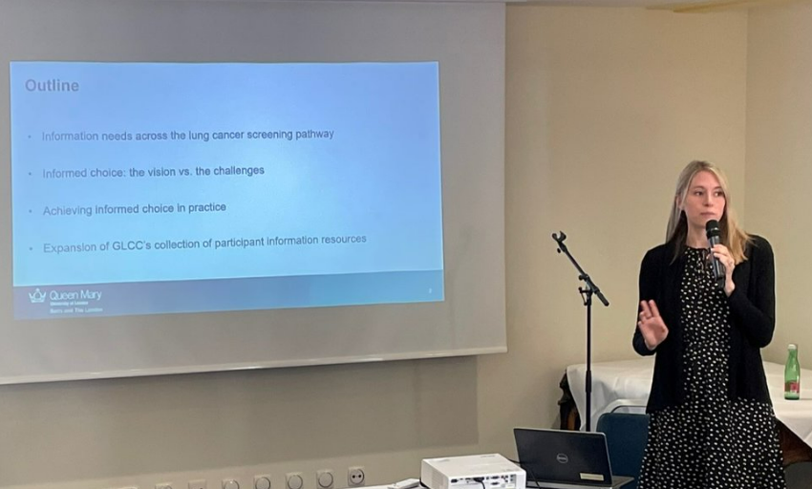
Review highlights key role of WIPH researchers in development of cluster randomised and stepped wedge trial methods
4 August (Clare Robinson, Sandra Eldridge, Richard Hooper. Centre for Evaluation and Methods)

A review in the August issue of Clinical Trials highlights the key role played by WIPH researchers in the development of cluster randomized and stepped wedge trials methods. These methods have formed a cornerstone for randomised evaluations of health technologies as they would be rolled out in practice by health services. Stepped wedge trials in particular are among the most widely touted yet simultaneously most poorly understood approaches to randomised evaluation. The review examines relative citation rates in the field to identify the most influential papers of all time, and flags 48 articles on cluster randomised and stepped wedge trials, of which 8 were co-authored by members of the WIPH Pragmatic Clinical Trials Unit. Review author David Murray concludes that the articles “make an excellent reading list for anyone interested in learning about the methods used in these designs and their appropriate applications in public health and medicine”. | 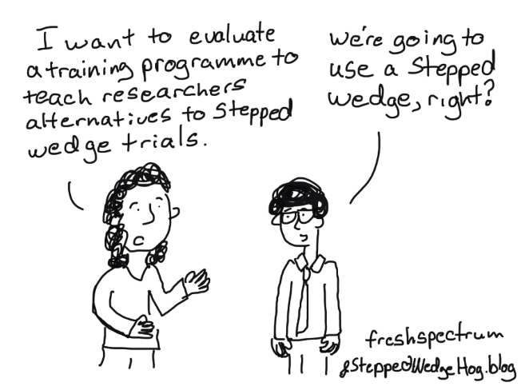  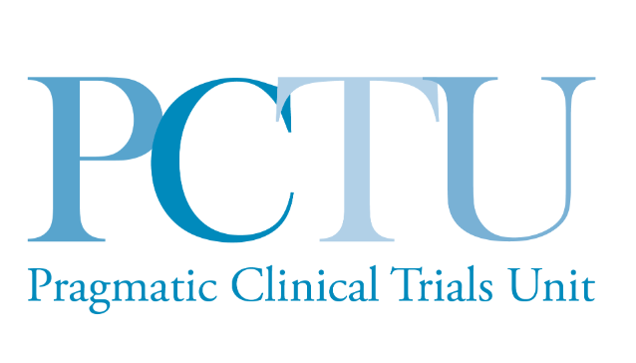
Prevalence of comorbidity in lung cancer screening populations
9 August (Rhian Gabe. Centre for Evaluation and Methods)

 | A systematic review of 69 papers reporting comorbidity in lung cancer studies has found that comorbidities were highly prevalent in lung cancer screening populations, and were likely to be more prevalent than in other cancer screening programmes. Meta-analysis of individual comorbidities showed an estimated prevalence of 35.2% for hypertension, 23.5% for history of chronic obstructive pulmonary disease (10.7% for severe COPD), 16.6% for ischaemic heart disease, 13.1% for peripheral vascular disease, 12.9% for asthma, 12.5% for diabetes, 4.5% for bronchiectasis, 2.2% for stroke, and 0.5% for pulmonary fibrosis. The authors conclude that Identifying individuals with frailty and comorbidities who might not benefit from screening should become a priority in lung cancer screening research.
Transferability of genetic loci and polygenic scores for cardiometabolic traits in British Pakistani and Bangladeshi individuals
9 August (Chris Griffiths, Sara Finer. Centre for Primary Care)

A study using data from 22,000 British Pakistani and Bangladeshi individuals from the Genes & Health cohort has produced the first comprehensive assessment of the transferability of cardiometabolic loci to a non-European ancestry population. British South Asians have 3 to 4-fold higher coronary artery disease risk than White British people. Researchers assessed whether published trait-associated genomic loci identified in predominantly European ancestry populations were shared by British Pakistani and Bangladeshi populations, and found high transferability of loci across several cardiometabolic traits. Results suggest there would be clinical value in adding polygenic risk scores to conventional risk factors in the prediction of coronary artery disease in primary care settings to improve the more efficient use of preventive interventions, such as lipid-lowering medications. The authors conclude that their protocol and new approach for transferability can serve as methodological standards in this developing field. |   
Stakeholder perspectives on DIALOG+ intervention for adolescents with common mental disorders in Colombia
11 August (Vicky Bird. Centre for Psychiatry and Mental Health)

 | A sub-study in the DIALOG+ digital intervention project has explored perspectives of adolescents, parents, educators/youth workers, and clinicians regarding the appeal and usability of the intervention for common adolescent mental disorders. Online Focus Groups were held with adults and adolescents in two cities in Colombia. A positive feature highlighted by all groups was the innovation of including a digital intervention in a traditional medical visit, and participants considered the active role that adolescents have when using the intervention empowering. Barriers identified included concerns from clinicians regarding the time required during consultations, and confusion with terminology. Additional domains particularly relevant for the adolescent population were suggested. Results show that the DIALOG+ intervention and supporting app are seen as innovative and appealing both to adolescents and adult stakeholders. The concerns raised will facilitate modifications.
Talking about oral cancer during routine dental check-ups
14 August (Suzanne Scott. Centre for Prevention, Detection and Diagnosis)

Dentists’ concerns that a communication guide developed to help them talk to patients about dental cancer during routine check-ups may raise patient anxiety have been documented as a barrier to these conversations. A study incorporating audio recordings of routine dental check-ups asked patients to rate their anxiety before and after their appointment, at which their dentist informed them that they were being checked for oral cancer. Results suggest that the extent to which oral cancer was discussed did not correlate with patients' post-appointment anxiety. Patients’ responses to the discussions were positive or neutral. Authors cautioned that the generalizability of the results of this small study may be limited, but note that using an evidence-based guide to talk about oral cancer did not appear to raise patients' anxiety in this practice population, and that the guide could help to increase awareness of oral cancer in the endeavour to facilitate early cancer diagnosis. | 
Cutting individual daily salt intake in China by 1g could save 4 million lives by 2030
16 August (Monique Tan, Feng He, Graham MacGregor. Centre for Public Health and Policy)

 | Estimates from a modelling study suggest that a reduction of just 1g in individual daily salt intake in China could ward off nearly 9 million cases of heart disease and strokes, and save 4 million lives in by 2030. Salt intake in China is among the highest in the world (~11 g/day) and cardiovascular disease accounts for 40% of deaths. Previous estimates of the health impact of reducing salt intake in China used either obsolete or otherwise unreliable data sources and did not account for the more prolonged effect of salt reduction on blood pressure over several years. In this study researchers compiled the latest and most reliable figures for population size, salt intake, blood pressure and disease rates by region and age and then estimated the impact on cardiovascular health. Authors conclude that a workable, coherent, sustainable and targeted salt reduction programme in China is urgently needed. Reducing salt intake in the Chinese population of 1.4 billion would also considerably improve global health.
FORTHCOMING EVENTS
Photography exhibition highlights pandemic experiences of people living with memory problems

The APPLE-Tree study is an RCT evaluating the clinical effectiveness of a behaviour change intervention that targets modifiable physical and mental health, and social and lifestyle risk factors, in individuals at high risk of dementia. The study will be based in the Centre for Psychiatry and Mental Health from February 2023, with centre lead Claudia Cooper as chief investigator. A group of study participants, supported by acclaimed photographer Sukey Parnell Johnson, has produced a photography exhibition giving insight into their own lived experiences. The project brings to the fore questions of memory, family, community, wellbeing, loss and hope, using an interdisciplinary approach to the study of memory problems. The exhibition will be held in the Frank and Steel Room, Wellcome Collection Euston, from 2-7pm on Wednesday 8 September. Book here for the free drinks reception from 7pm.

Many thanks to all who so enthusiastically contribute. Please send any news items for the next newsletter to j.a.mackie@qmul.ac.uk

