WOLFSON INSTITUTE OF POPULATION HEALTH
NEWSLETTER
ISSUE 23: 28 OCTOBER 2022

In this issue of our Wolfson Institute of Population Health Newsletter, we celebrate the achievements and work of staff and students in October.

FROM OUR DIRECTOR
Dear Colleagues

Returning from my African trip last week I was delighted to find the new academic year in full swing. In our last newsletter Ellie wrote about our Institute’s recent period of growth and substantial new grants. I’d like to give you more information about this, by sharing some metrics (with thanks to Tor Kemp, Institute Research Manager).

Awards won by the WIPH have:
● increased in number and award income by more than 40% year-on-year over the last 3 years;
● an excellent conversion rate (from bid submitted to award) of 36% last award year - well above the national average of most schemes;
● included 19 Fellowship applications last year, with almost a 50% success rate;
● already been won by all of our five centres during this first quarter of the 2022/23 award year, with substantial award income.

I am also very pleased to shine a spotlight on our fantastic WIPH students:
● Six students have completed and been awarded their PhDs in the last 12 months;
● We currently have 91 fully enrolled PGR students, including our September 2022 cohort of 18 new students;
● Our new students are mainly funded by the Wellcome Trust (33%), LISS awards (33%), with other sources including Barts Charity and government funding.
● We also have a further 5 Wellcome Trust-funded students, who have been awarded 1+3 studentships, and have just started their MRes year.
This research success is due to the combined efforts of every person in the Institute, from academics to research, teaching, and support staff, and I’d like to thank every one of you for your enthusiasm, dedication and hard work.  Warm thanks to all  Fiona |  |  | 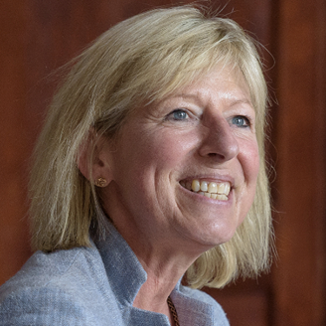
FROM OUR LEADERSHIP TEAMS AND REPRESENTATIVES

New Journal Club and APOLLO team website
(Deborah Swinglehurst. Complexity and Social Science Theme Lead)

Steph Taylor and Liz Steed have introduced an informal journal club, focusing on Complexity in Health Research, for people working on developing, evaluating, implementing or otherwise investigating complex health or social care interventions. We tested the water on 19 October to discuss We need to talk about complexity in Health Research: Findings from a focused ethnography, and were fortunate to have co-author Sara Paparini with us. Meetings are on the third Wednesday in the month, 2-3pm in Yvonne Carter Building Rm 2.15 (we will always try to find a bigger room so check for updates +/or sign on the door of 2.15). To join the mailing list contact Steph Taylor. On 16 November we will discuss Skivington et al A new framework for developing and evaluating complex interventions: update of MRC guidance

The APOLLO team, led by Deborah Swinglehurst in the Centre for Primary Care, has a new website. Please take a look if you would like to learn more about our social science research or to sign up for our news/blogs.

GENERAL INSTITUTE NEWS

Does sleep affect emotional reactivity?
4 October (Beth Stuart. Centre for Evaluation and Methods)

Previous findings have been inconsistent in studies investigating whether sleep affects cognitively unmodulated reactivity to emotional stimuli. Results from a systematic review followed by a synthesized narrative and meta-analytic approach suggest that sleep may have a larger effect on subjective emotional experience than on objectively measured physiological experiences of emotion. Researchers reviewed 24 studies with a view to determining whether sleep leads to attenuation, enhancement, or maintenance of emotional reactivity. They found that sleep might have a greater impact on responses that are subject to cognitive control than on those generated automatically, though they caution that a relatively small number of studies in this literature have taken psychophysiological measures. The paper concludes that sleep may affect emotional reactivity, but that studies need more consistency in methodology, commitment to collecting both psychophysiological and self-report measures, and should report REM sleep parameters. | 
Negotiating the polypharmacy paradox
10 October (Deborah Swinglehurst, Lucie Hogger, Nina Fudge. Centre for Primary Care)

 |  | An editorial in BMJ Quality & Safety has lauded a recent paper by CPC researchers as “an ideal model for managing polypharmacy”. The study, Negotiating the polypharmacy paradox: a video-reflexive ethnography study of polypharmacy and its practices in primary care, concluded that responsible decision-making about polypharmacy during medication review will depend crucially on the affective or emotional quality of the clinician-patient relationship. The editorial notes that “In-depth methods such as ethnography are vital to surfacing such work, and the paper by Swinglehurst and colleagues highlights the value of incorporating clinician reflection as an integral part. The paper contributes to our understanding of the challenge of tackling problematic polypharmacy by uncovering the nature of the work involved. Medicines optimisation involves much more than simply reviewing each item of medicine: it is a social process involving the management of uncertainty, in partnership with a patient over time, to achieve the optimal balance of medicines based on a patient’s priorities and goals.”

Barriers to GP Registration in North East London practices
12 October (Megan Clinch. Centre for Public Health and Policy)

A study among GP staff in NE London shows that reluctance to register new patients who lack documentation was generally fuelled not by lack of knowledge of official guidance, but by workplace and resourcing pressures, and moral judgements concerning who should be entitled to NHS services based on immigration status. Previous initiatives to improve inclusive registration have focused on reiterating NHS England guidance that documents are not required, but these results show that, despite good knowledge of guidance, most participants expressed reluctance to register those without documentation, often introducing additional hurdles or requirements in their everyday practice. Two themes emerged: that those without documents were perceived as burdensome, and/or that moral judgements were made about their deservedness to finite resources. Staff described a context of high workload, insufficient funding, and some felt that GP services should be restricted by immigration status, as is widespread in secondary care. The study concludes that improving inclusive registration practice requires: addressing staff concerns, supporting navigation of high workloads, tackling financial disincentives to registering transient groups, and challenging narratives that undocumented migrants represent a threat to NHS resources. Authors say it is imperative to acknowledge and address upstream drivers, in this instance the hostile environment. | 

Initiative to improve equal access to diabetes treatment wins award

13 October (Rumana Malik, Crystal Williams, Jayne Callaghan, Ranjan Patel. Centre for Primary Care)

  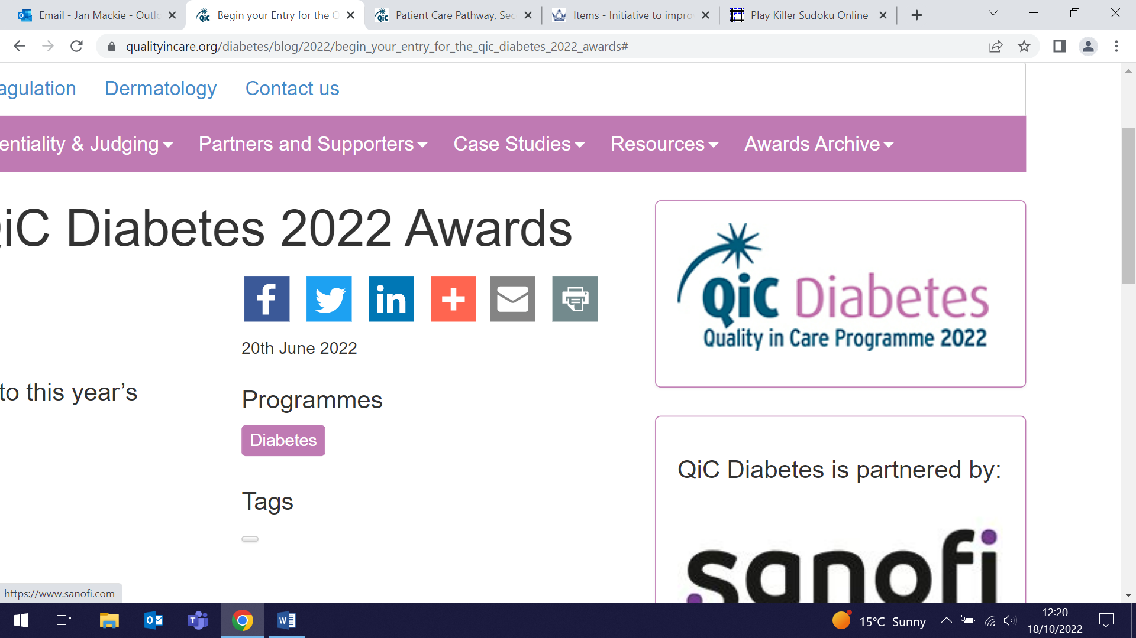 | An initiative by the WIPH CEG team to improve equal access to diabetes treatment in GP practices across NE London has won the Quality in Care Diabetes Award. The initiative was implemented in 150 practices which ran patient record searches to identify those with type 1 diabetes who may need additional support, including patients at high risk of complications or who had missed several appointments. Practice teams then used this insight to reach out to high-risk patients and offer a personalised approach to overcome potential barriers to accessing diabetes care. The region has since seen an 11% increase in the numbers of patients re-engaging with diabetes specialists at local hospitals and community care centres. The judges said: "This entry was the overwhelming favourite for the patient care pathway category. We were impressed with the patient-centricity, alongside the data-driven and evidence-based approach employed by creators of this entry. It used multiple initiatives with an excellent steer on quality improvement which continued during the COVID-19 pandemic.”

Covid risk factors among physicians in LMIC settings
14 October (Giuliano Russo. Centre for Public Health and Policy)

A cross-sectional survey comparing one developed (São Paulo) with one disadvantaged state (Maranhão) in Brazil has found that among 1183 doctors, COVID infections were higher where physician to population ratios were lower, even after controlling for general infection rates in different states. The study explored the association between physicians’ infection rates and their sociodemographic and employment characteristics and found that the infection rate in doctors in Maranhão was almost twice that in São Paulo. Authors suggest that in settings where health workers are scarce, physicians may take on multiple roles in different parts of the health system, thereby increasing infection opportunities. If confirmed, this finding would have substantial implications for the WHO global estimates of COVID infections and deaths, which would be higher than previously thought in poorer countries with fewer health workers per capita. The finding would have repercussions for the next global strategy for human resources for health, and support the case for additional investment to increase health worker to population ratios. | 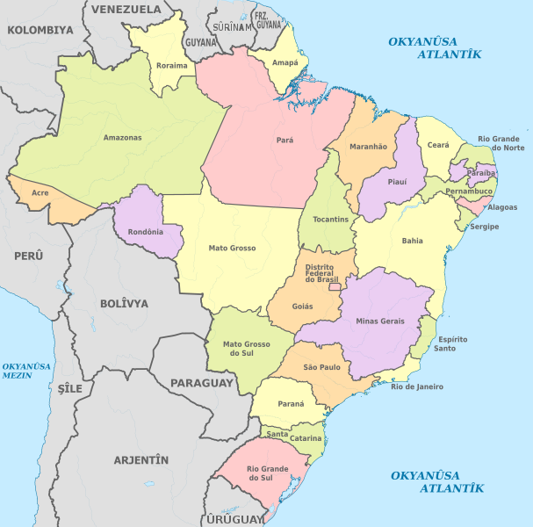
Preventing sexual harassment in the workplace to prevent depression
14 October (Vicky Bird. Centre for Psychiatry and Mental Health)

 | Sexual harassment in the workplace (SHWP) is highly prevalent and has a negative impact, including depression, on its victims. A new study incorporating two systematic reviews has found that there is no available evidence about the potential impact of interventions intended to prevent SHWP in relation to the prevention of depression. The first review focused on the association between depression and SHWP, and the second on policies and interventions to prevent such harassment. Researchers found a depression prevalence of 26%, and a 2.69 increased risk of depression among workers who experienced SHWP. Policies and interventions to address SHWP mostly focused on improvements in workers’ knowledge and attitudes about SHWP, but there was limited evidence regarding the effectiveness of these to prevent SHWP.
HEAL Study team attend National Trauma Care Conference
16-20 October (Heather McMullen. Centre for Public Health and Policy)

Members of the Bart’s Charity-funded HEAL study (Health Engagement to Avoid interpersonal violence injury in young Londoners) attended the 25th annual national Trauma Care Conference from 16-20 October in Staffordshire. HEAL explores public health response to violence affecting young people in East London through primary research sites in schools and youth centres, with the aim of building the picture of knife injury and serious youth violence in this area. On behalf of the team, HEAL PI Heather McMullen, presented as a panel member in the session entitled: The Future of Trauma Research, convened by Karim Brohi (QMUL Professor of Trauma Sciences). Heather shared some preliminary findings and future research directions on violence prevention. | 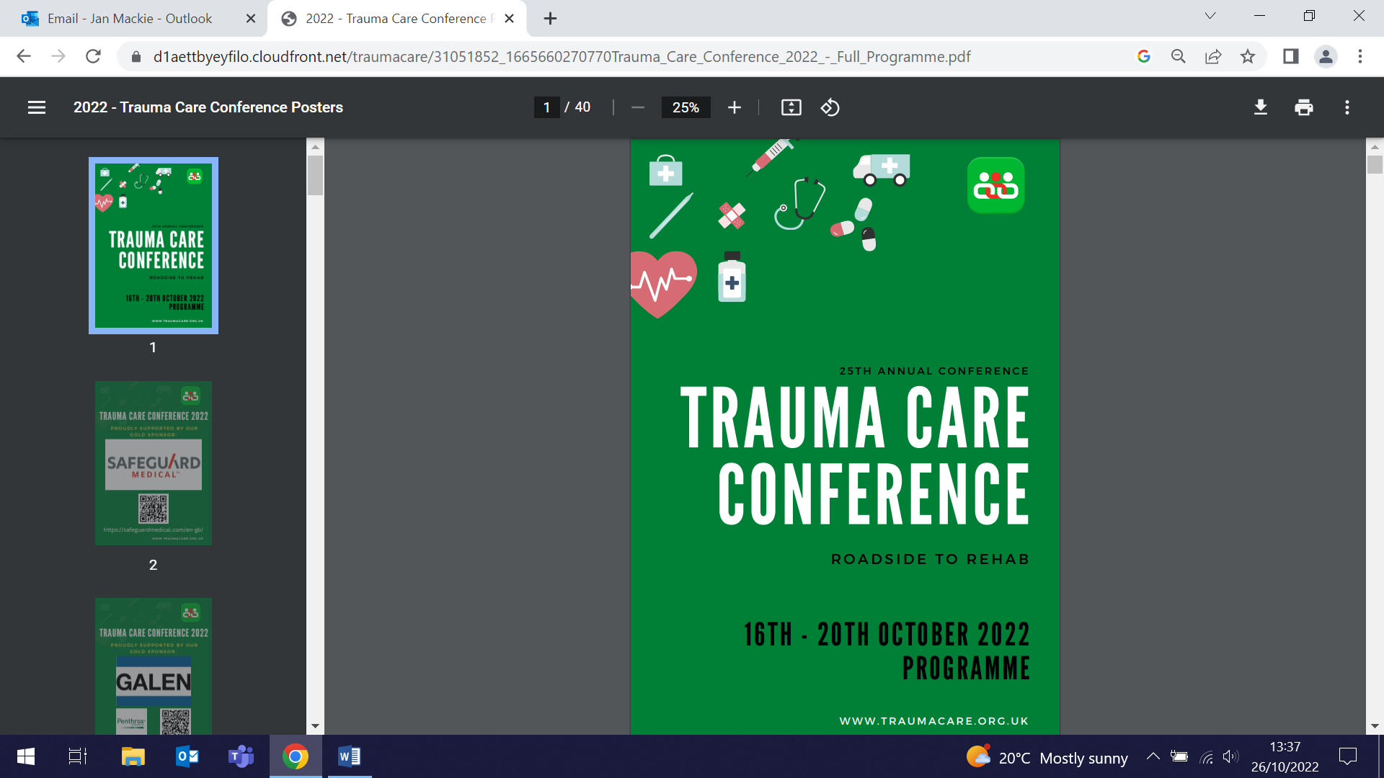

Relationship between depression and inflammation in chronic and end-stage kidney disease
18 October (Simone Jayakumar, Stacey Jennings, Christophe Clesse, Kam Bhui. Centre for Psychiatry and Mental Health)

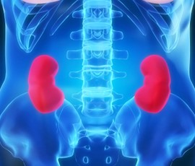 | An association between depression in patients with chronic kidney disease (CKD) and end-stage kidney failure (ESKF) and levels of pro- and anti-inflammatory cytokine has been identified in a review of 60 studies, including 9481 patients. Meta-analysis of cross-sectional associations revealed that patients with depressive symptoms had significantly higher levels of C-reactive protein, Interleukin 6 (IL-6), and tumour necrosis factor-alpha, and significantly lower levels of anti-inflammatory cytokine IL-10 than unaffected patients. Depression affects around 27% of patients in this population, and is associated with impaired quality of life and increased mortality. Authors suggest that clinical trials should investigate whether anti-inflammatory therapies could be effective in the prevention and treatment of depressive symptoms in these patients.
Early Detection of Cancer Conference 2022
18-20 October (Panos Alexandris, Emma Atakpa, Oleg Blyuss, Celeste Damiani, Joy Li. Centres for Prevention, Detection and Diagnosis/Evaluation and Methods)

A team of eight WIPH researchers attended this year’s Early Detection of Cancer Conference in Portland, Oregon, with five presenting posters. Poster topics included Lung cancer (Panos), Breast cancer (Emma and Celeste), Ovarian cancer (Oleg), and Bowel cancer (Joy). Also in attendance were Stephanie Bonfield, Belinda Nedjai, and Dharmishta Parmar. The 2023 conference, to be co-chaired by WIPH Director Fiona Walter, will be hosted by CRUK in Central Hall, Westminster, from 10-12 October. |   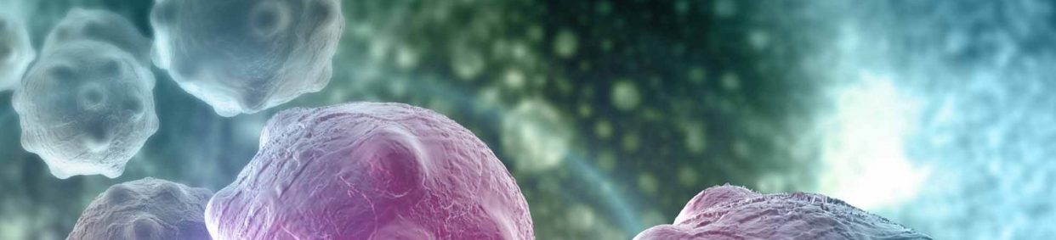
CEG Cancer Toolkit for GPs launched across North East London
20 October (John Robson, Karishma Bhuruth, Jo Tissier, Keith Prescott, Zaheer Ahmed, Isabel Dostal, Chris Carvalho, Anna Billington and CEG team. Centre for Primary Care)

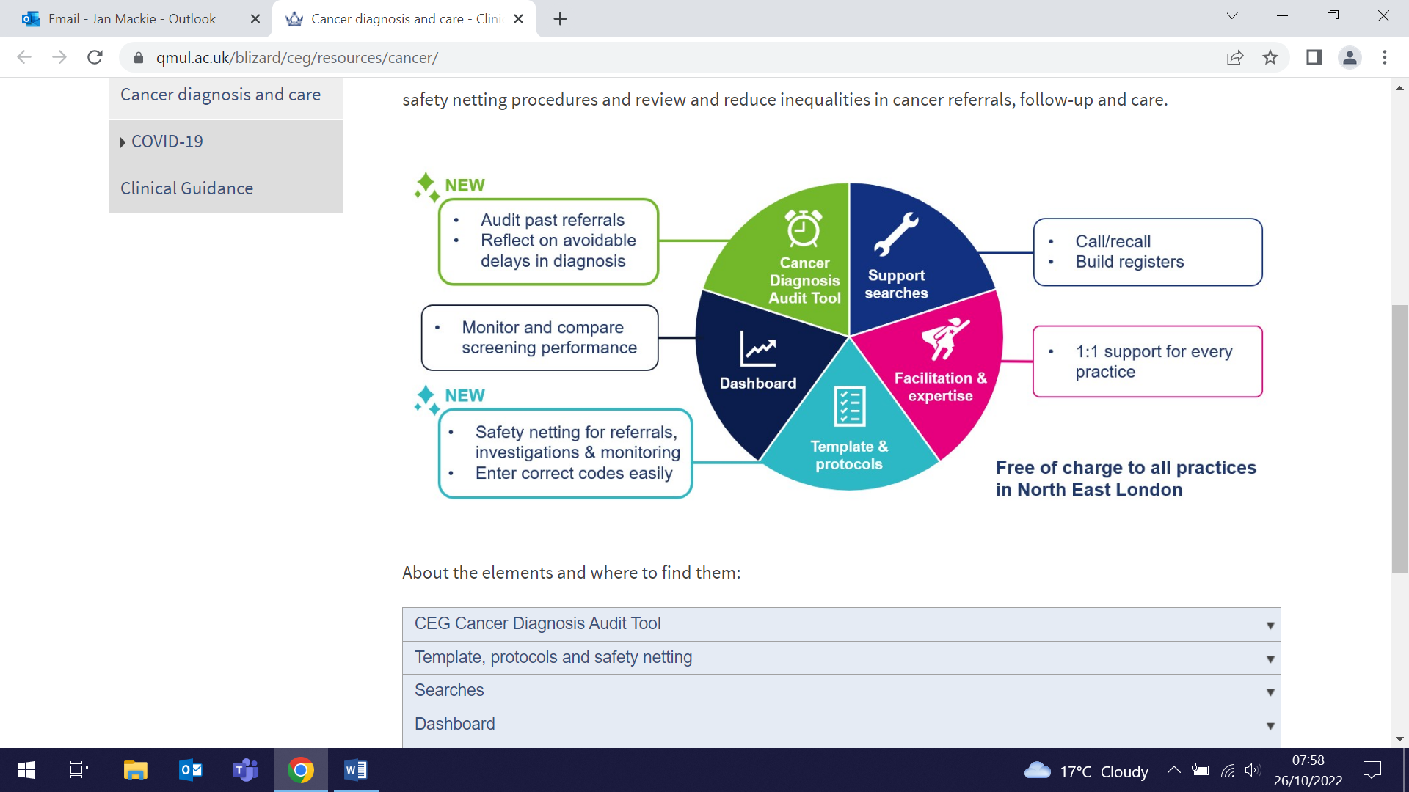 | A CEG-produced Cancer Toolkit comprising clinical templates, patient record searches, a data dashboard, and a new Cancer Diagnosis Audit Tool to enable critical reflection on any delays in recent cancer diagnoses, has been launched for practices across NE London. The toolkit was developed in collaboration with NHS cancer leads in each NE London locality, to ensure that the elements support both national and local service requirements. The launch included a practice-focused webinar by Chris Carvalho, attended by about 100 people from practices across NE London.
£7 Million NIHR award for new Global Health Research Centre
26 October (Vicky Bird, Stefan Priebe, Richard Hooper, Steph Taylor, Chris Griffiths, Yan Feng. Centres for Psychiatry and Mental Health/Evaluation and Methods/Primary Care)

Vicky Bird has been awarded a £7 million NIHR grant to co-direct a new Global Health Research Centre with partners across Latin America. The Centre will work with communities to develop innovative, low-cost solutions to improve healthcare for non-communicable diseases, with a key focus on indigenous populations. Long-term non-communicable diseases are a leading cause of disability and poor quality of life in Latin America. The five year grant will enable QMUL researchers and partners in Colombia, Bolivia, and Guatemala to investigate the best ways to manage long-term conditions, developing community-based interventions to change factors and behaviours linked to the development of long-term non-communicable diseases. The Centre will develop the skills of local researchers and clinicians, and will host a PhD and master’s programme to provide formal training for students in all three countries. | 
ECTRIMS Conference 2022
26-28 October (Ruth Dobson, Katila George, Ben Jacobs, Heather Mah, Fran Rios, Luisa Schalk, Alison Thomson, Nikki Vickaryous, Victoria Whitford. Centre for Prevention, Detection and Diagnosis)

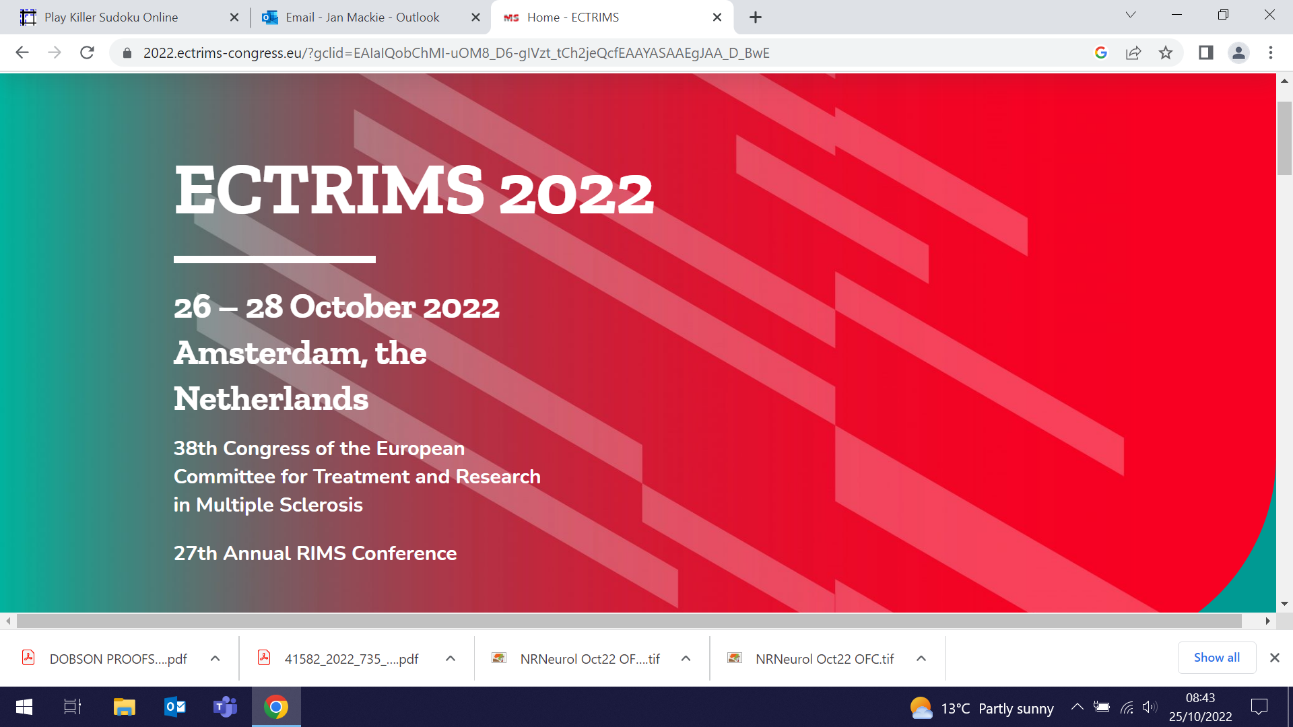 | The PNU Multiple Sclerosis research group, led by Ruth Dobson, decamped in late October to Amsterdam, to attend ECTRIMS, the world’s largest MS research meeting. Heather Mah and Alison Thomson presented work on the benefits of patient and public engagement, and Alison also delivered the results from the Under and Over study. Nikki Vickaryous, Fran Rios, and Luisa Schalk presented findings from their study of COVID vaccination. Ruth Dobson and Katila George covered results from several studies, including OPTIMISE-MS and the UK MS Pregnancy Register, and Victoria Whitford presented on cognition in MS, which was shortlisted for best poster. Thanks to Ben Jacobs (who also submitted a Late Abstract: The transcriptomic and clonal landscape of MS: a single-cell RNA sequencing study) for being our roving reporter on site!
FORTHCOMING EVENTS

Current Developments in Cluster Randomised Trials and Stepped Wedge Designs (14-15 November)

Booking is now open for the 8th annual meeting hosted by the Pragmatic Clinical Trials Unit (PCTU). The hybrid meeting be held on 14-15 November at the Whitechapel Gallery and on Zoom, and will include presentations, rapid fire talks, and discussions about recent developments in the design, conduct, analysis, and reporting of cluster and stepped wedge trials. This meeting will be of interest to statisticians, trial managers, clinicians, and others interested in running or supporting clinical trials, and will provide an opportunity to learn about latest methodological developments, and to network with other professionals in the field. View the programme, book now, or contact us for further information. | 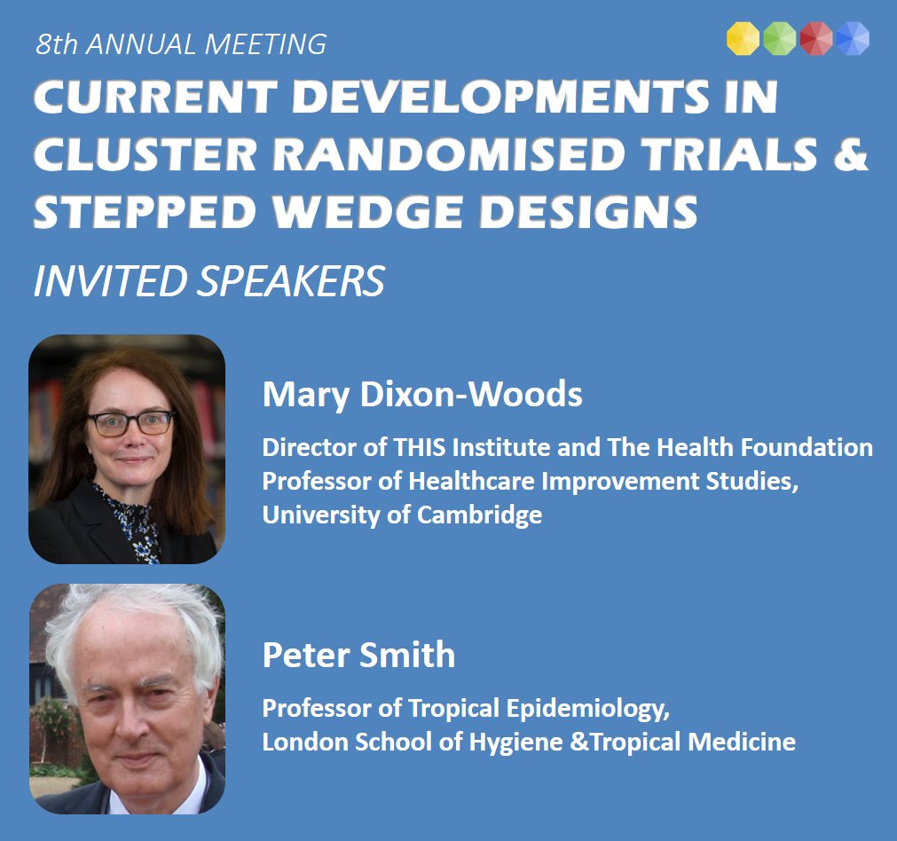
CanTest Collaborative: Primary Care Cancer Detection Summit
14-15 November
The CRUK-funded CanTest Collaborative, co-directed by Fiona Walter, is in its fifth and final year. To celebrate our capacity-building and research achievements, we are holding a Primary Care Cancer Detection Summit at the Wellcome Collection in London on 14 and 15 November. Experts from a range of disciplines will present on the latest research, clinical, and policy changes, and a Networking Reception will follow the main event on both days.  Monday 14 November: Where are we now? Showcasing current knowledge on cancer detection in primary care and wider. Speakers will include Michelle Mitchell (CEO Cancer Research UK) and Professor Sir Mike Richards (Diagnostics Clinical Advisory Group NHS England and Chair of the UK National Screening Committee).  Tuesday 15 November: Vision for the future: exploring opportunities for improving cancer detection and diagnosis. Speakers will include Professor Larry Kessler (Deputy Chair of the MCED Consortium) and Professor Peter Johnson CBE (National Clinical Director for NHSE Cancer programme).  Please register to join us for one or both days for what promises to be a state-of-the-art event, supported by CRUK. Click here to request further details. | 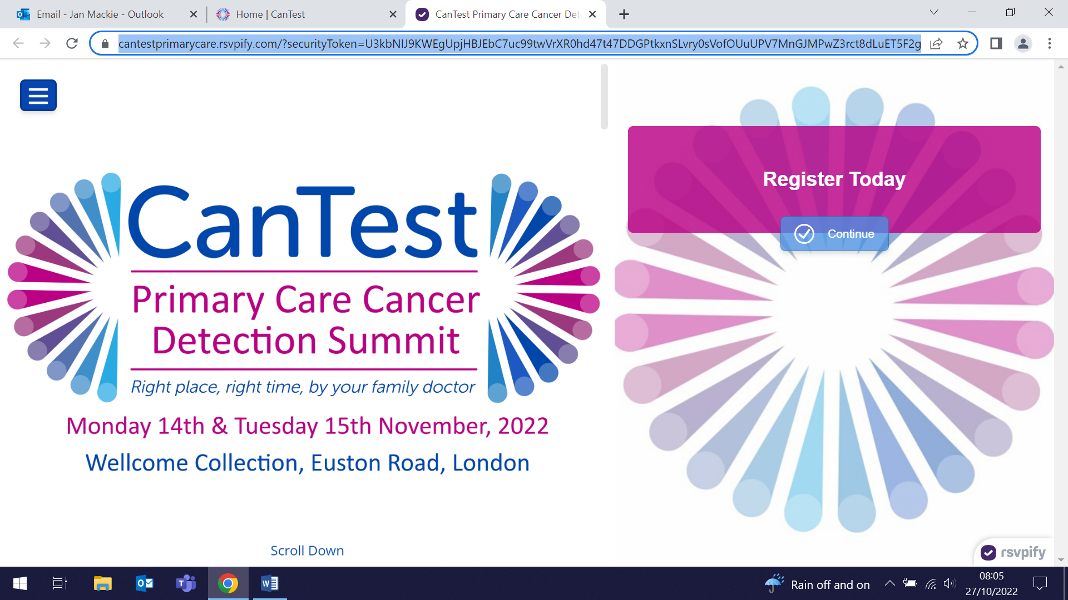  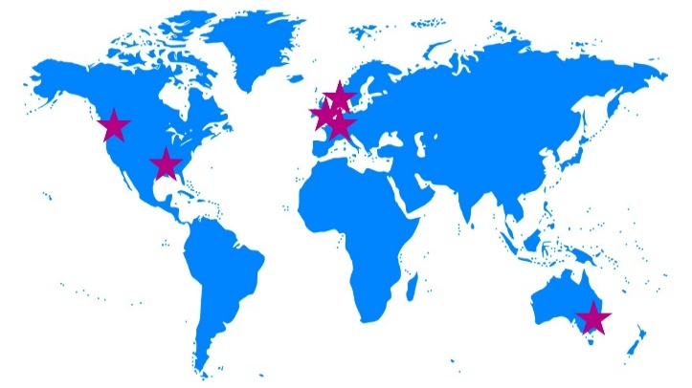
Many thanks to all who so enthusiastically contribute. Please send any news items for the next newsletter to j.a.mackie@qmul.ac.uk

