WOLFSON INSTITUTE OF POPULATION HEALTH
NEWSLETTER
ISSUE 25: 30 NOVEMBER 2022

In this issue of our Wolfson Institute of Population Health Newsletter, we celebrate the achievements and work of staff and students throughout November.

FROM OUR DIRECTOR
Dear Colleagues

The weather is turning colder and it feels very much like winter now - I hope that everyone is managing to stay warm. I’m delighted to say that we have a bumper edition WIPH Newsletter today, reflecting the fantastic work that everyone is doing. We also have some recent good news from the University-wide Research Highways project, showcasing Queen Mary research that tackles major societal issues and is collaborative, inclusive, and impactful. Among the ten projects selected from FMD, five (see below) are led by WIPH members, so congratulations everyone!

East London Genes and Health (Dr Sarah Finer and Professor David van Heel)

Improving outcomes for people with psychosis in Pakistan and India – enhancing the Effectiveness of Community-based care (PIECEs) (Professor Victoria Bird, Professor Stefan Priebe, Renata Peppl, Sana Sajun)

African aWAreness of CANcer and Early Diagnosis (AWACAN-ED): NIHR Global Research Group on Advancing Early Diagnosis of Cancer in Southern Africa (Professor Fiona Walter and Professor Suzanne Scott)

UK NSC Recommendations for targeted lung cancer screening (Dr Samantha Quaife, Professor Stephen Duffy, Professor Rhian Gabe and Daniel Vulkan)

Smoking cessation service (Shamsia Begum-Foreman)  Finally, we are looking forward to our Christmas Party at The Shield, Dawson Hall on Thursday 15 December from 17:00. Everyone is very welcome. We know that train strikes are scheduled on the days before and after, so will give updates nearer the time when we know if the strike is going ahead.  Warm wishes to all  Fiona |  | 
FROM OUR LEADERSHIP TEAMS AND REPRESENTATIVES

EDUCATION NEWS (Mark Freestone, Director of Education)

We are delighted to report that, following a six-hour meeting with the British Psychological Society, our MSc in Forensic Psychology and Mental Health has been re-accredited for another three-year period, with only minor conditions. To illustrate how seriously the BPS takes these reviews, we found out on the morning of the visit that a competitor had been stripped of their accreditation at a recent visit. Huge credit to Hannah Jones, Jenny Hopton, Alan Underwood, and Georgina Mathlin for successfully representing the course in such a positive light.

RESEARCH NEWS (Tor Kemp, Research Manager)

Please see below for forthcoming funding opportunities, seminars, workshops and conferences.

Funding Opportunities

SPCR Seedcorn Bridging Award : deadline Friday 6 January 2023
Please find details of this current SPCR call, which provides small awards to support researchers to develop applications or to bridge individuals in ‘funding gaps’.

Update to Brazil Accelerator Fund II | deadline Sunday 15th January 2023
Following the webinar held 17 November, please see updated guidance on finding research collaborators and applying to the call.

Seminars, Workshops & Conferences

SAPC SE Regional Meeting applications for workshops extended | deadline Monday 5th December
The SAPC SE Organising Committee 2023 are still looking for submissions for workshops and have extended the deadline to 11am on Monday 5 December. Guidance on abstract formatting, submission, and themes are available on the website.

QMUL Entrepreneurs Club | Tuesday 6th December 2022
The Entrepreneurs club brings together budding and established entrepreneurs from across the university, to share their experiences and talk about their entrepreneur journey. Join to hear Dr Karin Hing, one of the founding members of the award-winning QMUL spin-off company ApaTechTM.

BBSRC Innovation to Commercialisation of University Research Programme | deadline Monday 9th January
The ICURe programme is designed to help you understand whether there is a market for an invention or service, derived from your BBSCR or UKRI funded research.

In-person event: Blizard Institute Research Seminar Prof Graeme Meilligan | Thursday 19th January 2023, 12 -1pm
Prof. Graeme Milligan, Professor of Molecular Pharmacology at the School of Molecular Biosciences, University of Glasgow, will present “Can we drug receptors for microbially-produced and other metabolic hormones?".

Registration Open: NIHR PPI Training Sessions for Researchers in 2023 | Sessions held throughout Jan 2023
PPI Training Sessions for Researchers in 2023. These sessions will be held via Zoom. They are free for NIHR, NHS, academic or charity-funded researchers, students or staff in the UK. Please use work-related email to register

Call for oral abstracts and posters: Clinical Academic Research Day | deadline Tuesday 31st January
Please help support FMD’s upcoming inaugural Clinical Academic Research Day on 2 March 2023 by encouraging any clinical academic trainees you may know and/or supervise to participate by submitting abstracts for posters and research talks.

GENERAL INSTITUTE NEWS

Monkeypox in Brazil
10 November (Giuliano Russo. Centre for Public Health and Policy)

With almost 10,000 cases of monkeypox, Brazil is the second most affected country worldwide. A viewpoint paper highlights five factors to be considered to pre-empt a public health and social crisis from monkeypox: stigma associated with the infection; misinformation surrounding it; health system shortcomings; technological dependence on foreign vaccines and treatments; and the governance crisis within which the response to the epidemic plays out. Authors note that these challenges are generalizable to many low- and middle-income countries, and that threats to vulnerable populations from pre-existing systemic weaknesses or political circumstances weaken national health response. Local level contingency and preparedness plans can make a difference when federal level oversight is paralysed, and in addition to adequately resourcing healthcare delivery functions, strengthening domestic pharmaceutical production capacity can improve the health response. The paper concludes that policies and interventions in epidemic responses should be based on equity, inclusion of the most vulnerable, and participation of affected communities as part of the solution, rather than the problem. | 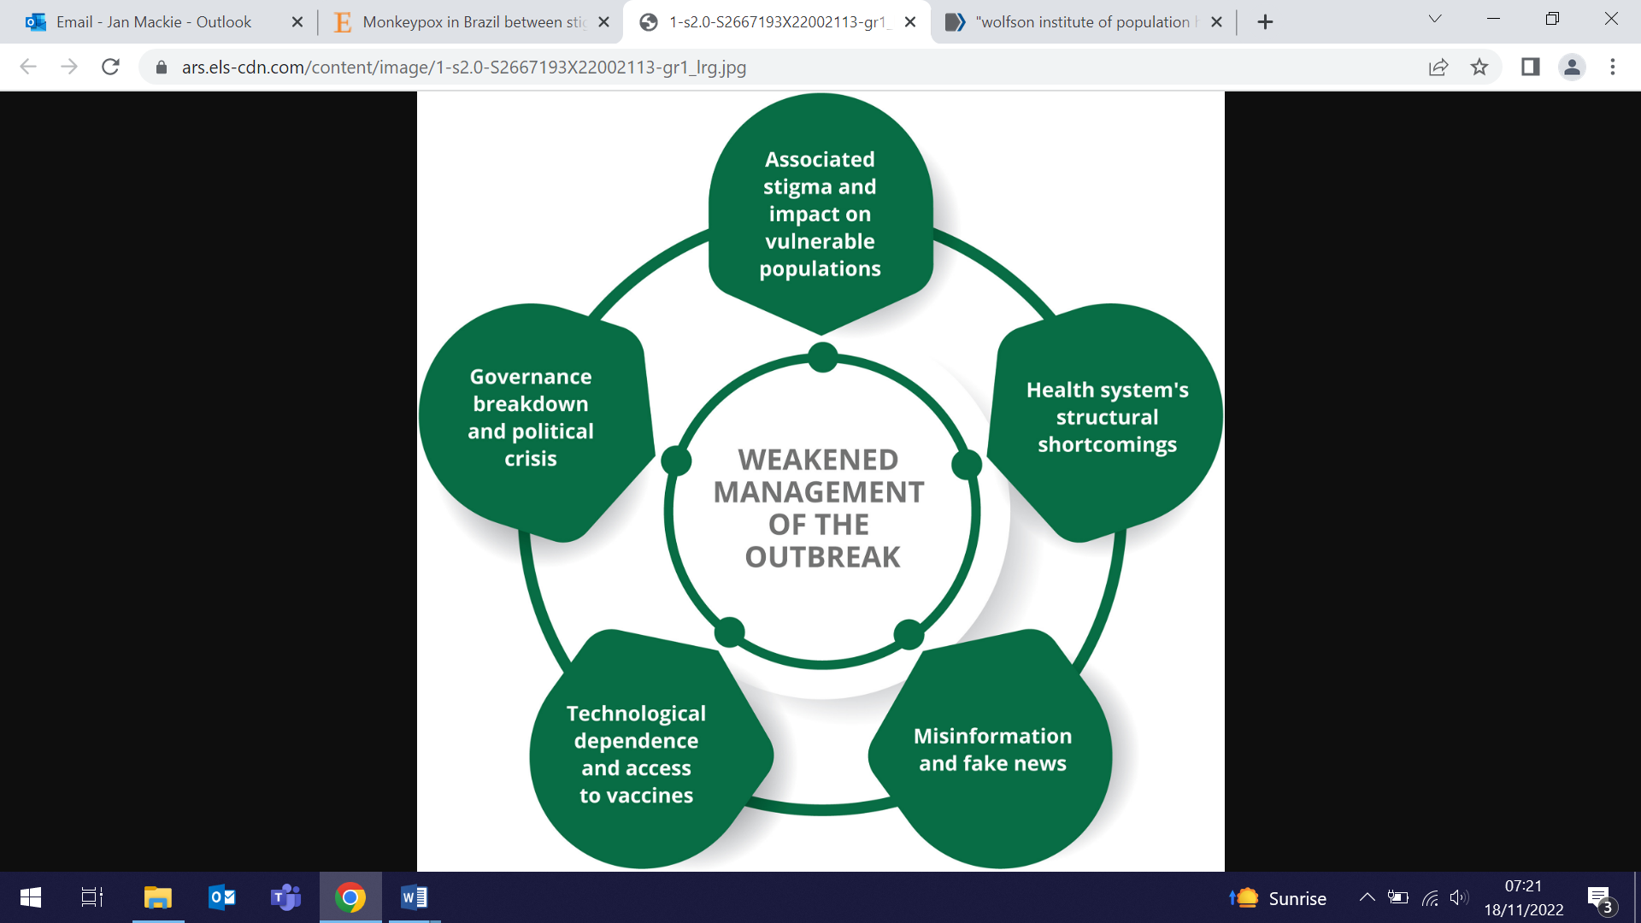
Bodily autonomy and climate justice
12 November (Heather McMullen. Centre for Public Health and Policy)

. | In a video interview recorded at an event on climate and health at COP27, Heather McMullen speaks about her work exploring the intersections between climate change, the environment, and sexual and reproductive health rights justice. She says there is no climate justice without bodily autonomy: “At the most fundamental level, if people don’t have control over their bodies….then they can’t react, adapt and respond to the climate crisis”.
Determinants of uptake and engagement in an obesity intervention
12 November (Alina Rodriguez. Centre for Psychiatry and Mental Health)

Using data from a large scale Polish screening programme, researchers have assessed uptake of and engagement with an obesity management intervention targeted at adolescents with BMI ≥90th percentile. Results showed that 34% of those with morbid obesity declined the initial invitation to participate in the behavioural intervention. Neither BMI nor readiness for change had an impact on uptake or engagement. Perceived family support, rather than initial motivation, facilitated engagement. Authors say that their results provide new insights on the importance of regional socio-geographical factors, including trust in local authorities. | 
24-hour sodium and potassium excretion in the Americas
15 November (Isabel Valero-Morales, MoniqueTan, Yu Pei, Feng He, Graham MacGregor. Centre for Public Health and Policy)

 | A meta-analysis of 74 studies from 14 countries in North/South/Central America and the Caribbean shows that sodium excretions are almost double the WHO maximum recommended level, and potassium excretions are 35% lower than the minimum requirement. The studies, published from 1990-2020, assessed excretion level using 24-hour urine samples, the most accurate method. Data revealed that over the past three decades, mean potassium intakes have been consistently low across the Americas. In contrast, mean sodium intakes have been high and slightly increasing. The analyses also revealed higher sodium and lower potassium intakes in lower-middle and upper-middle income countries of the Americas, and a lack of data in low-income countries.
Survival after cytoreductive surgery in advanced ovarian cancer
15 November (Oleg Blyuss, Ranjit Manchanda. Centre for Prevention, Detection and Diagnosis)

Researchers have published the protocol for the international multicentre study GO SOAR2, to examine survival in relation to cytoreductive surgery for women with advanced epithelial ovarian cancer. The standard of care for women with stage III-IV epithelial ovarian cancer is primary cytoreductive surgery (to remove all visible cancer) followed by chemotherapy, but neoadjuvant chemotherapy before and after interval cytoreductive surgery has become an alternative approach. The study will use abstracted data from 1000 patients undergoing interval (after 3-4 chemotherapy cycles) or delayed (≥5 cycles of chemotherapy) cytoreductive surgeries, or no cytoreductive surgery (≥5 cycles of chemotherapy alone), to determine comparative survival and whether there are international disparities in prevalent practice and access to cytoreductive surgery. Recruitment is expected to be completed by 2023, and results published by 2024. | 
Misleading Nutrition and Health Claims on Baby and Toddler Food and Drink
16 November (Action on Sugar group. Centre for Public Health and Policy)

 | Action on Sugar has called for the removal of misleading nutrition and health claims on baby and toddler food and drink products, urging the Health Minister to publish and mandate the now overdue Commercial baby food and drink guidelines. In a product analysis of nearly 100 baby and toddler breakfast items, researchers found worrying levels of sugar: Ella’s Kitchen Banana, Apple & Blueberry Baby Rice contained the equivalent of 4 teaspoons. All of the products analysed used nutrition or health claims on-pack, and 86% used a ‘no added sugar’ or ‘only naturally occurring sugars’ claim, despite many products containing added sugars in the form of fruit/vegetable juices, concentrates, purees and powders, misleading parents and carers into thinking that the product is healthier than it is. An Action on Sugar poll of over 1000 parents with young children revealed that 65% are concerned about sugar levels in ready-made/pre-packaged baby and toddler breakfast items, and 87% think it would be useful if added sugars were displayed on front of pack.
Response to monkeypox outbreak in at risk UK communities
16 November (Sara Paparini. Centre for Primary Care)

Results from a cross-sectional survey conducted in June-July ’22 using the Grindr dating app and social media channels show that 52% of the 1932 respondents considered themselves at risk from monkeypox. Despite 79% having completed higher education, 34% considered themselves to have limited understanding of public health information. The most trusted sources of information were healthcare professionals (37%), official health agencies (29%), and mainstream media (12%). 49% said they would attend a sexual health clinic if symptomatic, and 86% reported they would accept a vaccine. Authors conclude that social determinants of health inequalities already shaping the UK risk landscape were compounded in this new emergency, and that engagement with structurally disadvantaged members of affected communities and better dissemination of public health messaging by trusted healthcare professionals are essential for the public health response. | 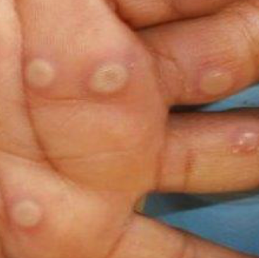
Cochrane Review: E-cigs more effective than traditional NRT to quit smoking
17 November (Peter Hajek, Hayden McRobbie. Centre for Public Health and Policy)

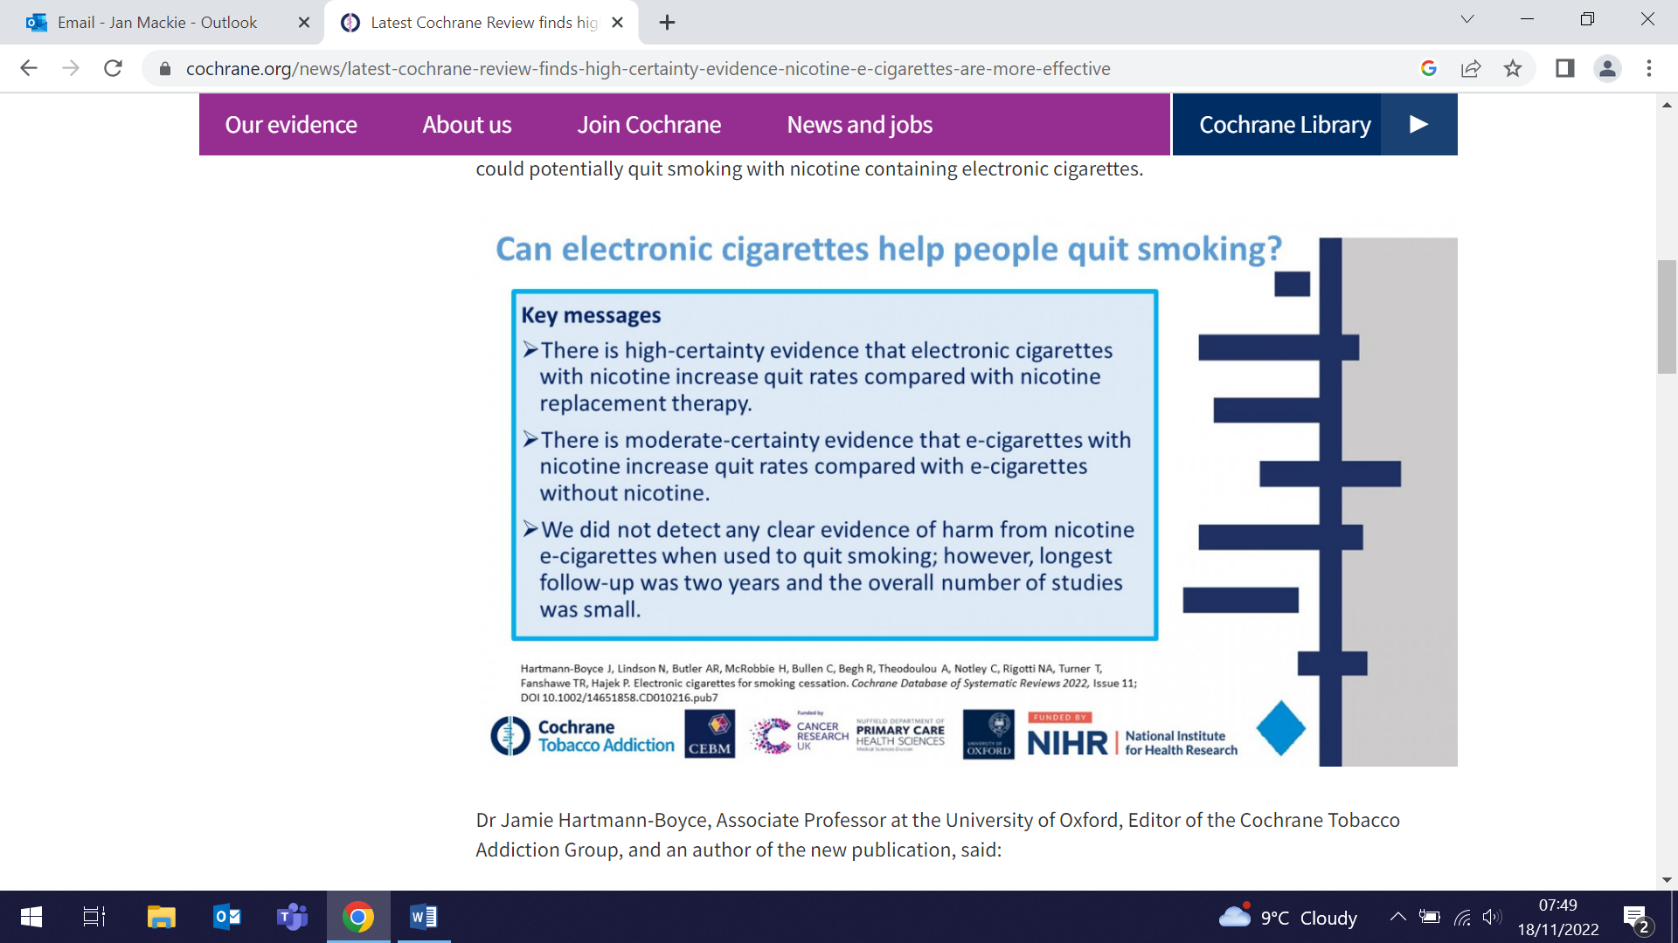 | The latest Cochrane Review has found “high certainty” evidence that nicotine e-cigarettes (or vapes) are more effective than traditional nicotine-replacement therapy (NRT) such as patches and chewing gums in helping people quit smoking.The CRUK-funded research shows that people are more likely to stop smoking for at least six months using e-cigarettes than NRT. Evidence also suggested that nicotine e-cigarettes led to higher quit rates than e-cigarettes without nicotine. The updated Cochrane review includes 78 studies in over 22,000 participants – an addition of 22 studies since the last update in 2021. Data from the review showed that if six in 100 people quit by using NRT, eight to twelve would quit by using e-cigarettes containing nicotine, meaning that an additional 2-6 people in 100 could potentially quit smoking with nicotine containing e-cigarettes.
Prevention of Hereditary and non-Hereditary Ovarian Cancer
17 November (Ranjit Manchanda. Centre for Prevention, Detection and Diagnosis)

Professor Ranjit Manchanda presented an invited talk on the prevention of hereditary and non-hereditary ovarian cancer at the International Research Meeting on Future Perspectives in Ovarian Cancer Research, organized by the Swedish Cancer Society. The conference was held at the Karolinska University Hospital in Stockholm on 16 and 17 November. |   
British Maternal & Fetal Medicine Society Annual Conference
18 November (Ioannis Karapanos, Elena Greco, Nikolina Jovanovic, Matina Iliodromiti. Centres for Public Health and Policy/Psychiatry and Mental Health)

 | Three posters authored by members of Women’s Health Research Unit were presented at the BMFMS Annual Conference in Birmingham on Friday 18 November. Ioannis Karapanos, MD(Res) postgraduate student under supervision of Drs Iliodromiti and Greco, presented “Delivering unexpected news in pregnancy: the perspectives of fetal medicine healthcare professionals”. Two further posters, led by Matina Iliodromiti, “A mixed method exploration of the impact of COVID-19 on ethnic inequalities in maternal and neonatal outcomes” and “The impact of the COVID-19 pandemic on inequalities on adverse maternity outcomes: Trends in England”, were presented on behalf of the unit by Jennifer Jardine, who previously completed her Academic Clinical Fellowship with the WHRU.
Relationship between the climate and environmental crises and child marriage
20 November (Heather McMullen. Centre for Public Health and Policy)

Results from a UNFPA-funded scoping review reveal evidence that environmental crises worsen known drivers of child marriage, pushing families to marry their daughters early through loss of assets and opportunities for income generation, displacement of people from their homes, educational disruption, and the creation of settings in which sexual violence and the fear of sexual violence increase. Researchers identified 24 relevant articles from both academic and grey literature. The results also showed that local socio-cultural contexts such as bride price or dowry practices further shape how these factors affect child marriage. The authors conclude that environmental crises such as climate change threaten the realisation of sexual and reproductive health and rights, and that, as many of the areas with the highest current rates of child marriage face the gravest environmental threats, action to tackle child marriage must take account of the link identified in this review. | 
Is Aspirin a wonder pill?
21 November (Jack Cuzick. Centre for Prevention, Detection and Diagnosis)

 | Jack Cuzick is extensively quoted in an article in the Daily Mail on whether aspirin should be used as preventive therapy for cancer: For the general population, daily aspirin’s general cancer-prevention benefits hugely outweigh the risks. There is no doubt that bleeding is a real issue, but even with that, the reduction in cancer risk outweighs it. The reason conventional research doesn’t show a cancer-prevention benefit, he argues, is that you have to wait more than five years before you find benefit. If you do less then you just don’t see it. Nothing positive happens in the first three years, only after five. Conventional research timespans tend to be too short to accommodate this, he says. It’s really important to get this right because it’s been messed around with people overhyping negative results. Professor Cuzick says he has been taking low-dose aspirin daily for the past 4-5 years. If you want to reduce your cancer risk, I recommend you keep your weight down, don’t smoke and take aspirin, he says. Our research findings suggest that you should take it between the ages of 50 and 65 for at least 5 years.
COP27 Blog
21 November (Chris Griffiths. Centre for Primary Care)

Writing from COP27 on the last day of the conference, Chis Griffiths reflects on three lessons learned. First, it is easy to criticise COP27 as an indulgence with a large carbon footprint, but the climate crisis won’t be solved by people working in silos, scattered across the globe. He argues that its problems need creativity mixed with an intersectional, multidisciplinary approach, co-created with people from all ages and countries. Second, the conference has brought home the fact that climate justice underpins everything. And third, he maintains that at COP27 participants see, feel, and hear the weight of passionate opinion. Chris says that he has been privileged to represent QMUL. | 
Freedom of Choice to Vaccinate: COVID-19 Vaccine Hesitancy in Italy
21 November (Veronica Toffolutti. Centre for Evaluation and Methods)

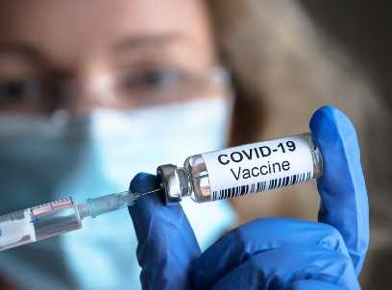 | In many countries, including Italy, strict vaccination policies and mandates to increase the uptake of COVID-19 vaccination have sparked debate on the freedom to choose whether or not to be vaccinated. Data from a May 2021 online survey of 984 unvaccinated individuals in Italy were analysed to examine people's belief in vaccine choice as a predictor of willingness to be vaccinated. Results showed that respondents who agreed that people should be free to decide whether to vaccinate without restrictions on their personal life had 85% lower odds of vaccine acceptance. Researchers hope that their results can inform the development of public health outreach, educational programs, and messaging.
Clinical management guidelines for germline pathogenic variant carriers
21 November (Ranjit Manchanda. Centre for Prevention, Detection and Diagnosis

Lack of guidelines for clinical management of the moderate ovarian cancer risk in patients with germline pathogenic variants (GPVs) in cancer predisposition genes BRIP1, PALB2 and RAD51D&C have led to questions about appropriateness and timing of risk-reducing gynaecological surgery. Appropriate management has also been unclear for the risk of a breast cancer association for RAD51C&D. A meeting convened by the UK Cancer Genetics Group and CanGene-CanVar project has produced national clinical management guidelines for patients with GPVs in BRIP1, PALB2 and RAD51D&C, recommending that these GPV carriers should receive detailed discussion about family history and individualised risk assessment, and be offered appropriate risk reducing gynaecological surgery. RAD51C&D and PALB2 carriers should also have an individualised risk assessment for breast cancer, and participate in appropriate breast screening. | 
Rebound in asthma exacerbations after COVID-19 restrictions relaxed
23 November (Hayley Holt, Mohammad Talaei, David Jolliffe, Chris Griffiths, Seif Shaheen, Adrian Martineau. Centres for Public Health and Policy/Primary Care/Prevention, Detection and Diagnosis)

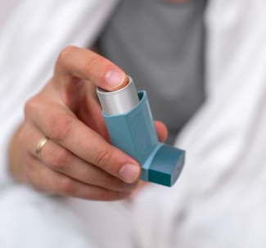 | Restrictions on social mixing early in the COVID-19 pandemic were linked to an international reduction in asthma exacerbations, but trends following relaxation of rules have not been described to date. A population-based study of 2312 UK adults with asthma from November 2020 - April 2022 collected data on face covering use, social mixing, incident acute respiratory infections, and severe asthma exacerbations. Results show that restriction relaxation led to reduced face covering use and increased social indoor mixing, and simultaneously to rising incidence of acute respiratory infections and severe asthma exacerbations. Incident non-COVID acute respiratory infections associated independently with increased risk of asthma exacerbation, both prior to and after emergence of the omicron variant.
How targeted lung screening can help the NHS save lives
23 November (Sammy Quaife. Centre for Prevention, Detection and Diagnosis)

In an opinion piece for the CRUK, Sammy Quaife reflects on the UK National Screening Committee decision to recommend a targeted lung screening programme, which she describes as the step-change in care that the NHS needs to catch lung cancer early, and something that so many of us in the lung cancer research community have been working towards for years. She notes that the return on lung screening investment could be massive. Lung cancer is the third most common cancer in the UK, causing 34,800 deaths every year, and there is huge potential not just for saving lives, but also for using money more cost-effectively, because it is much easier to treat lung cancer diagnosed early. Importantly, ≈30,000 extra cancer cases each year in the UK are due to deprivation, with lung cancer the biggest contributor to these excess cases. “It’s only right that we find ways to detect this disease as early as we can to save lives, and we must do so in a way that benefits everyone equally.” | 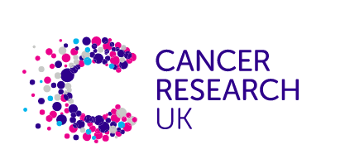  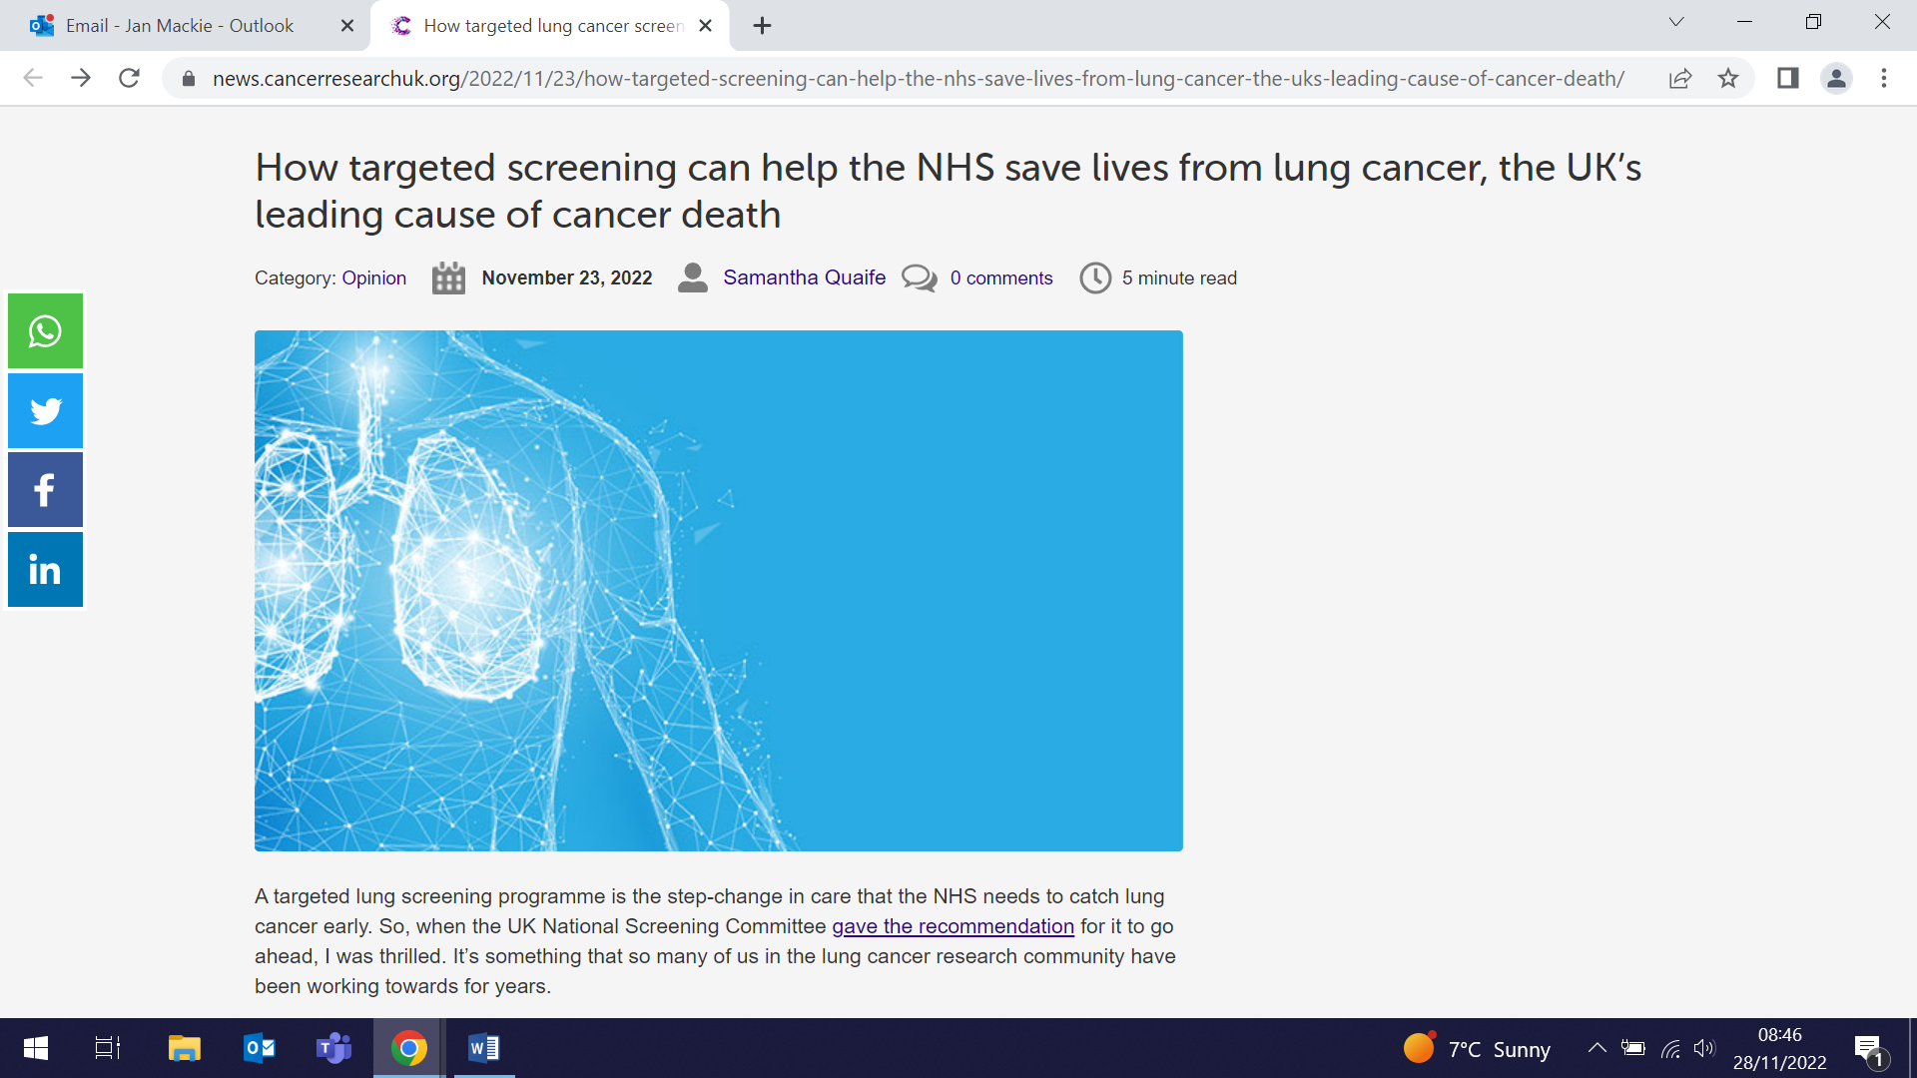
How timely is lung cancer diagnosis?
23 November (Fiona Walter. Centre for Prevention, Detection and Diagnosis)

 | Lung cancer survival is better if diagnosis is at an earlier stage, but diagnosis is challenging due to non-specific clinical presentation. A new study examined medical records of 711 primary lung cancer cases from ambulatory care clinics in Seattle (USA) to determine the pre-diagnostic time intervals and symptoms/signs recorded over the 2 years prior to diagnosis. Time points were defined for initial symptomatic presentation, chest imaging, specialist consultation, diagnostic confirmation, and treatment initiation. Natural Language Processing (NLP) was applied to identify symptoms/signs from free text clinical fields. Time from first recorded signs associated with lung cancer to diagnosis was 570 days. Interval from chest CT/xray imaging to diagnosis was 43 days, and from specialist consultation to diagnosis, 72 days. Disease was stage III or IV in 54.1% of diagnoses. Most cases (94.5%) were diagnosed after clinical presentation rather than screening. Authors conclude that by using advanced techniques such as NLP, signs associated with lung cancer can be identified more than a year prior to diagnosis.
Webinar series: Design and conduct of pilot and feasibility trials
23 November (Sandra Eldridge, Claire Chan, Saskia Eddy. Centre for Evaluation and Methods)

Sandra Eldridge, Claire Chan and Saskia Eddy from the Pilot and Feasibility Studies (PAFS) collaboration have co-created a YouTube Webinar Series about the design and conduct of pilot and feasibility studies. The series was produced with international collaborators Lehana Thabane, Mike Campbell, Christine Bond, Sally Hopewell and Gillian Lancaster from McMaster University, Canada, University of Sheffield, University of Aberdeen, University of Oxford and Keele University respectively. The PAFS collaboration are authors of the seminal CONSORT extension and PAFS framework papers. The webinar series will be of interest to trialists, trial methodologists, statisticians, as well as those who are new to PAFS. | 
Generalisability of pilot studies using area-level statistics
24 November (Adam Brentnall. Centre for Evaluation and Methods)

 | Implementing new technologies in national health care systems is sometimes informed by pilot studies applying the technology on a small scale in selected areas. Using the English HPV cervical screening pilot as a test case to determine how generalisable pilot results might be, researchers have compared pilot with non-pilot areas, and pilot regimens (in this case cytology v HPV screening). Seven area-level indicators associated with cervical cancer incidence were selected to produce a framework for pilot generalisability analysis. Results suggest that national statistical sources can help to establish the degree to which the types of areas outside pilot studies are represented, and the extent to which they match selected characteristics of the rest of the health care system. The authors conclude that this analysis lends support to extrapolation of process indicators from the HPV screening pilot across England.
The Value of Process Evaluations
25 November (Caroline French, Nina Fudge Steph Taylor. Centre for Primary care)

Process evaluations aim to understand how complex interventions bring about outcomes by examining intervention mechanisms, implementation, and context, but little attention has been paid to their value. Through a literature review, authors have determined three ways in which process evaluations may create value or negative consequences: through the socio-technical processes of 'doing' the process evaluation, through the features/qualities of process evaluation knowledge, and through using process evaluation knowledge. They note that stakeholders in different contexts may have different expectations of process evaluations and their value, and propose a planning framework to support an open and transparent process to plan and create value from process evaluations and negotiate trade-offs. This will support the development of joint solutions and, ultimately, generate more value from process evaluations to all. | 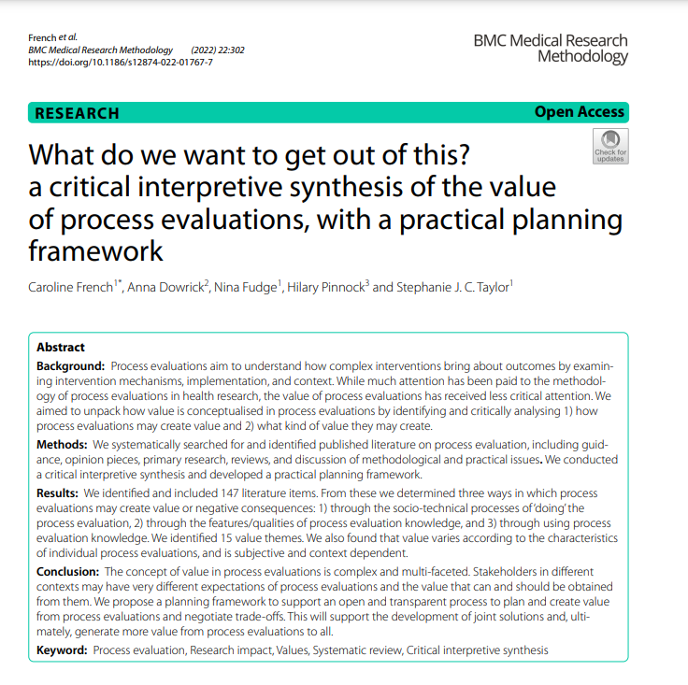
Alcohol and Parkinson's Disease
25 November (Harneek Chohan, Jon Bestwick, Alastair Noyce. Centre for Prevention, Detection and Diagnosis)

 | A systematic review and meta-analysis of observational studies examining the relationship between alcohol consumption and risk of Parkinson’s disease (PD) has compared risk in ever v never alcohol drinkers. From analysis of 52 studies including 63707 PD patients and >9.8 million controls, researchers found a statistically significant overrepresentation of never drinkers among PD subjects (OR for ever drinking alcohol 0.84), with similar effect estimates in males and females. A further synthesis of seven cohort studies suggested a negative, dose-dependent association between alcohol and risk of PD. Researchers caution that in the absence of a known neuroprotective pathway, there may be reason to doubt a true biological effect, and that the roles of survivor bias, selection and recall bias, misclassification, and residual confounding require consideration. Alternatively, observations might be attributable to reverse causation if those predestined for PD alter their alcohol habits during the preclinical phase.

Quality of life after hysterectomy for endometrial cancer prevention
26 November (Samuel Oxley, Xia Wei, Ashwin Kalra, Michail Sidaris, Ranjit Manchanda. Centre for Prevention, Detection and Diagnosis)

A systematic review of research on quality of life after hysterectomy to prevent endometrial cancer has found only four relevant papers. These showed that, after surgery, women had reduced worry about cancer, and were generally satisfied. Removal of both ovaries had a severe impact, resulting in menopause-symptoms, particularly for women not taking HRT. The authors also searched for studies reporting quality of life after hysterectomy to treat heavy or abnormal periods, and found 25 papers. These generally reported women to be satisfied after surgery, with improved quality of life, and that they were very unlikely to have worse sexual function or urinary problems. The review demonstrates that more research is needed to provide evidence on quality of life after this surgery to prevent endometrial cancer. | 
Multiple Sclerosis in Pregnancy
28 November (Ruth Dobson. Centre for Prevention, Detection and Diagnosis)

 | Women with multiple sclerosis (MS) and their clinicians face complex shared decisions around the use of disease-modifying therapy in pregnancy and postpartum, and knowledge and communication gaps may need to be addressed to improve outcomes for women with MS planning pregnancy. Existing pregnancy studies are subject to limitations including selection bias and missing data, but when these are combined with clinical expertise, consensus guidelines can be developed and used as a framework to support this complex decision-making process. A new commentary paper provides a practical evidence-based overview of the safety of disease-modifying therapies and symptomatic drug therapies during pregnancy and breastfeeding, and highlights where insufficient data exist to guide practice.
Uptake of UK primary care interpreting services by a South Asian population
29 November (Georgia Black. Centre for Prevention, Detection and Diagnosis)

Addressing language barriers in accessing healthcare is one avenue to improve equitable healthcare, in line with current UN Sustainable Development Goals. A paper based on a December 2020 survey examines uptake and experience of interpreting services in primary care among adults with limited/no English from Pakistani, Indian, or Bangladeshi ethnic backgrounds in communities across England including London, Birmingham, Leicester, Manchester/Oldham, and Bradford. Telephone survey interviews were conducted by multilingual researchers. The majority of respondents had used at least one type of formal interpreting service, with face-to-face interpreting being most common, but nearly half relied on family/friends. Co-author Dr Georgia Black said: "Being able to understand a doctor is such a fundamental part of high quality care, and yet very little has been known about how language barriers are overcome in the NHS. In the next phase of our research we will look at how interpreting services are delivered in different parts of the country, including our local population in East London.” | 
Many thanks to all who so enthusiastically contribute. Please send any news items for the next newsletter to j.a.mackie@qmul.ac.uk

