WOLFSON INSTITUTE OF POPULATION HEALTH
NEWSLETTER
ISSUE 28: 31 JANUARY 2023

In this issue of our Wolfson Institute of Population Health Newsletter, we celebrate the achievements and work of staff and students throughout January.

FROM OUR DIRECTOR
Dear Colleagues

As January slips away from us, I hope you are all well and back into the routine of work. While it has been great to see so many of you on site over the last few weeks, I need to encourage everyone to return to their offices for three days a week. Please discuss with your line managers if you have any problems with this.

In today’s newsletter we once again showcase the enormous diversity of work going on in WIPH. Particularly striking is the amount of media work our people have been doing throughout January: Charlie Marshall on Dementia Prevention (BBC), Graham MacGregor on blood pressure reduction (i-news), Kawther Hashem on the success of the soft drinks levy (Newsnight), and Alastair Noyce on nitrous oxide abuse (ITV evening news).
Press coverage of our work is not only a fantastic way to promote our teams and WIPH research focus, but also hugely significant for impact, especially as we start work on preparing impact case studies for the next REF exercise. Well done to all!  Warm wishes to all  Fiona | 
MEET WIPH

Meet: Trevor Sheldon (Interim WIPH Deputy Director)

How would you describe your roles and responsibilities?
The role is new and evolving but, so far, it consists of supporting the director in thinking about strategic and operational issues, deputising for her at faculty and other meetings and taking on projects as they arise. I also research and teach as part of the wonderful Global Public Health Unit.

What has been your greatest professional achievement?
Establishing and directing the Centre for Reviews and Dissemination at York, and through this, contributing to the early exciting days of evidence-informed health policy and practice.

What aspects of your role do you enjoy the most?
Thinking about strategy, working with such an energetic and positive director, and supporting more junior staff with their career development.

What would be your second choice as a profession?  Orchestral conductor or violinist (in a parallel universe of course).  What do you enjoy doing outside work?  In the limited time other than work and taking care of my 2½ year old twin grandchildren, I like to go to music concerts and string quartet competitions. I’m also an avid Arsenal fan.  Something most people don’t know?  Until I was in my late teens I had a bad stammer, which occasionally tries to poke its head out in situations like giving a speech. | 
FROM OUR LEADERSHIP TEAMS AND REPRESENTATIVES

Research News (Victoria Kemp, Research Manager)

LAUNCH: “How I got my Industry Funding? series | recording and slide decks available
For the launch of our new series, the Business Development & QM Innovation teams introduced the types of industry partnerships available, opportunities they see for WIPH based on our research strengths, and the sort of support they offer. See link above for the recording, and look out for the next in the series covering Consultancy.

Friday switch off and Write sessions | In person @UCL and online | Next meeting 3 Feb
The ARC Academy run a Switch Off and Write initiative. Although called a “writing” session, the leads encourage people to bring whatever they’re working on, which could be analysis, data cleaning, editing, presentations/posters etc, but should be a focused task that can be looked at for a couple of hours. All WIPH staff are welcome to join! Next meeting 3 Feb 10-12:30. Information available from Tor Kemp

Researchfish 2023 | Reporting window opens 6 Feb
The Researchfish 2023 reporting window opens Monday 6 Feb. You will receive internal comms in the lead up to and throughout the reporting period, and will be expected to complete reporting by the QMUL deadline (slightly ahead of the funder deadline). Please contact Tor Kemp with any queries.

NIHR Academy Mentoring Programme | Invitation to mentors and mentees | Deadline 24 Feb
This new programme offers post-doc NIHR Academy Members the opportunity to seek support for their academic and career development from a mentor drawn from the wide NIHR leadership community. The programme is now open for expressions of interest from both mentors and mentees, closing at 17:00 24 February.

MRC DTP in Translation Biomedical Sciences |Application open for project proposals | Deadline 27 Feb
This year will offer four x 4-year MRes/PhD studentships AND two x 4-year iCASE PhD studentships. Please develop your ideas for a rotation project and PhD project for the MRes/PhD studentships, and/or develop with your commercial partner a project that could be for the iCASE studentships. Deadline for proposals (both DTP and iCASE) is Monday Feb 27. Further information available from Tor Kemp

NIHR Development and Skills Enhancement Award | Deadline 31 March
The latest round of funding for DSE Award, a post-doc level award aimed at supporting NIHR Academy Members to gain specific skills and experience, has now opened. NIHR will cover the salary of successful applicants for up to 1 year, training and development costs up to £5000, conference costs up to £1000, and mentorship costs up to £1000. Applicants need to demonstrate what new skills and experience they hope to gain through the award, and how it will benefit their future career in health and care research. Award closes 31 March.

Research for Patient Benefit (RfPB) programme highlight notice: Nurses and midwives | Expression of interest deadline 21 April
The NIHR RfPB programme has launched the first in a series of highlight notices in support of NIHR strategy to strengthen careers of under-represented disciplines and specialisms. The first notice invites applications led by Nurses and Midwives. Two further calls will follow, focusing on methodologists and allied health professionals. Nurses and Midwives expression of Interest deadline 21 April

GENERAL INSTITUTE NEWS

Framework for access to social media data
10 January (Dennis Ougrin. Centre for Psychiatry and Mental Health)

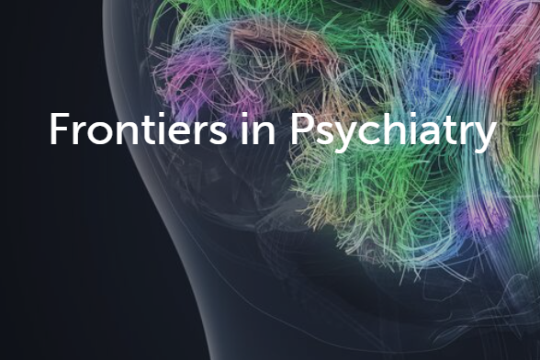  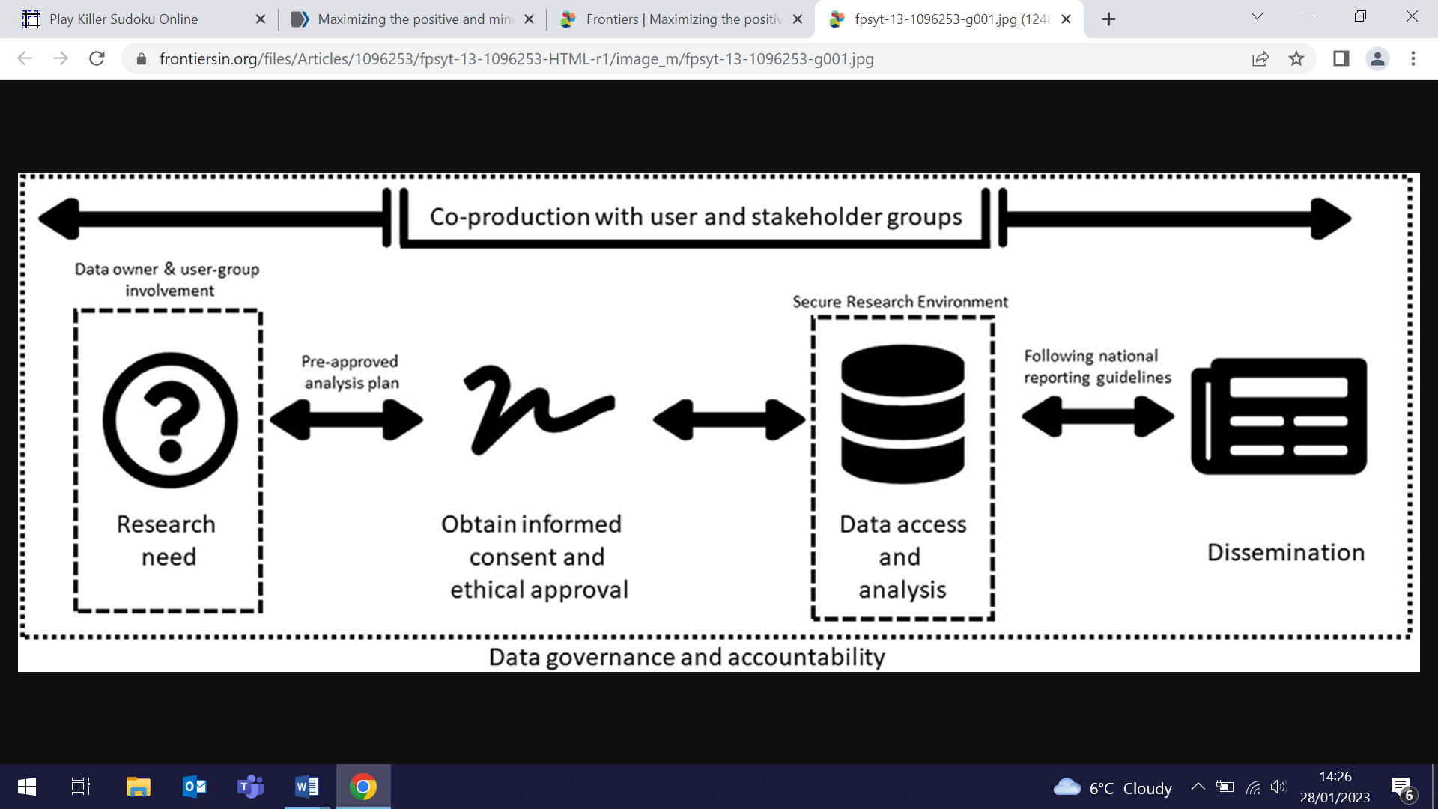 | Authors of a perspective article have proposed a framework to facilitate regulated and monitored access to social media platform data for researchers. Gaining informed consent for social media data access to study youth mental health has potential for significant benefits in public mental health, and data collected via social media platforms provide a unique opportunity to gather vital insights into participants' actions and activities. The proposed framework has four core elements: research need, ethical approval and informed consent, data access and analysis, and open dissemination. The authors hope the framework will stimulate social media platforms, policy makers, and researchers to make positive changes through collaborative working.
Prioritizing detection of rare pathogenic variants in population screening
13 January (Ranjit Manchanda. Centre for Prevention, Detection and Diagnosis)

Initiatives to maximize the preventive potential and public health impact of population genomic screening should prioritize monogenic testing for medically actionable conditions before or concurrently with polygenic testing, according to a new commentary. Researchers warn that using only polygenic risk scores (PRS) without monogenic testing is ill advised, as it will miss the most clinically significant genetic risk information associated with rare high-risk pathogenic variants for heritable conditions. They concede that PRS will be an important screening tool and that there is good evidence and emerging applicability for risk stratification in some diseases, citing risk-adapted screening for breast cancer as a prime example. However, they conclude that making clinical decisions based on PRS alone, without undertaking monogenic testing, may be potentially harmful by providing false reassurance of low genetic risk to some. | 
Physical health of individuals with psychosis
16 January (Tamara Pemovska, Nikolina Jovanović. Centre for Psychiatry and Mental Health)

   | Data from a study in which people with psychosis were prompted to discuss their physical health with mental health clinicians show that 54% of participants took up this opportunity. People with psychosis have poorer physical health than the general population. Researchers examined data from the IMPULSE RCT, in which the DIALOG+ intervention was delivered to 221 individuals with psychosis in clinical meetings over 6 months. In addition to understanding how physical health was discussed, they considered what actions were taken, and whether addressing clients’ physical health translated into physical health benefits and improved satisfaction with mental health services. Despite subjects’ enthusiasm to make changes to diet, smoking, and weight, and taking steps to achieve these goals, after 6 months no improvement was detected in satisfaction with physical health, severity of physical health problems, or satisfaction with services. The paper concludes that innovative approaches are needed to promote lifestyle change in individuals with psychosis.
Impact of internet use on student engagement and wellbeing
17 January (Ania Korszun, Ali Ajaz. Centre for Psychiatry and Mental Health)

In advance of the launch of their new study: Digital Life - Impact of internet use on student engagement and wellbeing, Ali Ajaz and Ania Korszun attended the Strategy launch at the House of Commons for their funding charity, Ygam (The Young Gamers and Gamblers Education Trust). Researchers hope the new study will enable a better understanding of online habits and problems experienced by QMUL students from diverse backgrounds. | 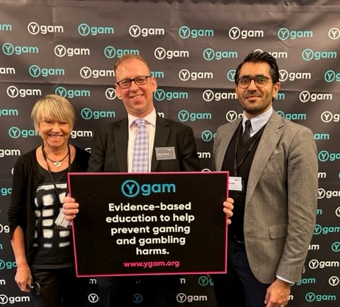
New NSC Research and Methodology Group
17 January (Adan Brentnall. Centre for Evaluation and Methods)

  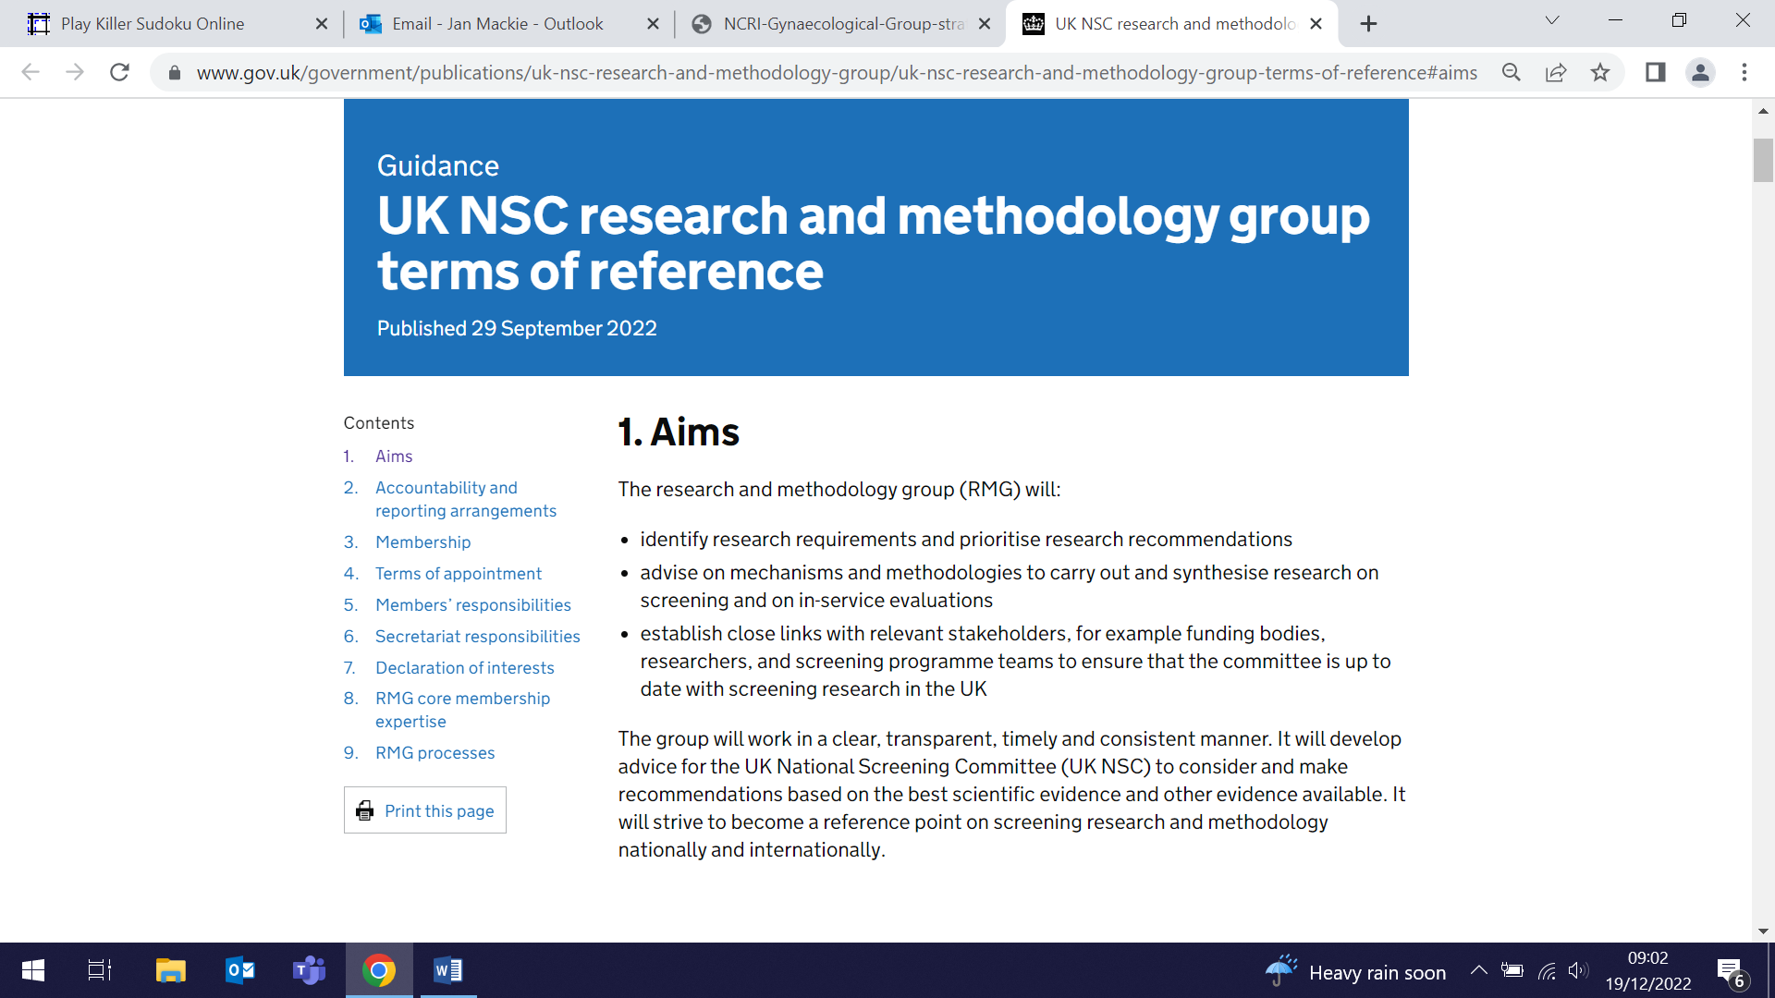 | Congratulations to Adam Brentnall, who has been appointed as a committee member of the newly formed UK National Screening Committee Research and Methodology Group, and attended the inaugural meeting on 17 January. The Group, chaired by Professor Sian Taylor Phillips, is formed of six core members and will meet 3-4 times a year to develop advice for the NSC. Terms of Reference include advising on mechanisms and methodologies to carry out and synthesis research on screening and in-service evaluations. Adam will remain a member for 3 years until 2025.
Salt reduction in the Eastern Mediterranean
18 January (World Action on Salt, Sugar and Health. Centre for Public Health and Policy)

The international arm of the Research and Action on Salt and Obesity Unit, World Action on Salt, Sugar and Health (WASSH) has published a salt reduction toolkit as part of its project to accelerate salt reduction policies in the Eastern Mediterranean region. The project, funded by Resolve to Save Lives, builds on a previous toolkit for the WHO South East Asia regional office, but is tailored to Eastern Mediterranean countries, with short case studies relevant to the region. Nine protocols provide guidance on setting up a salt reduction policy, including how to measure population intake, set reduction targets, and develop a front of pack nutrition label. | 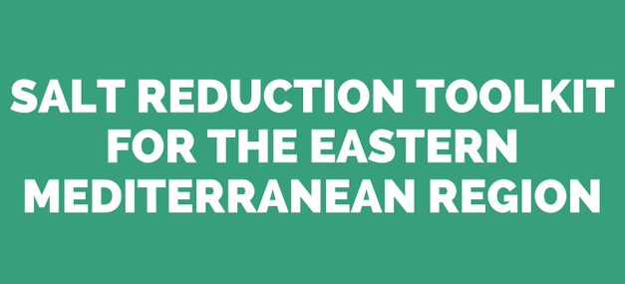  
Dementia Prevention: Think Brain Health Check-in Tool Launch
18 January (Charlie Marshall, Centre for Prevention, Detection and Diagnosis)

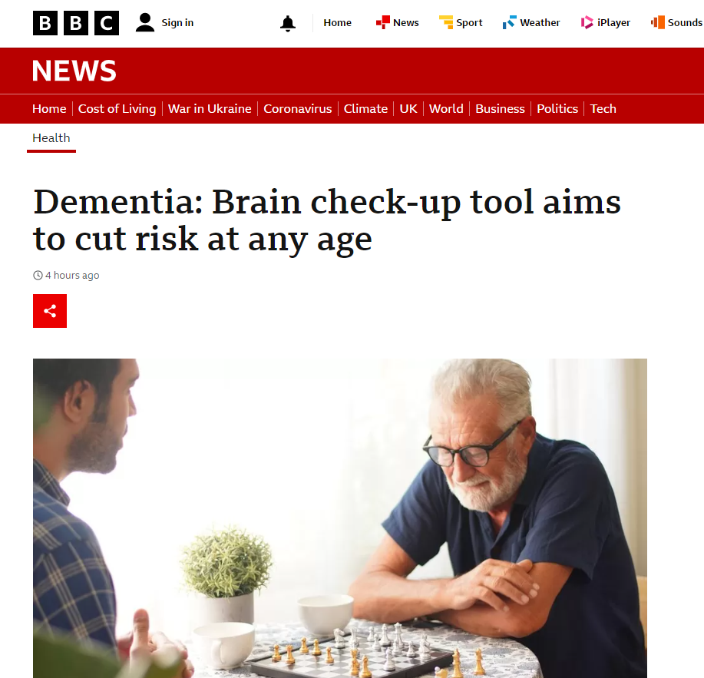  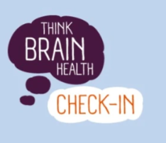 | Charlie Marshall joined a panel of leading researchers at an Alzheimer’s Research UK Science Media Centre briefing on dementia prevention. The briefing launched the next step in the Think Brain Health campaign, a new check-in tool to provide practical, targeted information based on responses to questions about dementia risk factors. The briefing made headline news across multiple media outlets, including lead health story on the BBC website, with Charlie extensively quoted. Individual risk of developing dementia is linked to a combination of age, inherited genes, and lifestyle. While some risk factors cannot be changed, the NHS Health Check for people aged 40-74 could test brain health and advise how to improve it, and also identify those with early signs of dementia. "We need the same diagnostic process for dementia as for cancer, and that means redesigning services" Charlie said. "We need to prepare now for delivering new treatments when they come."
Nutritional profile of plant-based meat analogues on sale in Australia
18 January (Roberta Alessandrini. Centre for Public Health and Policy)

Results from a study comparing the nutritional quality of 132 plant-based meat analogues with 658 equivalent meat products on sale in Australian supermarkets show that analogue products generally had a higher health star rating. The plant-based products had lower mean saturated fat and sodium content, but higher total sugar content. Meat and analogue products had a similar proportion of ultra-processed products (84% v 89%), but only 12% of meat analogues were fortified with iron, vitamin B₁₂ and zinc, commonly found in meat products. | 
Evaluating a call and recall system for improved childhood vaccination uptake
20 January (Milena Marszalek, Meredith Hawking, Ana Gutierrez, Isabel Dostal, Zaheer Ahmed, Nicola Firman, John Robson, Anna Billington, Ngawai Moss, Carol Dezateux)

 | The protocol has been published for a study to evaluate a quality improvement programme in primary care to improve timeliness and equity of childhood vaccinations. The observational study will run in 284 general practices in NE London, with a target population of children eligible for pre-school immunisations in a multi-ethnic disadvantage urban setting. Delivery of an Active Patient Link Immunisation call and recall system will be tested, with focus on uptake and use, implementation barriers and service improvements for clinical and non-clinical primary care staff, its fidelity and sustainability. The primary outcomes will be proportion of children receiving at least one dose of a DTaP or MMR vaccination administered, respectively, from age 6 weeks-6 months, or 12-18 months.
Ensemble learning for early detection of pancreatic ductal adenocarcinoma
20 January (Oleg Blyuss. Centre for Prevention, Detection and Diagnosis)

Researchers have developed a stacked ensemble modelling technique to achieve robust predictions for the early detection of pancreatic ductal adenocarcinoma (PDAC). Early detection is key to improving patient outcomes, as PDAC is mostly detected at advanced stages with associated poor survival. In a dataset of 249 controls and 143 post-menopausal women diagnosed with pancreatic cancer within 70 months of sample collection, the technique considerably outperformed previously reported biomarker combinations. Results showed that with ensemble learning PDAC status could be predicted up to a year before diagnosis with an AUC of 0.91 (sensitivity 92%, 90% specificity), and at two years prior to diagnosis with an AUC of 0.85 (sensitivity 61%, 90% specificity). | 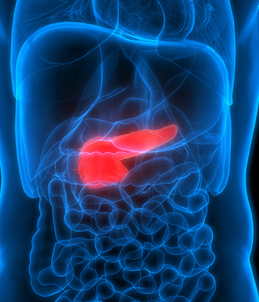
Ygam study presentation at QMUL Digital Lives programme launch
20 January (Anna Rouskova. Centre for Psychiatry and Mental Health)

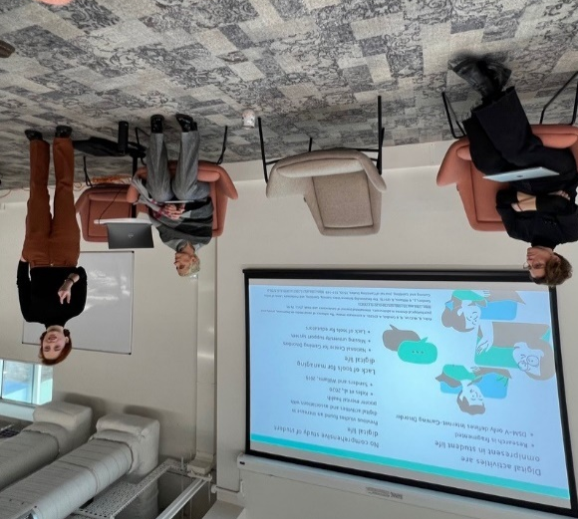 | Research student Anna Rouskova delivered a presentation on the forthcoming WIPH Ygam study at the launch event for a new QM programme, Digital Lives (Humanising the Digital) on 20 January. Digital Lives is an Institute for the Humanities and Social Sciences initiative to bring together researchers and practitioners across faculties and beyond, to recognise the relationships between people, data, and digital technologies.
Exhibition highlights needs of people living with memory concerns
23 January (Claudia Cooper. Centre for Psychiatry and Mental Health)

A photography exhibition at the House of Commons highlights the experiences of people living with memory problems. Participants in the APPLE-Tree (Active prevention in people at risk of dementia) study worked with photographer and artist Sukey Parnell Johnson to create the exhibition, intended to spark conversations about how society supports, includes, and respects people with memory problems. The five year APPLE-Tree study, led by QMUL in collaboration with the International Longevity Centre-UK, explores how to support people with memory concerns to make changes that reduce their chances of dementia. Daisy Cooper MP, sponsor of the House of Commons exhibition (pictured), said: “By raising the issues and developing better prevention strategies and support programmes, projects like the APPLE-Tree study benefit everyone. As policy makers grapple with streamlining health and care services to better support people living with dementia, projects like the APPLE-Tree study bring the issue visibly into the heart of Westminster.” The installation opens to the public on 1 February at Holy Sepulchre (the musicians’ church) in Holborn. | 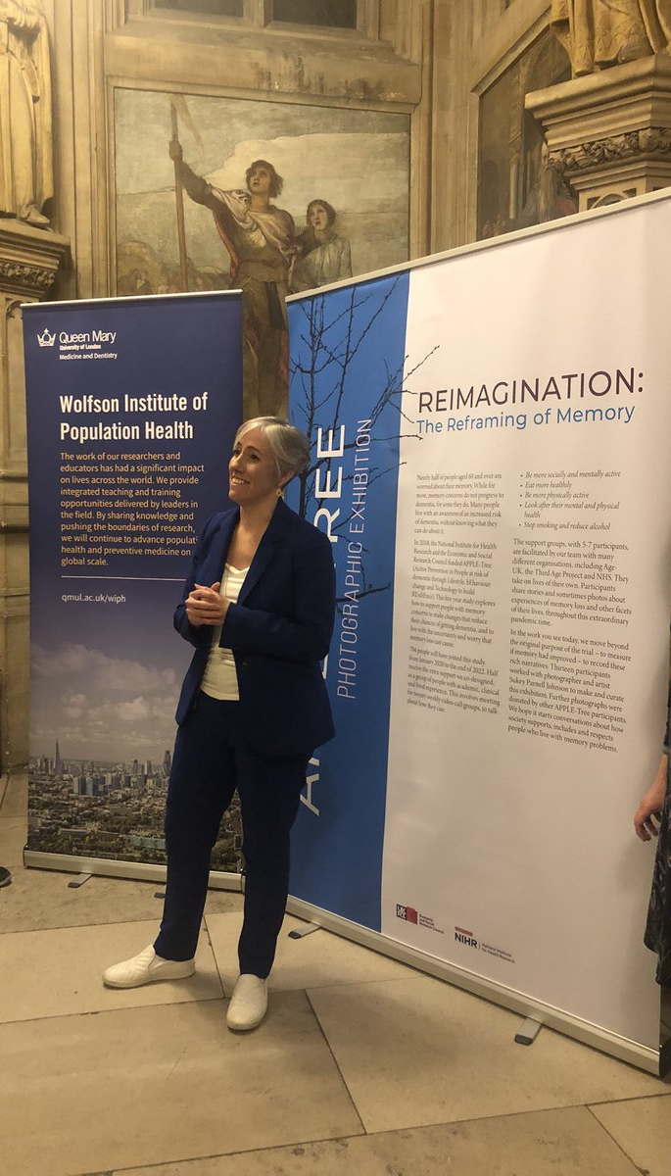
Tips to prevent high blood pressure
23 January (Graham MacGregor. Centre for Public Health and Policy)

   | Graham MacGregor has been quoted extensively in an inews article on how to prevent high blood pressure, the biggest risk factor for death globally through conditions like heart disease, strokes, kidney disease, peripheral arterial disease, and vascular dementia. A third of the population has sufficiently raised blood pressure to consider treatment. If your blood pressure is consistently 140 over 90, it’s beneficial to lower it with drugs he explained. Even if your blood pressure falls within the normal range, you’re still at greater risk if it’s 130 over 80, for example, than 110 over 70. Graham told inews that we should all be considering lifestyle changes, and losing weight and reducing salt intake are two of the best things for a healthy blood pressure, but he warned: While too much salt is a major underlying cause of hypertension, much of the salt in our diets is hidden in processed foods. The traffic light labels on food packaging can help consumers in choosing lower salt convenience food options.
Reflections of a re-engaged blood donor
23 January (Stephen Hibbs. Centre for Primary Care)

In a letter in Transfusion Medicine, haematologist Stephen Hibbs reflects on the reasoning behind his 15 year hiatus and recent re-engagement with blood donation, describing it as prolonged cognitive dissonance with a sudden surfacing and need for resolution. After a few donations in his late teens he found reasons to delay donating, including uncertainty around eligibility after overseas travel, for 15 years. Despite knowing (and teaching) the importance of blood donation and transfusion, he believed that he would soon donate again, but took no action on this. His reconnection was triggered during a transfusion revision course on which students asked whether they were blood donors, a question he had not been asked for some time. I suddenly became aware of the conflict between my identity and my practice, he writes, drawing an analogy with the thought process of the relapsed smoker maintaining a non-smoker identity. He suggests that in cases like his, an additional recovery activity might be a simple clarifying question: are you still a blood donor? | 
Diagnostic Performance of Biomarkers for Bladder Cancer
24 January (Fiona Walter. Centre for Prevention, Detection and Diagnosis)

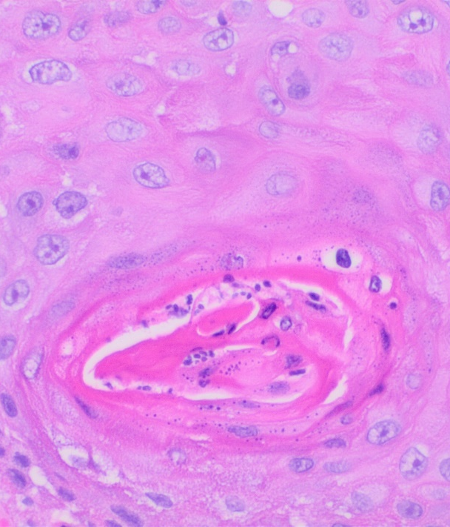 | A systematic review of evidence on the diagnostic performance of biomarkers to detect bladder cancer has revealed three biomarkers with similar discriminative ability (adjusted AUC estimates ranging from 0.650- 0.707). NMP-22, UroVysion, and uCyt+ were identified in at least five studies. Narrative synthesis revealed the potential of these biomarkers for use in the general population based on their reported clinical utility, including effects on clinicians, patients, and the healthcare system. Researchers also identified some promising novel biomarkers and biomarker combinations with negative predictive values of ≥ 90%, which have potential for use as a triage tool in community and primary care settings for reducing unnecessary specialist referral.
Government considering banning sale and possession of Nitrous Oxide
26 January (Alastair Noyce. Centre for Prevention, Detection and Diagnosis)

An ITV news report on plans for a government ban on sales and possession of laughing gas included an interview with Alastair Noyce, who said he treats around one nitrous oxide casualty a week. He explained that nitrous oxide causes a range of different symptoms, including numbness in the legs and arms, difficulty walking and falls, and also problems with the bladder and bowel. Police warn that obtaining nitrous oxide is as easy as buying a loaf of bread, and policing minister Chris Philp is reportedly pushing for the ongoing review of nitrous oxide by the independent Advisory Council on the Misuse of Drugs to be fast-tracked to April. There are suggestions that a formal announcement on a ban could be made as part of the government’s antisocial behaviour strategy due later this year. Al is a member of the ACMD Nitrous Oxide Working Group producing the review. | 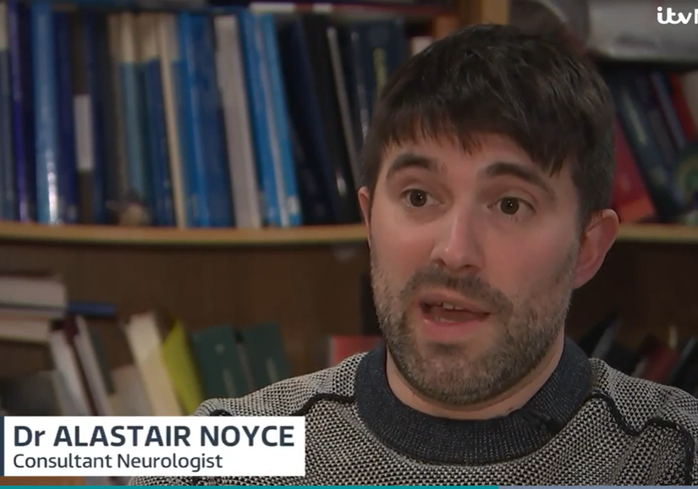  
Newsnight covers Success of the Soft Drinks Industry Levy
26 January (Kawther Hashem. Centre for Public Health and Policy)

 | In the light of new evidence on the association between decreased prevalence of obesity among primary school children and the UK Soft Drinks Industry Levy, the BBC’s Newsnight programme interviewed Kawther Hashem from the WIPH Research and Action on Salt and Obesity Unit about the success of the levy (also known as the sugar tax). A proposal from the WIPH Action group formed the basis of the UK Government’s Childhood Obesity Plan, which incorporated the Soft Drinks Industry Levy. The tax to encourage drinks manufacturers to reformulate their products was implemented in April 2018. New research from Cambridge University found an 8% relative reduction in obesity levels in 10/11 year old girls 19 months after the levy was introduced, with greatest reductions in girls from schools in the most deprived areas. Kawther told Newsnight that the levy has categorically reduced sugar in drinks, and shows that tax acts as an industry incentive to do exactly that.
Society for Academic Primary Care SE Annual Meeting
26 January (Sarah Pocknell, Jamie Ross, Stuart Rison, Dipesh Gopal, Ratna Sohanpal. Centre for Primary Care)

Five CPC staff made presentations at the 2023 SAPC South East Scientific Meeting. This year’s meeting theme was Health Equity for People and Planet. Presentations included: Making visible the hidden work of medicines talk in primary care medication reviews (Sarah Pocknell), Influences on patient uptake and engagement with the NHS Digital Diabetes Prevention Programme: a qualitative interview study (Jamie Ross), Hypertension in the time of COVID-19: Blood pressure control was maintained during the pandemic and so were pre-existing health inequities (Stuart Rison), Primary care practitioners’ experiences of cancer care reviews: A qualitative study (Dipesh Gopal), and Patient, Carer and Professional perspectives on the opportunities and challenges for REMOte CARE in chronic obstructive pulmonary disease - A qualitative study (Ratna Sohanpal). | 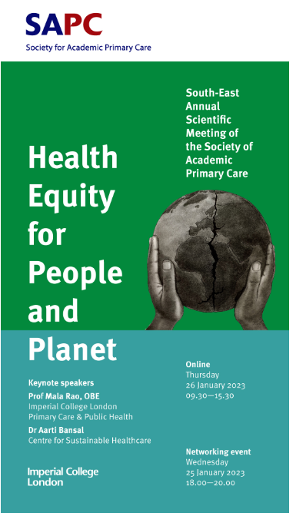
Hospital architecture in times of crisis
27 January (Nikolina Jovanović. Centre for Psychiatry and Mental Health)

 | Against a background of the ongoing COVID-19 pandemic and the war against Ukraine, key concepts in healthcare architecture during crises are outlined in a new paper authored by psychiatrist and architect Nikolina Jovanović. During crises such as public health emergencies, military conflicts, or natural disasters, health systems must be prepared to react quickly and flexibly to increased treatment and care needs. Healthcare spaces should be planned and designed with a high degree of adaptability to meet challenges. The paper discusses how interventions can focus on adapting existing healthcare facilities and public spaces, building new units, and repurposing civil facilities for hospitals, and considers a range of building typologies including modular containers, tents, and other lightweight structures. The author concludes that each facility needs a unique approach, based on its foundational infrastructure and the type of crisis, but that the guiding principles identified in this paper can be used for any type of facility and any type of crisis.
FORTHCOMING EVENTS AND NOTICES

Environment & Health Seminar Series: The Built Environment
7 February 13:00-14:00

This online seminar on 7 February will present two talks, focusing on the built and urban environment.  Talk 1: Community Rainwater Management in Hull: How to Nurture Climate Justice (Megan Clinch).  Talk 2: Impact of selective licensing schemes for private rental housing on mental health and social outcomes in Greater London, England: a natural experiment study (Jakob Petersen). Attendance is free, and there will be an opportunity to ask questions and discuss the topic with speakers. Register via Zoom. For any queries about the event please contact enh-mdt@qmul.ac.uk | 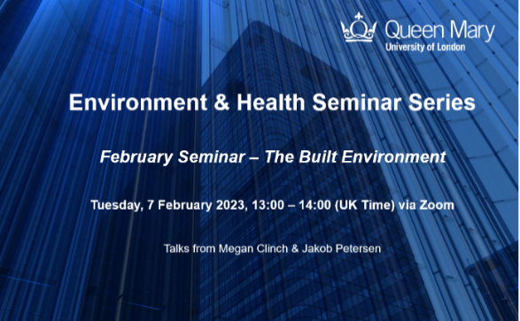
Many thanks to all who so enthusiastically contribute. Please send any news items for the next newsletter to j.a.mackie@qmul.ac.uk

