WOLFSON INSTITUTE OF POPULATION HEALTH
NEWSLETTER
ISSUE 29: 14 FEBRUARY 2023

In this issue of our Wolfson Institute of Population Health Newsletter, we celebrate the achievements and work of staff and students in late January and the first half of February.

FROM OUR INSTITUTE MANAGER
Dear Colleagues

I am delighted to write the introduction this week whilst Fiona is on her holidays. It was a great pleasure to attend the Graduation Ceremonies last month in my role as Procession Manager. Despite the train strikes, it wonderful to see so many students, families and academics attending to help celebrate the success of our students. I know that Stephen Duffy and his wife Prof Linda Sharples were particularly proud to watch their son Bill receive his degree.

We have now developed a Staff Survey Action Plan following the results of the survey held last year and I will be circulating it in the coming days. I would like to thank the very effective Working Group for developing these actions; it was a collaborative effort and has produced some interesting ideas. We will be sharing our implementation plans via some new pages on the Intranet and would warmly welcome additional support with the next phase, so please do volunteer if you see something that interests you.

I am pleased to confirm that we will be re-starting the Inaugural Lectures programme this year, after somewhat of a hiatus during the pandemic. We have a significant number of new professors to formally welcome and we are working with the Vice-Principal’s Office to establish dates across the coming year. We will share the programme in due course and I look forward to seeing many of you at these lovely events.  Warm wishes  Ellie | 
MEET WIPH

Meet: Heather McMullen, Lecturer in Global Public Health (CPHP)

How would you describe your roles and responsibilities?
I run the MSc module Gender, Sexuality and Health. I also lead on a study on violence affecting young people in East London, and for the last couple of years I have headed up a partnership with the UNFPA exploring the relationship between climate change and sexual and reproductive health and rights.

What has been your greatest professional achievement?
This is a hard question, but I feel great whenever my work connects with people. What I find most satisfying is when either in teaching or through research I can help translate concepts and ideas in ways that are useful for people. We recently presented some early findings from our violence study to some community workers and it really resonated. I was in a good mood for a couple days!

What aspects of your role do you enjoy the most?
I love being out in the community and meeting people. I particularly enjoy working with young people, who are often inspiring, funny, and articulate about what is going on in their lives. Being part of interdisciplinary teams and designing projects is really cool. I feel lucky to be working in public health, where there is no end of interesting things to explore.

What would be your second choice as a profession?  I nearly went into media and journalism, and I have done some training in counselling and movement therapy, so I would imagine a profession where I get to learn about people.  What do you enjoy doing outside work?  I like to take the odd dance or art class, as well as jogging around the park.  Something most people don’t know?  I used to be a dedicated martial artist! | 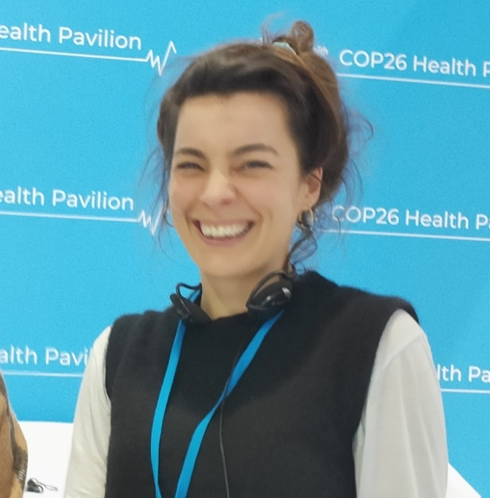
FROM OUR LEADERSHIP TEAMS AND REPRESENTATIVES

Research News (Victoria Kemp, Research Manager)

Call for abstracts (extension): NIHR GP ACF Conference 2023 | Deadline 20 Feb
This call for abstracts for the annual national conference for academic GPs in training has been extended to Mon 20 Feb. Registration is also open for the Conference, to be held 18-19 April. The aim of this annual conference, supported by the NIHR School for Primary Care Research, is to bring together all GP ACFs and other early career GP researchers on the academic track to share their research ideas and pilot results, and to hear from experts in the field on a variety of relevant research findings and methodological innovations.

FREE NIHR Webinar: Embedding PPIE into your research | Online 21 Feb
The NIHR are running a free webinar 'Embedding PPIE in your research' on Tuesday 21 February (1-1.45). This webinar will demonstrate how to integrate PPIE into your research and focus on working with underserved groups or topics.

Call for abstracts: Society for Social Medicine Annual Scientific meeting | Deadline 28 Feb
The conference covers a range of subjects including epidemiology, medical and health needs of society, health services, and prevention of disease. Research addressing important issues in population health sciences and includes qualitative, quantitative and mixed methods approaches is welcome. The conference offers good networking opportunities for ECRs and MCRs and a good forum for inequalities-related papers.

GENERAL INSTITUTE NEWS

Lung check uptake in an ethnically and socioeconomically diverse high risk UK population
27 January (Sammy Quaife. Centre for Prevention, Detection and Diagnosis)

 | The SUMMIT study has examined uptake of a lung health check invitation among high risk candidates across ethnic and socioeconomic groups currently under-represented in clinical studies. From over 2.3 million records in 251 primary care practices across north east and north-central London, 95,297 individuals aged 55-77 with a history of smoking in the past 20yrs were eligible for invitation, of whom 29,545 (31%) responded. Re-invitation letters were sent to a subsample of 4594 non-responders, of whom 642 (14%) responded. Uptake was higher in women than men, those aged 65-69 v 55-59, groups with less deprivation, individuals of Asian vs White ethnicity, and individuals who were former smokers vs current smokers. When ethnicity was further subdivided, uptake was lower among individuals of other White ethnicity than White British ethnicity, and higher among those of Chinese, Indian, and other Asian ethnicities than among those of White British ethnicity. Authors conclude that inviting eligible adults for lung health checks in areas of socioeconomic and ethnic diversity should achieve favourable participation in lung cancer screening overall, but inequalities by smoking, deprivation, and ethnicity persist.
WHO European Centre for Primary Health Care Team visit Spain
27 January (Sara Calderon, Centre for Primary Care)

As part of a multidisciplinary team led by the WHO European Centre for Primary Health Care, PhD student Sara Calderon visited Spain to support the Spanish Ministry of Health in addressing current challenges in primary health care. The team met national health authorities, scientific societies, patient organisations, and trade unions, visited health care facilities, and spoke with frontline primary care workers in two regions. The mission will produce a country case study documenting the history of primary health care reforms, as well as pressing issues and possible solutions. Despite Spain having a strong model and good outcomes, primary health care is at a juncture due to long standing deficits, health workforce shortages, Covid-19 impacts, and sociodemographic dynamics. Urgent evidence-informed policy action is needed to reverse current trends and ensure effective primary care response to present and future patient and population care needs. | 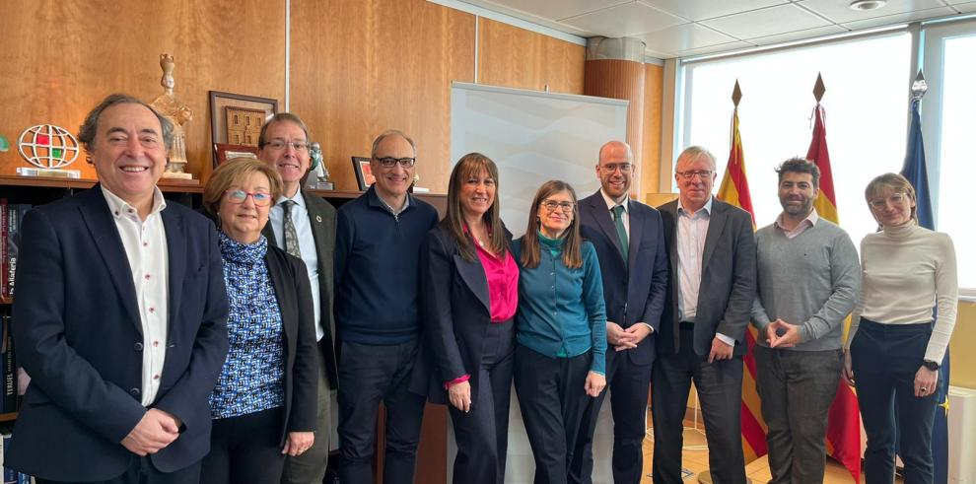  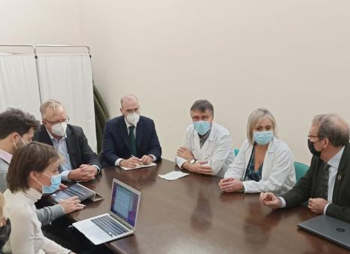
BJC most cited and downloaded papers of 2022
30 January (Stephen Duffy, Jonathan Myles, Daniel Vulkan. Centre for Prevention, Detection and Diagnosis)

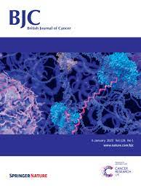 | The British Journal of Cancer has recognized a paper by Stephen Duffy and colleagues as one of its most cited and downloaded papers of 2022. The projected impact of the COVID-19 lockdown on breast cancer deaths in England due to the cessation of population screening: a national estimation published on 2 February last year had been downloaded 3225 times by the end of January 2023.
Action plan to prevent Alzheimer’s disease
31 January (Alastair Noyce. Centre for Prevention, Detection and Diagnosis)

An international task force of scientists from twenty-eight institutions has published guidelines for innovative services to prevent Alzheimer’s disease, laying the foundations for a preventive protocol that could be deployed on a large scale. Based on the collective experience of the task force members, the report identifies four pillars of this novel concept in the field of dementia and Alzheimer’s: risk assessment, risk communication, risk reduction, and cognitive enhancement. These pillars will enable second generation memory clinics (Brain Health Services) to reach out to the segment of the population whose memory is still functioning well and who wish to preserve or improve it - a population that does not find answers in the current clinics. | 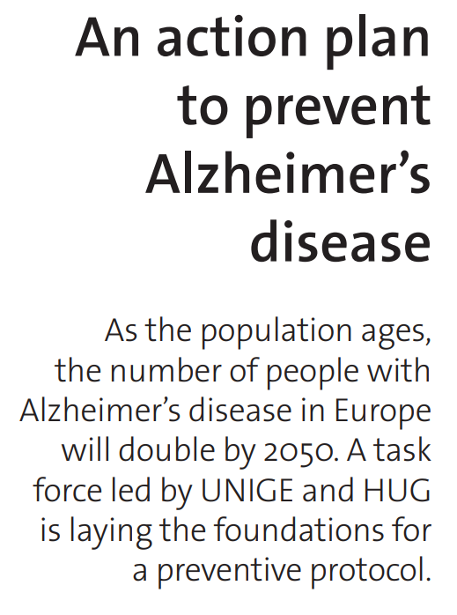
Follow-up tuberculosis screening of migrants identified as high risk
31 January (Dominik Zenner. Centre for Public Health and Policy)

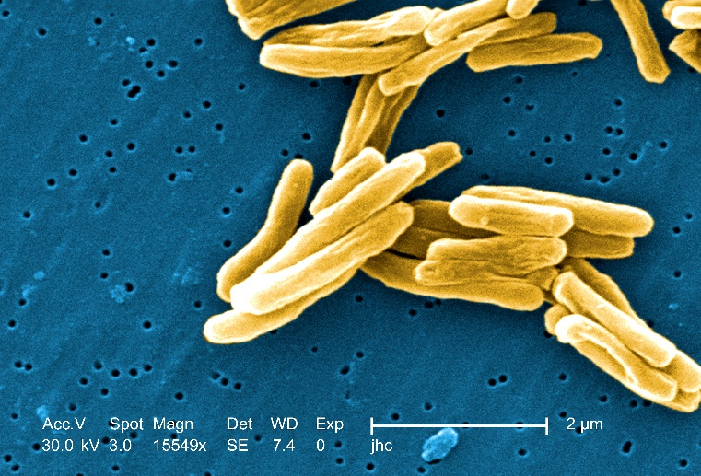 | Follow-up of migrants classified as at-risk of developing TB at initial screening is effective, but programmes vary across countries. A systematic review of 23 studies reporting follow-up screening programmes across seven countries identifies programme characteristics, coverage (proportion of eligible migrants screened) and yield (positive results among those eligible for follow up screening). Coverage was higher than 60% in the majority of studies and tended to be lower in voluntary compared with compulsory programmes. Yields were below 1500 cases per 100,000 eligible migrants in the majority of studies with large sample sizes. Voluntary programmes had similar yields compared with mandatory programmes, and repetitive screening did not lead to higher yields compared with one-off screening. Authors suggest that screening strategies should consider marginal costs for each additional round of screening.
Interventions to decrease hospital transfers for long-term care residents
2 February (Daniel Stow. Centre for Primary Care)

Researchers have synthesised evidence from 43 RCTs to evaluate interventions that influence acute hospital admissions of long-term care facility residents. In the UK these residents make up 185 000 emergency hospital admissions annually; avoiding unnecessary hospital transfers would benefit them and reduce demand on healthcare systems. The study identified multiple interventions, including advance care planning and goals of care setting, which both appear to reduce hospitalisations from such facilities. Other effective interventions included nurse practitioner/specialist input, palliative care intervention, influenza vaccination, and enhancing access to intravenous therapies in long-term care facilities. The paper concludes that more than one intervention will probably be needed to have an impact on healthcare usage across the long-term care facility population, but that these findings could usefully identify effective interventions that can be combined, as well as highlighting interventions for evaluation or that do not effectively decrease healthcare usage. | 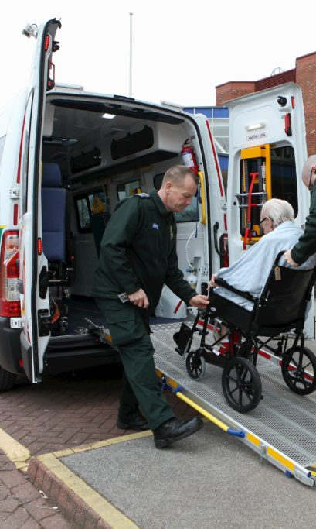
Early Career Researcher Award
2 February (Sarah Pocknell. Centre for Primary Care)

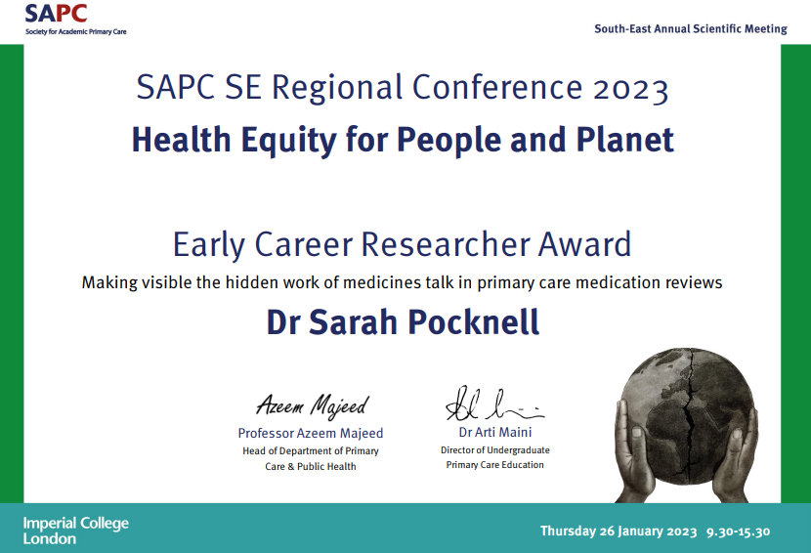 | Sarah Pocknell has received the 2023 Society for Academic Primary Care SE Regional Conference Early Career Researcher Award for her presentation Making visible the hidden work of medicines talk in primary care medication reviews. Sarah has recently finished her NIHR SPCR bridging fund fellowship in the WIPH under supervisors Deborah Swinglehurst and Nina Fudge, and is currently preparing this piece of work for publication.
Proactive breast cancer risk assessment in primary care
3 February (Fiona Walter, Centre for Prevention, Detection and Diagnosis)

In 2022, the NICE withdrawal of a recommendation that breast cancer risk assessment in primary care should occur only when women present with concerns paved the way for a primary care-based screening programme to identify those at moderate/high breast cancer risk. A new review comparing the literature on proactive breast cancer risk assessment in primary care against the consolidated framework for screening finds that risk assessment for women aged under 50 satisfies many of the standard principles for screening. The review shows that large numbers of women at moderate or high risk are currently unidentified, risk models exist that can identify those women with reasonable accuracy, and management options offer the opportunity to reduce breast cancer incidence and mortality in that group. However, authors note that some uncertainties and research gaps remain, particularly around the programme/system requirements, and these must be addressed before benefits can be realised. | 
Could future mental imagery reduce COVID-19 impact on negative mood and symptoms in young people?
4 February (Jennifer Lau. Centre for Psychiatry and Mental Health)

 | Despite playing a key role in adolescent depression, disruptions in prospective mental imagery are commonly neglected, as current interventions tend to focus on verbal techniques to alleviate negative mood, rather than enhancing positive mood. A study investigating the concurrent relationships between the vividness of negative and positive prospective mental imagery with negative and positive mood, researchers examined whether prospective mental imagery moderated the impact of COVID-19-linked stress on mood. In 2602 people aged 12-25 who completed a prospective imagery task and reported their symptoms, elevated vividness of negative future images amplified the association between COVID-19 linked stress and negative mood. Authors say that future mental imagery may be differentially associated with negative and positive moods, but this needs to be replicated in clinical populations to support novel adolescent psychological treatments.
New diabetes drugs do not tackle root causes of obesity
5 February (Graham MacGregor. Centre for Public Health and Policy)

Experts warn that new drugs to help people lose large amounts of weight by making them feel full after eating are not an excuse to avoid tackling the root causes of obesity. NICE has approved two such diabetes vaccinations, Saxenda and Wegovy. The proportion of obese adults in England rose from 14.9% to 28% from 1993-2019, and in 2019-20 10780 hospital admissions were directly attributable to obesity. Graham MacGregor told the Guardian that unhealthy food is the biggest cause of death and disability in the world. “The question is what are you going to do about it? Are you going to let the food industry go on feeding us this rubbish and promoting it … and then give drugs to try and stop the effects of all this unhealthy food? Or are you going to try to stop the food industry doing this? I would think it’s inevitable that these drugs will be widely used…It would be so much better to prevent this in the first the place.” |   
Safety guidelines for MS symptomatic therapies during pregnancy and breastfeeding
5 February (Iyer Priyanka, Ruth Dobson. Centre for Prevention, Detection and Diagnosis)

 | In pregnant women with Multiple Sclerosis (MS) symptoms such as fatigue and spasticity are commonly reported and can worsen. Prescribing medications for these women during pregnancy and breastfeeding is challenging, and patients are often advised to stop all symptomatic therapies based on low quality or limited evidence that these drugs are harmful. A new set of guidelines provides evidence-based recommendations on the safety of symptomatic therapies during pregnancy and breastfeeding, for GPs and specialist teams working with people with MS who are hoping to embark on pregnancy or are currently pregnant. Authors generated a list of 24 medications for review, grading evidence on each using standardised criteria. Developed recommendations were distributed to experts in the field, and revised according to feedback. The resulting guidelines aim to provide a consensus on the current evidence base to facilitate informed decision-making and optimise pre-conception counselling for women with MS.
Cochrane Review: Taking vitamin D does not reduce risk of asthma attacks
6 February (David Jolliffe, Chris Griffiths. Centres for Public Health and Policy/Primary Care)

An updated Cochrane Review finds that vitamin D supplements do not reduce risk of asthma attacks in children or adults. The previous (2016) review found vitamin D deficiency to be linked to increased risk of severe asthma attacks. Data in the new assessment are taken from 20 RCTs of 2225 participants with asthma (v 9 trials and 1093 subjects in 2016) and include better representation of children with asthma. Researchers compared patients assigned to take vitamin D with those given a placebo, and found no statistically significant difference in the number who experienced an asthma attack requiring treatment with a course of steroid tablets. Chris Griffiths said: Evidence from trials rarely stands still, and contrasting findings here ironically may be a result of more people taking supplements after widespread media coverage of previous trial results favouring vitamin D supplementation. Our results also show us that more evidence is needed in people with severe vitamin D deficiency. Chris added his praise for QMUL Med student Annie Williamson (first author) “who has done a truly outstanding job”. |   
Association between schizophrenia and distance visual acuity
7 February (Claudia Cooper. Centre for Psychiatry and Mental Health)

 | A study of genetic evidence has found that schizophrenia is a causal risk factor for poorer visual acuity, but not the converse. Increased rates of visual impairment have been observed in people with schizophrenia. Researchers used bidirectional, two-sample Mendelian randomisation to assess the effect of poor distance acuity on schizophrenia risk, poorer visual acuity on schizophrenia risk, and schizophrenia on visual acuity, in European and East Asian ancestry samples. They found little evidence that poor distance acuity was causally associated with schizophrenia. The paper concludes that these results highlight the importance of visual care for people with psychosis, and refute previous hypotheses that visual impairment is a potential target for prevention of schizophrenia.
Breast cancer risk models: Variability when applied at individual level
7 February (Adam Brentnall. Centre for Evaluation and Methods)

Researchers quantifying accuracy and disagreement between common breast cancer risk models in categorizing individual women as average v high risk for invasive breast cancer have found substantial variation in risk estimates. The study compared three models: Breast Cancer Risk Assessment Tool (BCRAT), Breast Cancer Surveillance Consortium (BCSC), and International Breast Intervention Study (IBIS) in 31,115 women aged 40-74 attending screening mammography from 2011-2015. Model discrimination and calibration at the population level, and inter-model agreement for 5-year breast cancer risk at the individual level were calculated using cutoffs of ≥1.67% and ≥ 3.0%. Almost half (46.6%) were classified high risk by at least one of the three models (if all three models were applied) for the ≥ 1.67% threshold, and 11.1% for ≥ 3.0%. Authors say clinicians should be aware of the high false-positive and false-negative rates and variation between models when talking with patients. | 
High-intensity interval training in cardiac rehabilitation
8 February (Thomas Hamborg. Centre for Evaluation and Methods)

 | To address the lack of consensus on prescribing high-intensity interval exercise training (HIIT) for people with coronary artery disease, researchers conducted an RCT of 382 patients from 6 outpatient cardiac rehabilitation (CR) centres, randomised to twice-weekly HIIT (n=187) or moderate intensity steady-state exercise (MISS) (n=195) for 8 weeks. Primary outcome was change in cardiorespiratory fitness (peak oxygen uptake, VO2 peak). At 8-week follow up, peak oxygen uptake improved more with HIIT than with MISS (2.37 mL.kg-1.min-1; SD 3.11 v 1.32 mL.kg-1.min-1; SD 2.66). Authors conclude that HIIT should be considered by all CR programmes as an adjunct or alternative to MISS.
RCT Protocol to test DIALOG-A among Colombian adolescents with depression
8 February (Stefan Priebe, Victoria Bird. Centre for Psychiatry and Mental Health)

Authors have published the protocol for an RCT to evaluate the use of the DIALOG+ intervention (DIALOG-A) in community treatment of Colombian adolescents with depression and anxiety. Clinicians will be randomized 2:1 to either the intervention (12 clinicians:72 adolescents) or control group (6 clinicians:36 adolescents) (routine care). In the intervention arm clinicians will use DIALOG-A with adolescents monthly over 6 months. Outcomes will be measured at baseline, 6 months, and 9 months. Quantitative and qualitative analysis of data from semistructured interviews with all clinicians and a subset of adolescents in the intervention arm, to be conducted at the end of the intervention period. If results are positive, DIALOG-A can be implemented into routine care of adolescents with these mental health problems, and will provide valuable insight to other middle-income countries. | 
Perceptions of the National Child Measurement Programme in England
9 February (Meredith Hawking, Carol Dezateux, Deborah Swinglehurst. Centre for Primary Care)

 | As part of the government’s approach to reducing childhood obesity, the English National Child Measurement Programme is a nationally mandated public health initiative in which BMI of primary school children is calculated at age 4-5 and again at 10-11, with results issued to parents. Drawing on experiences of children categorised as overweight or very overweight by the programme, and on those of their parents, a new study outlines how those parents come to resist and reframe the programme and its results to protect their children from a weight-focused future, and how they consider the potential risks of bullying, dysfunctional eating, and mental health consequences more important than future risks of being overweight. Lead author Meredith Hawking said: Many parents have legitimate concerns about the impact the Programme might have on children’s self-perception and food practices as they grow older. More research is needed to understand whether these concerns are borne out in the long term and to find ways to mitigate them if the programme is to continue. The authors observe a central paradox of this programme: that the children it sets out to help may be the most likely to be harmed by it.
Pilot and feasibility studies: extending the conceptual framework
9 February (Claire Chan, Sandra Eldridge, Saskia Edddy. Centre for Evaluation and Methods)

Authors of a 2016 paper presenting a conceptual framework to define pilot and feasibility studies have extended their framework to incorporate feasibility pathways, including internal pilot studies. The new paper considers when different approaches to feasibility and pilot and studies are more effective, and provides examples of the uncertainties and compromises researchers navigate. The authors conclude by considering the funders’ perspective in making resource decisions to include feasibility work, and the policy implications of these. | 
QMUL Apprenticeship Awards
9 February (Fahmida Akthar. Centre for Primary Care)

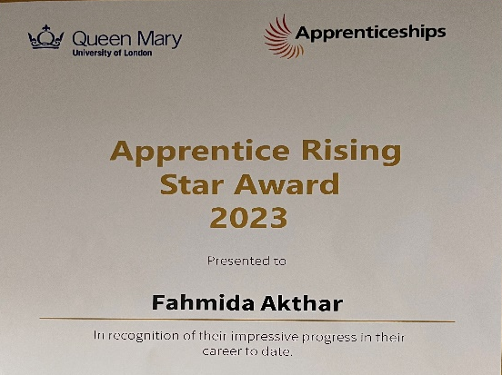 | Fahmida Akthar, Data and Communications Assistant in the CEG has received a QMUL Apprentice Rising Star Award 2023. The award was presented to Fahmida by Principal, Colin Bailey, at an event held at the Octagon. The ceremony was part of the Queen Mary University of London National Apprenticeship Week celebrations. Congratulations Fahmida!
Salt reduction in Malaysian out-of-home sectors
9 February (Feng He, Mhairi Brown. Centre for Public Health and Policy)

In a study into attitudes towards salt reduction in the out-of-home food sector in Malaysia researchers conducted discussions with multiple stake holders, including policy-makers and the food industries. Participants agreed that salt intake in Malaysia is high, and they considered lack of awareness, poor eating culture and behaviour, and frequent eating out to be among the causes of this. Government strategies have included awareness campaigns, education, sodium content labelling, and product reformulation, and some food industries have tried to reduce salt, and labelled the sodium content on their food products. Perceived barriers include poor consumer acceptance, lack of knowledge and resources, and challenges in reformulation, as well as lack of guidelines and salt targets. Suggested enablers to change included prioritizing the salt reduction strategy, increasing awareness, collaboration and engagement, research, and technology (particularly for reformulation and shelf-life stability), incentives, and salt tax. |   
UN International Day of Women and Girls in Science
11 February (Rohini Mathur. Centre for Primary Care)

 | On International Day of Women and girls in science QMUL featured Rohini Mathur, WIPH Professor of Health Data Science. The article shines a light on her research to address health inequalities, particularly in our local communities, which are among the most disadvantaged and socially diverse in the UK, and where rates of ill health are among the highest in Western Europe. In a recorded video Rohini said: “My work focuses on how to make the best use of routinely connected health data to identify and tackle inequalities.”
FORTHCOMING EVENTS AND NOTICES

Primary Care-IHSE Collaborative Afternoon: 1 March

All WIPH colleagues with a primary care remit are invited to an afternoon of collaboration and joint learning between the Community Based Medical Education department (IHSE) and the Centre for Primary Care (WIPH) from 1-4pm on 1 March. This in-person event at the DERI basement (Empire House, Whitechapel campus) is an informal, relaxed gathering to foster a stronger connection between the two centres. Please join us for some short presentations and parallel workshops from each centre. | 
Inaugural Clinical Academic Research Day: 2 March

Queen Mary's Faculty of Medicine and Dentistry Clinical Academic Research Day will take place from 10:00-17:30 on 2 March in the Octagon, Mile End Campus. This new event will showcase the exciting research being done by our clinical academic trainees at all stages. All clinical academic trainees - Specialist Foundation fellows, Academic Training Fellows, PhD or MD students or Clinical Lecturers, and supervisors - are invited to attend. The event is free to attend, but registration is required. Contact: Bijal Tailor or book tickets here. | 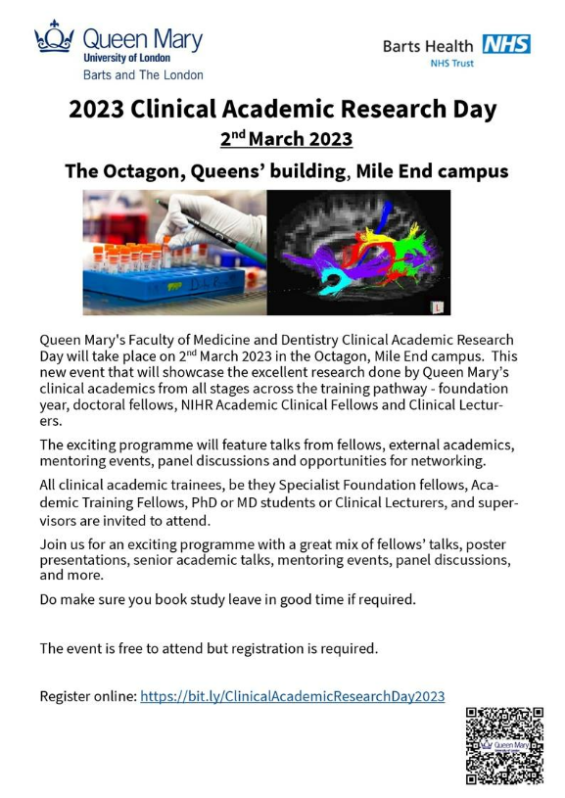
Many thanks to all who so enthusiastically contribute. Please send any news items for the next newsletter to j.a.mackie@qmul.ac.uk

