WOLFSON INSTITUTE OF POPULATION HEALTH
NEWSLETTER
ISSUE 30: 28 FEBRUARY 2023

In this issue of our Wolfson Institute of Population Health Newsletter, we celebrate the achievements and work of staff and students throughout February.

FROM OUR DEPUTY INSTITUTE MANAGER, TRACY CONNELLY
As Fiona has been enjoying a well-deserved break, I’m back in the hot seat to update you with some stimulating news regarding the Institute.

We are looking to reinstate our EDI group and look forward to as many of you as possible joining and supporting this group. I am sure you all recognise the importance of doing your part here, although I appreciate the time constraints we face, but I would encourage you to get involved when and where you can. Please look out for details from Evangelos Katsampouris, WIPH Academic EDI Lead (who is also the subject of Meet WIPH in this issue – see below).

Following our Institute H&S audit in September 2022, we received the report in December 2022, and the Committee are working their way through the imposed actions. H&S is the remit of all of us as individuals, but again, please support your H&S Officer (this will be your Centre/Unit Administrator) if asked. Going forward, the Committee will launch a summer newsletter and an end of year report which will be distributed via a number of avenues.
For those who follow or observe the Christian faith, we are now in Lent! I am totally rubbish at giving anything up, so I try to adopt a trait that benefits me and others, such as patience, being kind(ER), a simple act that makes someone else smile. It’s the little details that count! As the days appear longer, brighter, and less sultry, I hope you enjoy whatever you have planned for Spring.  Best wishes  Tracy | 
MEET WIPH

Meet: Evangelos Katsampouris (Postdoctoral Research Fellow in Behavioural Science, CPDD)

How would you describe your roles and responsibilities?
I am currently involved in lung cancer screening research, working with patients and healthcare professionals on the Qualitative Pulmonary Nodule Surveillance Study. I am also working to help re-establish the Equality Diversity and Inclusion Group at WIPH, which is something I am very passionate about. As Academic Rep I may soon reach out to you all for feedback on ways we can improve EDI in WIPH.

What has been your greatest professional achievement?
This is yet to come!

What aspects of your role do you enjoy the most?
Interacting with different people as part of our study is something I find very interesting, and part of my role involves some teaching and supervision, which I really enjoy. But I enjoy all of it - with its pros and cons, ups and downs – and especially seeing the research through, from the very beginning to the very end.

What would be your second choice as a profession?  Any profession where I could interact with people and hear their stories or support them to learn - so a teacher perhaps?  What do you enjoy doing outside work?  I enjoy meeting friends, exercising and travelling.  Something most people don’t know?  I am a (really!) good cook, excelling at Greek and Italian cuisine, and currently practising at tapas. | 
FROM OUR LEADERSHIP TEAMS AND REPRESENTATIVES

Research News (Victoria Kemp, Research Manager)
Project Involvement: NIHR SPCR-funded Q-DaPS | Deadline 10 March
Are you or your colleagues planning a qualitative study in the near future? Do you or your colleagues have existing qualitative data with permission to share and re-use?
We would like to bring to your attention the NIHR SPCR funded project ‘Qualitative Data Preservation and Sharing’ (Q-DaPS). Email Karen Lloyd, Q-DaPS Senior Research Associate, for them to explain how you can participate in the study.

Funding: UKRI Future Leaders Fellowship Round 8 | Opening 27 March
Apply for funding to support ambitious research or innovation across UK Research and Innovation’s (UKRI) remit. You must be an early career researcher or innovator and be either: (i) looking to establish or transition to independence, or (ii) developing your own original and ambitious plans within a commercial setting.

Workshop: Revitalising Community Nursing Research | Taking place 28 March
This regional workshop, facilitated by a James Lind Alliance Advisor, will bring together stakeholders and research advisors to develop priorities relevant to community nursing. They are particularly looking for attendance from Senior Nurses working across the Community portfolio at a strategic level. When: Tuesday 28 March, 1.30-5pm. Where: Axis Conference Centre, 3 Venture Rd, Chilworth, Southampton SO16 7NP

GENERAL INSTITUTE NEWS

Endometriosis and pregnancy outcomes: the role of parity
1 February (Beth Stuart. Centre for Evaluation and Methods)

 | A systematic review examining the role of parity in the relationship between pregnancy outcomes and endometriosis has found no significant differences in pregnancy outcomes when comparing multiparous women with or without endometriosis, but some evidence suggesting that primiparous women with endometriosis maybe at higher risk of adverse pregnancy outcomes than multiparous women. From 11 studies, researchers found that among women with endometriosis, primiparous women had almost double the risk of hypertensive disorders of pregnancy compared with multiparous women. Primiparous women with endometriosis were at significantly increased risk of preterm delivery, caesarean delivery, and placenta praevia compared with primiparous women without endometriosis. There were no significant differences in outcomes when multiparous women with endometriosis were compared with multiparous women without endometriosis.
Impact of study factors in the association of periodontal disease and cognitive disorders
1 February (Jianhua Wu. Centre for Primary Care)

Researchers have assessed study factors that may have an effect on reported associations between periodontal disease and cognitive disorders. In a systematic review they analysed results in 39 observational studies reporting the prevalence or risk of cognitive decline, dementia or Alzheimer's disease in people with periodontal disease, compared with healthy controls. The studies showed increased risk of cognitive disorder with periodontal disease, and that risk of cognitive decline increased according to severity of periodontal disease. They also showed that for every 10% population increase in females, the risk of cognitive decline increased by 34%, and that self-reported periodontal disease showed a lower risk of cognitive disorders compared with clinically diagnosed periodontal disease. The paper concludes that prevalence and risk estimates of cognitive disorders in association with periodontal disease can be influenced by gender, the disease classification of periodontal disease, and its severity. | 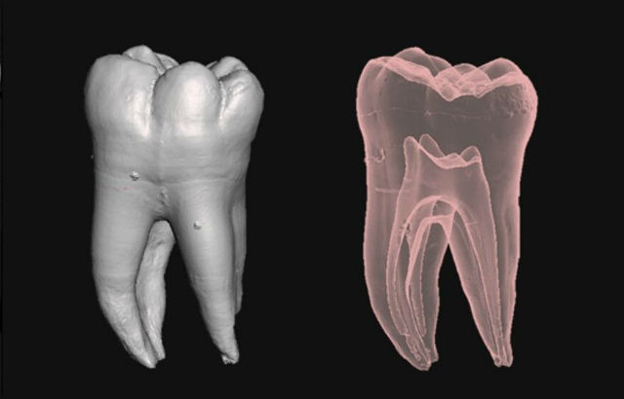
Cognitive impairment in REM-sleep behaviour disorder and individuals at risk of Parkinson's
2 February (Alastair Noyce. Centre for Prevention, Detection and Diagnosis)

 | Mild cognitive impairment is common at diagnosis of Parkinson’s Disease and also in patients with REM sleep behaviour disorder, but its prevalence amongst individuals at increased risk of Parkinson’s has been unclear. New research assesses cognition in 208 participants in the PREDICT-PD study and 25 participants with REM sleep behaviour disorder. Cognition scores were worse in participants deemed to be at high v low Parkinson’s risk, and also in the group with REM sleep disorder v healthy participants. Researchers conclude that REM sleep behaviour disorder may represent a specific pathway to Parkinson’s, with high levels of cognitive impairment and a specific cognitive profile.
Architecture of abnormal reward behaviour in dementia
9 February (Charles Marshall. Centre for Prevention, Detection and Diagnosis)

Abnormal reward processing is a hallmark of frontotemporal dementia, but little is understood about the phenotypic architecture. Comparing an intensively phenotyped patient cohort representing all major syndromes of sporadic frontotemporal dementia and Alzheimer’s disease with a healthy cohort, a new study assesses behavioural responsiveness for canonical primary (appetite, sweet tooth, sexual activity) and non-primary (music, religion, art, colours) rewards. Altered responsiveness was exhibited by most patients with behavioural and semantic variants of frontotemporal dementia, and about 2/3 of patients in the other dementia group - significantly more frequently that in controls. Hedonic behavioural changes were underpinned by a ‘gating’ factor determining emergence of altered reward behaviour, and a ‘modulatory’ factor, determining how that behaviour is directed. The principal gating factor was associated with a common profile of grey matter atrophy in anterior cingulate, bilateral temporal poles, right middle frontal and fusiform gyri. Authors say the findings define a multi-domain phenotypic architecture for aberrant reward behaviours in major dementias, with novel implications for understanding and managing these diseases. | 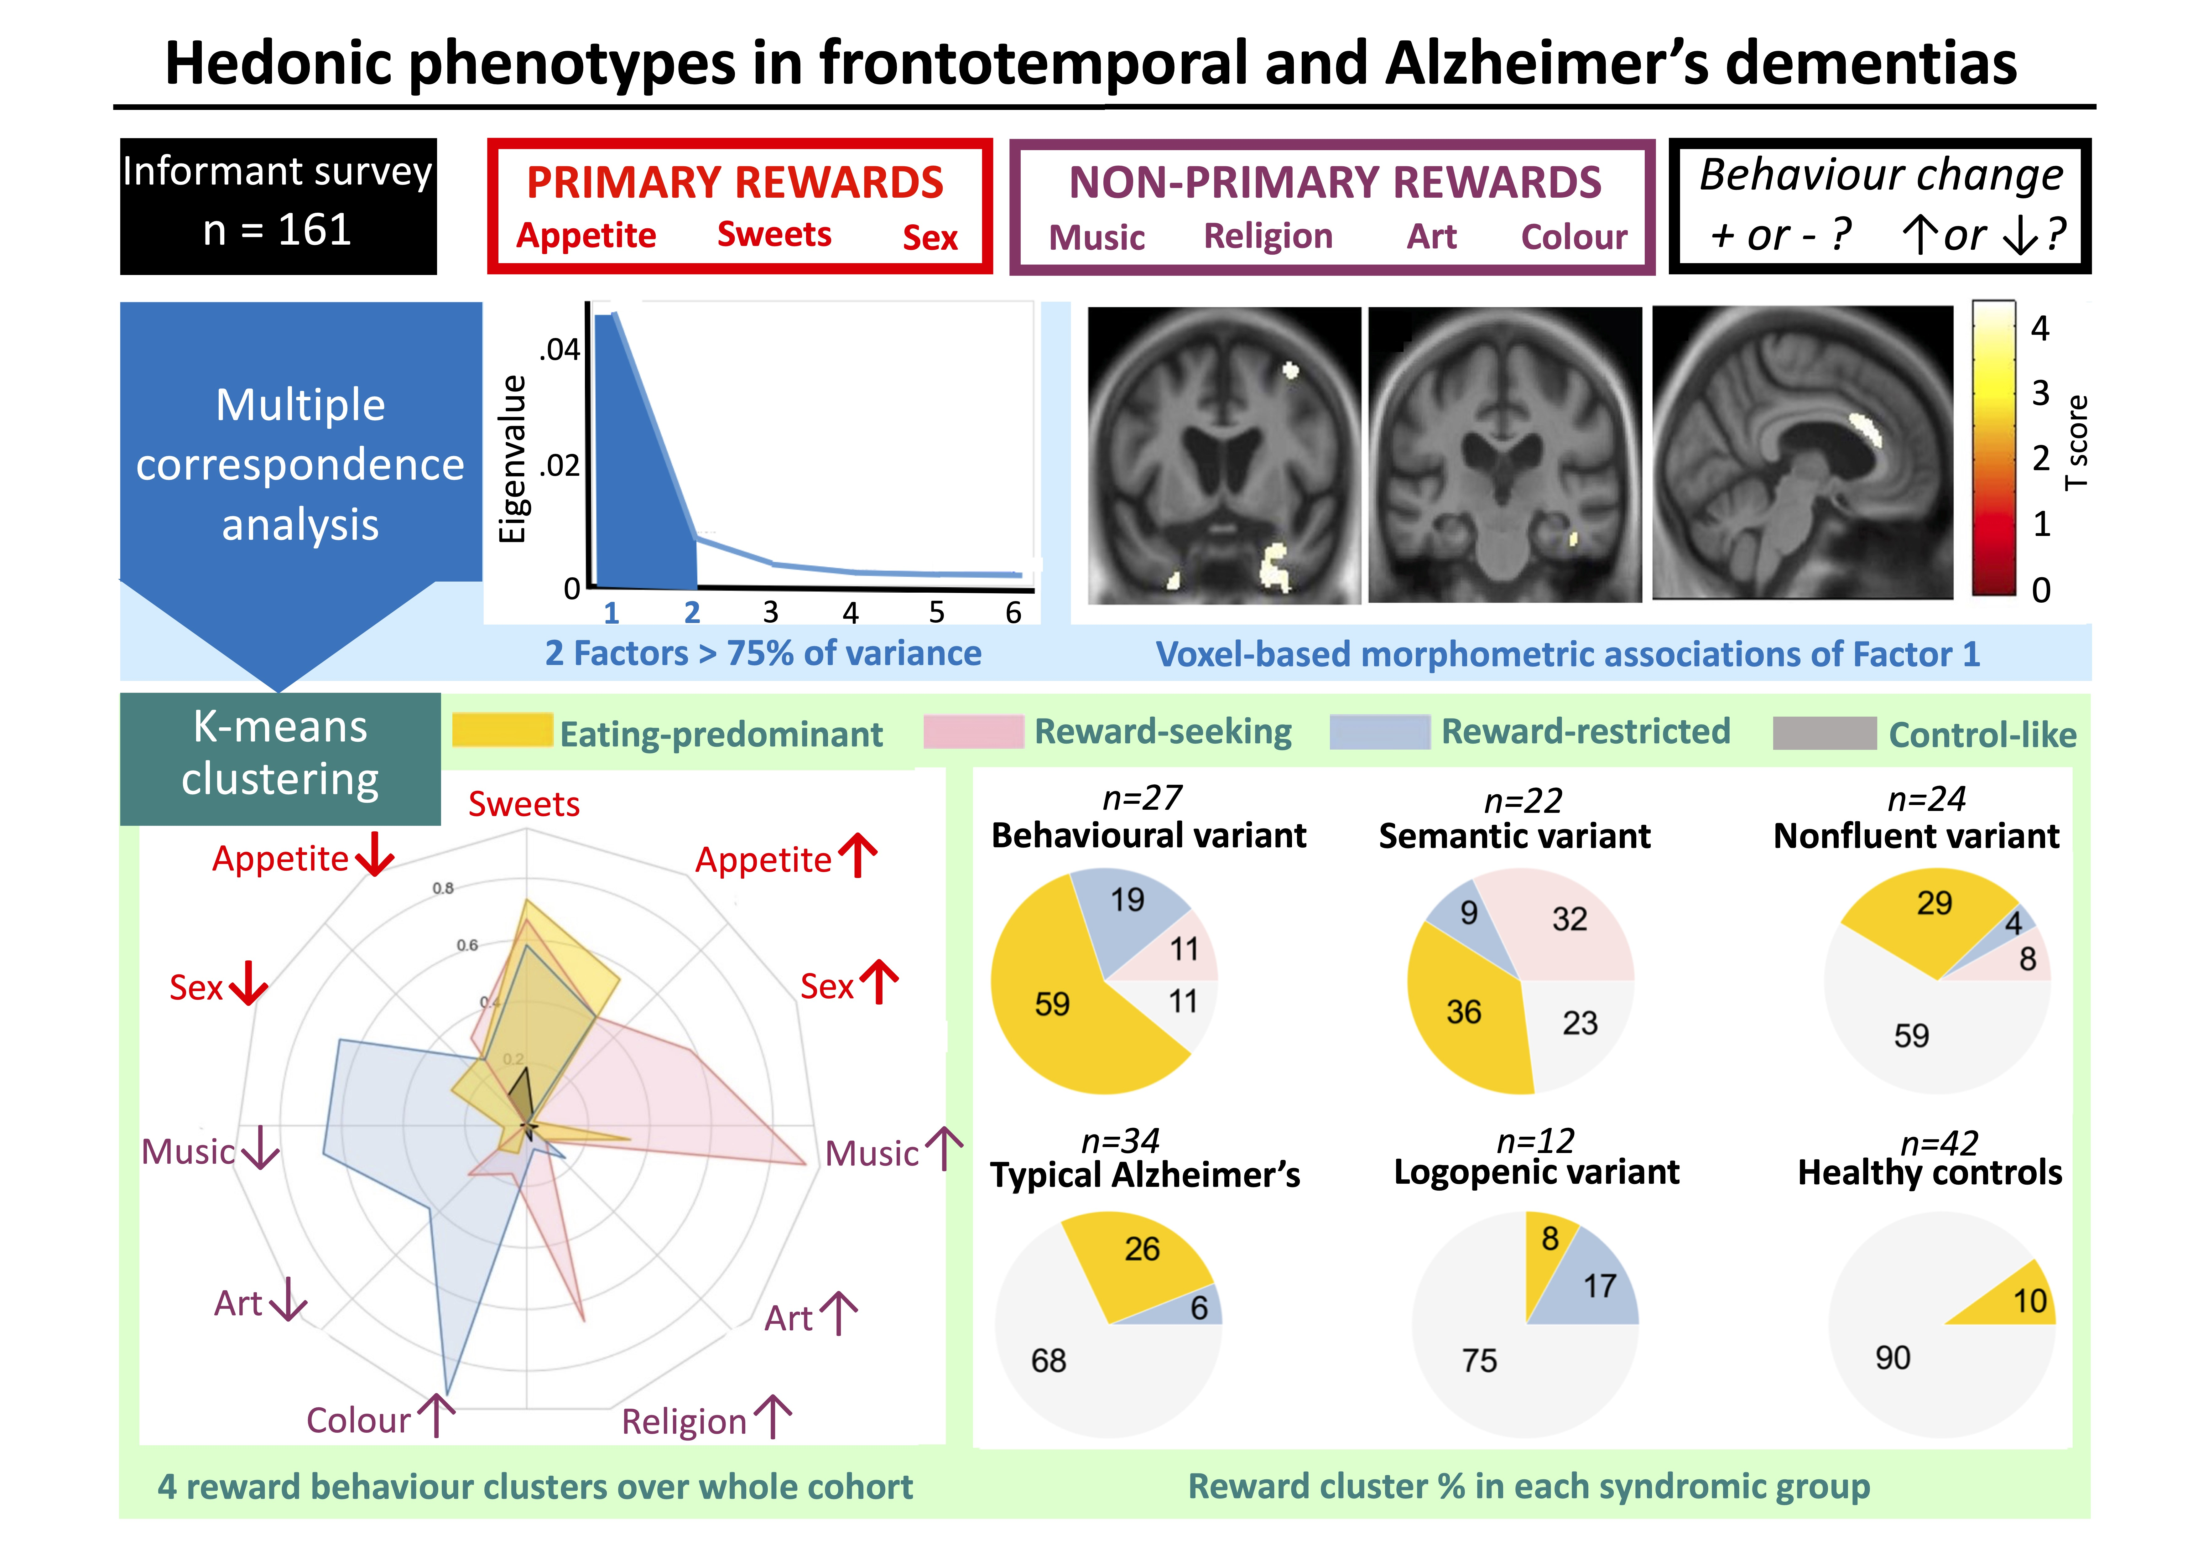  
Approach-avoidance tendencies in individuals with elevated blood pressure
10 February (Jennifer Lau. Centre for Psychiatry and Mental Health)

   | A study exploring reported blunted responses to stimuli in individuals with high blood pressure (BP) compares how participants with either high or low blood pressure completed approach/avoidance tasks. Participants completed two tasks, the first (congruent) where they pulled a joystick towards them when viewing a happy face (approach) and pushed it away when viewing an angry face (avoid), and in the second (incongruent) task reversing these action-to-emotion pairings. Overall participants were faster in performing the congruent than incongruent tasks. Among the low BP group, there were no reaction time differences to happy and angry expressions on either the congruent or incongruent tests, but those with high BP were quicker to respond to actions paired with angry than happy facial expressions across both tests. The results contrast with most earlier findings, which reported dampened emotional responses, irrespective of emotional valence, in relation to elevated BP.
Reliability of retrospective childhood maltreatment reports by individuals with bipolar disorder
10 February (Georgina Hosang, Athina Manoli, Sania Shakoor, Camilla Parker. Centre for Psychiatry and Mental Health)

Childhood maltreatment is associated with the etiology of bipolar disorder, but most studies use retrospective self-reports, which are vulnerable to bias. New research examines test-retest reliability over 10 years and the impact of current mood on retrospective reports of childhood maltreatment in 53 participants with bipolar disorder. Good agreement was found between Childhood Trauma Questionnaire reports at baseline and 10-year follow-up for these participants. Beck Depression Inventory and Self Report Mania Inventory were used to assess depressive and manic symptoms, and higher scores were recorded among participants who reported abuse (but not neglect) compared with those without such reports. Authors conclude that these findings support using retrospective maltreatment self-reports in research and clinical practice, but recommend that current mood should also be taken into account. | 
Obesity Stigma: Causes, Consequences, and Potential Solutions
14 February (Lola Oyebode. Centre for Public Health and Policy)

 | Results from a literature review show that although obesity stems from a complex interplay of genetic and environment factors, most of which are outside an individual’s control, obesity stigmatisation is widespread and has damaging consequences including psychological, physical, and socioeconomic harm. The paper asserts that obesity stigma does not prevent obesity, and that a concerted and sustained effort from multiple stakeholders and key decision-makers within society is required to dispel myths around personal responsibility for body weight, and to foster more empathy for people living in larger bodies. Authors say that this would also enable more effective policies and interventions, targeting the social and environmental drivers of health, to ultimately improve population health.
Interventions to reintroduce/increase assisted vaginal births
14 February (Soha Sobhy. Centre for Public Health and Policy)

A systematic review of studies implementing interventions to reintroduce or increase assisted vaginal births concludes that, while increased use was not associated with significant increases in adverse maternal or perinatal outcomes, there is insufficient evidence to indicate which interventions are more effective to safely increase use of assisted vaginal births. Assisted vaginal births can reduce maternal and perinatal mortality and morbidity associated with complications in the second stage of labour. The 16 studies examined (10 from LMICs) described interventions with components such as didactic sessions, simulation, hands-on training, guidelines, and audit/feedback. None assessed women’s views or designed interventions using behavioural theories. Interventions were less successful in LMICs than in HICs, and the main barriers to the successful implementation of the initiatives were related to staff and hospital environment. | 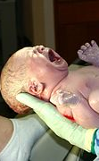
Best Available Treatment Study: therapy for multisystem inflammatory syndrome in children
14 Feb (Oleg Blyuss. Centre for Prevention, Detection and Diagnosis)

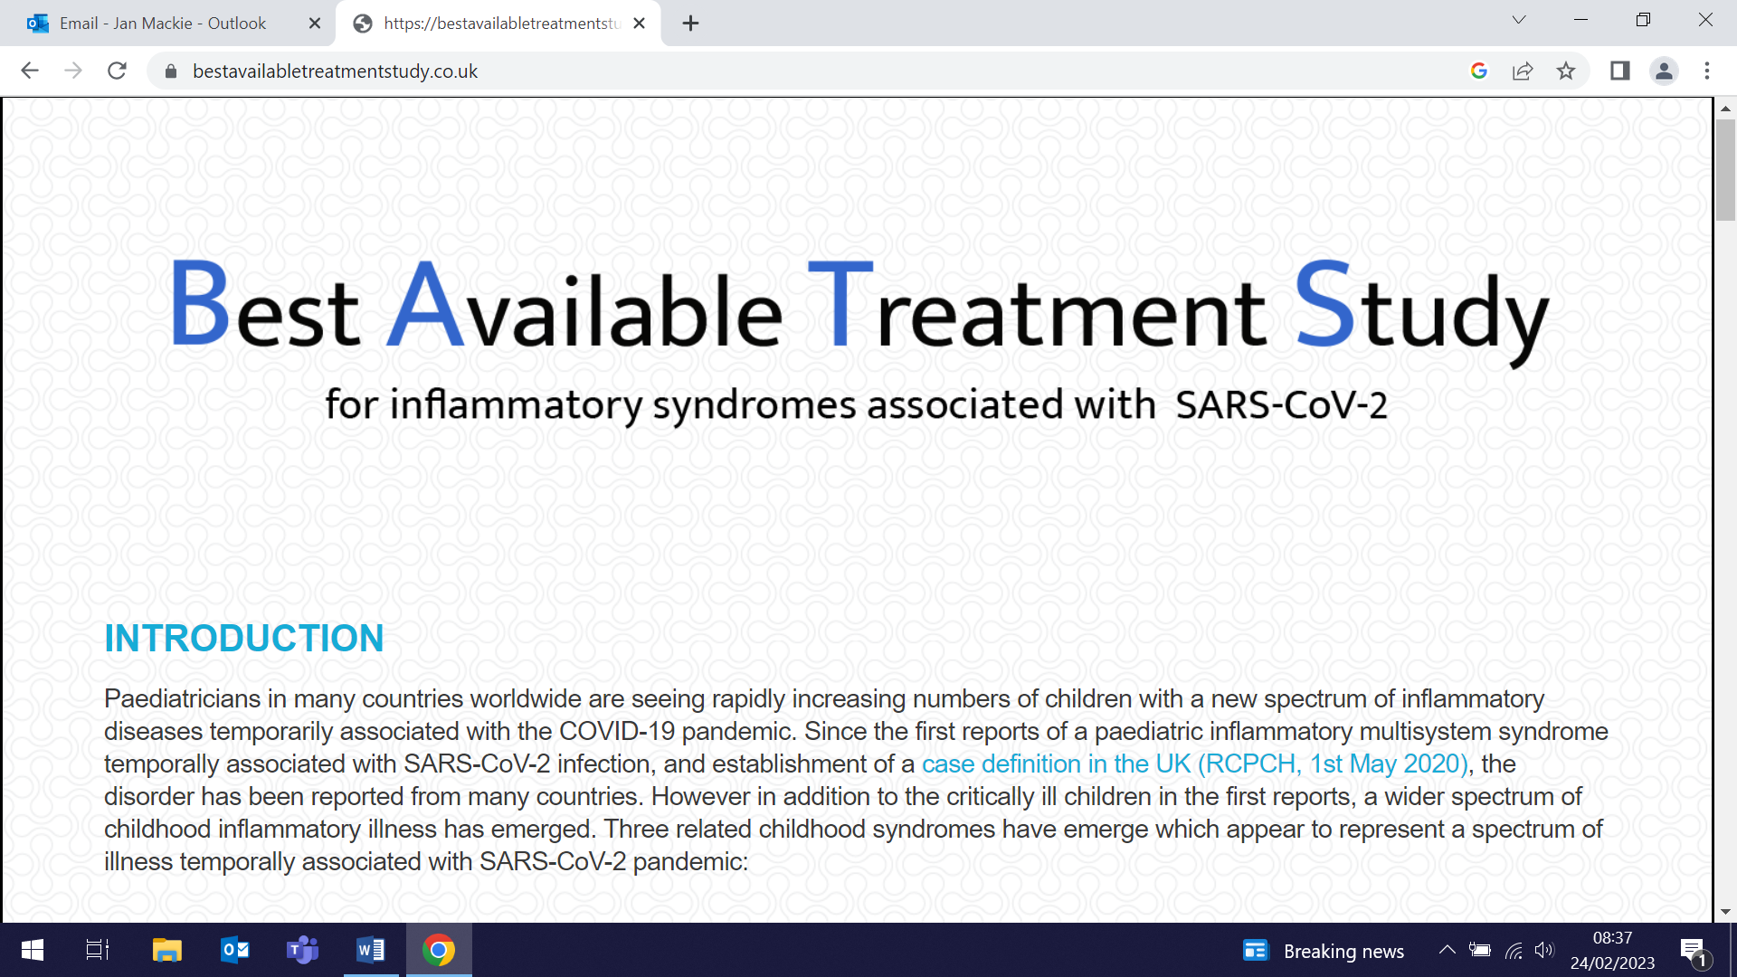  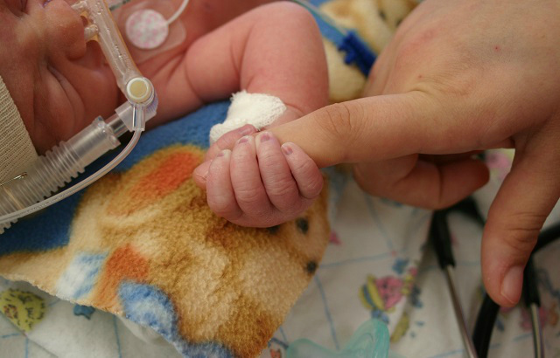 | Identified in the first wave of the COVID-19 pandemic, multisystem inflammatory syndrome in children (MIS-C) was a new disorder causing shock and multi-system failure in children 4-6 weeks after SARS-CoV-2 infection. Treatments of known benefit for other inflammatory disorders were rapidly adopted. A study comparing primary treatments (intravenous immunoglobulin, intravenous immunoglobulin plus glucocorticoids, or glucocorticoids alone) examines primary outcomes, including inotropic or ventilator support after treatment initiation, death, and time to improvement on an ordinal clinical severity scale. The analysis included 2009 children (median age 8y) with clinically diagnosed MIS-C from 39 countries. Results showed that recovery rates, including occurrence and resolution of coronary artery aneurysms, were similar for primary treatment with intravenous immunoglobulin v glucocorticoids or intravenous immunoglobulin plus glucocorticoids. Researchers suggest that initial treatment with glucocorticoids might be advantageous in view of the cost and limited availability of intravenous immunoglobulin in many countries.
Impact of multiple COVID-19 waves on UK gynaecological cancer services
16 February (Samuel Oxley, Ashwin Kalra, Michail Sideris, Emma Christine Atakpa, Adam Brentnall, Rhian Gabe, Ranjit Manchanda) Centres for Prevention, Detection and Diagnosis/Evaluation and Methods)

A study published in Cancers assesses responses to surveys of staff in UK cancer hospitals after the 2020, 2021 and 2022 Covid waves, and quantifies the impact of multiple COVID-19 waves on UK-wide gynaecological cancer service provision. The surveys, sent to British Gynaecological Cancer Society members, showed that during the first COVID wave, urgent referrals fell by 50%, 49% of hospitals reported reduced staffing, theatre capacity was reduced by 40%, 30% of planned operations were postponed, and 75% of outpatient consultations were remote. By the second wave there was a return to pre-pandemic urgent referral levels, fewer hospitals reported staffing reductions, and theatre capacity was reduced by 10%, with 5% of operations postponed. The third wave showed worsening staff reductions, similar to the first wave, but pre-pandemic levels of urgent referrals/workload continued, with little reduction in surgical capacity. | 
Creative writing workshops in a forensic mental health ward
16 February (Maria Turri. Centre for Psychiatry and Mental Health)

 | A creative writing intervention, focussing on everyday experiences and implemented in a forensic mental health ward as an innovative method for humanising care, is discussed and evaluated in a new study based on interviews with the mental health professionals involved. Analysis of the interviews revealed two themes: A new way of learning about each other, and Imagining beyond the staff-resident relationship. The authors discuss the benefits of the intervention in terms of its potential to foster mutuality and empathy beyond the illness narrative, and conclude that the workshops have potential to create collaborative environments and equalise relationships.
£4 million EU Grant for ETHEREAL Project
16 February (Beth Stuart. Centre for Evaluation and Methods)

A £4million EU grant has been awarded to fund the ETHEREAL (Epigenetic Genetic Mental Health Cascade Based Personalised Prevention of Non-communicable Disease in Adolescents with Autism) project. The study will investigate the use of statistical and machine learning approaches to help identify young people with Autism Spectrum Disorder who will develop mental health disorders. Lead statistician and co-applicant on the grant, Beth Stuart, said that the research will explore which factors may be linked to this, and whether personalised strategies can be developed to help improve clinical management. The project was launched at a meeting on 16 February, and will run for three years. | 
Osteoporosis-related characteristics in an English care home
17 February (Rohini Mathur. Centre for Primary Care)

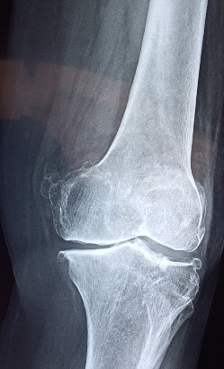 | A study comparing 8,366 care home residents with 16,143 age matched non-care home residents examines fracture risk factors, fracture rates, post-fracture outcomes, and osteoporosis treatment duration. Fracture risk factors, including higher BMI, history of falls, prior fracture, and prior hip fracture were more common among care home residents. The fracture rate was also higher in the care home cohort. Osteoporosis treatment was initiated in 3.6% of residents, and 46% of these remaining on treatment at 12-months. Among care home residents who experienced fracture, 21.9% received an osteoporosis diagnosis, and following a hip fracture, 21% of residents initiated osteoporosis treatment. Authors conclude that osteoporosis diagnosis, treatment rates, and treatment duration were low among care home residents, and that this finding represents an opportunity to improve osteoporosis management in this vulnerable population
NIHR awards £1.8 million to develop digital hearing tests for dementia diagnosis
17 February (Charles Marshall. Centre for Prevention, Detection and Diagnosis)

The NIHR has awarded £1.8 million to fund the DIADEM (Digital assessment of auditory perception in dementia) project, led by Charles Marshall. Current dementia diagnostic tests are ‘blunt’ and expensive, and people who are more deprived or from minoritised ethnic groups tend to be diagnosed later and less accurately. New digital hearing tests that measure early brain changes in dementia could transform dementia diagnosis. The team’s proof-of-concept work shows that these tests can differentiate Alzheimer’s patients from controls with very high accuracy, measure disease severity, monitor response to treatment, and stratify risk of incident dementia over a 10 year follow-up in healthy adults. DIADEM will evaluate the tests in real world settings, in NHS memory clinics serving a diverse and deprived population. | 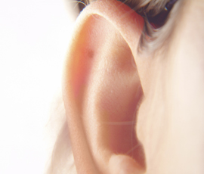
Association between visual impairment and psychosis
17 February (Claudia Cooper. Centre for Psychiatry and Mental Health)

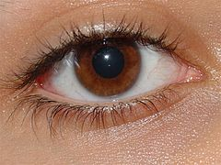 | A theorised association between visual impairment and psychosis is examined in a new study conducted in the UK Biobank cohort. In a nested case control study of 116,000 adults, researchers tested whether a Schizophrenia Spectrum Disorder (SSD) diagnosis as exposure was associated with visual impairment. They also tested longitudinally whether poorer visual acuity, and thinner retinal structures on Optical Coherence Tomography scans in 2009 were associated with psychotic experiences in 2016. Results showed that people with visual impairment had greater odds of SSD than controls, and there was evidence that poorer visual acuity was associated with psychotic experiences during follow-up. In complete case data (15% of this cohort) no clear association was found, although confidence intervals included the multiple imputation effect estimates. Optical Coherence Tomography measures were not associated with psychotic experiences. While the findings highlight the importance of eye care for people with psychotic illnesses, the study could not conclude whether visual impairment is a likely causal risk factor for psychosis.
Weight change comparison: face-to-face v digital delivery of the English NHS diabetes prevention programme
20 February (Jamie Ross. Centre for Primary Care)

Face to face (F2F) diabetes prevention programmes encouraging behaviour change towards weight loss, healthy eating, and increased exercise are known to be effective. In 2017-18, 65741 patients in England in the NHS Diabetes Prevention Programme made a choice from offers of group-based F2F delivery, digital delivery, or a choice between digital and F2F, thereby enabling a robust study to compare weight changes at 6 months in these cohorts. Weight change data were missing for around half of patients, and researchers estimated the average effect by making a range of assumptions in order to include all participants in the programme. The study found that, in all scenarios, enrolment in the digital programme was associated with clinically significant reductions in weight at least equivalent to weight loss in the F2F programme. Patients who chose digital after being offered a choice of digital or F2F achieved (significantly) better weight loss outcomes than those offered only F2F. | 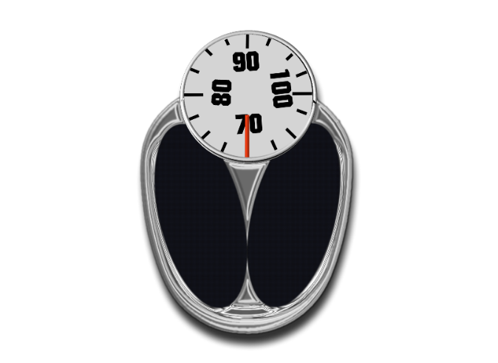
New guidelines for recognising and treating nitrous oxide abuse
23 February (Alvar Paris, Alastair Noyce. Centre for Prevention, Detection and Diagnosis)

 | Recommendations from a research paper on the diagnosis and treatment of subacute combined degeneration of the spinal cord (N₂O-SACD) caused by nitrous oxide abuse have been simultaneously adopted as official clinical practice guidelines by the Association of British Neurologists. The research is based on a project to improve diagnosis and treatment of N₂O-SACD at the Royal London Hospital, where a new case presents, on average, once a week. A large majority of patients present with inability to walk, falls, and tingling or loss of sensation in their feet and hands. While the condition may be treated effectively if recognised early, it is commonly misdiagnosed and inappropriately treated, and no agreed treatment guidelines have previously existed.
Genetic risk scores in symptomatic cancer detection
23 February (Evangelos Katsampouris, Sammy Quaife. Centre for Prevention, Detection and Diagnosis)

An editorial in the British Journal of General Practice states the case for improved cancer triaging in primary care to achieve better cancer detection. Most cancers in the UK are diagnosed following symptomatic presentation to primary care, with GPs basing referral on presenting clinical features with a 3% or greater chance of cancer. Authors suggest that incorporating a genetic risk score (GRS), giving a personalised risk of developing a particular cancer in a patient’s lifetime, would improve risk stratification and inform clinical decision making for patients presenting in primary care. While evidence for clinical use of GRS in the early detection of cancer is almost exclusively in the context of asymptomatic risk prediction and targeted screening, and is limited to heritable cancers, the CRC UK Stratified Medicine Programme has demonstrated that routine genomic testing can be delivered at scale in a timely manner in the NHS. The authors predict: Widespread genomic testing is coming. | 
Individual-level UK healthcare costs associated with cardiovascular events
23 February (Runguo Wu, John Robson, Boby Mihaylova. Centres for Evaluation and Methods/Primary Care)

 | Individual-level healthcare cost prediction models have been developed to help inform assessments of the value of health technologies and policies to reduce risks and healthcare costs for cardiovascular disease (CVD). Researchers used data from the UK Biobank on people aged 40-70 to construct regression models of primary and hospital care costs associated with myocardial infarction (MI), stroke, coronary revascularization, incident diabetes mellitus and cancer, and vascular and nonvascular death. In people without previous CVD mean annual primary and hospital care costs were £360 and £514, respectively. Excess primary care costs were £190 and £360 following MI and stroke, respectively; excess hospital costs decreased from £4340 and £5590, respectively, in the year of these events, to £190 and £410 two years later. People with previous CVD had more than twice higher annual costs, and incurred higher excess costs for cardiovascular events. Authors provide an Excel calculator to facilitate the use of the models.
Reactions following SARS-CoV-2 vaccination: incidence determinants and serological correlates
25 February (Hayley Holt, David Jolliffe, Mohammad Talaei, Matthew Greenig, Seif Shaheen. Centres for Public Health and Policy/Prevention, Detection and Diagnosis)

In a study among 9003 UK adults receiving SARS-CoV-2 vaccines, researchers used dried blood spots collected before and after vaccination to determine serologic responses, and assessed reactive symptoms after first vaccine dose. Results show that 47.3% of participants experienced reactive symptoms and that factors associated with lower risk of symptoms included older age, male sex, and receipt of an mRNA vaccine v ChAdOx1 nCoV-19. Post-vaccination anti-S titres were higher among participants who experienced reactive symptoms after vaccination. Authors conclude that improved public understanding of the frequency of reactive symptoms and their positive association with vaccine immunogenicity could potentially increase vaccine uptake. | 
Gynaecological Surgery Education in India
25-28 February (Ranjit Manchanda. Centre for Prevention, Detection and Diagnosis)

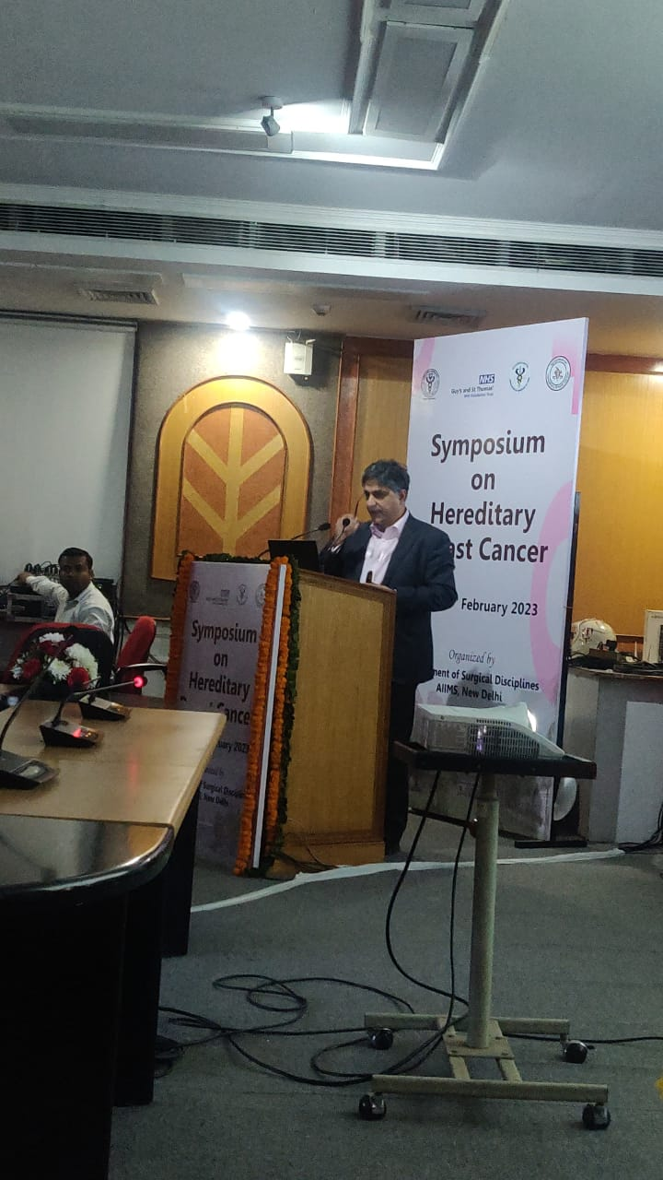 | Through the second half of February Professor Ranjit Manchanda has been presenting a series of talks and masterclasses at symposia and workshops in India. His talk to the Symposium of Hereditary Breast Cancer in New Delhi on 25 February covered “Gynaecological management of hereditary breast and ovarian cancer syndrome: implications for breast surgeons”. He then moved on to present at the Masterclass and Live Surgical Workshop in Gynae Oncology for the Association of Gynaecologic Oncologists of India.
FORTHCOMING EVENTS AND NOTICES

Dementia & Delerium: From Genes to Care (1 March)

The next Barts Academic Afternoon, will be held from 2-5pm on Wednesday 1 March at the Morris Lecture Theatre. Dementia& Delerium: From Genes to Care will be chaired by Claudia Cooper, with presentations aimed to highlight recent developments in dementia and delerium research with a focus on local clinical research and the implications of this for day-to-day practice for all psychiatrists. Speakers include Fiona Walter, Charles Marshall, Claudia Cooper, and Afia Ali. All are welcome to attend, and there is no need to register in advance. |   
Inaugural Clinical Academic Research Day: 2 March

Queen Mary's Faculty of Medicine and Dentistry Clinical Academic Research Day will take place from 10:00-17:30 on 2 March in the Octagon, Mile End Campus. This new event will showcase the exciting research being done by our clinical academic trainees at all stages. All clinical academic trainees - Specialist Foundation fellows, Academic Training Fellows, PhD or MD students or Clinical Lecturers, and supervisors - are invited to attend. The event is free to attend, but registration is required. Contact: Bijal Tailor or book tickets here. | 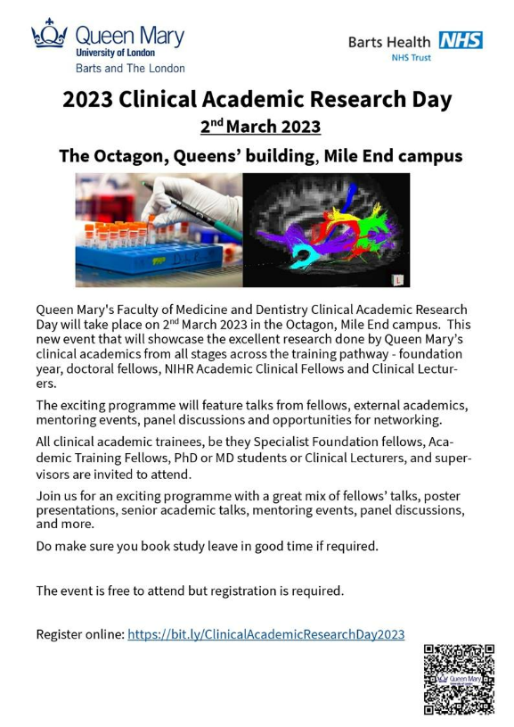
QMUL Pregnancy Research Network Launch: 9 March

The launch and inaugural meeting of the new QMUL Pregnancy Research Network will take place from 1-5pm on 9 March at the Clark-Kennedy Lecture Theatre, Whitechapel. The network aims to bring together QMUL researchers working on any aspect of pregnancy, women’s and child health, to forge collaborations between clinical and non-clinical academics working in this field, and to update on new and upcoming projects related to the network. Speakers will include Sarah Finer: Pregnancy research in Genes & Health: recent findings and future opportunities. Anyone interested in work in this field is welcome to attend. | 
Many thanks to all who so enthusiastically contribute. Please send any news items for the next newsletter to j.a.mackie@qmul.ac.uk

