WOLFSON INSTITUTE OF POPULATION HEALTH
NEWSLETTER
ISSUE 32: 12 APRIL 2023

In this issue of our Wolfson Institute of Population Health Newsletter, we celebrate the achievements and work of staff and students through the second half of March and early April.

FROM OUR DIRECTOR
Dear Colleagues  Hoping everyone has had a lovely break over the last week, with some warm spells and the daffodils and magnolias finally out to herald Spring.  As the overarching aim of our Institute is to explore the causes of poor health and design novel interventions and evaluate measures aimed at improving the health and quality of life of individuals and populations, I’m delighted to see such a strong focus on addressing health inequalities in this newsletter. | 
Rohini Mathur’s excellent BMJ editorial examined the collection and use of ethnicity data. For those who haven’t yet met her, Rohini joined the Centre for Primary Care late last year, and is providing strong leadership in data science with a focus on health inequalities. Two other recent arrivals to our Institute, Lola Oyebode and JohnFord, have also published reviews, respectively contributing to our understanding of at-risk groups for infectious disease worldwide, and premature mortality in England, while Joe Freer published guidelines for GPs on inequalities in childhood short stature.

Congratulations to you all on yet another strong showing of valuable research.

With warm wishes

Fiona

MEET WIPH

Meet: Simpson Wong (Lecturer in Mental Health. Centre for Psychiatry and Mental Health)

How would you describe your roles and responsibilities?
I teach several pathways of the MSc Mental Health programmes, mainly Cultural Psychology and Psychiatry, Psychological Therapies and Public Mental Health, and I am currently involved in a multidisciplinary study investigating child development using molecular genetic, behavioural genetic, and neuro-imaging techniques. I also study the interplay between physical and mental health in children with special educational needs and their parents.

What has been your greatest professional achievement?
I published a book on guiding educators to create educational comics: When a teacher met a cartoonist: A guide to creating educational graphic novels. The comic artist who helped me to design and draw was my student, and then my research assistant. I could never have imagined motivating a comic artist to work as a research assistant for more than a decade! Because of this publication, I feel I can call myself a “book” author.

What aspects of your role do you enjoy the most?
I enjoy chatting with students and colleagues, because life stories are fascinating. I enjoy the intellectual exchange as well.

What would be your second choice as a profession?
Whatever role might allow me to spend time with different kinds of residential properties in the UK - perhaps an estate agent, builder, or gardener? British architectural style and interior design are really impressive!
What do you enjoy doing outside work?  Outside of work I try to keep myself away from computers and screens. I enjoy driving, eating, watching films, shopping, visiting museums, and playing basketball, both alone and with my family.  Something most people don’t know?  Simpson is a nickname given to me by my friends in boarding school when I was studying year 7 in Hong Kong. I arrived thinking that the boarding school would provide me with sportswear, so I didn’t need to bring any. It turned out that nothing was provided, and so I wore a t-shirt printed with Bart Simpson riding a skateboard up until term break. | 
FROM OUR LEADERSHIP TEAMS AND REPRESENTATIVES

Education Update: Mark Freestone (Director of Education)

Digital Education news: Welcome to Ava Kanyeredzi, who joins us as a Senior Lecturer in Mental Health and also the Institute’s new Digital Education lead. Ava will be working with WIPH distance learning programme leads, as well as the new FMD Digital Education Community of Practice (DeCoP), chaired by Andrew Harmer, to refresh our mental health distance learning offerings over the next year.
BSc BioMed Projects: The Faculty is still seeking supervisors for undergraduate non-medical students on the biomedical sciences BSc module BMD600, and also the ‘Public engagement in science’ module BMD606. Please email Joanne Littlefair if you are able to support a student lab (including dry lab) research project or public engagement project.
GENERAL INSTITUTE NEWS

Eosinophilia and over-prescription of SABA inhalers
15 March (Hajar Hajmohammadi, Chris Griffiths, Anna De Simoni. Centre for Primary Care)

Eosinophilia and over-prescription of short-acting beta-agonist (SABA) inhalers are strongly associated with exacerbation risk in asthma. An analysis of electronic health records for SABA over-prescribed asthmatic patients in NE London shows that many are non-eosinophilic, with a low exacerbation frequency, suggesting disproportionately high SABA prescription compared with other asthma control markers. Eosinophilia was significantly less likely in female patients, patients with multiple mental health comorbidities, and those with SABA repeat prescriptions. When stratified by latent class (uncontrolled, mild, or difficult asthma), mild was the largest class. SABA overuse may result from repeat prescriptions dispensed but unused, and use for non-asthma breathlessness. | 
WIPH Expert Comment: Britain slips in global life expectancy rankings
16 March (Jonathan Filippon. Centre for Public Health and Policy)

 | Comments from Jonathan Filippon were widely quoted in international media outlets, including The Times, Guardian, and New York Post, in response to a new publication by researchers from Oxford and LSHTM showing that the UK now ranks 29th in global life expectancy, and second worst in the G7. In his comments, disseminated by the Science Media Centre, Jonathan said: Poorer people die sooner, but the question that lingers is why social inequality gets worse, here and on the other side of the pond, simultaneously over so many decades. We do need to look at the predominant ideologies running at both nation states.
Argatroban coagulation assay interference: potential for clinical decision-making errors
20 March (Peter MacCallum. Centre for Prevention, Detection and Diagnosis)

A recent UK NEQAS publication suggests interference in Clauss fibrinogen activity (Fib-Ac) assays in the presence of the direct thrombin inhibitor Argatroban. A new study examines the relationship between argatroban levels in 133 residual ex vivo plasmas from 13 Barts NHS patients and multiple fibrinogen activity and antigen assays using samples with argatroban levels above 0.05μg/mL. Fibrinogen antigen (Fib-Ag) and Fib-Ac were measured on one aliquot, and HemosIL Fibrinogen-C (Fib-C) and HemosIL QFA Thrombin (QFA) were used to measure Fib-Ac on the second aliquot. Argatroban levels in 129 samples were below 2.40μg/mL, twice the upper limit of the suggested therapeutic range. Findings indicate that Fib-Ac results using Fib-C in patients on argatroban should be regarded cautiously as they may lead to anticoagulation being paused or fibrinogen replacement being administered when argatroban levels are within or even below the therapeutic range. Authors suggest that a similar study be performed in samples from patients receiving bivalirudin. | 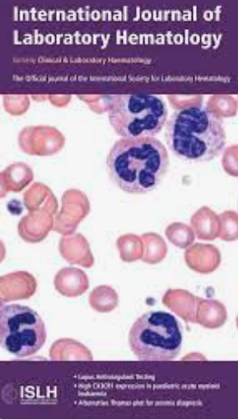
QM Education Excellence Awards: President and Principal’s
20 March (Jonathan Kennedy. Centre for Public Health and Policy)

   | Jonathan Kennedy and colleagues Danielle Thibodeau and Ceri Bevan were recipients of a President and Principal’s Prize at the 2023 QMUL Education Excellence Awards. The award recognised the team’s work developing a virtual exchange programme between global public health students and pre-med students at UC Santa Cruz, focused on the theme of pandemics. The project, funded by the US-UK Fulbright Commission's Global Challenges Teaching Award, was the first virtual exchange programme developed at QMUL, and the first to combine virtual exchange and pandemic simulation.
Migration and health in the context of global climate change
20 March (Dominik Zenner. Centre for Public Health and Policy)

To better understand relationships between climate change-related events, migration patterns, and their implications for health, a new paper proposes a conceptual model based on responses from interdisciplinary experts to an 11 item questionnaire focusing on 3 themes: predicting population migration by understanding key variables, health implications, and suggestions on policy and research. Participants framed the impacts of climate change events on migration patterns and their health implications as non-linear and indirect, comprising many interrelated individual, social, cultural, demographic, geographical, structural, and political determinants. Authors say inclusive and equity-based health services, improved and faster administrative systems, less restrictive immigration policies, globally trained staff, efficient and accessible research, and improved emergency response capabilities are needed, and that focus should be on increasing preventive and adaptation measures in the face of environmental changes and responding efficiently to different phases of migration. | 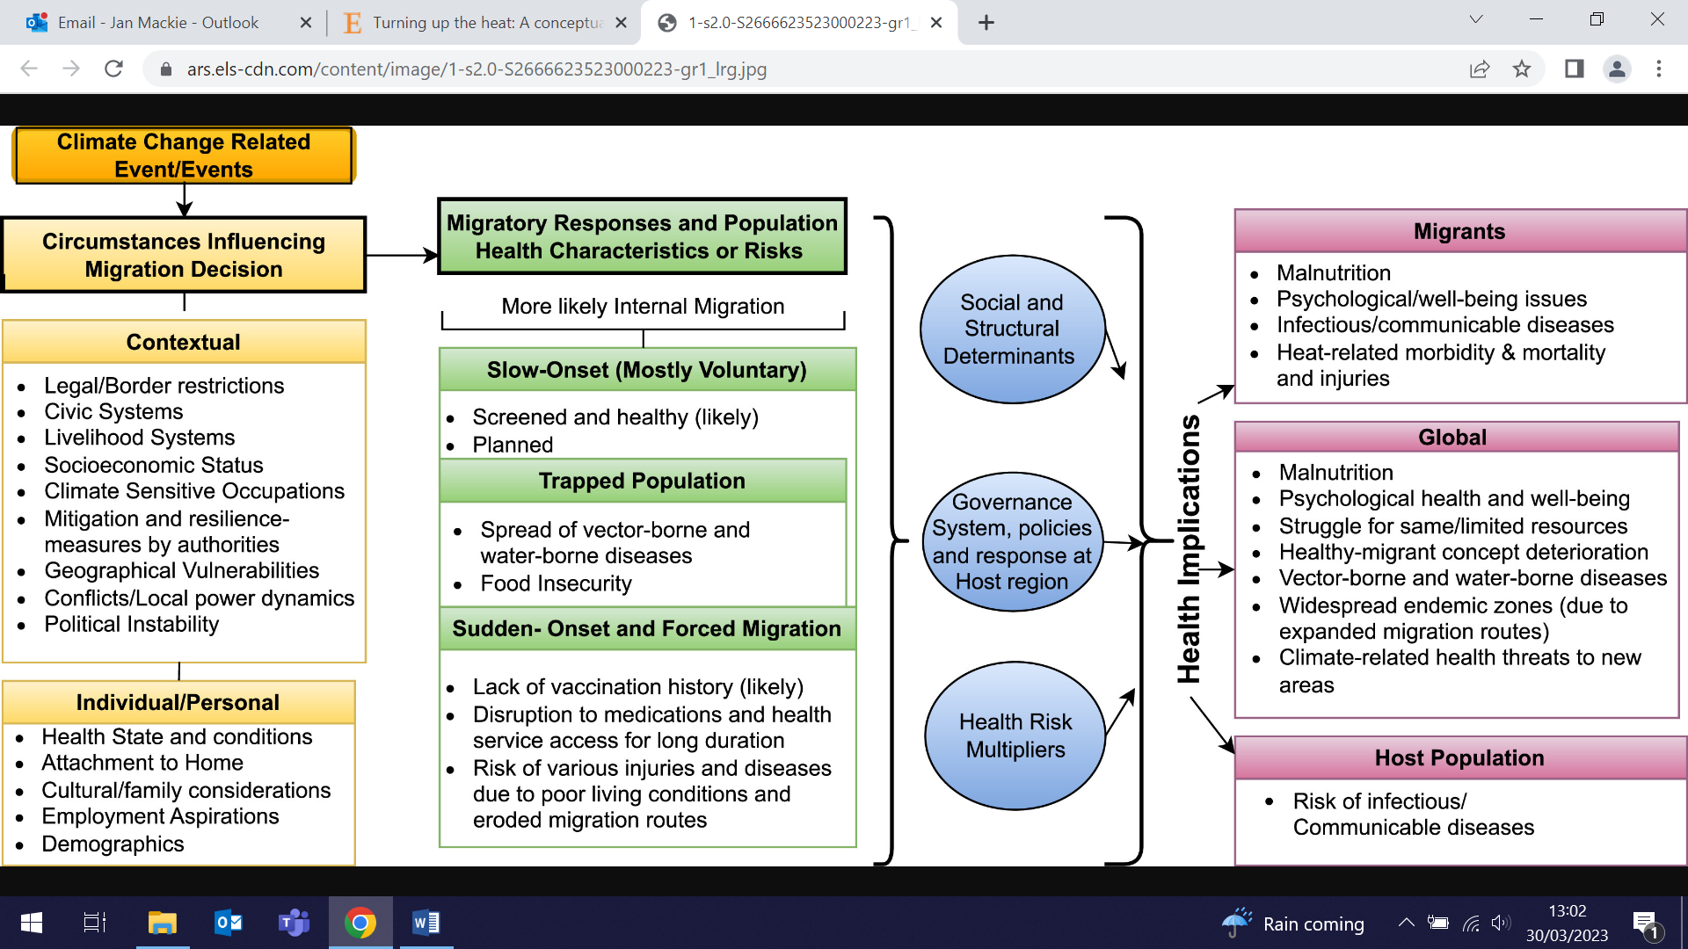  
Voices of Women of African Descent for Reproductive and Climate Justice
21 March (Heather McMullen, Natasha O’Sullivan. Centre for Public Health and Policy)

  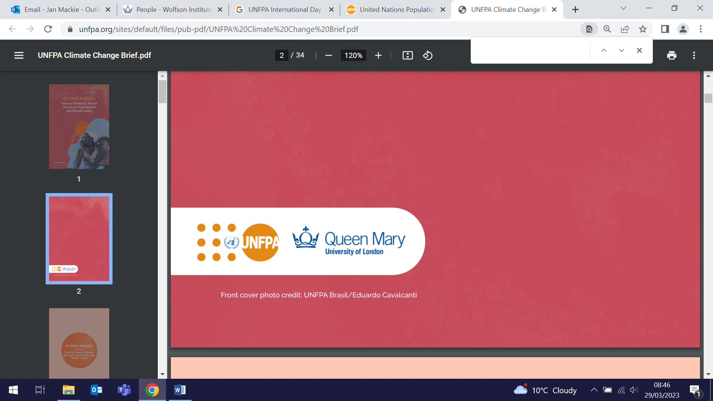 | To coincide with International Day for the Elimination of Racial Discrimination on 21 March, the United Nations Population Fund (UNFPA) released an advocacy brief: In our words: Voices of women of African descent for reproductive and climate justice. Co-produced with QMUL partners, the brief explores how climate change disproportionately harms women of African descent and other members of marginalized communities, and exacerbates obstacles to their achievement of sexual and reproductive health and rights. Contributing WIPH author, Heather McMullen, said that the brief also makes clear that despite having contributed very little to the global climate crisis, communities of African descent are too often left to deal with its worst effects.
Residual risks from multicancer early detection tests
21 March (Fiona Walter. Centre for Prevention, Detection and Diagnosis)

An editorial in Cancer discusses the potential of multicancer early detection (MCED) tests, the challenges in their evaluation and, crucially, the downstream clinical pathways from their use. MCED tests being developed rely primarily on detection and analysis of cell-free DNA, with some now undergoing clinical and feasibility studies. Fiona Walter and colleagues reflect that a positive MCED test result requires subsequent testing to identify the cancer signal origin, and that failure to confirm this implies a subsequent unknown residual risk. Residual risks modelled to date have wide ranges, and authors say that these need to be narrowed to provide the foundation for formal guidance to primary care and other clinicians and patients, to guide decisions about further diagnostic evaluation. | 
JAMA Neurology: Top 3 Altimetric Scores for 2022
22 March (Charles Marshall. Centre for Prevention, Detection and Diagnosis)

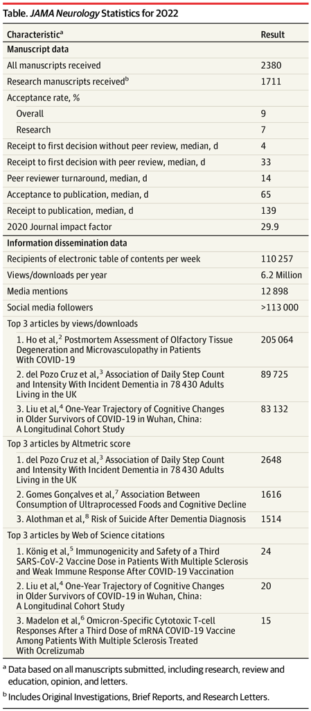 | A 2022 paper on the risk of suicide after a dementia diagnosis, authored by Charlie Marshall and colleagues, has been highlighted in the JAMA Neurology top three Altimetric hits of the year, with a score of 1514. JAMA Neurolology has 6.2 million downloads annually.
2022 Gerald L. Klerman Young Investigator Award
22 March (Georgina Hosang. Centre for Psychiatry and Mental Health)

Congratulations to Georgina Hosang, who is the recipient of the 2022 Gerald L Klerman Young Investigator Award. The Depression and Bipolar Support Alliance (DBSA) Scientific Advisory Board Klerman Award committee noted that they were “most impressed with the scope and impact” of her research on bipolar disorder and major depression. Georgina will attend the ISBD Conference reception in Chicago in June to accept her award. |   
Population-based data support adoption of primary HPV screening in the US
22 March (Jack Cuzick, Rachael Adcock. Centre for Prevention, Detection and Diagnosis)

 | Addressing the absence of real-world evidence for the United States (US) to support the adoption of primary HPV screening, new research provides the first population-based data comparing co-testing vs cytology-only as the initial screening test. The data from New Mexico, where multiple disparities exist across highly varied healthcare delivery settings, show that adding HPV testing to cytology substantially increased the yield of cervical precancer (CIN2+/CIN3+) during conditions of opportunistic cervical cancer screening and follow-up, and that CIN3+ was rarely diagnosed in HPV-negative women with abnormal cytology. Authors conclude that these results support primary HPV-only screening in the US.
WIPH Expert Comment: Progestogen-only pill breast cancer risk
22 March (Stephen Duffy. Centre for Prevention, Detection and Diagnosis)

In comments disseminated through the Science Media Centre, Stephen Duffy assessed new research from Oxford University on the breast cancer risk of the progestogen-only contraceptive pill. Noting that ten years after stopping, there was no excess risk associated with oral contraceptive use, he added that the results are reassuring, in that the effect is modest. Stephen’s comments were published by the BBC and the Daily Mail, among other syndicated media outlets. | 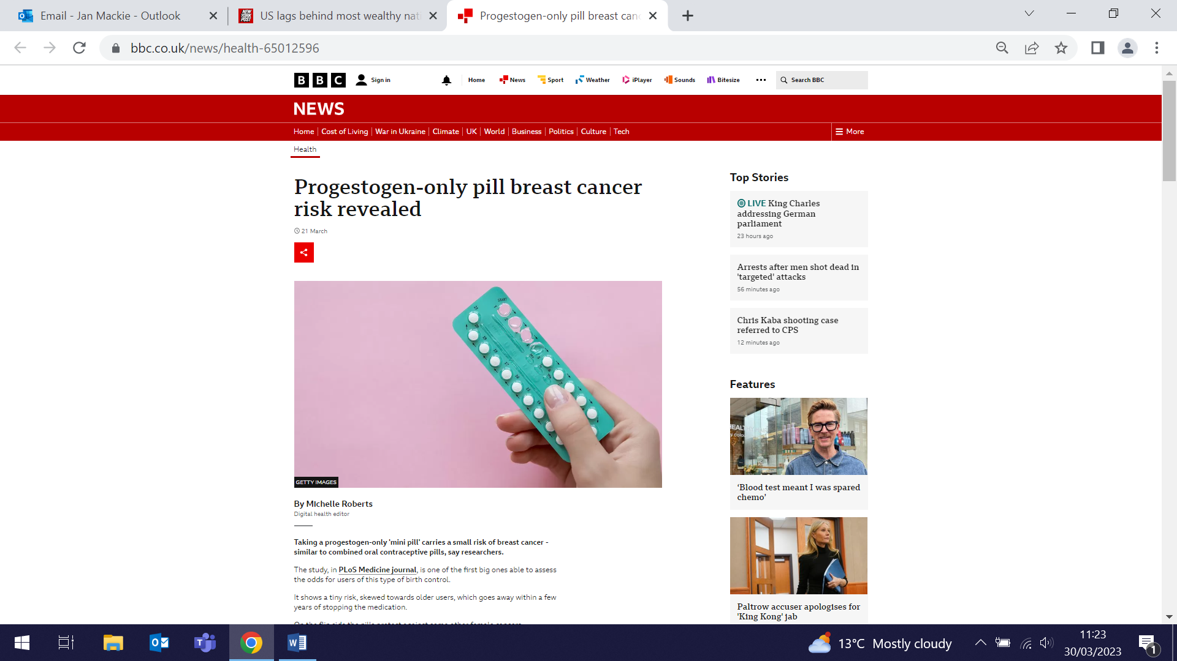
Primary care support for patients affected by domestic violence and abuse during the pandemic
23 March (Anna De Simoni, Chris Griffiths. Centre for Primary Care)

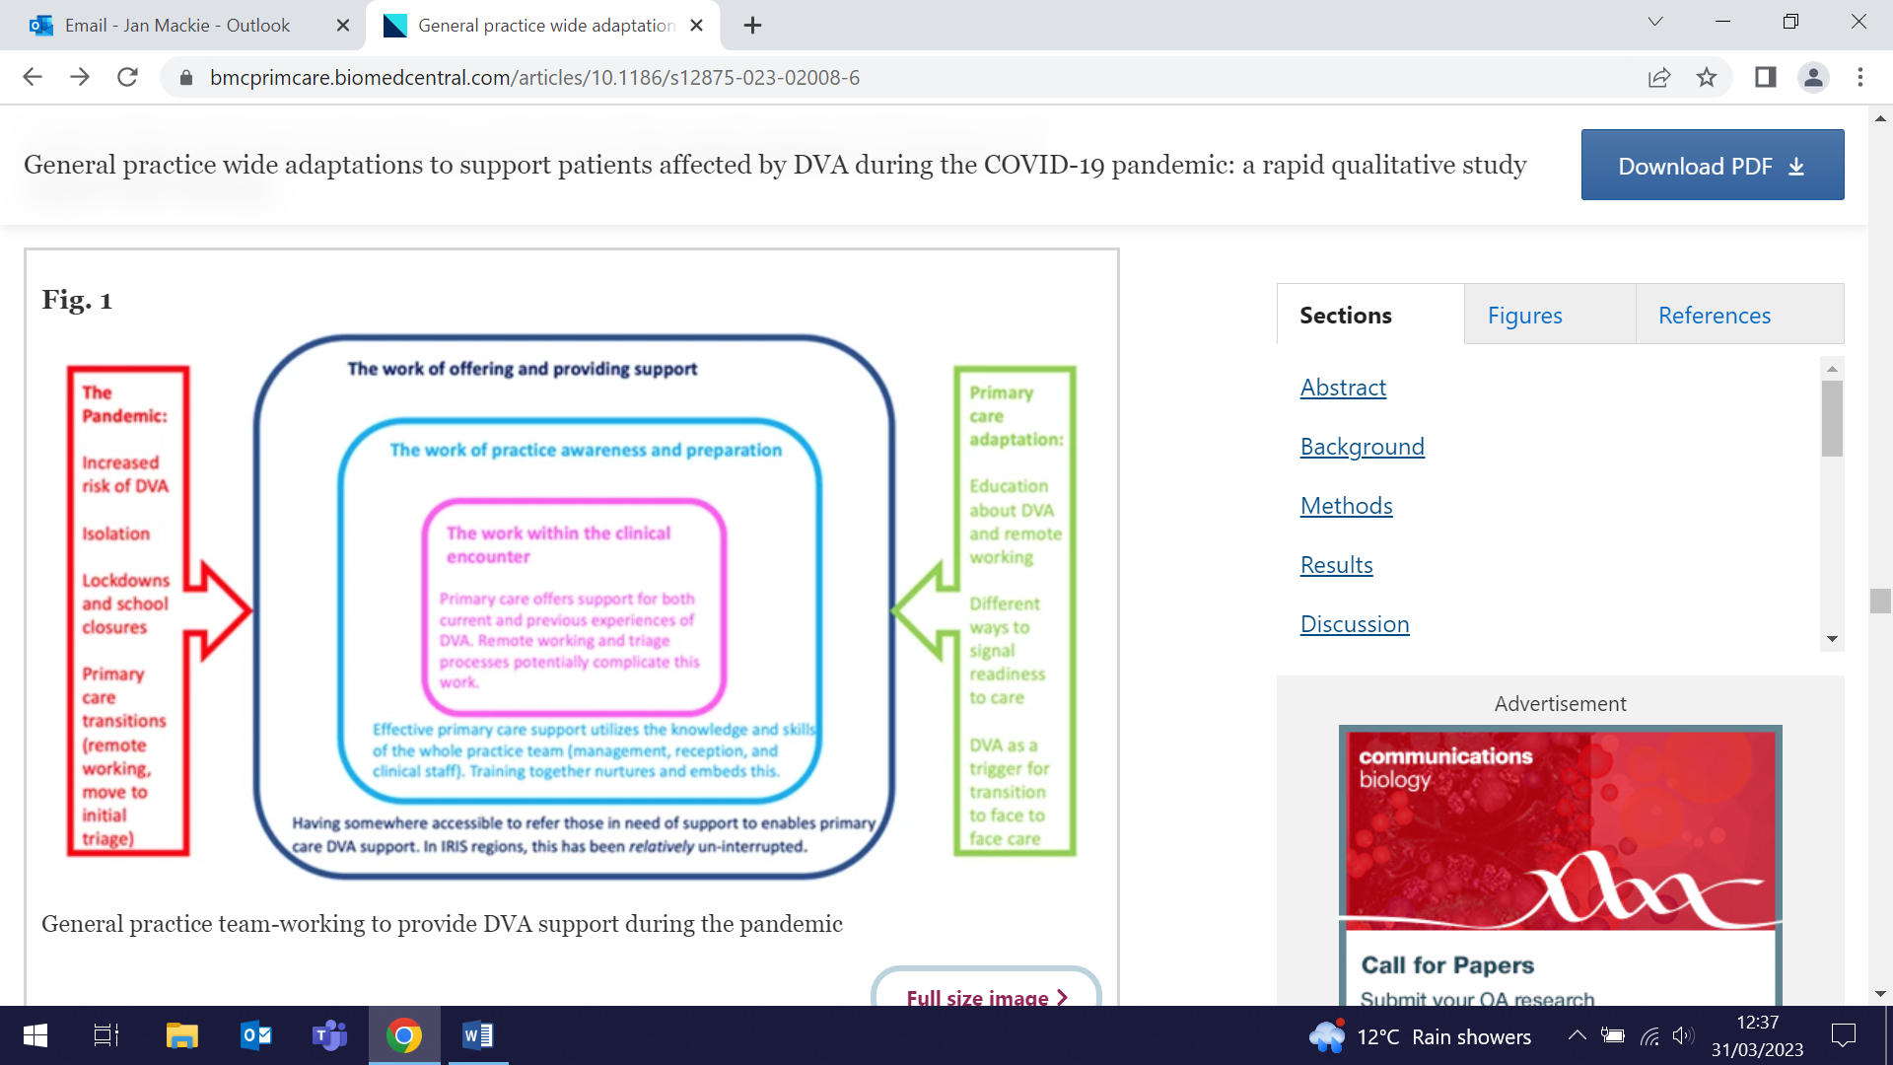   | An interview-based study investigating the adaptation of general practice to care for those affected by domestic violence and abuse (DVA) during the pandemic has developed recommendations for primary care teams. General practice adaptations to deliver DVA care were grouped by theme: 1) Making practice accessible for DVA care, adapting telephone triaging for appointments, promoting availability of DVA support online; 2) Team-working to identify DVA, new collaborations including whole team adaptations in information processing and communication; 3) Adapting to remote DVA consultations, addressing challenges of safety, privacy, and developing trust remotely; 4) Referring for specialist DVA support - effective and largely unchanged in the pandemic. Authors note that pandemic disruption revealed how team dynamics and interactions before, during, and after clinical consultations contribute to identifying and supporting patients experiencing DVA, and that remote assessment complicates access to and delivery of DVA care.
Exemestane dose regimens for Stage 0 to II ER+ Breast Cancer
23 March (Andrea DeCensi. Centre for Prevention, Detection and Diagnosis)

A randomised multicentre, presurgical, double-blind clinical trial among 180 postmenopausal women with estrogen receptor (ER) positive breast cancer compares standard 25mg daily dose of exemestane with 25mg either once or 3 times/week. Researchers examined the percentage reduction of circulating serum estradiol, and found that the 3 times/week regimen was noninferior to a once-daily dose, but the once weekly schedule was less effective. They conclude that the reduced 3times/week schedule should be examined in prevention studies, and in women who do not tolerate the daily dose in the adjuvant setting. | 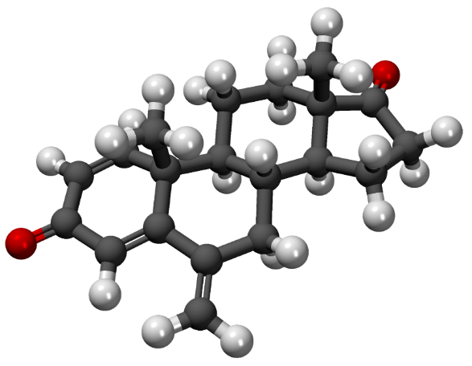
Safety netting in language discordant consultation: does it translate?
24 March (Eleanor Southgate. Centre for Primary Care)

 | Academic Clinical Fellow Eleanor Southgate was selected to deliver a plenary at the 14th Annual Cancer and Primary Care Research International Network (Ca-PRI) Conference in Oxford on 24 March. Eleanor’s talk Safety netting in language discordant consultation: does it translate? A qualitative study of healthcare interpreters’ perspectives on safety netting in primary care consultation was the Prize Talk in the Early Diagnosis Category and was exceptionally well-received by the audience. Well done Eleanor!
Budgeting for PPI staff costs in research funding applications
25 March (Anna De Simoni. Centre for Primary Care)

The pivotal role played by research and professional services staff in academic institutions in sustaining and making Patient and Public Involvement (PPI) successful is often overlooked, with funding application budgets usually focusing on costs for PPI members. Using the example of a dedicated PPI Platform developed by the Asthma UK Centre for Applied Research (AUKCAR), which has detailed information to support the costing of PPI in funding applications, researchers discuss how this initiative can be adapted and how the PPI expertise within AUKCAR can be translated more widely. | 
Sunday Times Book of the Week: Pathogenesis
26 March (Jonathan Kennedy. Centre for Public Health and Policy)

 | In anticipation of its release on 13 April, Jon Kennedy’s new book Pathogenesis has received multiple reviews, including the prestigious accolade of Book of the Week by the Sunday Times. This sweeping history is Kennedy’s debut, and a powerfully argued one writes Science Editor Ben Spencer, in a review entitled “Great men didn’t shape history – germs did”. Further reviews continue to pop up, including the Telegraph (“absorbing”), Times, and Guardian.
Outcomes following spirometry performed alongside lung cancer screening
27 March (Rhian Gabe. Centre for Evaluation and Methods)

A study describing downstream events for people referred for further assessment as a result of unexplained airflow obstruction at a Lung Health Check in the Yorkshire Lung Screening Trial finds that among 2391 participants who underwent spirometry alongside low-dose computed tomography screening, about one-third of those referred declined further assessment. Of patients seen who then underwent postbronchodilator spirometry, 29% did not have airflow obstruction. Overall, 2.3% of participants undergoing Lung Health Check spirometry commenced new pharmacotherapy, and 0.2% entered pulmonary rehabilitation. Researchers say that while measuring spirometry alongside lung screening offers possible earlier diagnosis of chronic obstructive pulmonary disease, real-world challenges exist in actioning these findings. | 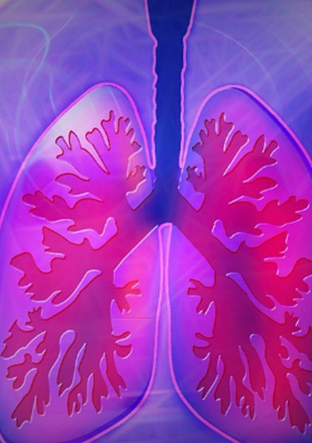
Lung cancer screening decision control among high risk candidates
27 March (Sammy Quaife. Centre for Prevention, Detection and Diagnosis)

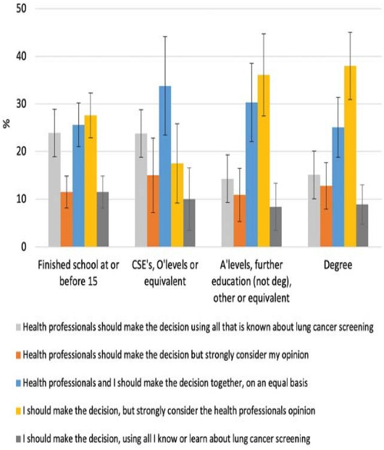 | Preferences for either shared (with a health care professional) or individual decision making in lung cancer screening vary across different sociodemographic groups, and aligning approaches with individual preferences may improve uptake. A study examining preferences for decision control in 727 high-risk lung cancer screening candidates in the UK finds that 69.7% preferred to be involved in the decision with varying degrees of input from a health care professional. Only 10.2% wanted to make the decision alone. Preferences were associated with educational attainment. Authors conclude that one-size-fits-all approaches may be inadequate in meeting diverse preferences, particularly those placing sole onus on the individual.
Salt Content in Bread
30 March (Action on Salt Team. Centre for Public Health and Policy)

A new Action on Salt report shows that 3/4 of packaged sliced bread sold in UK supermarkets contains as much salt or more per slice than a packet of ready salted crisps. Salt is the major contributing factor for raised blood pressure, the world’s biggest killer accounting for 60% of strokes and 50% of heart disease. Bread is the main source of dietary salt in the UK, with over 60 loaves purchased per person each year, and so is a key target for reducing population blood pressure. Even small reductions in bread salt content will have a significant impact on public health: a 6% reduction in the average salt content of bread would remove 926 tonnes of salt from the UK diet annually. Action on Salt are calling on the UK government to implement mandatory salt reduction targets to prevent thousands of premature deaths. The report was widely covered in multiple media outlets. | 
Using ethnicity data to improve healthcare
30 March (Rohini Mathur. Centre for Primary Care)

 | A BMJ editorial examining the collection and use of ethnicity data notes that the UK is one of only 5 European countries where collection of ethnicity data in health and social care datasets is mandatory, but datasets are not as reliable as they should be. Improving understanding of the purpose of data collection is vital to ensure adherence to data collection standards. With trust in public authorities low among some ethnic minority groups, those collecting data must justify their activities by showing they contribute to the public good, while acknowledging and mitigating risks. Including the groups most affected throughout the process of data collection and use is central to building trust. The most important causes of ethnic inequalities in health care are not controlled by the healthcare system, but public health and healthcare tools can help to ameliorate access, experience, and outcomes. Authors conclude that the social licence is fragile, and failing to show that data collection produces social value will threaten the quality of the information we obtain.
Assessment of childhood short stature
30 March (Joseph Freer. Centre for Primary Care)

A BJGP editorial and accompanying GP guidelines address the issue of inequalities in childhood short stature, providing practitioners with advice on determinants, history, evaluation, and red flag markers for use in consultations. The most deprived areas in England have twice the prevalence of short stature in the least deprived areas, and girls and ethnic minority groups with short stature are less likely to be referred, assessed, and treated despite their greater need. Authors say it is critical that primary care providers are able to accurately assess growth when they encounter short children or when assessing chronic illness, and crucial that clinicians recognise their implicit biases and understand the social disparities in the assessment of childhood short stature to improve timely diagnosis, referral, and early access to treatment. | 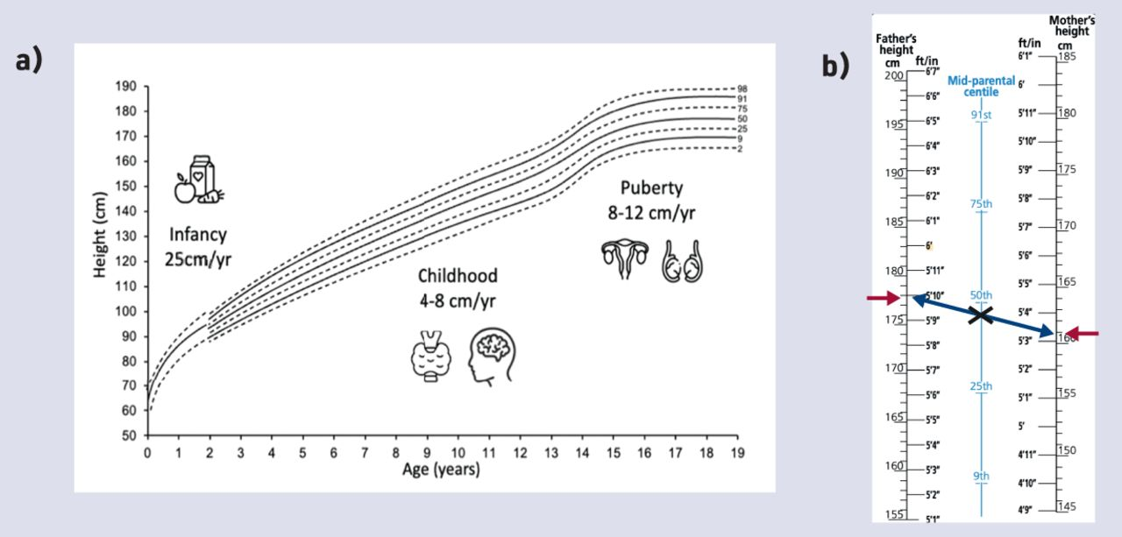
Solution-focused approaches in adult mental health research
30 March (Lauren Jerome, Philip McNamee, Nadia Abdel-Halim, Kathryn Elliot. Centre for Psychiatry and Mental Health)

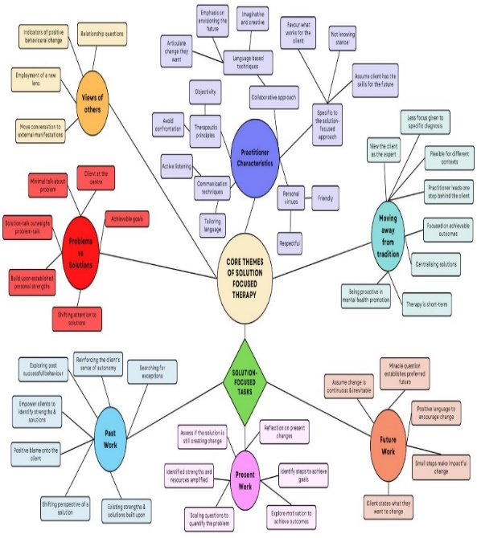 | Evidence from 56 papers on solution focused approaches to treatment in adult mental healthcare is synthesised in a review aiming to define how the concept of this approach is understood, and how it may have changed since its original presentation. Papers spanned various clinical contexts and countries, but the underlying principles and concepts of solution-focused approaches were similar. Authors identified 5 key themes which they hope will support clinicians to understand the mechanisms through which solution focused approaches work and how key principles of the approach can be utilised in adult mental health settings.
Risk-stratified breast cancer screening in the BC-Predict study
1 April (Adam Brentnall, Jack Cuzick, Stephen Duffy. Centre for Prevention, Detection and Diagnosis)

A study evaluating introducing risk-stratified screening in NHS breast screening shows that a real-time offer of breast cancer risk screening is feasible. Of every 6 women at high risk of breast cancer, 5 do not know their risk status. Women invited to breast screening at 7 NHS sites in NW England were offered BC-Predict risk screening, calculated using mammographic density and (for a sub-group) saliva testing for a polygenic risk score. After screening, risk feedback letters were sent recommending that women at high (≥8% 10yr) or moderate (5-<8% 10yr) risk make appointments to discuss prevention/early detection options. Onsite recruitment with a paper questionnaire achieved 63.2%, v<10% with the standard BC-Predict invitation only. Risk appointment attendance was highest for women at high risk (40.6%), and 77.5% of those opted for preventive medication. | 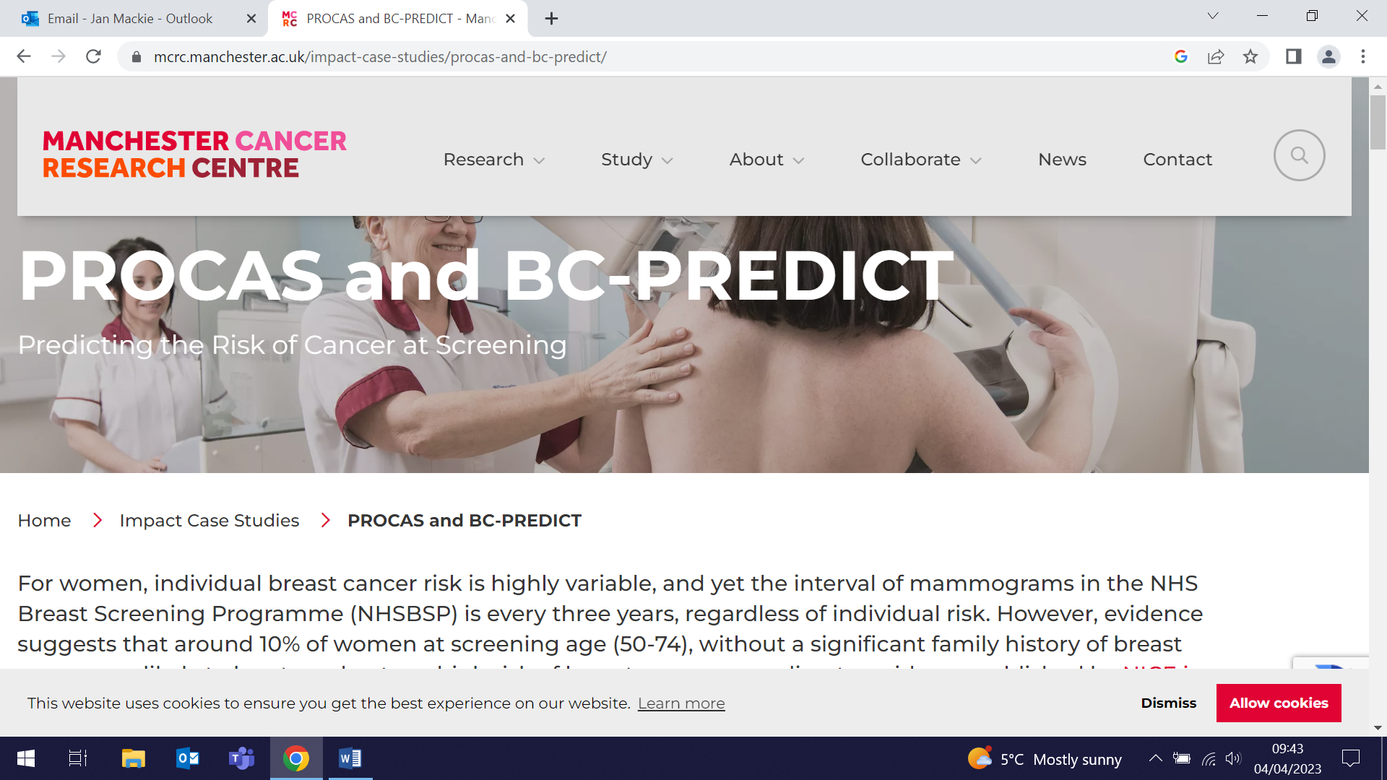  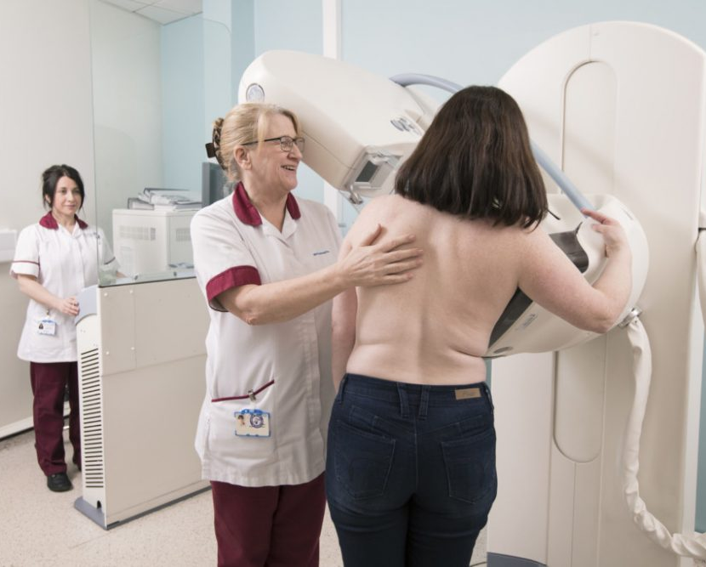
Genes & Health granted £2 million MRC Award
3 April (Sarah Finer. Centre for Primary Care)

 | The CPC Genes & Health genetic research programme has been awarded a £2 million MRC grant to expand its work on improving health for British Bangladeshi and British Pakistani communities into the fields of mental health and pregnancy research. Studies show that individuals belonging to South Asian communities are comparatively less likely to receive diagnosis for mental health conditions such as depression and, similarly, British South Asian women face greater risks for disorders such as gestational diabetes and pre-eclampsia compared with the general population during and after pregnancy. The funding will allow Genes & Health to develop an innovative online platform for use in generating large-scale mental health research, and to establish a new pregnancy cohort to enable a greater understanding of pregnancy-associated medical disorders and prediction of long-term health risks following illness.
IMP²ART: RCT of Asthma self management in primary care
3 April (Liz Steed, Atena Barat, Thomas Hamborg, Steph Taylor. Centres for Primary Care/Evaluation and Methods)

An RCT to address the issue of poor implementation of supported self-management for asthma in practice will determine whether facilitated delivery of the IMP²ART (IMPlementing IMProved Asthma self-management as RouTine) strategy increases provision of asthma action plans and reduces unscheduled care in routine UK primary care. The published protocol shows that 144 practices will be assigned either to usual asthma care (control) or to the IMP²ART implementation strategy arm, in which practices receive organisational resources to help prioritise supported self-management (including audit and feedback; an IMP²ART asthma review template), training for professionals, and resources to support patients to self-manage their asthma. Primary clinical outcome will be the between-group difference in unscheduled care in the second year after randomisation (12-24 months post-randomisation), assessed from routine data. |   
Evaluation of the 1997-2010 English Health Inequalities Strategy
3 April (John Ford. Centre for Primary Care)

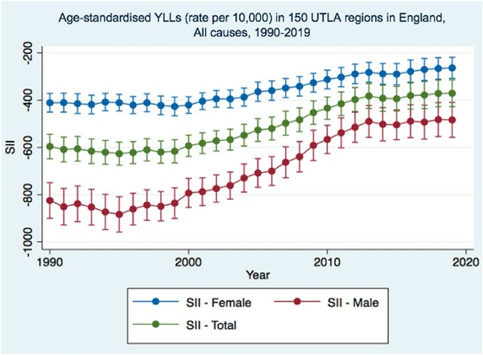  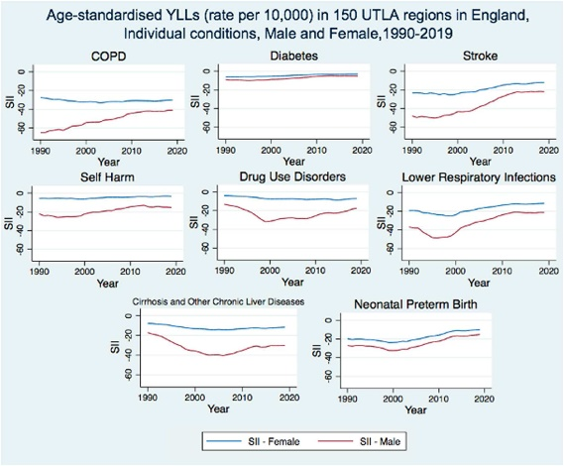 | The effectiveness of the English Health Inequalities Strategy, implemented from 1997-2010, is evaluated in a paper using premature mortality data for 150 upper tier local authority regions from 1990-2019. Trends in absolute inequalities in years of life lost (YLL) for all causes were stable from 1990-2000, then decreased up to 2010, after which improvement slowed. Similar trends were seen for individual causes, including ischaemic heart disease (IHD, stroke, breast cancer and lung cancer amongst females, and IHD, stroke, diabetes and self-harm amongst males. The trend was also observed for certain risk factors, notably blood pressure, cholesterol, tobacco and diet. Inequalities were generally greater among males than females, but trends were similar across both sexes. The English Health Inequalities Strategy coincided with significant reductions in inequalities in YLLs due to IHD and lung cancer, and authors conclude that government strategy drawing from the NHIS success is needed to tackle current health inequalities.
Health inequalities in infectious diseases
4 April (Lola Oyebode. Centre for Public Health and Policy)

A systematic overview of 108 published reviews synthesises evidence on inequalities in infectious disease and finds strong evidence that people who are socially excluded, in vulnerable populations, and of lower socioeconomic status are consistently at higher risk of infectious diseases, antimicrobial resistance and incomplete/delayed vaccination. Research focused on TB, HIV, sexually transmitted infections, hepatitis C, vaccination, and antimicrobial resistance in publications since 2000. Ethnicity and sexual orientation were important factors contributing to inequalities. Commonalities in the associations and their directions suggest that targeting interventions for some high risk-groups that may have benefits across multiple infectious disease outcomes. | 
How UK Supermarkets drive higher sugar sales
5 April (Action on Sugar Team. Centre for Public Health and Policy)

   | In collaboration with the Feedback Global environmental campaign group, Action on Sugar have produced a report on the excessive supply and consumption of sugar in the UK, presenting the health and environmental benefits of sugar reduction. Sugar Rush: How UK supermarkets drive high sugar sales highlights how supermarkets create and curate food environments and how their decisions on which products to stock, market, and how to price and package them currently foster excessive sugar purchasing and consumption. The report also notes that UK grown sugar beet accounts for over half of consumed sugar, and occupies the same amount of land to grow as all other vegetables combined. Damage from sugar beet harvest accounts for the removal of 4-600,000 tonnes of prime non-renewable topsoil each year.
SAICRED Trial funding from the Deborah James Bowelbabe charity
5 April (Oleg Blyuss. Centre for Prevention, Detection and Diagnosis)

Multiple media outlets, including the BBC, reported on the allocation of £4 million of funding from the Bowelbabe charity set up by campaigner Dame Deborah James, who died from colorectal cancer in 2022. Dame Deborah’s family selected the work to be funded, including the SAICRED project, led by Oleg Blyuss, looking at using artificial intelligence and blood tests for early detection of lung, bowel and pancreatic cancers in women. | 
Who funds WHO? An analysis of donor voluntary contributions
6 April (Obichukwu Iwunna, Andrew Harmer, Jon Kennedy. Centre for Public Health and Policy)

 | As part of the BMJ's celebration of the World Health Organization (WHO) 75th anniversary, a new paper examines WHO funding, which relies increasingly on voluntary contributions that tend to be earmarked for donor-specified projects. Concerns exist that this trend diverts focus from WHO’s strategic priorities and gives undue power to a handful of wealthy donors. Results show that over the last decade voluntary contributions increased from 75% to 88% of the WHO budget, with high-income countries and donors based in these countries providing 90% of voluntary contributions in 2020. The share of voluntary contributions provided to WHO by upper middle-income countries was consistently less than that by lower middle-income countries, and upper middle-income countries contributed the least proportion of their gross national income. Authors recommend that WHO working groups should focus on the incentives that determine donor support for specified and flexible voluntary contributions.
FORTHCOMING EVENTS AND NOTICES

Inaugural Lecture: Ranjit Manchandra (13 April)

Ranjit Manchanda will deliver his Inaugural lecture, My journey: A tryst with cancer prevention”, on Thursday 13 April at an event starting at 5:30pm in the G02 Lecture Theatre in the Joseph Rotblat building. Ranjit will describe and reflect on his journey, covering trials and research in population-based genetic testing, mainstreaming genetic testing, population risk stratification, targeted screening, targeted cancer prevention, related health economic issues, and a commitment to teaching and training. Please register here to attend. | 
Seminar: Population health approaches to dementia risk (25 April)

Charles Marshall, Clinical Senior Lecturer in Dementia in the WIPH Preventive Neurology Unit, will deliver a seminar entitled ‘Population Health Approaches to Dementia Risk’ as part of the FMD Lifelong Health Multidisciplinary Research Theme. The talks will be held via Zoom from 1-2pm on 25 April. Register here to attend. | 
London Pancreas Workshop (28 April)

Fiona Walter will present a talk on CanDetect at 9:45am the London Pancreas Workshop on 28 April. Fiona is co-lead on the CanDetect collaborative which aims to accelerate progress towards improving cancer outcomes by focussing on the transformative implementation in primary care of tests to support early detection of cancer, including upper gastro-intestinal cancers. The Workshop will be held at Charterhouse Square. Registration and details here. | 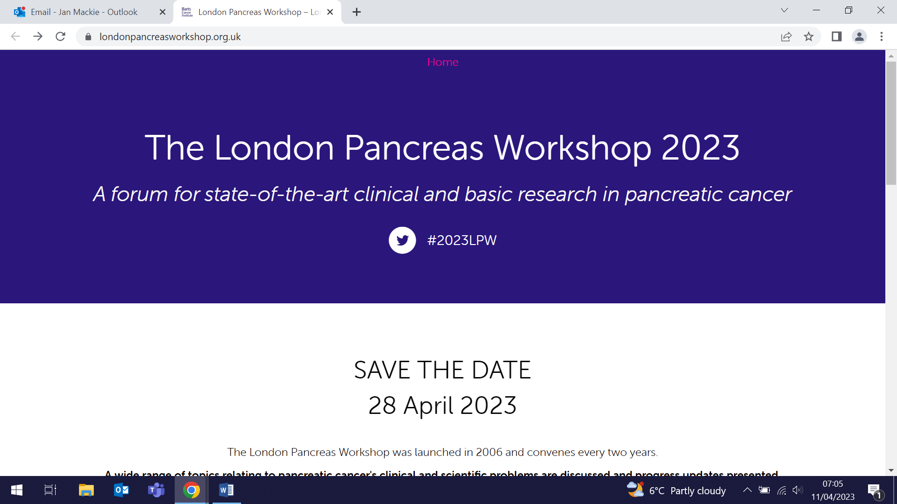  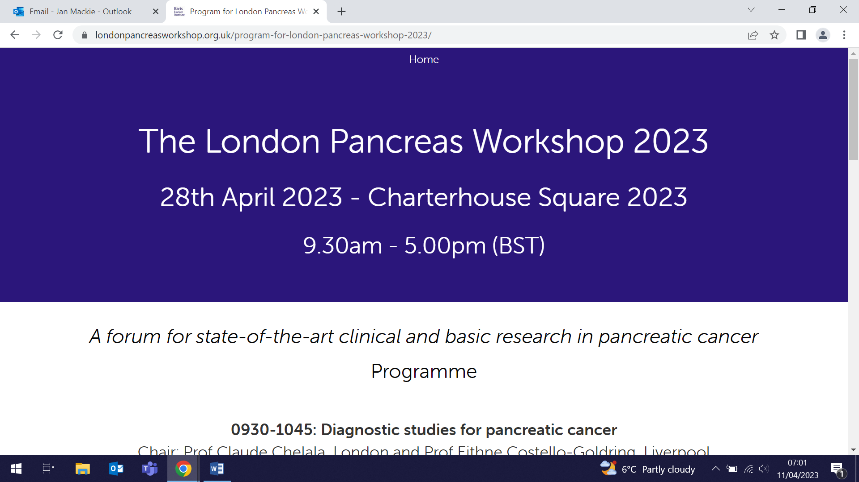
Launch Event: Youth Resilience Unit (4 May)

All WIPH staff are invited to an event to celebrate the launch of the Youth Resilience Unit, on Thursday 3 May at the Peston Lecture Hall, QMUL Graduate Centre, Mile End Road from 5-7:30pm. Through talks, stories and a panel discussion, the event will feature our work and partnerships centred on the needs, assets, and strengths of children and young people facing mental adversity. Please join us for an evening of conversation, followed by networking and canapes. Book here. | 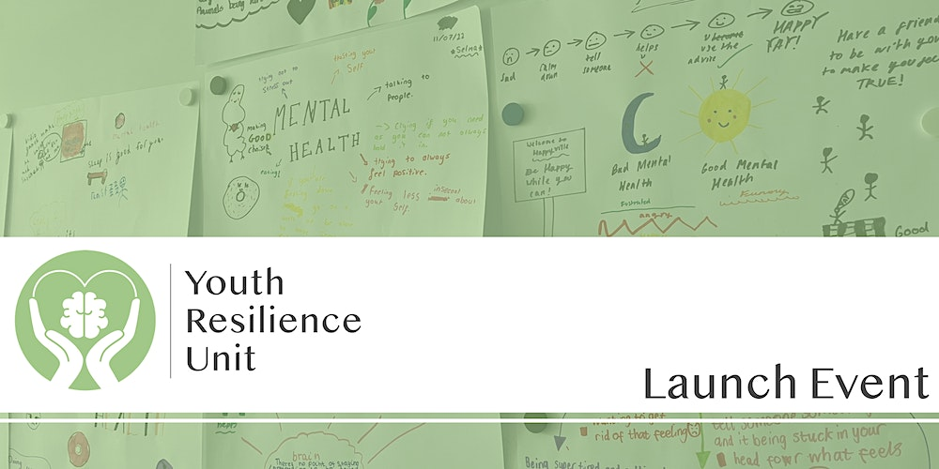
Many thanks to all who so enthusiastically contribute. Please send any news items for the next newsletter to j.a.mackie@qmul.ac.uk

