WOLFSON INSTITUTE OF POPULATION HEALTH
NEWSLETTER
ISSUE 33: 26 APRIL 2023

In this issue of our Wolfson Institute of Population Health Newsletter, we celebrate the achievements and work of staff and students through April.

FROM OUR DIRECTOR
Dear Colleagues  Our Institute publications focusing on inequalities continue apace, revealing the extent of undiagnosed autism in England, and a new computer risk model for inviting participants for clinical trials which addresses the “healthy volunteer” effects and the inequity that exists in many health research studies. As always, the newsletter gives us plenty to think about, as well as sparking ideas for potential new collaborations, so please don’t hesitate to reach out to colleagues across the Institute to share ideas. | 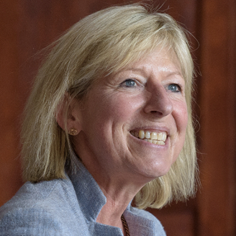
It’s been great to welcome more people back to work in recent months. You’ve now heard from Tracy that our next step towards improving our daily working experience and the quality of our environment is our IT refresh project. Do get in touch with your Centre admin team if you have any questions.

Also, some advance warning that the 2023 staff survey will be launched next Tuesday, 2 May. Please make time to complete the survey - your feedback is hugely valued, and I hope you’ll appreciate that we have already acted on many aspects of feedback received from last year’s survey.

Wishing you a peaceful Bank holiday weekend

Fiona

MEET WIPH

Meet: Laura Miller, Programme Manager in the CEM Pragmatic Clinical Trials Unit

How would you describe your roles and responsibilities?
I am a manager for the IBD-BOOST research programme, which focuses on developing and evaluating management interventions to improve the well-being of people with Inflammatory Bowel Disease. Among other things, I oversee day-to-day running, site set-up/close-down, programme recruitment, the development of study documentation and amendments for ethical approval, training, budget and financial management, database and online survey testing, and supporting the team.

What has been your greatest professional achievement?
Finishing recruitment for all of the 3 studies in the IBD-BOOST programme after Covid-related delays, and being able to provide support and encouragement to participants going through the BOOST online self-management intervention. Also having my first publication!

What aspects of your role do you enjoy the most?
I really enjoy collaborating, problem-solving, and working with our BOOST team (who are a fab bunch!), as well as hearing about other exciting research projects that are happening and chatting to patients about what issues are important to them.

What would be your second choice as a profession?  I previously did a foundation course in counselling which I really enjoyed, so it would be nice to try out those skills again (or audition for a west-end show hehe!)  What do you enjoy doing outside work?  I enjoy crafts (particularly knitting and crochet!), fashion, and music, and have recently joined a local branch of the ‘Some Voices’ choir and performed in a concert at the Outernet.  Something most people don’t know?  At age 29, I am still learning to ride a bike! | 
FROM OUR LEADERSHIP TEAMS AND REPRESENTATIVES

Research News: Tor Kemp (Research Manager)

QMUL Research & Innovation Awards | Nomination deadline 1 May
Nominations for the QMUL Research and Innovation Awards close on 1 May. Please consider nominating any of your team members or colleagues (or yourself) to be recognised for their achievements and successes. First prize in each category will receive funding for future activities/ professional development. Categories include Outstanding Research Supervisor, Excellent Research Support, Early Career Researcher, Outstanding interdisciplinary research project, Technician, and Research Impact. The VP will also award a prize for Research Excellence to an individual or group of researchers who can demonstrate sustained, outstanding achievement in any field of research.

NIHR Advanced Fellowship Round 10 | Deadline 6 July
This postdoctoral Fellowship is aimed at anyone not yet in a professorial post. Recognising the importance of funding ECRs to undertake postdoc research, NIHR are looking to expand the number of Advanced Fellowships they fund, and to encourage more applications from those researching in social care, public health, dementia and multiple long term conditions (multimorbidities). Researchers from any professional background, clinical or non-clinical, are eligible for Advanced Fellowships, and active clinicians/practitioners can request up to 40% of time be dedicated to clinical/professional service/development, which the Fellowship will cover. Application deadline 13:00 6 July.

NIHR Advanced Fellowship+ | NIHR Efficacy and Mechanisms Evaluation programme collaboration with NIHR Academy | Deadline 6 July
This collaboration provides an opportunity, for those wishing to pursue an NIHR Advanced Fellowship, that will also support project funding to deliver and gain experience of leading a clinical study with appropriate mentorship. Interested applicants are encouraged to approach the CTUs to discuss support.

Seminar | WIPH How I got my Industry Funding series | Session 18 May
Do you want to know more about commercial funding? The launch of the WIPH “How I got my Industry Funding” series in January was well attended and provided a useful overview of different types of industry funding. If you missed it, click here to access the recording and/or slides. We have since also heard from Andrew Shaw (Consultancy & Contract Research Manager) and Yan Feng about Consultancy, and Heather Ramsay on Contract Research: non clinical. Our upcoming fourth session, on Contract Research: clinical, will be held from 12:15-1pm on 18 May.

Online short course | Introduction to Lifestyle Medicine | Start date 14 May
Those interested in learning about nutrition, exercise, sleep, behaviour change, social networks and deprescribing, please consider booking here for this short online course. Following its successful launch in summer 2022 and a well-attended 2nd course version in January 2023, U. of Birmingham is running this course again in May. “I really enjoyed the course. I thought there was a good selection of materials and I enjoyed the varied approach. Overall, it was a really good course and I would recommend it to others. It was excellent value as well” (University Lecturer).

PPI | Top tips for involving carers in their work
NIHR have published a set of graphics to support the involvement of unpaid/family carers in health and social care research: “We hope our graphics will provide support for both researchers and carers to work together”. This resource has been added to the PPI section of the WIPH Research pages of the intranet

Collaboration | WIPH-SEMS | Events and actions
Academic colleagues from WIPH and SEMS met late March 2023 to share research interests and help identify areas of collaboration. The long-term goal is to establish groups of researchers and get ahead of the curve in terms of relevant funding calls which support these exciting research collaborations. If you are interested please add your details to this spreadsheet. WIPH colleagues are also warmly invited to attend SEMS Bioengineering Research Away Day on 27 June afternoon. The event will focus on: Programme grant scoping and preparation (eg. EPSRC Healthcare Technologies, UKRI Cross Research Council Schemes), and Research and Funding Collaborations with different Schools and Institutes. Please contact Zion, Yi or Mohammad if interested in attending.

Impact | Call for applications: WIPH Academic Impact Lead | Deadline noon 28 April
Deadline for applications for the WIPH Academic Impact Lead is noon, Friday 28 April. Contact Tor Kemp for more information.

GENERAL INSTITUTE NEWS

Autism in England: assessing underdiagnosis inequalities
3 April (Claudia Cooper. Centre for Psychiatry and Mental Health)

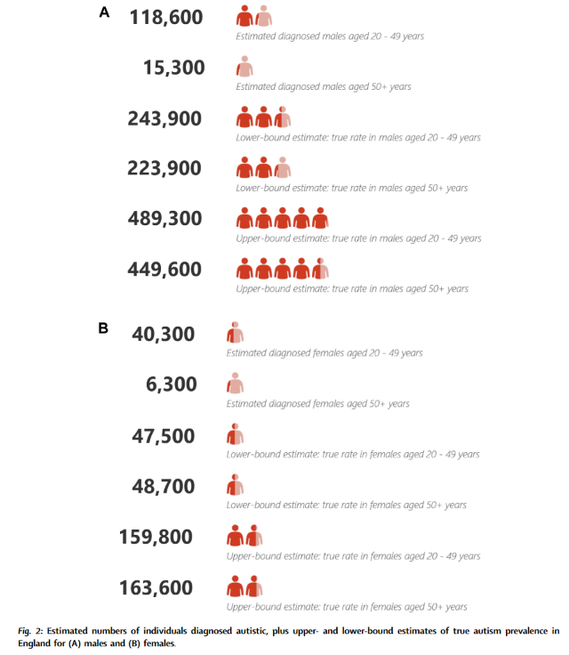 | Addressing the lack of research on the extent of underdiagnosed autism in England, a new study for the first time estimates autism underdiagnosis according to key demographics. Using data from English primary care for >5 million individuals, results suggest that prevalence of autism has been stable over the last 70-80 years, but that 150,000 - 500,000 people aged 20-49, and 250,000 - 600,000 aged 50+ in England may be autistic, but undiagnosed. Authors say these findings highlight continuing inequalities in access to autism diagnostic assessments for adults in England, and suggest that policy initiatives designed to address underdiagnosis in adults have not yet been effective.
Black & South Asian women's experiences in UK perinatal mental health services
3 April (Maev Conneely, Stefan Priebe, Nikolina Jovanovic. Centre for Psychiatry and Mental Health)

Black and South Asian women are less likely than White British women to access support from perinatal mental health services, despite experiencing similar or higher levels of distress. An interview study among Black and South Asian women finds a wide range of experiences and a complex interplay of factors affecting access to and experience of services. Main access barriers were attributions related to mental distress, stigma, mistrust and lack of visibility of services, and organizational gaps in the referral process. While the findings suggest that many women feel heard and supported by services, clarity on what the services are and what support they offer would improve accessibility. | 
Editorial: Reproductive outcomes for parents conceived by assisted reproduction
5 April (Stamatina Iliodromiti. Centre for Public Health and Policy)

 | A BMJ editorial commends the scope and precision of definitions in a paper on reproductive health outcomes for people born through assisted reproductive technologies (ART). The study analyses Norwegian data on pregnancies registered to almost a million parents born 1984-2002 and compares outcomes for parents conceived by ART or naturally. Results show that obstetric and perinatal outcomes for problems including lower birth weight, earlier gestational age at birth, congenital malformations, and admission to neonatal intensive care are similar for parents conceived by ART or naturally. The editorial notes the clear definition (excluding intrauterine insemination) of ART, and the inclusion of all births in Norway from 1984 to 2002, and all registered pregnancies and births to this population to 2021.
What causes delays in diagnosing blood cancers?
11 April (Georgia Black. Centre for Prevention, Detection and Diagnosis)

A review of 15 studies finds that factors contributing to delays in diagnosing blood cancers include both patient (gender, age, ethnicity) and health system (poor communication and seeing a locum clinician in primary care) factors. Evidence suggests 4 types of patient interpretation of symptoms: symptoms compatible with normal health, event-linked problems, mild or chronic illness, and non-specific unwell state. These interpretations were linked to different help-seeking behaviours, after which patients often experienced delays due to diagnostic pathway barriers, including healthcare professionals' interpretation of symptoms as non-serious, misleading blood tests, or discontinuity of care. Authors conclude that difficulty in diagnosing blood cancers due to non-specific heterogeneous symptoms is reflected in how those symptoms are interpreted by patients and managed by healthcare professionals. | 
The synaptic hypothesis of schizophrenia version III
11 April (Ellis Chika Onwordi. Centre for Psychiatry and Mental Health)

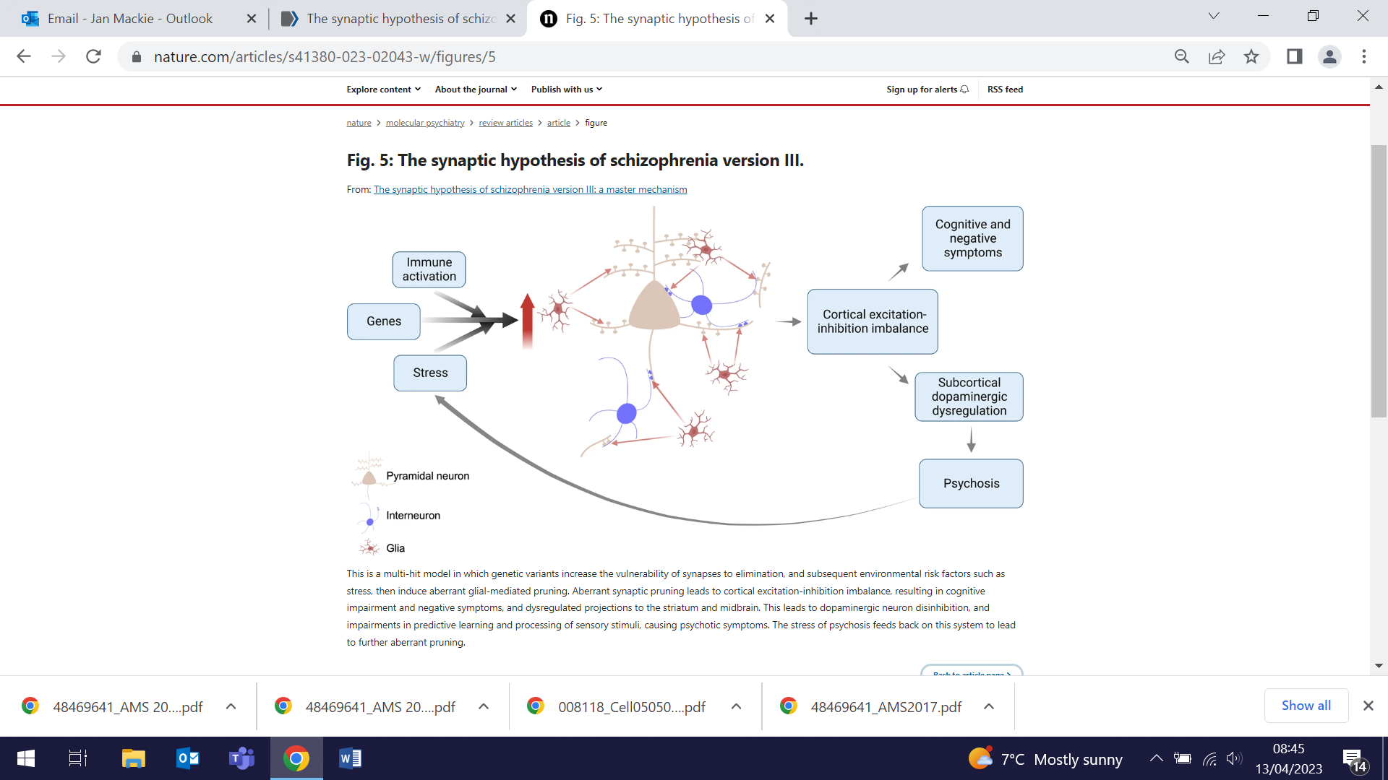 | A paper reviewing evidence from neuroimaging and post-mortem studies suggesting that synaptic development is abnormal in schizophrenia explores preclinical, genetic and induced pluripotent stem cell studies to consider the mechanism underlying synaptic changes. The authors provide an updated synaptic hypothesis of schizophrenia (version III). They propose that synaptic loss disrupts cortical pyramidal neuron function, contributing to negative and cognitive symptoms, and disinhibits projections to mesostriatal regions, contributing to dopamine overactivity and psychosis. Version III accounts for the typical onset of schizophrenia in adolescence/early adulthood and its risk factors and symptoms, and identifies synaptic, glial and immune targets for treatment.
Breast cancer polygenic risk scores for Ashkenazi Jewish women
12 April (Adam Brentnall, Jack Cuzick. Centres for Evaluation and Methods/Prevention, Detection and Diagnosis)

Some polygenic risk scores (PRS) for predicting breast cancer risk presume that Ashkenazi Jewish (AJ) women are of white European origin. A comparison of two scores (SNP142/SNP78) uses data from the UK PROCAS study and a regional (Manchester) genetics data base, cross-checked against data from the BCINIS (Northern Israel) study, to assess discrimination and calibration. Results showed that Western European breast cancer PRS overestimates risks in the AJ population. Authors conclude that, for AJ women, PRS need to be recalibrated using AJ-derived effect allele frequencies. | 
Risk disclosure for patients with isolated rapid eye movement sleep behaviour disorder
12 April (Cristina Simonet, Harneek Chohan, Aneet Gill. Centre for Prevention, Detection and Diagnosis)

 | Isolated rapid eye movement sleep behaviour disorder (iRBD) is associated with increased risk of Parkinson's and other synucleinopathies, but no consensus exists about disclosure of this risk to patients. A survey assessing views on risk disclosure among 31 patients with iRBD showed that 1/3 had not been informed about the link between iRBD and other conditions by clinicians at diagnosis, but 90% would have liked to have received prognostic information from the diagnosing clinician, and 60% thought this should happen at the point of diagnosis. Almost 3/4 had searched for this information online.
Quality of life after risk-reducing surgery for breast and ovarian cancer
12 April (Xia Wei, Samuel Oxley, Michail Sideris, Ashwin Kalra, Adam Brentnall, Li Sun, Ranjit Manchanda. Centres for Prevention, Detection and Diagnosis/Evaluation and Methods)

A review assessing the impact on health-related quality of life following risk reducing mastectomy (RRM), salpingo-oophorectomy (RRSO), early salpingectomy and delayed oophorectomy (RRESDO) for breast and ovarian cancer examines outcomes from 34 studies. Qualitative synthesis and fixed-effects meta-analysis were used to assess results from studies reporting health related quality of life, sexual function, menopause symptoms, body image, cancer-related distress or worry, anxiety or depression. The review finds that RRM and RRSO reduce cancer-related distress, and do not affect health related QoL. Authors suggest that women and clinicians should be aware of body image problems post-RRM, together-with sexual dysfunction and menopause symptoms post-RRSO, concluding that RRESDO may be a promising alternative to mitigate QoL-related risks of RRSO. | 
Outcomes for clinical trials of interventions for heavy menstrual bleeding
13 April (Natalie Cooper, Alex Tan, Matina Iliodromiti. Centre for Public Health and Policy)

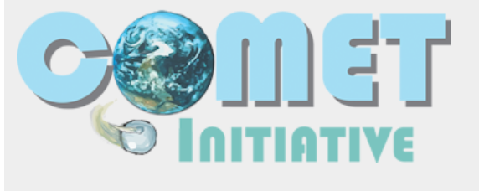  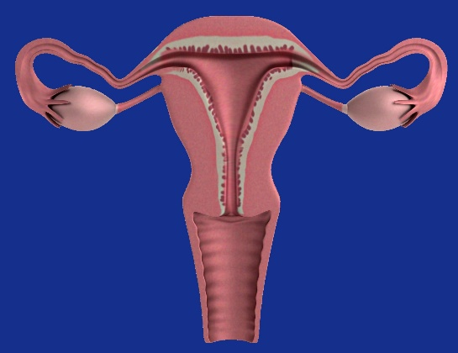 | A collaboration of clinicians, patients, academics, and guideline developers from across 6 continents has produced a core set of 10 outcomes for heavy menstrual bleeding, which is feasible for use in clinical trials. Using Core Outcome Set methodology, stakeholders considered 114 outcomes, and developed a consensus on those that should be reported in all future trials of interventions, systematic reviews, and clinical guidelines to underpin policy: subjective blood loss; flooding; menstrual cycle metrics; severity of dysmenorrhoea; number of days with dysmenorrhoea; quality of life; adverse events; patient satisfaction; number of patients going on to have further treatment for heavy menstrual bleeding, and haemoglobin level.
Inaugural Lecture
13 April (Ranjit Manchanda. Centre for Prevention, Detection and Diagnosis)

Congratulations to Professor Ranjit Manchanda on delivering his Inaugural Lecture entitled ‘My journey: A tryst with cancer prevention'. Ranjit spoke to over 100 attendees about his work in gynaecological oncology, including his research programme in Targeted Precision Prevention, and about the challenges, milestones, friendships, and collaborations along the way. The lecture was introduced by the Vice Principal, and a celebratory reception followed. | 
WIPH Expert Comment: Hearing aids may protect against higher risk of dementia
13 April (Charles Marshall. Centre for Prevention, Detection and Diagnosis)

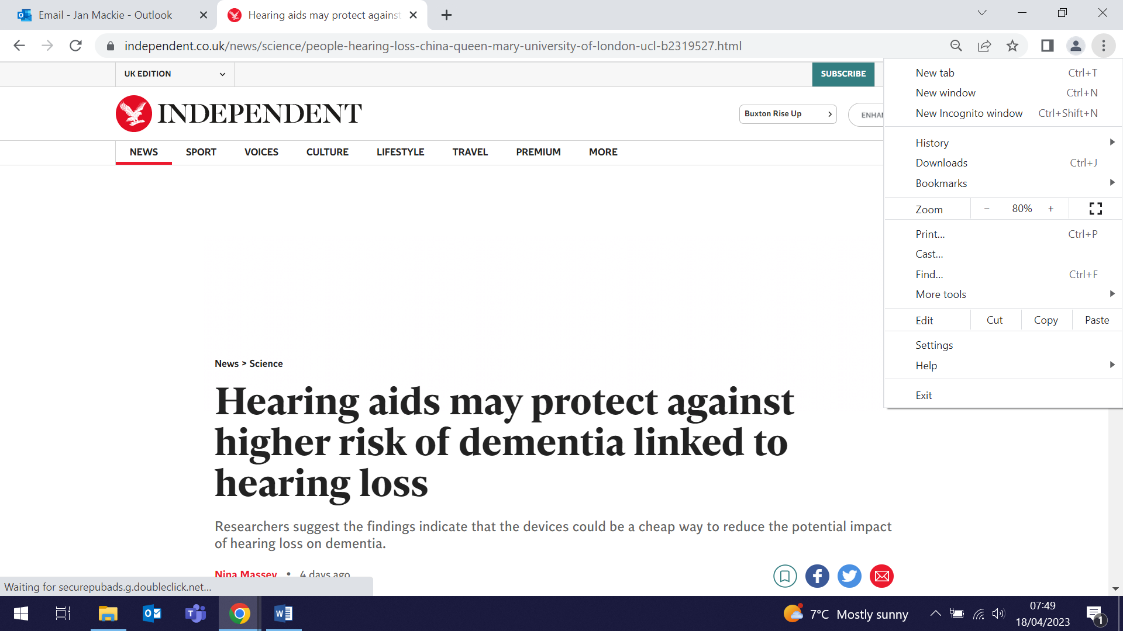       | Comments by Charles Marshall, about a new paper from Shandong University on dementia risk among people not using hearing aids, were disseminated by the Science Media Centre and cited in the Daily Mail, Independent, and Evening Standard. He said that hearing aids produce slightly distorted sound to which the brain has to adapt for hearing aids to be helpful. People at risk of developing dementia may have early changes in their brain that impair this adaptation, and may choose not to use hearing aids. This would confound the association, making it seem that hearing aids are reducing dementia risk, when actually their use is just identifying people with relatively healthy brains. Hopefully this paper will lead to randomised trials of hearing aid use to provide a stronger foundation for public health advice about whether correcting hearing loss might help to prevent dementia.
Pathogenesis: A history of the world in eight plagues
13 April (Jon Kennedy. Centre for Public Health and Policy)

The long-awaited release of Jon Kennedy’s new book received wide media interest, with new reviews in The Economist, Washington Post, Atlantic  and Wired. Jon was also interviewed on BBC Radio 4's Inside Science, the RTE1 Ray D'Arcy show, and Times Radio. Congratulations on a hugely successful launch Jon. | 
WIPH Expert Comment: Is vaping safe or not?
16 April (Peter Hajek. Centre for Public Health and Policy)

 | Stories in the Guardian and Daily Mirror on the dual government campaigns to promote e-cigarettes to help people quit smoking tobacco at the same time as cracking down on youth vaping featured comments from Peter Hajek: Vaping and other low-risk nicotine products have potential to practically eradicate smoking-related death and disease. This new step is a sensible, pragmatic, science-based initiative and good news for public health. While young non-smokers experiment with vaping, very few progress to daily use, and vaping has much lower addictive potential than cigarettes.
Psychological therapies for depression and cardiovascular risk
18 April (Claudia Cooper. Centre for Psychiatry and Mental Health)

People with depression are up to 72% more at risk of developing cardiovascular disease (CVD). To determine whether positive outcomes from psychotherapies may be associated with CVD risk reduction, a retrospective cohort study analysed data from >600,000 individuals extracted from linked electronic healthcare record databases in England. Results show that after a median 3.1yrs follow-up, reliable improvement from depression symptoms was associated with a lower risk of new onset of any CVD, coronary heart disease, stroke, and all-cause mortality. For all outcomes the association was stronger in those aged <60. More research is needed to understand the causality of these associations. | 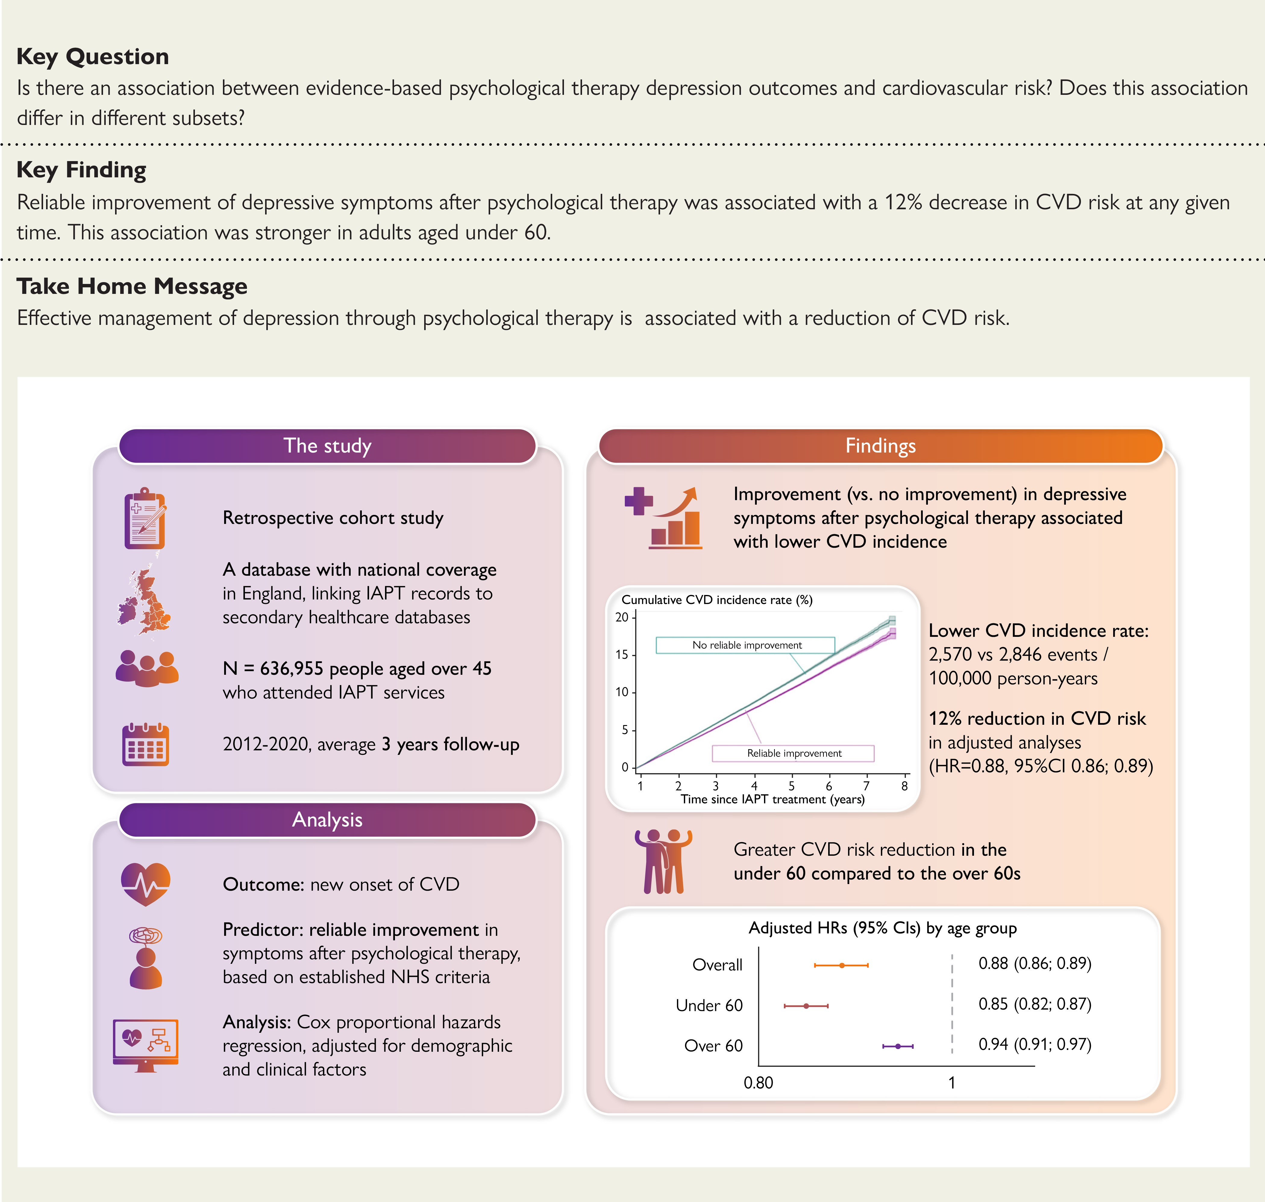
Cardiovascular events and imaging phenotypes in UK Biobank participants with past cancer
18 April Fiona Walter, John Robson. Centres for Prevention, Detection and Diagnosis/Primary Care)

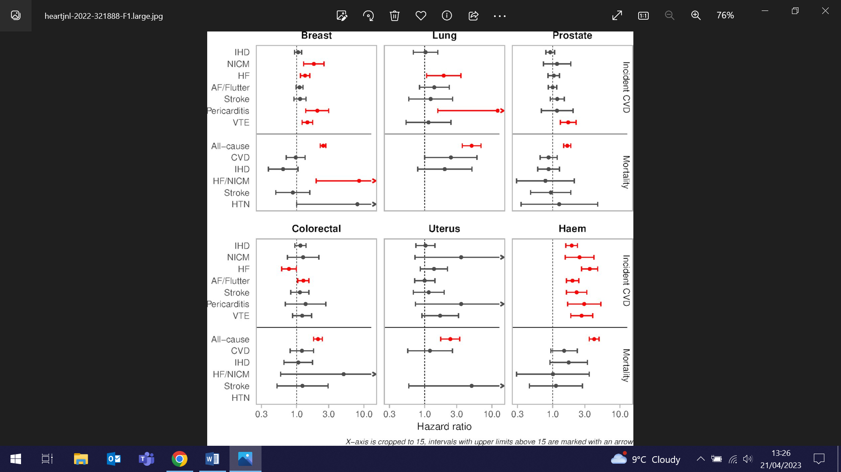 | A study of over 18000 UK Biobank participants with history of six common cancers uses health record linkage to evaluate associations of cancer history with cardiovascular disease (CVD). Participants with cancer had high burden of vascular risk factors and prevalent CVDs. Haematological cancer was associated with increased risk of all incident CVDs considered. Lung cancer was associated with increased risk of pericarditis, heart failure and CVD death, and prostate cancer was linked to increased venous thromboembolism risk. Authors conclude that cancer history is linked to high CVD risk, which appears independent of vascular risk factors and persists several years after cancer diagnosis.
Homologous recombination deficiency in newly diagnosed high-grade epithelial ovarian cancer
18 April (Ranjit Manchanda. Centre for Prevention, Detection and Diagnosis)

A report on the first year of routine homologous recombination deficiency (HRD) testing among women with newly diagnosed stage III/IV high-grade epithelial ovarian cancer in the NHS in England, Wales, and Northern Ireland shows that the real world prevalence of HRD in this group was 37%. Most tumours positive for HRD were BRCA1/2 wild-type. Of 2829 tumours tested, 87% and 77% respectively successfully underwent BRCA1/2 and genomic instability score (GIS) testing. All complete and partial assay failures were due to low tumour cellularity and/or low tumour DNA yield. Authors note that the rapid uptake of testing in this setting demonstrates the power of centralized NHS funding, centre specialization, and the NHS Genomic Laboratory Hub network. | 
Changing to virtual meetings: impact for cancer multidisciplinary teams
19 April (Daisy McInnerney, Sammy Quaife. Centre for Prevention, Detection and Diagnosis)

 | The UK National Cancer Plan requires every cancer patient's care to be reviewed by a multidisciplinary team (MDT). The protocol has been published for a study to explore how the change from face-to-face to virtual cancer MDT meetings during the COVID-19 pandemic may have had an impact on the effectiveness of decision-making. The mixed-methods study will incorporate three phases - subremote qualitative interviews with cancer MDT members, a national cross-sectional online survey, and live observations of virtual/hybrid cancer MDT meetings - to assemble quantitative and qualitative data for analysis. Key findings will be used to develop a resource pack for MDTs to translate learnings from this study into improved effectiveness of virtual MDT meetings.
Stefan Priebe Retirement
19 April (Stefan Priebe. Centre for Psychiatry and Mental Health)

Celebrating 40 years of research in Social and Community Psychiatry, the retirement event for Stefan Priebe, who has spent his career leading psychiatry research in the UK and abroad, was held on 19 April. Stefan qualified as a Neurologist, Psychiatrist and Psychotherapist in Germany, has worked as Professor for Social and Community Psychiatry in QMUL since 1997. He has also served as Director of the WHO Collaborating Centre for Mental Health Service Development, and the NIHR Global Health Research Group. Our sincere thanks go to Stefan for his years of service and the huge contribution he has made to research in social and community psychiatry. | 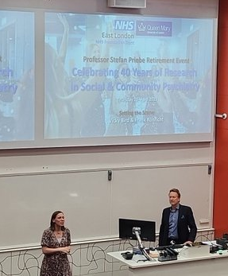
Predicting cardiovascular disease by machine learning and statistical techniques
19 April (Mohammad Talaei. Centre for Prevention, Detection and Diagnosis)

   | Using multiple prediction models and machine learning (ML) techniques, researchers have developed classification models for predicting the future occurrence of cardiovascular disease (CVD) events in a large sample of Iranians. Analysis of data from 5432 people in the 16 year Isfahan Cohort Study showed that age, systolic blood pressure, fasting blood sugar, two-hour postprandial glucose, diabetes mellitus, history of heart disease, history of high blood pressure, and history of diabetes are the most contributing factors for predicting CVD. Researchers say that using conventional statistical models alongside ML algorithms makes it possible to take advantage of both techniques, and that, generally, Quadratic Discriminant Analysis can accurately predict the future occurrence of CVD events with a fast (inference speed) and stable (confidence values) procedure.
National Conference on MS for Primary Care in Scotland
20 April (Alison Thomson, Ruth Dobson. Centre for Prevention, Detection and Diagnosis)

Alison Thomson and Ruth Dobson both presented in person at this event in Glasgow, which is key for dissemination of multiple sclerosis research to healthcare professionals across Scotland. Alison spoke on the Under & Over study: Learnings from a remote upper limb rehabilitation study for people with MS, and Ruth talked on Approaches to MS treatments during pregnancy – balancing risks and benefits. | 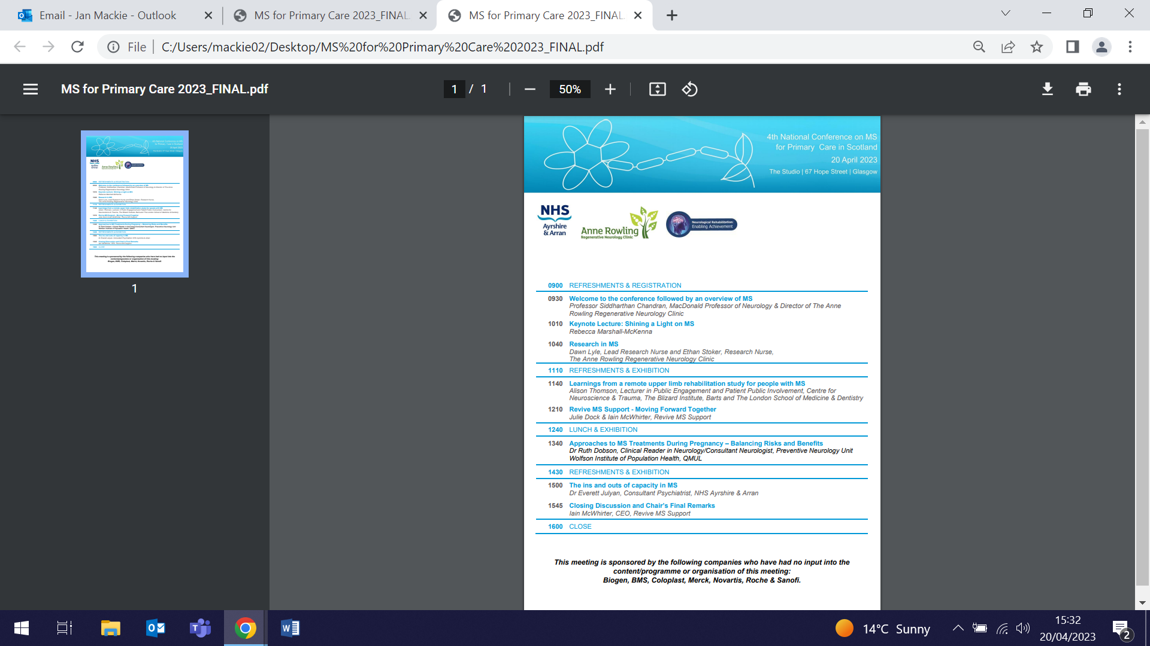
Symptoms and signs of lung cancer before diagnosis
20 April (Fiona Walter. Centre for Prevention, Detection and Diagnosis)

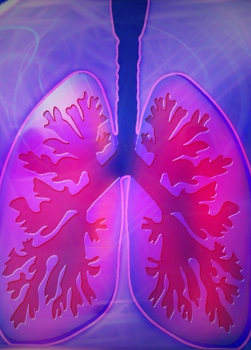 | A study using electronic health records from the ambulatory care clinic at University of Washington Medicine (USA) identifies lung cancer associated symptoms and signs at time of diagnosis, and at 1/3/6/12 months prior to diagnosis. Results show that 11 symptoms and signs recorded during the study period were associated with a significantly higher chance of being a lung cancer case. Of these, 7 were significantly associated with lung cancer 6 months prior to diagnosis: haemoptysis, cough, chest crackles or wheeze, bone pain, back pain, weight loss, and fatigue. Patients diagnosed with lung cancer appear to have symptoms and signs recorded that distinguish them from similar matched patients in ambulatory care, often 6 months or more before diagnosis, suggesting opportunities to improve the diagnostic process for lung cancer.
Celebrating Earth Day
22 April (Chris Griffiths. Centre for Primary Care)

As part of the worldwide celebration to mark Earth Day, QMUL has recognised the work of Queen Mary’s inspiring environment experts, who are producing research to protect our planet. From the article: “Queen Mary has been leading research on the negative health effects of air pollution which is the top environmental risk to human health in the UK, leading to around 40,000 premature adult deaths. Research from Professors Jonathan Grigg and Chris Griffiths has shown the long-term damage that air pollution has on human health, from asthma to dementia, heart disease and cancer. Their research has helped inform the global understanding of, and response to, the health risks of air pollution and was instrumental in the introduction of London’s Ultra Low Emission Zone.” | 
New computer model addresses inequity in selecting clinical trial participants
24 April (Adam Brentnall. Centre for Evaluation and Methods)

 | A new computer model to select who is invited to clinical trials will ensure that participants are more diverse than usual. People who enrol in health research studies such as cancer screening trials usually have better health than the target population (the "healthy volunteer” effect). The new model tilts clinical trial participation invitations towards groups less likely to join, to ensure that enough people are included in the trial from all major societal and ethnic groups. The model was tested in practice in recruitment to the NHS-Gallieri multi-cancer screening trial. Over 11 months ≈1.5 million invitations were sent to recruit 140,000 people, making it likely to be the fastest recruiting trial of this size ever. This method of inviting participants for clinical trials addresses the “healthy volunteer” effects and inequity that exist in many health research studies, and can be adapted for use in other trials or research studies.
FORTHCOMING EVENTS AND NOTICES

London Pancreas Workshop (28 April)

Fiona Walter will present a talk on CanDetect at 9:45am the London Pancreas Workshop on 28 April. Fiona is co-lead on the CanDetect collaborative which aims to accelerate progress towards improving cancer outcomes by focussing on the transformative implementation in primary care of tests to support early detection of cancer, including upper gastro-intestinal cancers. The Workshop will be held at Charterhouse Square. Registration and details here. | 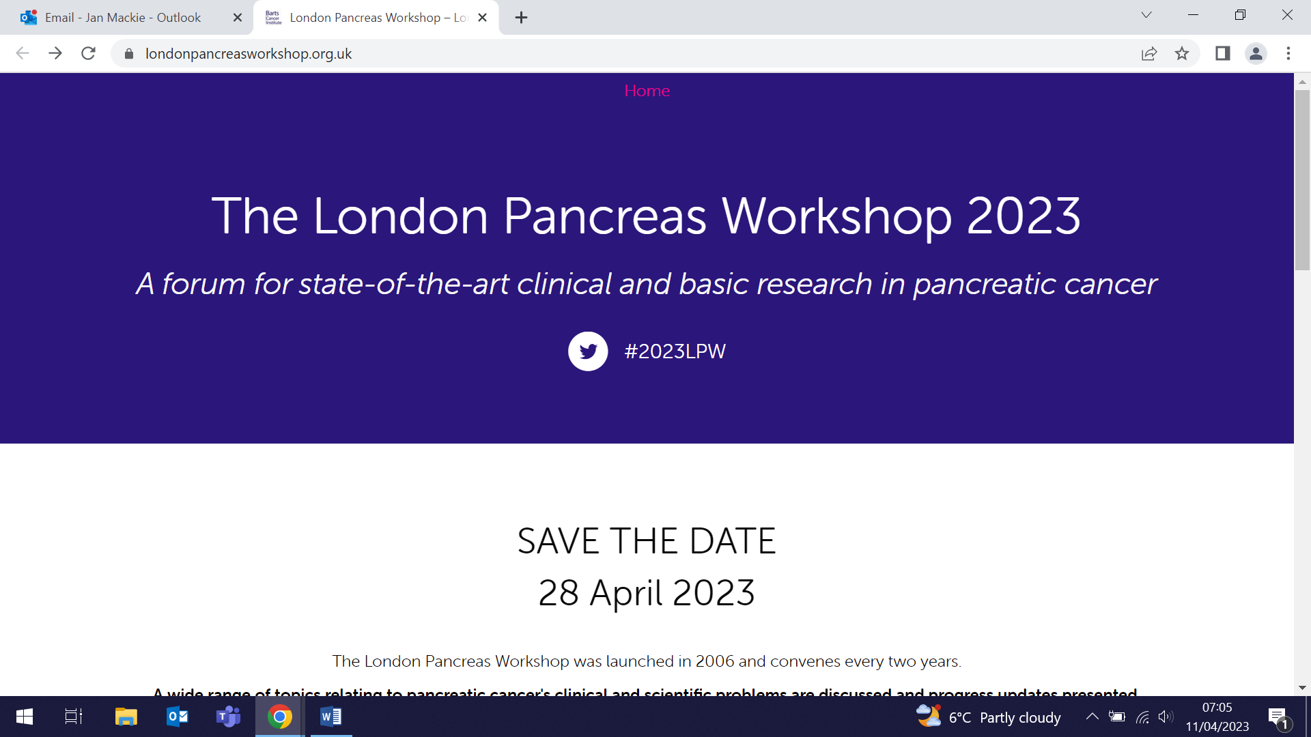  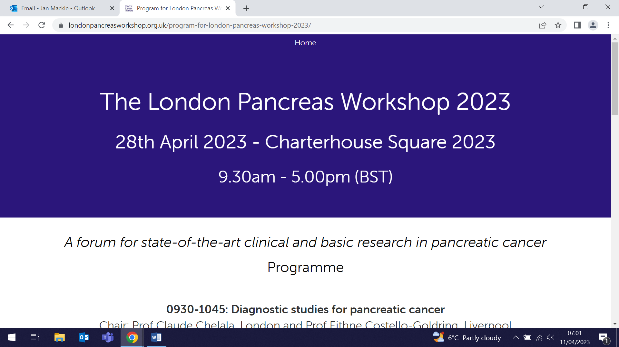
Launch Event: Youth Resilience Unit (4 May)

All WIPH staff are invited to an event to celebrate the launch of the Youth Resilience Unit, on Thursday 3 May at the Peston Lecture Hall, QMUL Graduate Centre, Mile End Road from 5-7:30pm. Through talks, stories and a panel discussion, the event will feature our work and partnerships centred on the needs, assets, and strengths of children and young people facing mental adversity. Please join us for an evening of conversation, followed by networking and canapes. Book here. | 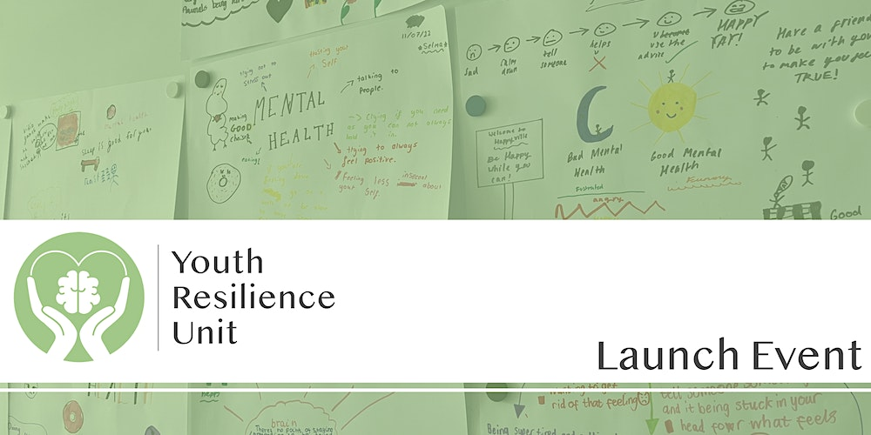
Type 2 diabetes prevention and self-management: what works, why and what changes are needed? (26 May)

WIPH Senior Lecturer in Primary Care Jamie Ross will speak at this free in-person NIHR event in Manchester on 26 May. Under the NHS Long Term Plan, three national programmes to prevent and manage type 2 diabetes have been implemented: Healthier You - NHS Diabetes Prevention, Healthy Living for People with Type 2 Diabetes, NHS Low Calorie Diet. At this event, the teams conducting the programme evaluations, DIPLOMA, HED-LINE and RE-MISSION, will share insights from their work. The event will be of interest to national and local commissioners, patients and members of the public, and researchers. Registration is now open. | 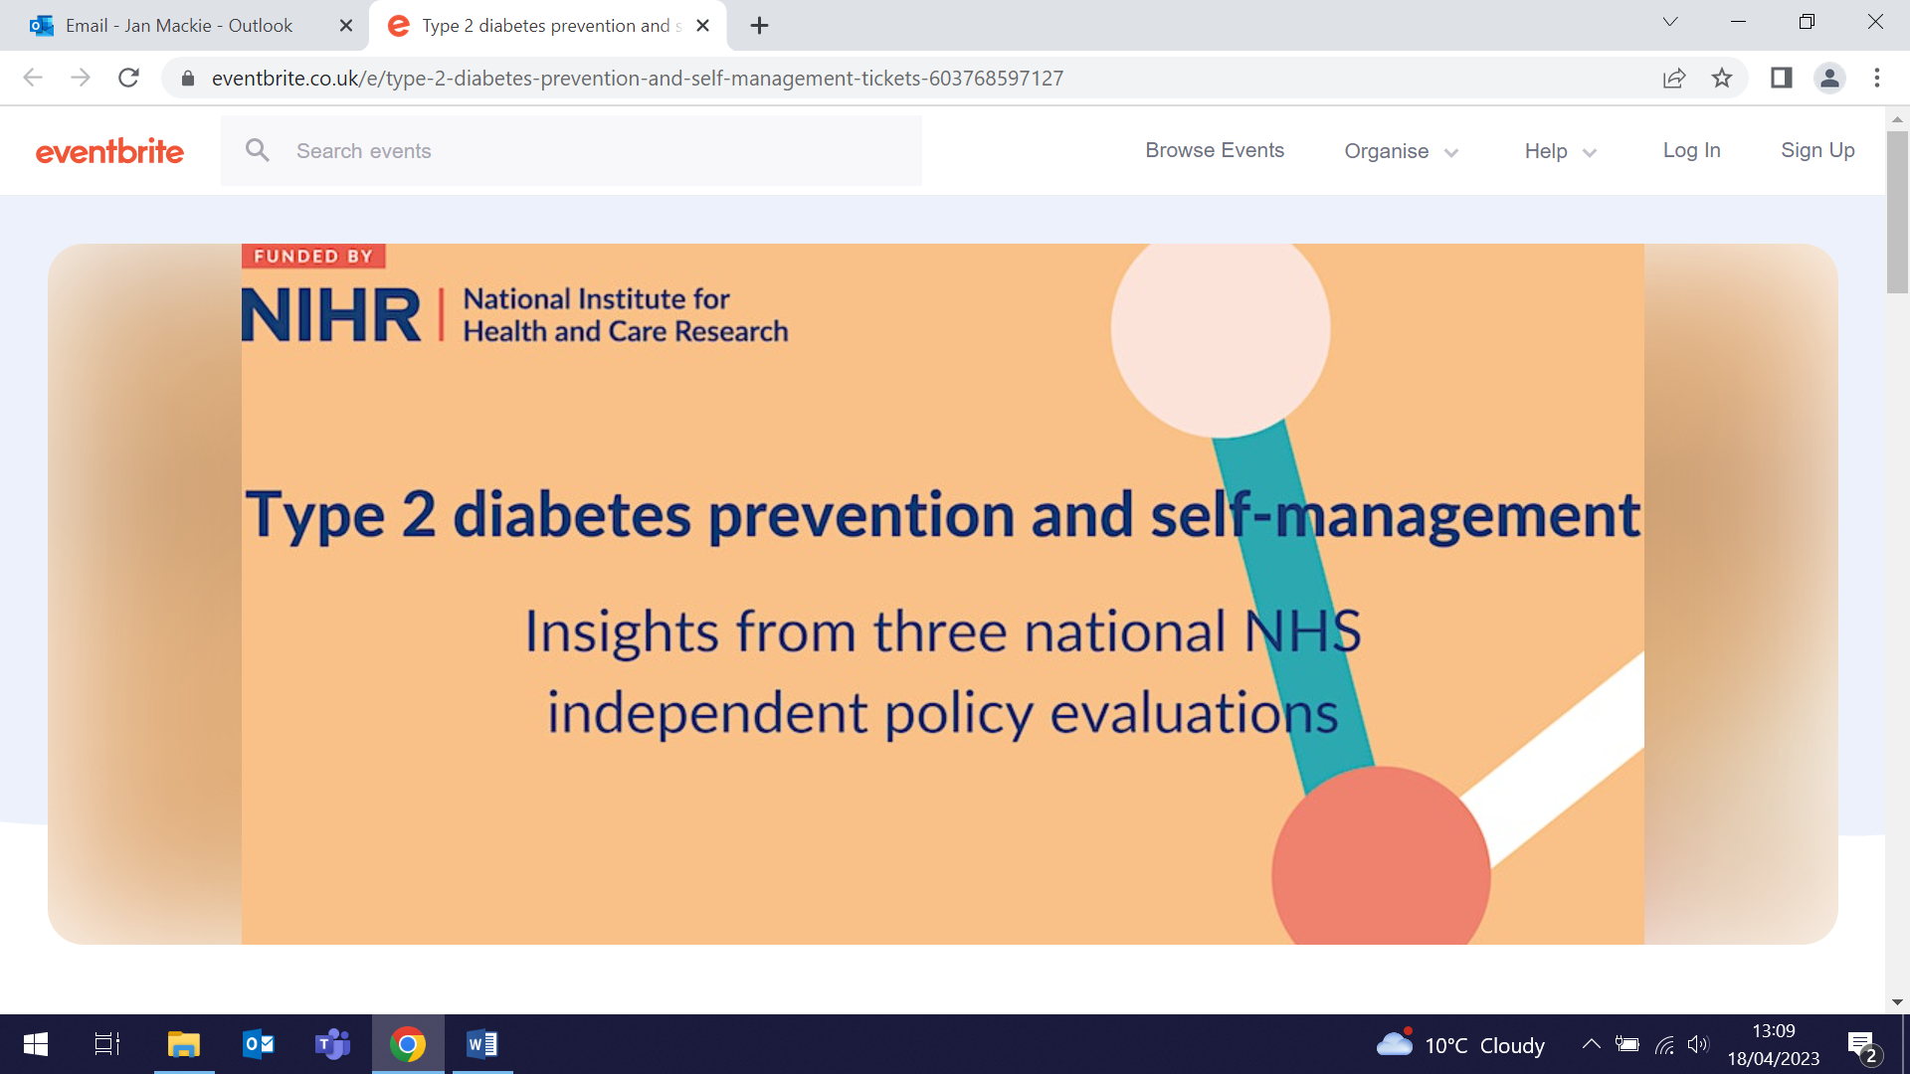
Many thanks to all who so enthusiastically contribute. Please send any news items for the next newsletter to j.a.mackie@qmul.ac.uk

