WOLFSON INSTITUTE OF POPULATION HEALTH
NEWSLETTER
ISSUE 34: 11 MAY 2023

In this issue of our Wolfson Institute of Population Health Newsletter, we celebrate the achievements and work of staff and students through April and early May.

FROM OUR DIRECTOR
Dear Colleagues

The sun is shining and the trees are in full bloom - finally, Spring is well underway!

Yesterday I attended a Thanksgiving Service at St Paul’s Cathedral in celebration of St Bartholomew’s Hospital 900th anniversary. It was a moving and magnificent occasion, with the choir voices soaring up into the huge dome above us. Celebrating 900 years of continuous care provided here made many of us reflect on the meaning of care and continuity, and how this is at the heart of so much of what our community continues to contribute 900 years on.

These reflections continued in conversations afterwards at the reception at the Guildhall, where the Lord Mayor pledged his support for Barts900 fundraising activities. It was heartening to meet so many local healthcare colleagues, full of support for the work of our Wolfson Institute.  Looking forward to seeing as many of you as possible for the Principal’s visit on 23 May – 3pm at the Derek Willoughby Lecture Theatre, Charterhouse Square - with a cream tea afterwards!  With warm wishes  Fiona | 
MEET WIPH

MEET WIPH – Ben Jacobs, Clinical Fellow (CPDD)

How would you describe your roles and responsibilities?
I’m doing a PhD on Multiple Sclerosis genetics, so I spend most of my day playing with data, reading/writing, or gazing thoughtfully out the window. I also do a general neurology clinic once a week with my supervisor Ruth Dobson.

What aspects of your role do you enjoy the most?
Working with energising and inspiring people. Having the time and mental space to think about challenging problems. And having the vague hope that if I do good work it may make a difference to people with MS in the long-term.
What would be your second choice as a profession?  Stand-up comic or professional football player.  What do you enjoy doing outside work?  Mainly reading the WIPH newsletter, but also watching TV, football, running, cycling.  Something most people don’t know?  I was briefly in the top 100 in fantasy football this season only to suffer a calamitous late season collapse. | 
GENERAL INSTITUTE NEWS

Did the pandemic lead to improved focus on health inequalities in England?
6 April (John Ford. Centre for Primary Care)

The COVID-19 pandemic rapidly exacerbated health inequalities. An analysis of English national policy documents produced during the pandemic identifies how inequalities were framed, and how this then framed policy solutions. Results show certain solutions being repeated and recycled, with limited broader focus on the wider determinants. Instead of a positive vision of a society of equitable health, what constitutes health inequalities was obfuscated, and instead of tackling health inequalities across the social gradient in proportion to need, attention was focused on those at greatest risk. Responsibility and accountability for delivering progress was delegated to local jurisdictions, without sufficient resource redistribution. Researchers identify options to address health inequalities, but note that these currently remain outside of the policy language of health inequalities. | 
Clozapine prescription rates in Southeast Europe
11 April (Manuela Russo, Nikolina Jovanovic. Centre for Psychiatry and Mental Health)

 | To determine whether the antipsychotic medication Clozapine is under prescribed in South East Europe (SEE), a study in Bosnia & Herzegovina, Kosovo by UN resolution, Nth Macedonia, Montenegro, and Serbia examines prescription rates in 401 outpatients with psychosis. Results show clozapine was prescribed to 37.7% of patients, with cross-country variation from 25% in Nth Macedonia to 43.8% in Montenegro. Most patients on clozapine (70.5%) were prescribed at least one more antipsychotic. Clozapine prescription rates in SEE outpatients are higher than in Western Europe, but average dose is significantly below the optimal recommended therapeutic dosage. These results may indicate that clozapine is prescribed mainly for its sedative effect, rather than antipsychotic. Authors hope their findings may encourage relevant stakeholders to address this non-evidence-based practice.
Patient perceptions of empathy in primary care telephone consultations
12 April (Beth Stuart. Centre for Evaluation and Methods)

Using online surveys and interviews of adults who underwent UK primary care consultations in May-Oct 2020, researchers have investigated patient perceptions of empathy in telephone consultations. In the online surveys clinical empathy of practitioners was rated between good and very good, but telephone consultations were rated slightly lower. Interviews with a subset of survey responders revealed 3 qualitative themes on how telephone consultations can shape clinical empathy: setting for an empathic encounter; feeling connected; being acknowledged. Authors conclude that practitioners may increase their empathic verbalisations in telephone consultations by using verbal responses to demonstrate active listening, and by clearly describing and/or implementing next steps in management. | 
EduSaltS Mobile health intervention to scale up salt reduction in China
17 April (Feng He. Centre for Public Health and Policy)

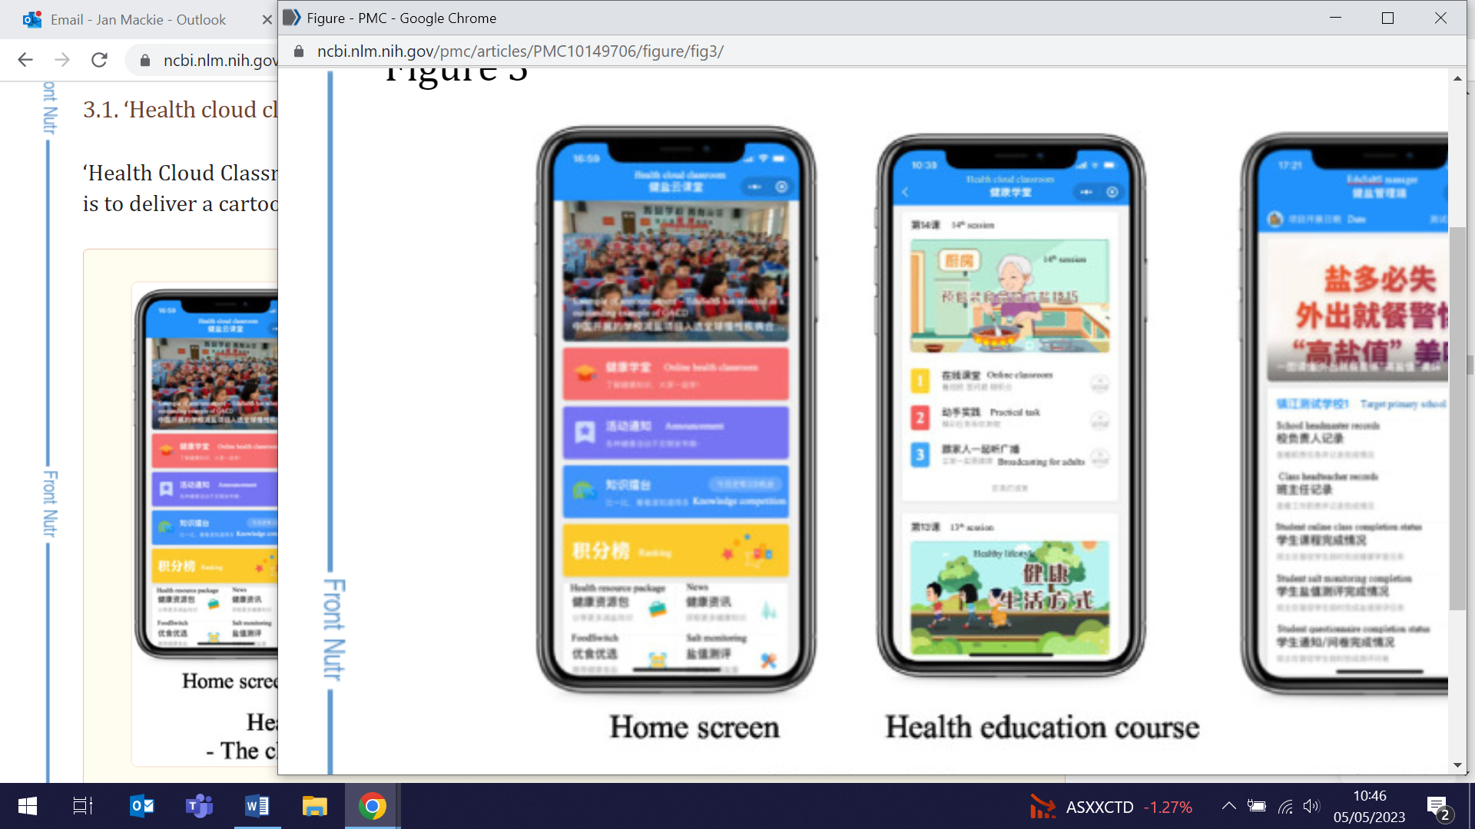 | The EduSaltS mobile health (mhealth) intervention is a scale-up of an earlier programme to reduce salt intake in China through integrated routine health education delivered in primary schools. EduSaltS includes an online WeChat-based education platform installed on users’ smartphones to deliver cartoon video classes, and a set of offline activities. Early stage roll-out evaluation shows that a one-year course has been successfully implemented among 54,538 children and their families from 209 schools in 2 cities, with an 89% average course completion rate. Researchers say these results illustrate the preliminary scalability of the intervention, and that global health impact can be achieved through dissemination and adaptation of this research in other countries.
UK Food and Drink Show 2023
24 April (Kawther Hashem. Centre for Public Health and Policy)

Representing Action on Sugar, Research Fellow Kawther Hashem appeared as a panelist and speaker at the 2023 UK Food and Drink Shows. On a panel alongside industry representatives she talked about Soft drinks reformulation: the clock is ticking for other categories. Kawther also spoke on Sugar-smart: Whose responsibility is it to make better choices on food? and about the sugar reduction programme and the advertising and promotion restrictions in place. | 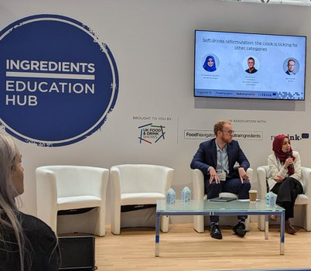
PNU Fundraiser for MS Society
25 April (MS Group, Centre for Prevention, Detection and Diagnosis)

 | On 25 April the Preventive Neurology Unit Multiple Sclerosis Group held a cake sale fundraising event for the MS Society, as part of MS Awareness Week 2023. The team raised a fabulous total of £450 (before gift aid) through their stalls in the Wolfson building and the John Vane Centre at Charterhouse, and say they were completely overwhelmed by the outstanding support of colleagues. Many thanks to all who supported - and well done all!
RCT Protocol: Workplace intervention for cancer prevention in China
25 April (Changqiong Wang, Stephen Duffy, Graham MacGregor, Feng He. Centres for Public Health and Policy/Prevention, Detection and Diagnosis)

Workplace health promotion is known to be effective and cost-effective in reducing cancer burden in developed countries. The protocol for a stepped-wedge cluster RCT in China describes a study of 750 employees across 3 cities, in which 15 workplaces are sequentially introduced to an intervention (WECAN) of on and off-line health related activities. Employers will provide supportive policies, environment, and benefits to facilitate the adoption of healthy behaviours, with a mobile application ‘Healthy Workplace’ developed to support the intervention. Primary outcome will be the change in a Healthy Lifestyle Index Score, which includes smoking, alcohol consumption, physical activity, diet, and body mass index. | 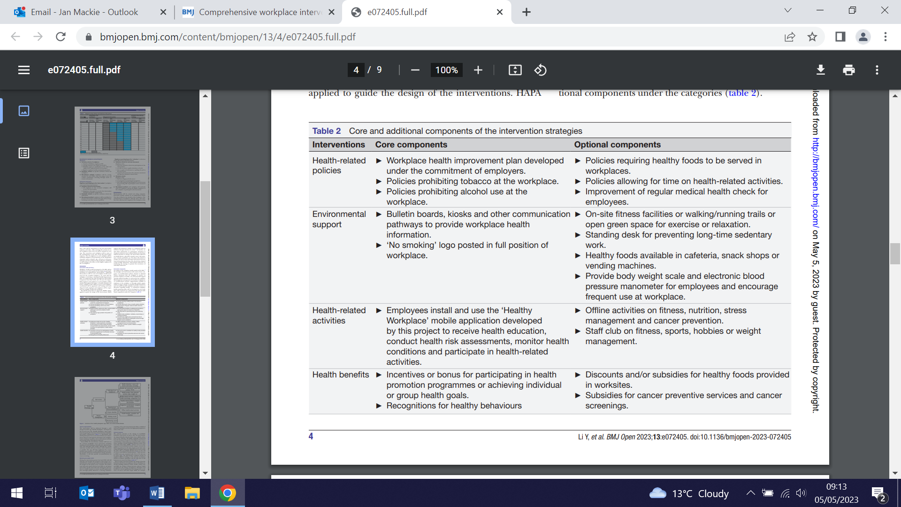
Early post-operative changes in renal transplant recipients and donors
26 April (Ruchika Kohli, Peter MacCallum. Centre for Prevention, Detection and Diagnosis)

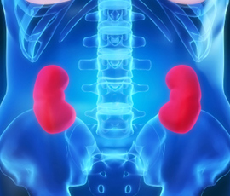 | To address uncertainty about the benefit of pharmacological thromboprophylaxis following renal transplant surgery, a new study compares haemostatic parameters before and after surgery in 28 recipients and 24 donors. Blood samples collected at five time points, from baseline to 120 hrs after surgery, were assayed for in vitro thrombin generation, factor VIII activity, von Willebrand factor antigen, D-dimer, antithrombin activity, prothrombin fragment 1+2, thrombin antithrombin complexes, and plasminogen activator inhibitor-1 antigen. Persistence of a hypercoagulable state was more prominent in recipients after 24hrs, despite recovery in renal function and initiation of thromboprophylaxis.
Fulbright QMUL Award
26 April (Selina Vickery. Centre for Public Health and Policy)

Incoming (2023/24) MSc student, Selina Vickery, who will be joining the Global Public Health Unit, has been awarded a Fulbright scholarship through the US-UK Fulbright Commission. Selina is one of only three Fulbright recipients in QMUL. Congratulations are in order for this prestigious high profile award. | 
Short tenure of primary care physicians in Brazil
27 April (Giuliano Russo. Centre for Public Health and Policy)

 | Factors associated with the tenure of primary health care (PHC) physicians are investigated in a study of 2335 public health doctors in São Paulo (Brazil) from 2016-2020. Short tenure undermines continuity of care and compromises health outcomes. Median physician tenure was 10.94 months, with higher tenure associated with age at hire (ie. Age 30-60) and professional experience over 5 years. Authors conclude that characteristics (eg. specializations and experience) related to low tenure can be changed through investments in PHC infrastructure and changes in work conditions, policies, training, and human resource policies, and that a remedy for the short tenure of physicians is essential to guarantee a robust PHC system.
Trauma-informed care in general practice
27 April (Dipesh Gopal. Centre for Primary Care)

An analysis investigating the role of trauma- informed care (TIC) in general practice suggests that awareness and training is important not just for healthcare professionals, but also for reception staff, care navigators, and community link workers. Empowering colleagues to uncover previous life traumas may help clinicians understand the relationship between the trauma and the reason for current presentation, and may improve clinician-patient relationships and patient healing because of their trauma being ‘seen’. TIC principles can be used to build trusting relationships with patients, giving informed choices and providing safety in the clinical space. Authors suggest that TIC could give clinicians a lens to understand the intersection between health and trauma. | 
Caring for hospice in-patients with delirium
2 May (Trevor Sheldon. Centre for Public Health and Policy)

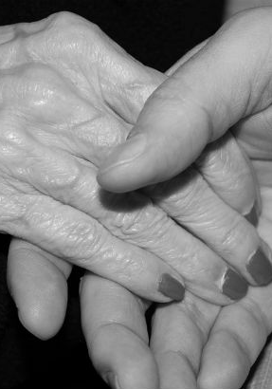 | To better understand current multidisciplinary care for delirium in hospice inpatient settings, an interview study explores staff and volunteer practice in two hospices. Findings show that practice was focused on managing hyperactive symptoms of delirium through medication and non-pharmacological strategies. This focus was influenced by staff and volunteers' emotional responses to the distress associated with hyperactive symptoms of delirium as well as their understanding of delirium prevention, recognition and care. Authors say the findings can inform hospice-tailored interventions to develop a shared team understanding and engage staff's emotional responses to improve delirium care, and that reflective learning opportunities could increase understanding of the potential to reduce patient distress through prevention and early recognition of delirium.
BRCA 2023 - Moving into the Mainstream
2-5 May (Ranjit Manchanda. Centre for Prevention, Detection and Diagnosis)

Ranjit Manchanda attended the Ninth International Symposium on Hereditary Breast and Ovarian Cancer (BRCA 2023 - Moving into the Mainstream) in Montreal, speaking at two sessions and chairing a third. His talks were entitled Cost-effectiveness and population impact of mainstreaming for breast and ovarian cancer, and Exploring cut-offs: When is the risk high enough to consider salpingo-oophorectomy? He also chaired the session on Population-based testing for HBOC-related genes: Pros and cons. | 
Effect of temperature changes on eczema in children
2 May (Beth Stuart. Centre for Evaluation and Methods)

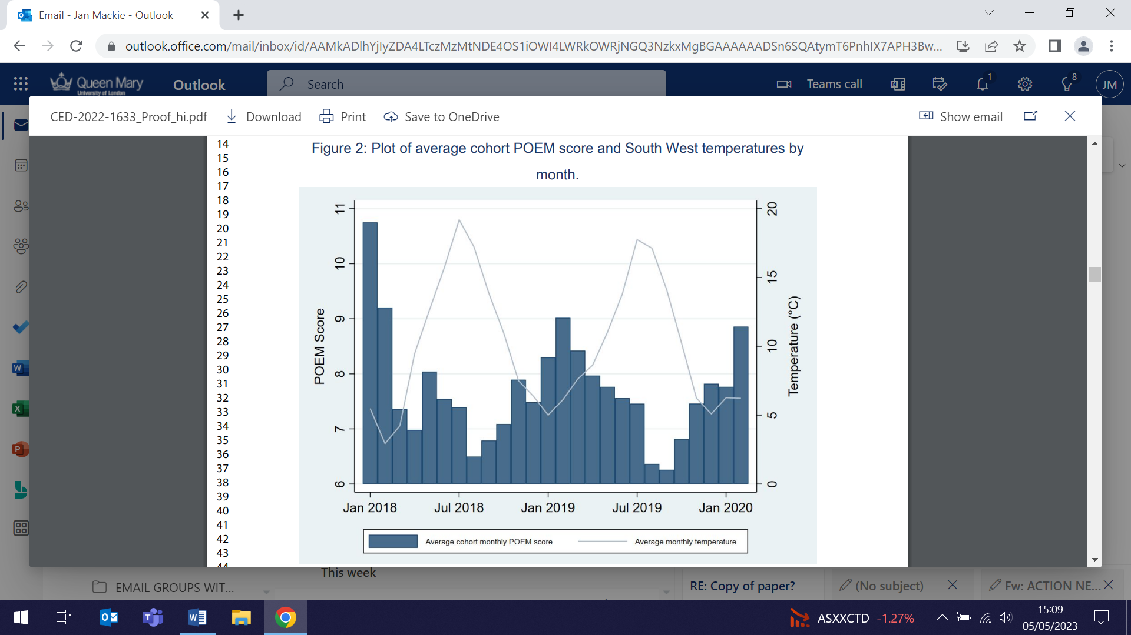 | To investigate the effect of short-term temperature variations on eczema symptoms in children, researchers combined data from a UK RCT cohort of 519 children with eczema aged 6m-12y with observed temperature data from 2018-20. Results showed seasonal variation in patient-oriented eczema measure scores, suggesting symptoms worsening with colder weather and improving with warmer weather. The findings are consistent with previous studies demonstrating either improvements in eczema symptoms or reduced flares in hot weather. Worse disease and different emollient types did not increase susceptibility or provide protection against temperature changes. Researchers suggest further work is needed on the role of sunlight, humidity, air pollution and other environmental factors.
Roadmap for a UK national lung cancer screening programme
2 May (Sammy Quaife. Centre for Prevention, Detection and Diagnosis)

Following the recommendation in favour of lung cancer screening with low-dose computed tomography by the UK National Screening Committee in 2022, a meeting of stakeholders and UK experts has produced a roadmap of work needed to prove deliverability in preparation for a national roll-out. The consensus on the key requirements and priorities for effective implementation of a programme presented in this policy review will be an important tool in the expansion and evolution of an already successful programme to national level, and provides a summary for those organising and delivering lung cancer screening in other countries. | 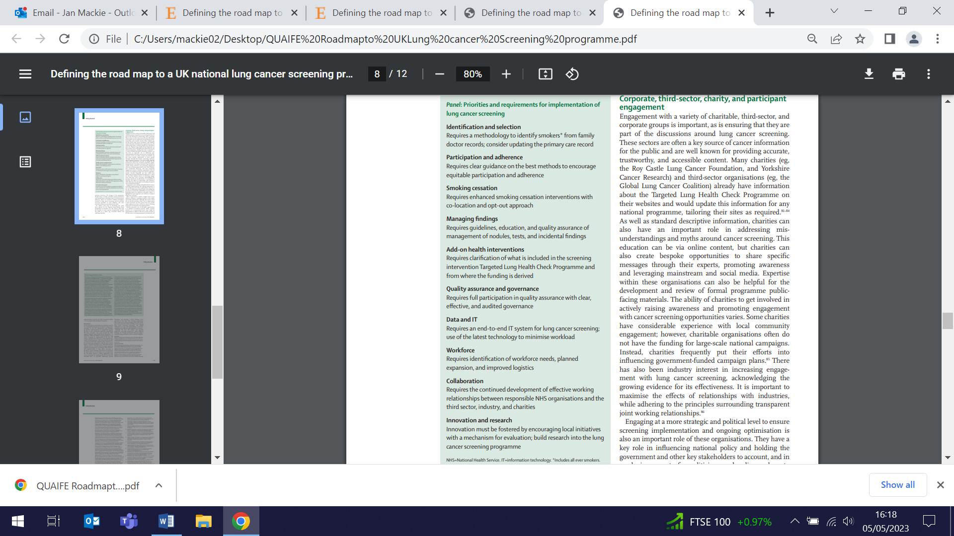
Presentation to the National Child Measurement Programme team
3 May (Meredith Hawking. Centre for Primary Care)

 | Meredith Hawking presented research findings to the National Child Measurement Programme team, part of the National Office for Health Improvement and Disparities. Through the programme, children of primary school age are weighed and measured at school by visiting health professionals, with BMI calculated and results issued to parents, categorising children as underweight, healthy weight, overweight or very overweight. The paper synthesised qualitative research into the experiences of children categorised as ‘overweight’ and ‘very overweight’, and those of their parents. Results show that the programme may be having a negative impact on self-perception and food practices of some children, and particularly those the programme aims to help.
Expert Opinion: World ‘on cusp of first generation treatments for Alzheimer’s’
3 May (Charlie Marshall. Centre for Prevention, Detection and Diagnosis)

Media coverage of trial results showing that donanemab slows both cognitive and functional decline included widely quoted comments from Charles Marshall: This is hugely exciting news, providing further evidence that it is possible to slow down Alzheimer’s disease. When the full results are published we will be able to start carefully balancing the risks and benefits, and this will inform decisions about whether donanemab should be routinely given to patients with Alzheimer’s disease. For this to be possible, we will also need substantial new investment in dementia clinics that can deliver accurate diagnosis, treatments that are given as infusions, and appropriate safety monitoring. Without this, there is a very real risk that existing health inequalities are exacerbated as only a few patients living near large teaching hospitals will benefit. | 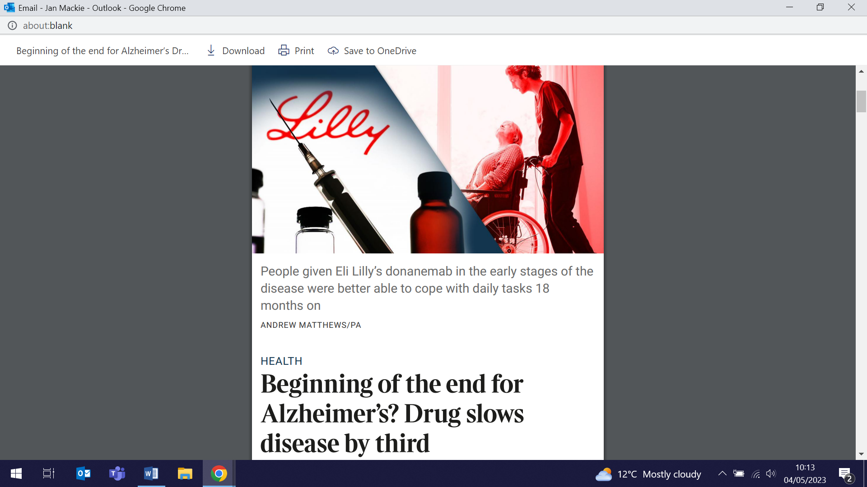  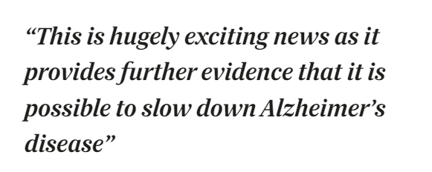
Toolkit for virtual and hybrid cancer MDT meetings
4 May (Daisy McInnerey, Sammy Quaife. Centre for Prevention, Detection and Diagnosis)

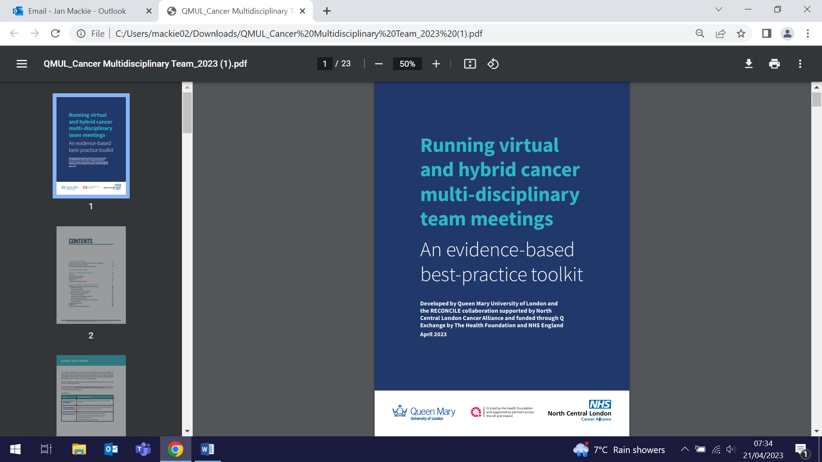 | A new toolkit developed by WIPH researchers in collaboration with the North Central London Cancer Alliance is designed to help cancer MDT members run and participate in effective virtual and hybrid MDT meetings. It includes a one-page summary of core best-practice principles, guidance on application of these principles, and role-specific checklists. Funded through Q Exchange by The Health Foundation and NHS England, the kit is based on evidence from a national research programme, and co-designed with cancer MDT members, healthcare managers and patients.
Physical activity in UK primary school children during lockdown
4 May (James Scales, Rosamund Dove, Helen Wood, Harpal Kalsi, Grainne Colligan, Florian Tomini, Boby Mihaylova, Sandra Eldridge, Chris Griffiths. Centres for Primary Care/Evaluation and Methods)

Using physical activity data measured by triaxial accelerometers worn by 179 primary school children in London, Luton, and Dunstable, new research explores the impact of COVID-19 lockdown on children’s physical activity. Data were collected for 5 consecutive days pre-pandemic and again during the first 3 months of 2021. A 10.8 minute reduction in daily time spent in moderate to vigorous physical activity and a 33.2 minute increase in daily sedentary activity were observed during lockdown, reflecting a reduction in daily moderate to vigorous physical activity for those not attending school during lockdown. There was no significant change for those who continued to attend school. These findings suggest that the loss of in-person schooling was the single largest impact on physical activity in this cohort. | 
Non-linear effects and effect modification at participant-level in individual patient data meta-analysis
4 May (Nadine Marlin, Richard Hooper. Centre for Evaluation and Methods)

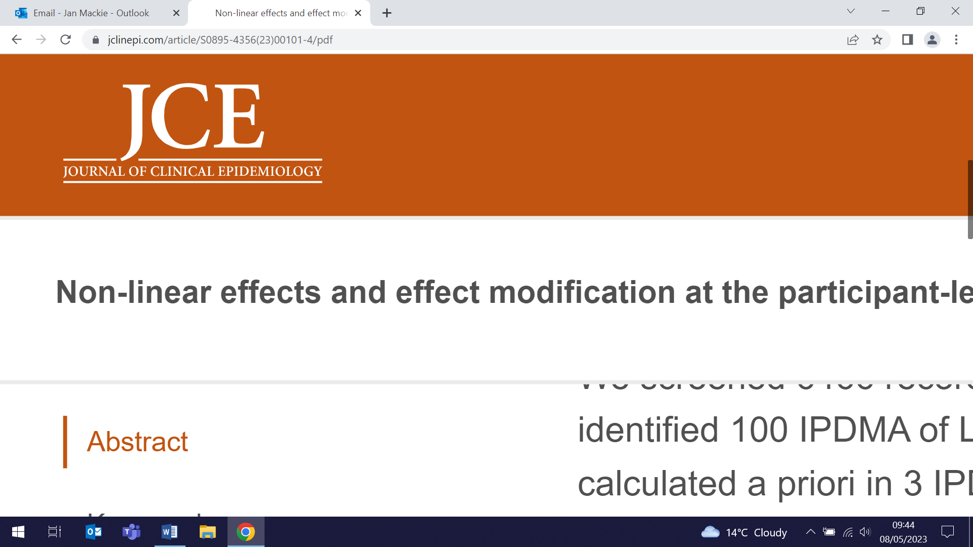   | An extensive two-part publication reviews analysis methods and methodological guidelines for linear effect modification, non-linear associations, and non-linear effect modification at the participant-level in individual participant data meta-analyses (IPDMA). The studies conclude that (i) investigation of effect modification at the participant-level is common in IDPMA projects, but methods are often open to bias or lack detailed descriptions, and non-linearity of continuous covariates and power of IPDMA are rarely assessed; and (ii) detailed methodological guidance on IPDMA of effect modification at participant-level is available, but because methodology papers for sample size and non-linearity are rarer and may not cover all scenarios, further guidance is needed on these aspects.
Interview in The Times: New Alzheimer’s drugs rely on early diagnosis
4 May (Charlie Marshall. Centre for Prevention, Detection and Diagnosis)

A Times article on recent trial results for donanemab for Alzheimer’s patients includes an interview with Charles Marshall on the difficulties in Alzheimer’s diagnosis. All patients in the trial had been diagnosed using PET scans, but most memory clinics cannot undertake these. Charles told the Times: From the time people first develop symptoms to diagnosis is typically around 3 years. If you look at the current state of diagnostic services for dementia, as a society we simply wouldn’t tolerate it for cancer. We have a widely-held view that cancer should be detected early. We don’t have that for dementia. A lot of that stems from the nihilism about “Well, there’s nothing that can be done”, but the new drugs may change that, as well as leading to a push for simpler, cheaper, biomarkers of the disease. |   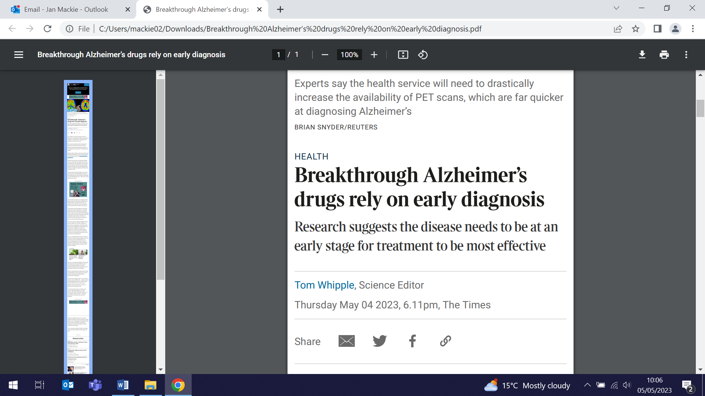  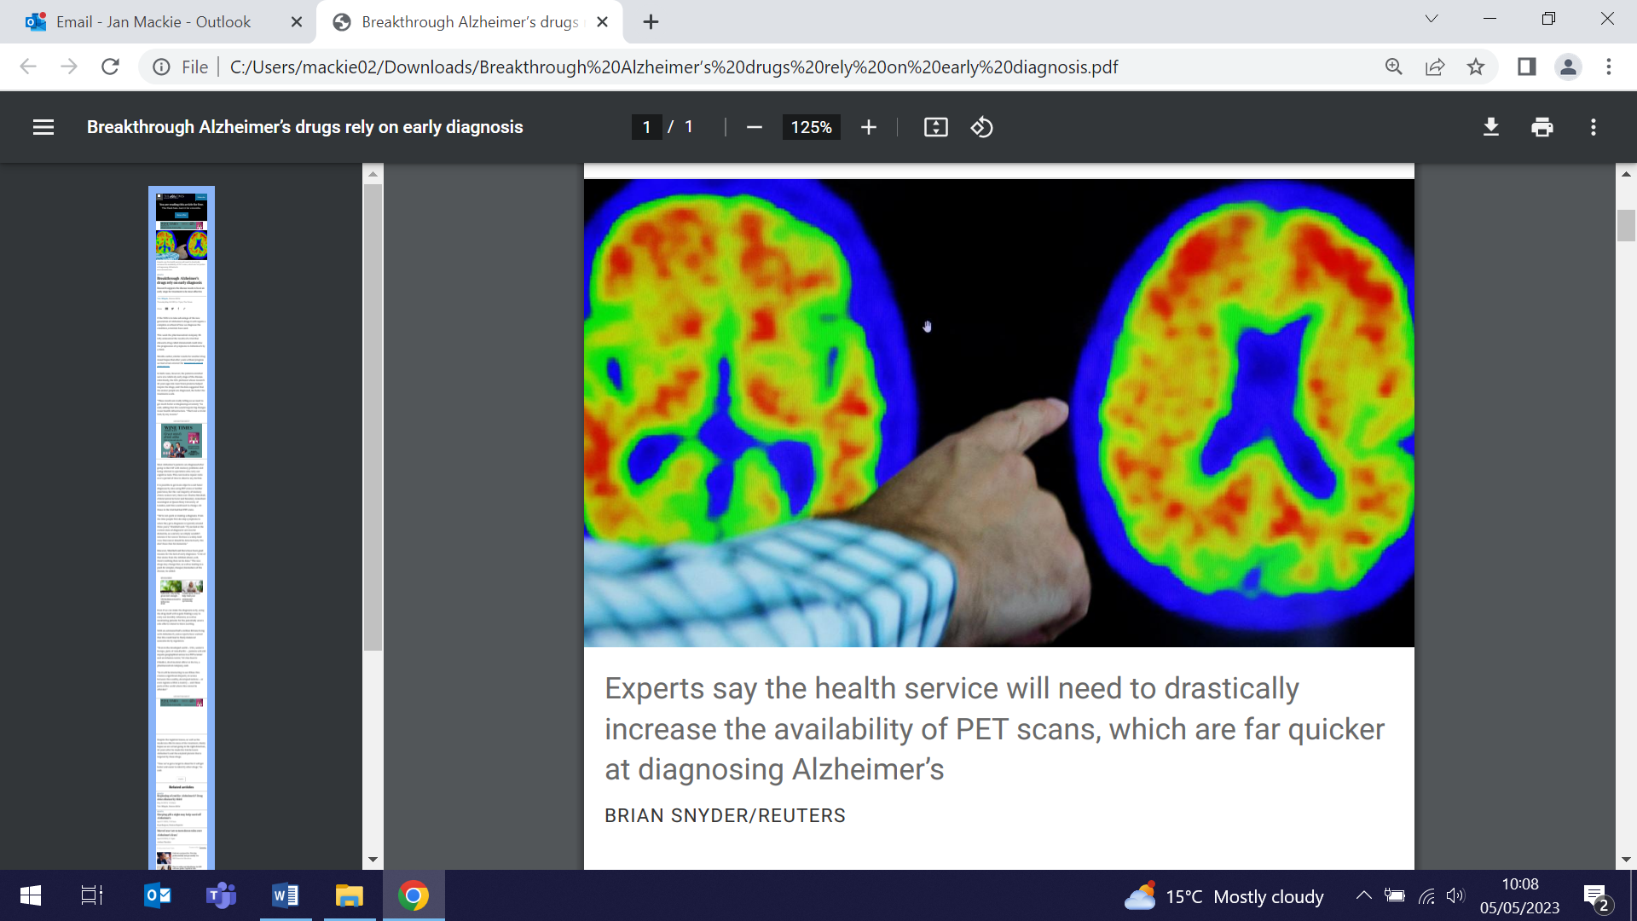
Group music therapy for adults with long-term depression
5 May (Catherine Carr, Emma Millard, Stefan Priebe. Centre for Psychiatry and Mental Health)

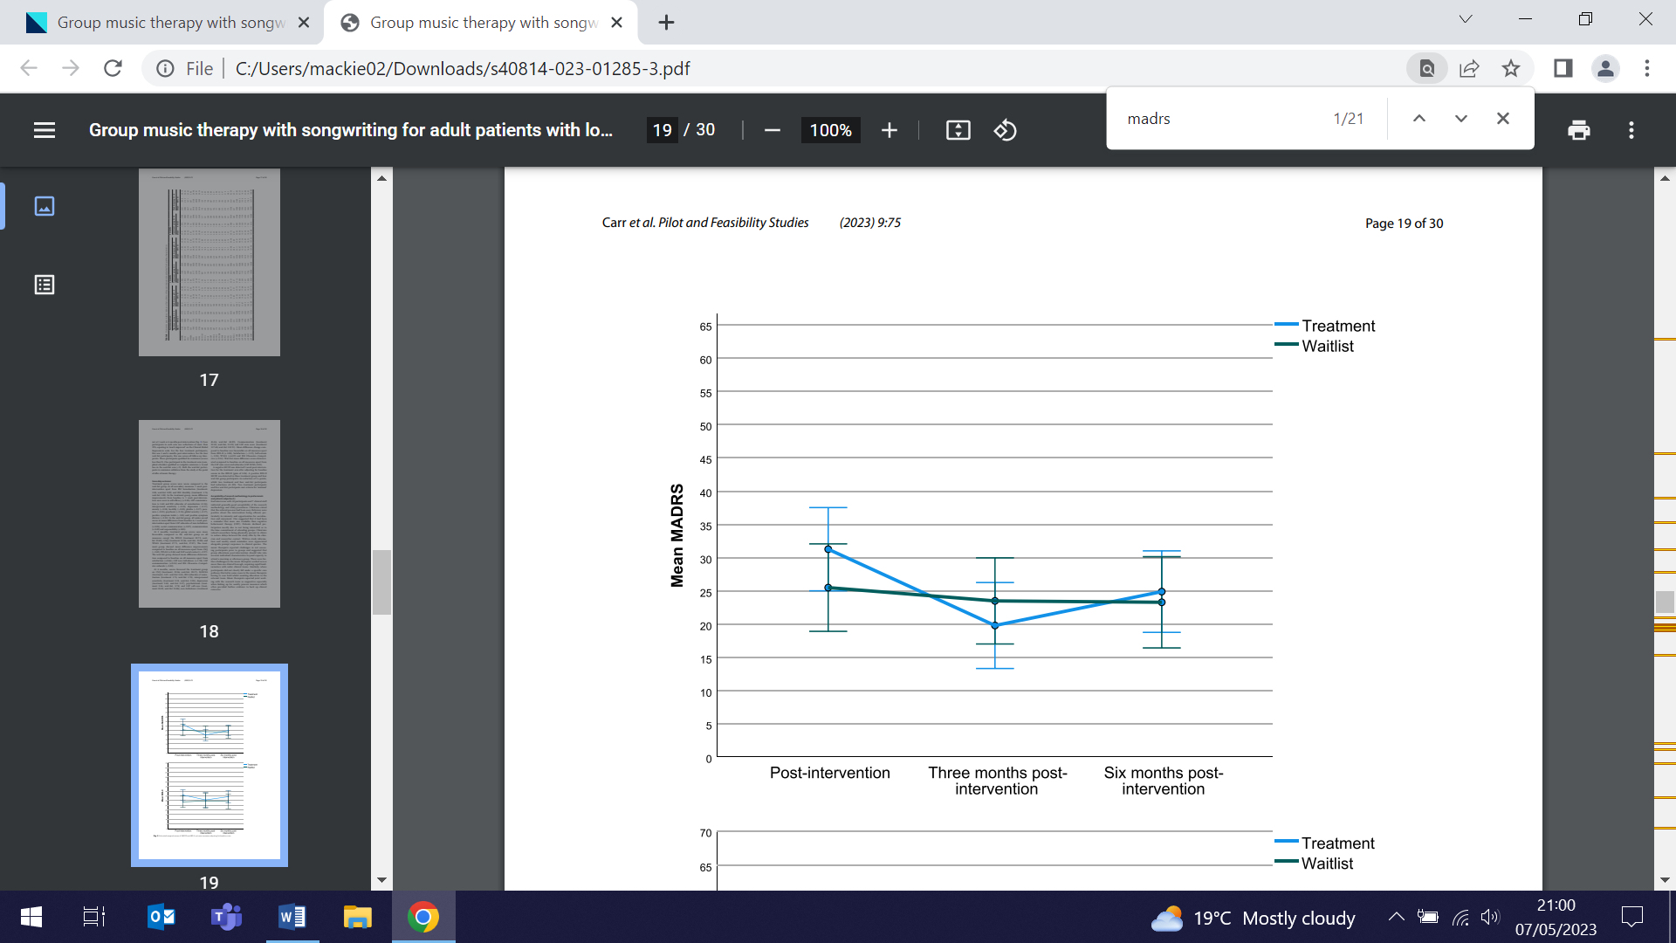 | A feasibility study of the utility of group music therapy for long-term adult depression randomises 30 patients to a control group or the SYNCHRONY intervention of 42 sessions of group music therapy with songwriting 3 times weekly. Depression, social functioning, distress, quality of life, satisfaction and service use were assessed at 4 time points to 6 months post-therapy. Outcomes for 10/20 treatment and 9/10 control arm patients show that at 3 months post therapy, the treatment arm improved from baseline on all measures except satisfaction and functioning. At 6 months post-therapy, quality of life, distress, and functioning improved, with reduction in health service contacts. While clinical outcomes from a feasibility study should be interpreted cautiously, authors conclude that with some developments and modifications, a full RCT is feasible.
Type 1 Diabetes and Parkinson's: Potential Protective Link?
6 May (Alastair Noyce. Centre for Prevention, Detection and Diagnosis)

Using Mendelian randomization, linkage disequilibrium score regression, and multi-tissue transcriptome-wide analysis, a new study has found a potentially protective role of type 1 diabetes (T1D) for Parkinson’s risk, as well as motor and cognitive progression. Results also show a negative genetic correlation between T1D and Parkinson’s, and identified eight genes in cross-tissue transcriptome-wide analysis that were associated with both traits. Authors say larger comprehensive epidemiological and genetic studies are required to validate the findings. | 
Protocol for Fluid Optimisation in Emergency Laparotomy (FLO-ELA) Trial
6 May (Neil Walker, Boby Mihaylova. Centre for Evaluation and Methods)

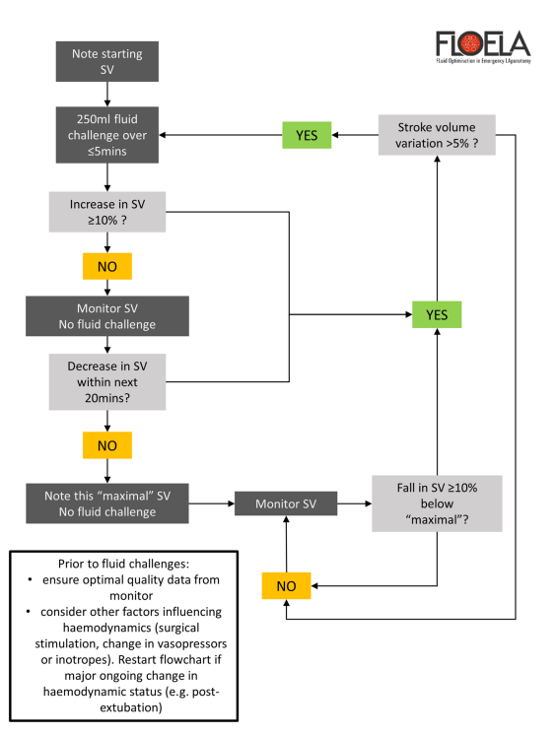 | To address a paucity of evidence evaluating cardiac-output guided haemodynamic therapy in patients undergoing emergency gastrointestinal surgery, the published protocol for the FLO-ELA trial describes a multi-centre RCT of 3138 patients aged ≥50 undergoing major emergency gastrointestinal surgery in up to 50 UK hospitals. The trial assesses use of minimally invasive cardiac output monitoring to guide protocolised administration of intra-venous fluid compared with usual care without cardiac output monitoring, based on the number of days spent alive and out of hospital following surgery. Participant recruitment started in September 2017 and is expected to complete by the end of 2023.
Social and cultural influences on mental and cancer-related health care interventions for ethnic minority patients
10 May (Dipesh Gopal, Imran Khan, Ania Korszun, Steph Taylor, Sheila Donovan, Elisavet Moschopoulou. Centres for Primary Care/Psychiatry and Mental Health)

A meta-ethnography investigating relational influences on mental health and cancer-related health care interventions for racially minoritised people in the UK finds that developing better connections between ethnic minority patients and health care professionals could drive more positive health care experience. The paper investigates social and cultural influences on health care interventions, focusing on psychological approaches and/or cancer care to inform the SUrvivors' Rehabilitation Evaluation after CANcer (SURECAN) trial of a new psychological therapy for those living with or beyond cancer. Co-author Dipesh Gopal said: Health care that fails to appreciate the centrality of creating safety and connectedness in care consultations for all kinds of patients risks inadvertently othering patients. The paper concludes that training around the hidden affective relationality of consultations merits consideration to improve care for diverse patients. | 
Swahili translation and validation of the Warwick Edinburgh Mental Wellbeing Scale
10 May (Lola Oyebode. Centre for Public Health and Policy)

 | The Warwick Edinburgh Mental Wellbeing Scale (WEMWBS) has been translated into 30+ languages. In this study, a questionnaire including WEMWBS, socio-demographic, and self-reported health information was translated into Swahili, and used to collect data from 3052 students and 574 teaching staff in the Girls' Education Challenge (GEC) project in Tanzania. WEMWBS scores were used to explore associations between individual characteristics and high/low mental wellbeing. Participants considered WEMWBS understandable and relevant to their lives. In GEC schools wellbeing was higher in students in the final 2 years of school v the first 2. Among adults, being male, urban residence, absence of markers of social marginality, and better self-reported health were all significantly associated with better mental wellbeing. The Swahili translation of WEMWBS is now available for use.
FORTHCOMING EVENTS AND NOTICES

New: WIPH Health Inequalities Reading Club (25 May)

As part of the WIPH strategy to extend research on health equity, Sara Paparini (Centre for Population Health and Policy) has initiated a new Health Inequalities Reading Club, an informal opportunity to review literature together and share our ideas and work in this area. The club will meet 1-2pm on the last Thursday of each month, ideally in person but with a hybrid option. An initial online meeting will be held at 1pm on 25 May, to discuss Gee et al: A life course perspective on how racism may be related to health inequities. Am J Public Health. 2012 May;102(5):967-74. All welcome, teams meeting link to join here. | 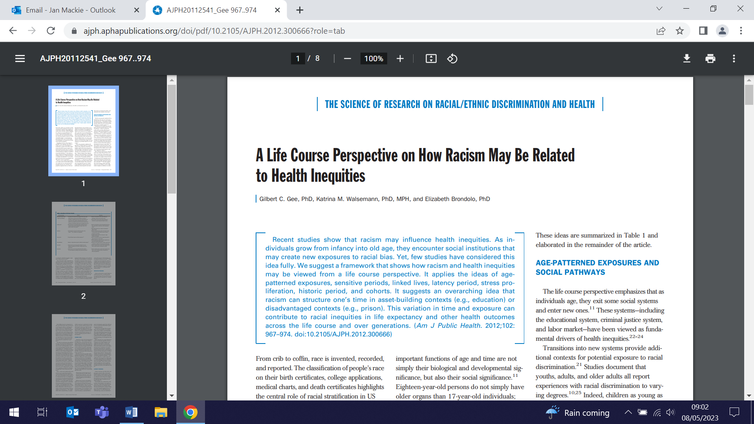
Type 2 diabetes prevention and self-management: what works, why and what changes are needed? (26 May)

WIPH Senior Lecturer in Primary Care Jamie Ross will speak at this free in-person NIHR event in Manchester on 26 May. Under the NHS Long Term Plan, three national programmes to prevent and manage type 2 diabetes have been implemented: Healthier You - NHS Diabetes Prevention, Healthy Living for People with Type 2 Diabetes, NHS Low Calorie Diet. At this event, the teams conducting the programme evaluations, DIPLOMA, HED-LINE and RE-MISSION, will share insights from their work. The event will be of interest to national and local commissioners, patients and members of the public, and researchers. Registration is now open. | 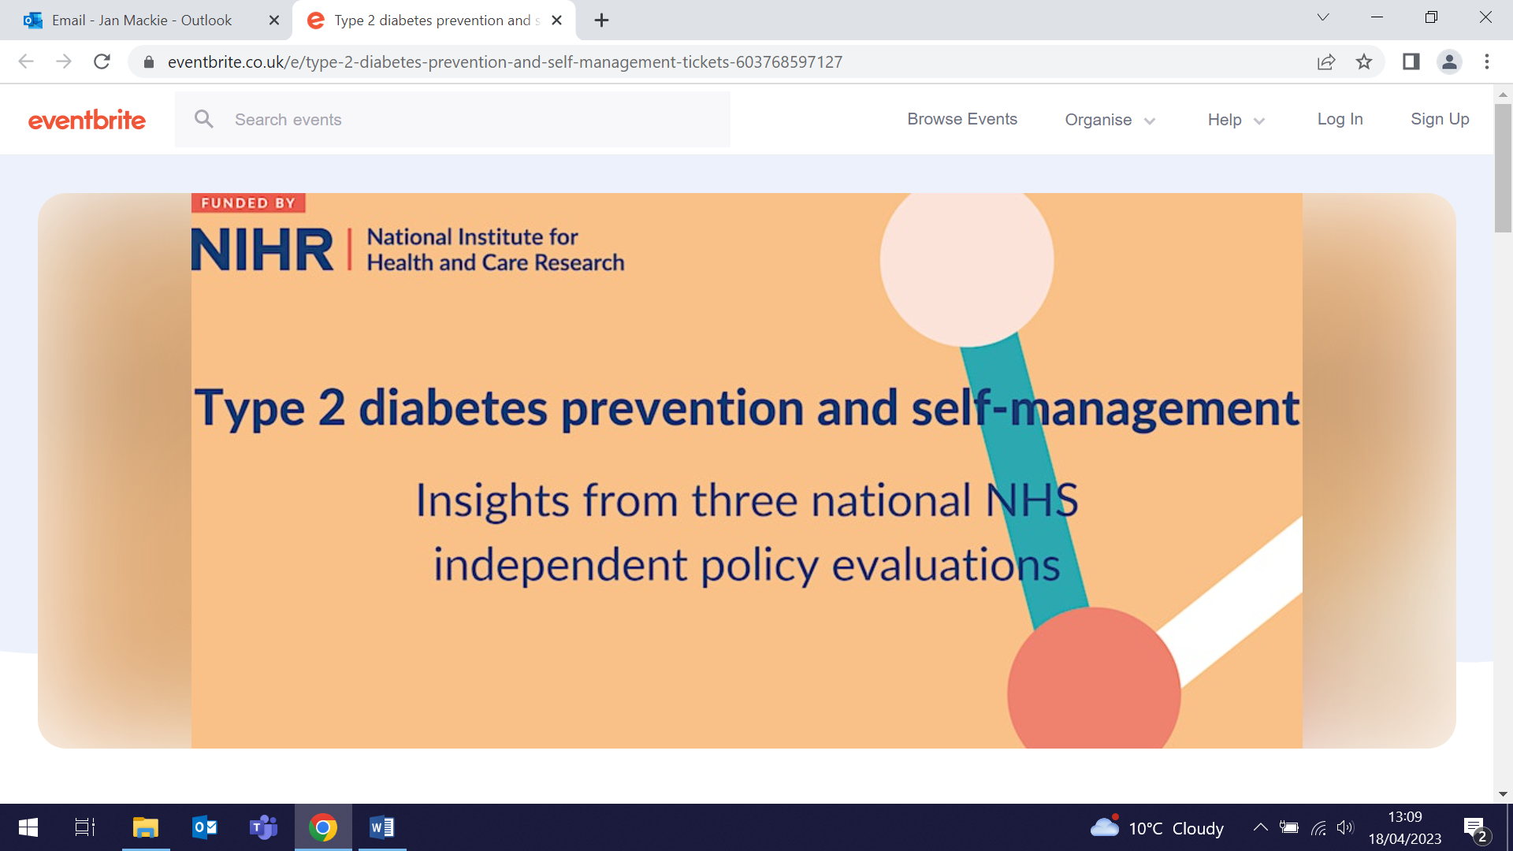
Many thanks to all who so enthusiastically contribute. Please send any news items for the next newsletter to j.a.mackie@qmul.ac.uk

