WOLFSON INSTITUTE OF POPULATION HEALTH
NEWSLETTER
ISSUE 35: 31 MAY 2023

In this issue of our Wolfson Institute of Population Health Newsletter, we celebrate the achievements and work of staff and students at the end of April and throughout May.

FROM OUR DIRECTOR
Dear Colleagues

Hoping that everyone was able to enjoy some of the lovely Bank holiday sunshine and warmth.

Matching the warm weather, we have had a week with much to celebrate. First, we had the Principal’s visit, giving him an occasion to hear about the breadth and depth of our work, and to share his fascinating perspectives on running a University. Thanks to all for the excellent turnout and to those who prepared and asked questions during the really interesting Q&A session. We had excellent feedback.

On Thursday many of us attended the inaugural QMUL Research and Innovation Awards ceremony in the fine setting of the Law Society, Chancery Lane. Huge congratulations to our WIPH award winners, particularly Sammy Quaife for the Outstanding Early Career Researcher award and the SHARE Collaborative (Sara Paparini, Social Science Lead) for the Research Impact: Culture, Civic Community and Policy award (see photos and story of 25 May below for more details).

Finally, I’m delighted to announce that WIPH reached a brilliant 71% participation rate in the QM Staff Survey (and note that Ellie promised us a BBQ if we reached 70%). Thanks to all for taking time to respond, and we look forward to understanding the results, finding areas to focus on, and taking action to drive change.

With warm wishes

Fiona

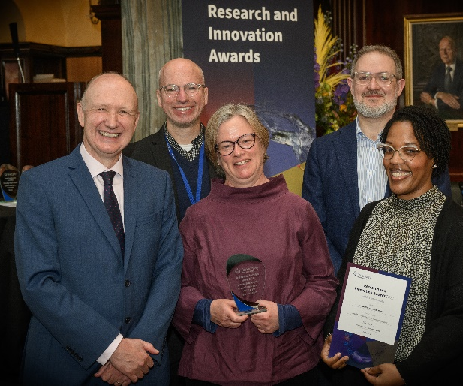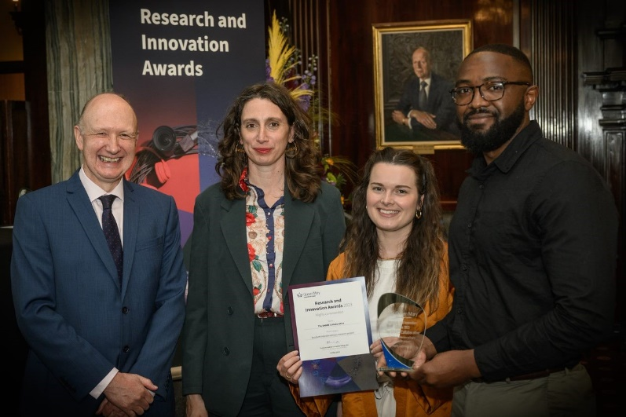

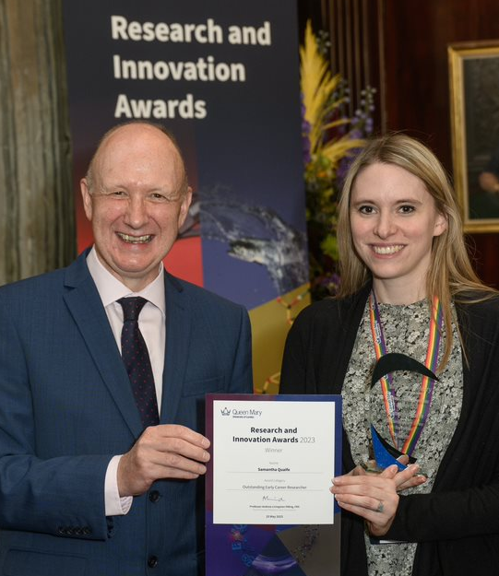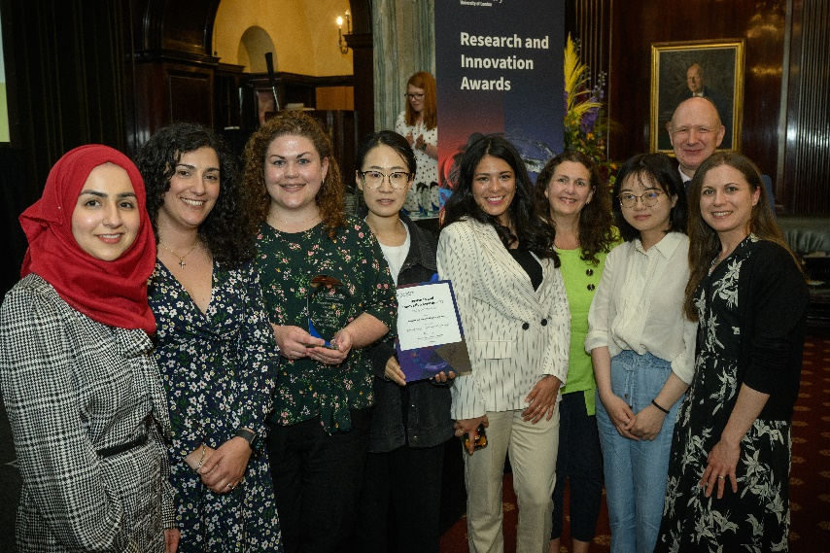
MEET WIPH

MEET WIPH – Victoria Amoah (Centre Manager, CPMH)

How would you describe your roles and responsibilities?
I’m responsible for overall CPMH operational activities, including facilitating effective information flow, financial planning, budgeting, costings for research proposals, and monitoring Worktribe until projects are live. I also manage the centre's HR process for recruitment, appraisal, staff management, training and development, promotion and grading reviews, coordinating honorary academic titles, and administering business case documentation for new and replacement appointments.

What has been your greatest professional achievement?
I received an award for leading a team that successfully delivered customer-focused operations at student survey. By driving forward excellence as the standard, I achieved a radical increase in student satisfaction and student experience. The department was previously ranked very low, but I worked hard to ensure that we actively promoted an environment of continuous improvement and best practice, to achieve a monumental change in results, bringing our ranking into the top ten.

What aspects of your role do you enjoy the most?
Administering and supporting grant bids - it’s always rewarding when a bid you’ve supported is successful. The energy and the feeling of joy is remarkable! In CPMH I have been supporting the culture change and its implementation. It has been insightful and an honour to be part of this innovation, and to create good working relationships.

What would be your second choice as a profession?
My second choice would be to work with children, especially listening to their views, as they are inspiring and motivating. I would like to research youth development and the associated behavioural factors.

What do you enjoy doing outside work?
I enjoy spending quality time with my lovely girls and hubby. Games night on Saturdays are the best moments, bringing joy, laughter and tears. We always end up with smiles on our faces, regardless of the winner!
Something most people don’t know?  There is a special garden I love in the town of Aburi, close to my hometown in Ghana. It features 32 acres of uncultivated land, kept wild to maintain ecological balance, and also many trees that arrived in the late 19th century from far-flung places in Central America, Mexico, Malaysia, India and the Caribbean. In particular there is a mahogany tree planted by the late Queen Elizabeth II in 1961, and a silver oak planted by King Charles III (then Prince of Wales) in 1977. I spent a lot of time here when growing up, but back then I did not appreciate the richness of its flora and fauna, or the ecological importance. I now visit the garden with great admiration when I’m on vacation. | 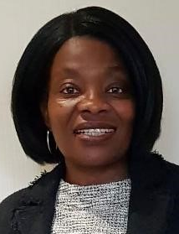
FROM OUR LEADERSHIP TEAMS

New Institute Academic Impact Lead Appointed
From Steph Taylor (Director of Research)

Congratulations to Dr Charles Marshall, Clinical Senior Lecturer in the CPDD Preventive Neurology Unit, who has been appointed as the first WIPH Academic Impact Lead. In addition to helping to identify and support Impact Case Studies from WIPH staff in the next REF exercise, Charlie will help foster and promote a wider range of research and academic impact across the Institute. Please reach out to Charlie through Tor Kemp or Jan Mackie if you have academic and research impact you’d like to discuss.

Research News
From Tor Kemp (Research Manager)

Impact | PowerPoint providing overview of Impact at QMUL
A huge thank you to Luke Cridland (Impact Officer, FMD) and Hannah Bentley (Executive Officer, Research & Innovation) for the talk on Impact at the last All Staff Meeting. Please see the link to the slides

Applications open | NIHR Development and Skills Enhancement Award – changes | Next submission deadline July 28
The DSE award is a post-doc level award to support early to mid-career researchers to gain skills and experience to support the next phase of their research career. In a change from previous rounds, applicants no longer need to be NIHR Academy members to apply and the requirement for matched funding has been removed.

Applications open | Kennedy Trust Research Ignition Awards | Deadline June 26
The Kennedy Trust is a charity focussed on providing sustainable, long-term funding of medical research into rheumatic and related musculoskeletal, immunological and inflammatory diseases. With the goal of stimulating new and ambitious avenues of research, the Trust’s new Research Ignition Awards provide up to £100k over 1-2 years to support incisive and cutting-edge projects in areas that that have a clear relation to pathways in these conditions, where scientific evidence is still being accumulated and needs a major boost, and/or where questions are not being routinely investigated by other researchers. Please click here to download an application form. Applications should be emailed to submissions@kennedytrust.org by 23:59 26 June.

NIHR Survey | Disability Inclusion | Deadline June 26
NIHR plans to create a Disability Framework to help them set out priorities to improve their disability inclusion and create person centred ways of working which allow equitable involvement for all. The framework will be informed by people's experiences of the NIHR, to help understand and address the barriers disabled people face when engaging with them. If you have engaged, or have tried to engage with the NIHR in any way in the last 5 yrs, please complete the survey.

DERI Symposium | UKRI/BBSRC AI for Drug Discovery programme | June 28
This QMUL Digital Environment Research Institute hosted symposium aims to introduce attendees to the AI for Drug Discovery Landscape and to facilitate networking between AI for Drug Discovery Programme students, supervisors and industry partners. To be held at the Royal Pharmaceutical Society, this event is open to anyone interested in joining the programme, and those currently working in complementary areas who are interested in AI for Drug Discovery.

NIHR Hybrid event | Statistics group annual event | July 3
The NIHR Statistics Group invites you to join them for their annual routine data group event. This year’s theme is: Analysis of classification problems using machine learning and statistical methodologies in routine data. Aiming to explore the functionality of machine learning techniques in handling large/routinely collected datasets, and compare its utility against statistical techniques, the event will be held Monday 3 July 10:00-17:00 at the Axis Conference Centre, 3 Venture Rd, Southampton Science Park, Chilworth, Southampton, SO16 7NP.

Training courses| ARC Centre for Ethnic Health Research | Various dates
The ARC Centre for Ethnic Health Research team is offering each ARC two free places to their training courses on: (i) Effective Community Engagement and (ii) Cultural Competence. Please click on the links above for more details on course dates and registration. If you are interested in attending from ARC North Thames, please email arc.norththames@ucl.ac.uk and flag “FAO Lucy Thompson” in the subject line.

WIPH Postgraduate Studies Day 13 June
We are still seeking student presentations and panel members (with supervisor and examiner experience) for our annual WIPH Postgraduate Studies Day. The event will take place Tuesday 13 June 12:30-4pm, followed by an early evening BBQ on CHSQ lawn. This is an opportunity for PhD students to present their research to peers, and broaden their current research perspectives. Our objectives for the annual programme are dissemination, networking, communication and Fellowship. Please contact Patrick Mullan if you are able to contribute. As with last year, the winning student talks will be presented at the WIPH annual showcase on 28 June.

EDI News
(Evangelos Katsampouris – Equality Diversity and Inclusion Lead)

Have you ever witnessed something happening that you thought was wrong, for example, harassment of a colleague, and felt that you were unable to help? If you’d like to learn about how to overcome such concerns and about speaking up, the EDI Group encourages all WIPH colleagues, students, and staff, to undertake the Queen Mary Bystander Course training, available through QMPlus.

If you are keen to become involved in the WIPH EDI Group, or to raise and discuss an EDI-related issue, please send us an email at: wiph-edi-request@qmul.ac.uk.

GENERAL INSTITUTE NEWS

Prostate specific antigen density in predicting cancer progression
29 April (Oleg Blyuss. Centre for Prevention, Detection and Diagnosis)

In active surveillance for prostate cancer, prostate-specific antigen density (PSAD) is an important baseline predictor, but its use in follow-up and the best way of measuring it is unclear. Little is known about PSAD predictive value (v PSA), but two possible approaches are to use baseline gland volume as a denominator in all calculations throughout active surveillance (nonadaptive PSAD), or remeasuring gland volume at each new MRI scan (adaptive PSAD). Results from a study of 322 prostate cancer patients under active surveillance in Wales show that, because of its high sensitivity, serial nonadaptive PSAD significantly outperformed both adaptive PSAD and PSA for follow-up prediction of prostate cancer progression. Non-adaptive PSAD was superior in patients with smaller baseline gland volume but serial PSA was better in men with prostate values >55 ml. | 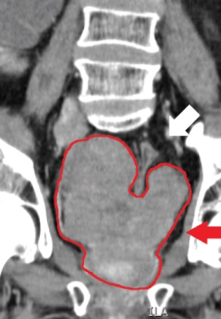
Patient perspective in decision-making in MS: OwnMS study results
9 May (Alison Thomson. Centre for Prevention, Detection and Diagnosis)

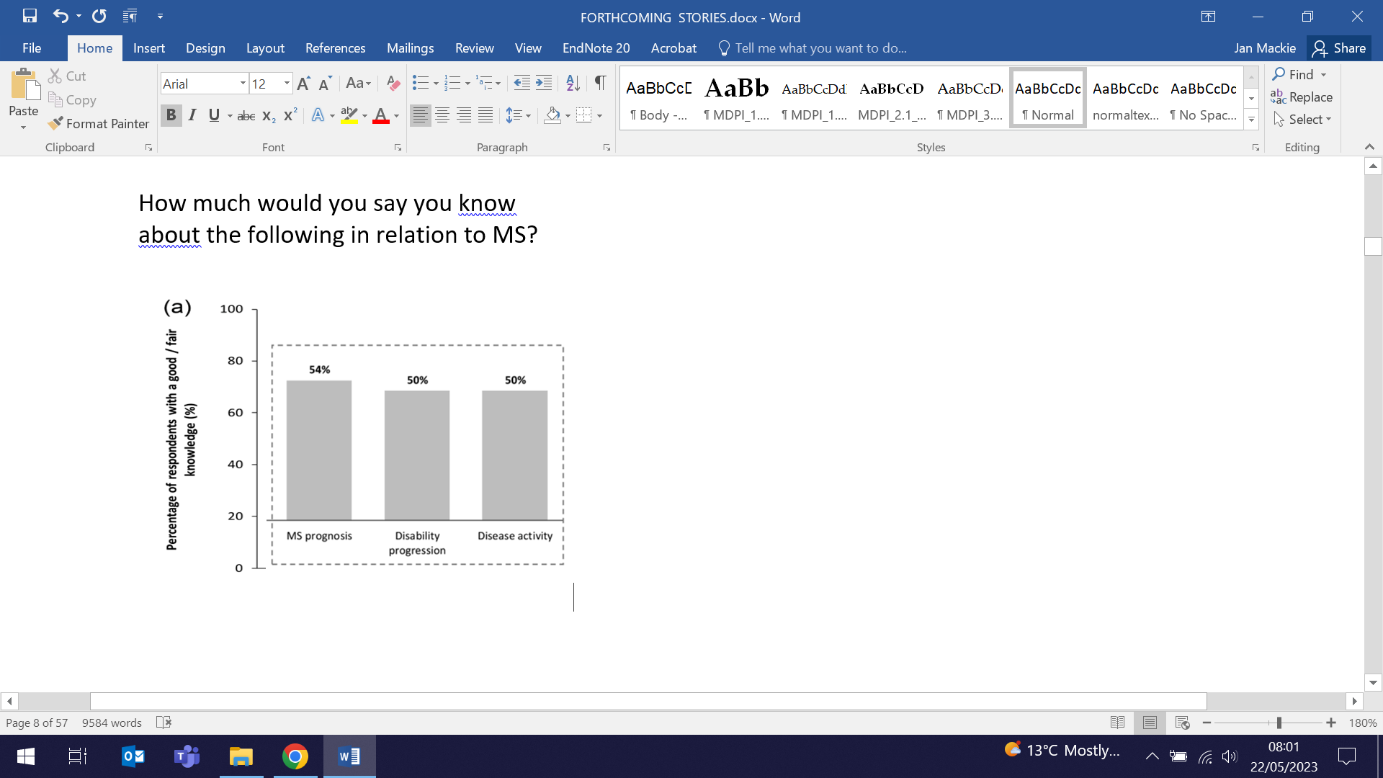  How much would you say you know  about the following in relation to MS? | Results from a quantitative survey of 117 adults with relapsing-remitting multiple sclerosis (RRMS) show that those with a good knowledge of their MS feel most able to plan and take decisions, but that clinical teams have a greater role to provide information, educate and support. The ability to plan for the future and to understand the course of MS were key priorities for respondents. The proportions reporting knowing a 'great deal' about MS prognosis (16%) and disability progression (9%) were low. Discussing goals and planning alongside prognosis and disability progression with care teams may enable people with RMMS to make informed treatment decisions and to self-manage and plan for the future, factors which are important in maintaining independence.
Improving access to dementia diagnosis in England, Wales and N. Ireland
10 May (Charles Marshall. Centre for Prevention, Detection and Diagnosis)

Introducing Dementia Action Week (15-22 May), a report and consensus statement co-authored by Charlie Marshall and released by the Alzheimer’s Society advocates for practical changes and tangible solutions to improve access to timely and accurate dementia diagnoses. Produced through roundtable discussions with senior dementia stakeholders and people living with dementia across England, Wales, and N. Ireland, the solutions set a foundation to increase dementia diagnosis rates. Goals include better funded, evidence-based dementia pathways, utilisation of new disease-modifying treatments (eg Lecanemab) as a driver for immediate system change to increase diagnosis rate, and addressing the pandemic-related drop in diagnosis rates, including building capacity to increase rates in future. Signatories call for fair access to dementia diagnosis for all to be prioritised, and for routine underfunding of dementia pathways to be addressed. | 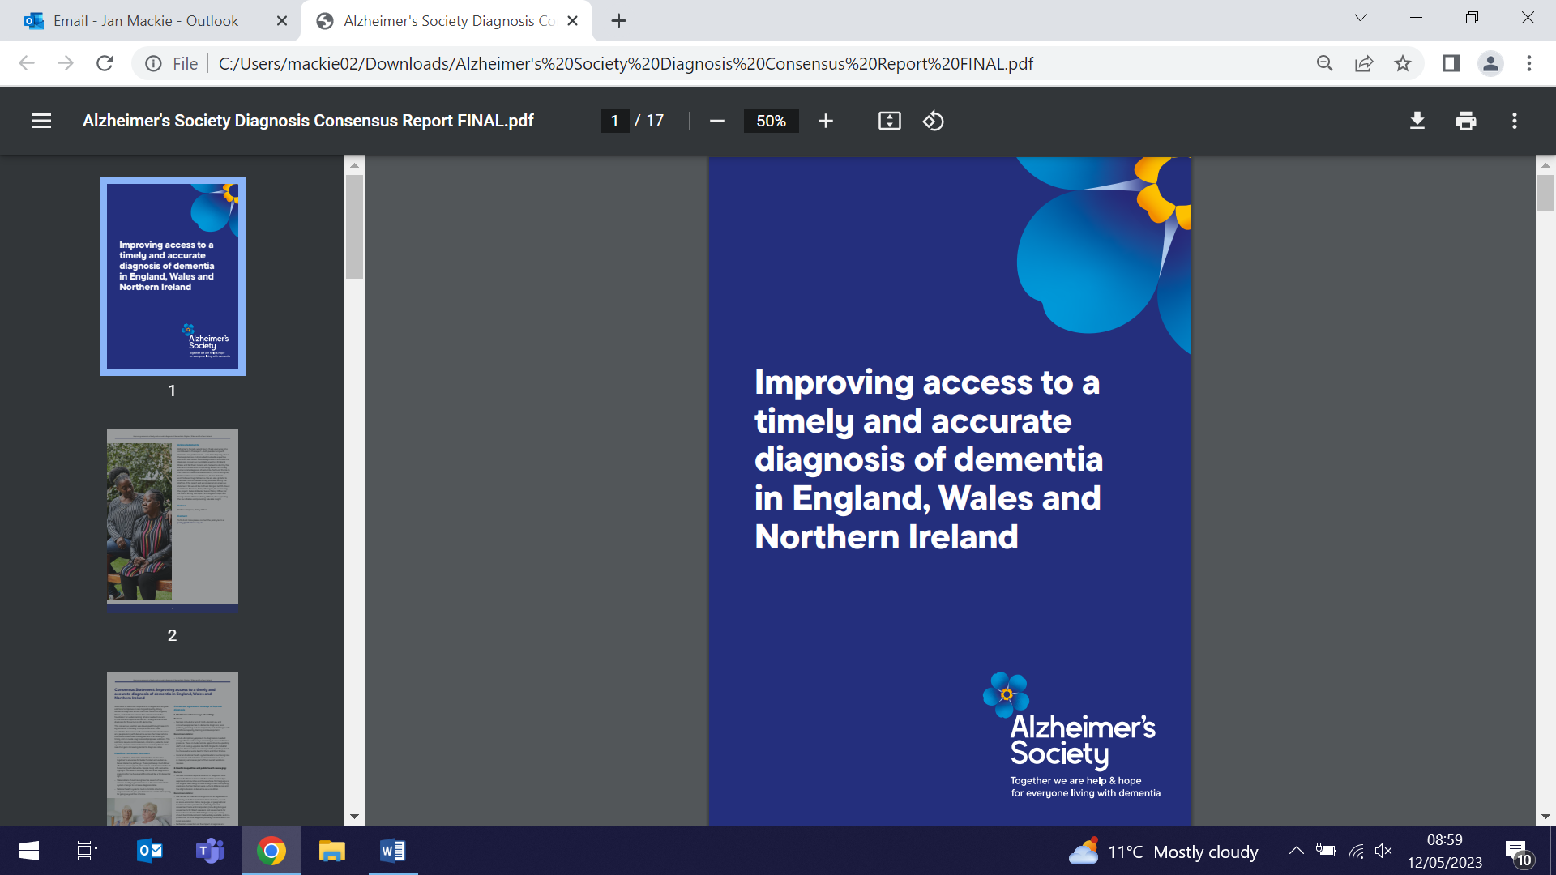
Using microbiological outcomes in clinical trials: Stakeholder perspectives
10 May (Beth Stuart. Centre for Evaluation and Methods)

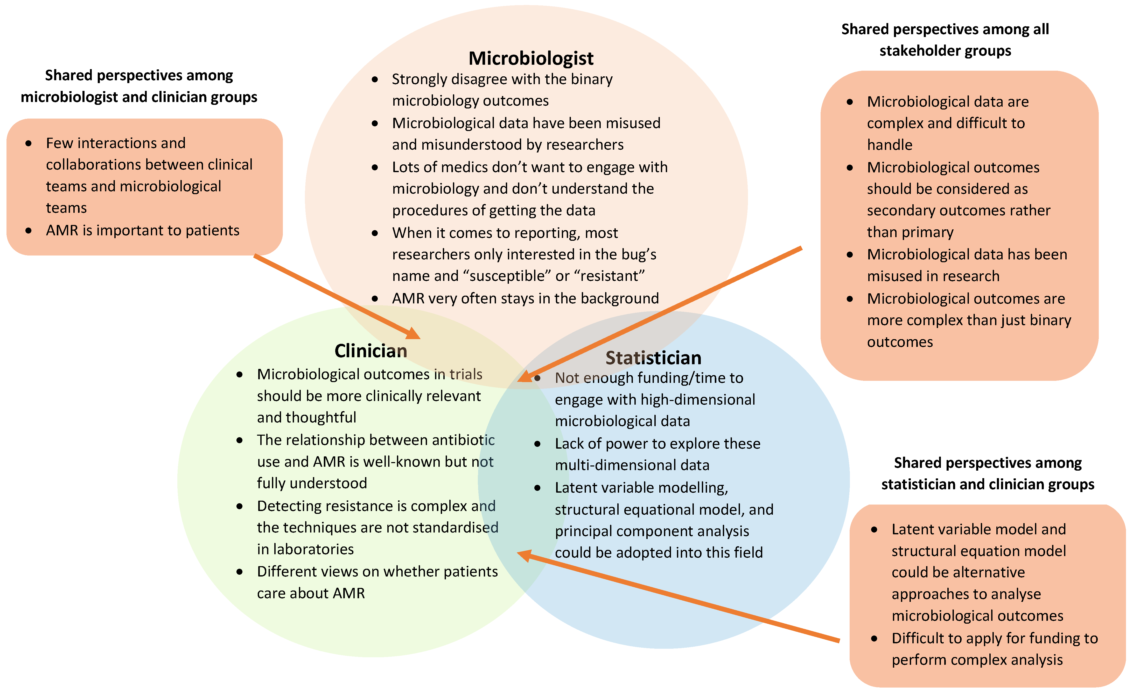 | A stakeholder engagement group has addressed issues with the use of microbiological data in clinical trials, perspectives on current microbiological outcomes reported in trials, and alternative statistical approaches to analyse these data. The group identified factors such as unclear sample collection process, dichotomising or categorising complex microbiological data, and unclear methods of handling missing data, that contribute to the low quality of microbiological outcomes and the analysis of these outcomes in trials. The published paper reaches a consensus that not all of these factors could be easily overcome, but there is room for improvement and researchers should be encouraged to understand the impact of misusing these data.
Expert Opinion: Breast cancer screening in Britain v USA
11 May (Stephen Duffy. Centre for Prevention, Detection and Diagnosis)

Discussing claims that breast cancer screening is “broken” post-covid, and that Britain has fallen behind as the US introduces mammographic screening for women from age 40, Stephen Duffy told The Times that, while screening women <age 50 would save lives, there are questions about cost-effectiveness. “However, this is not the main consideration for the NHS screening programme. In the recovery period following the Covid pandemic, screening services are working flat out to catch up with the backlog incurred in the pandemic period. A major expansion in the target population would not be practicable right now.” He added that some groups tend to develop breast cancer at younger ages, and that “once the screening services have stabilised, it is likely that there will be a need to reconsider the lower and upper age limits for breast screening.” | 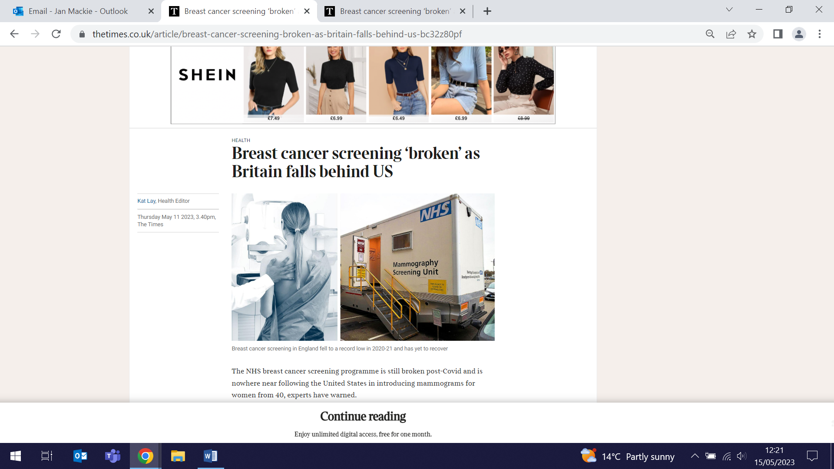
Resistance exercise dose components for tendinopathy management
11 May (Victoria Tzortziou Brown. Centre for Primary Care)

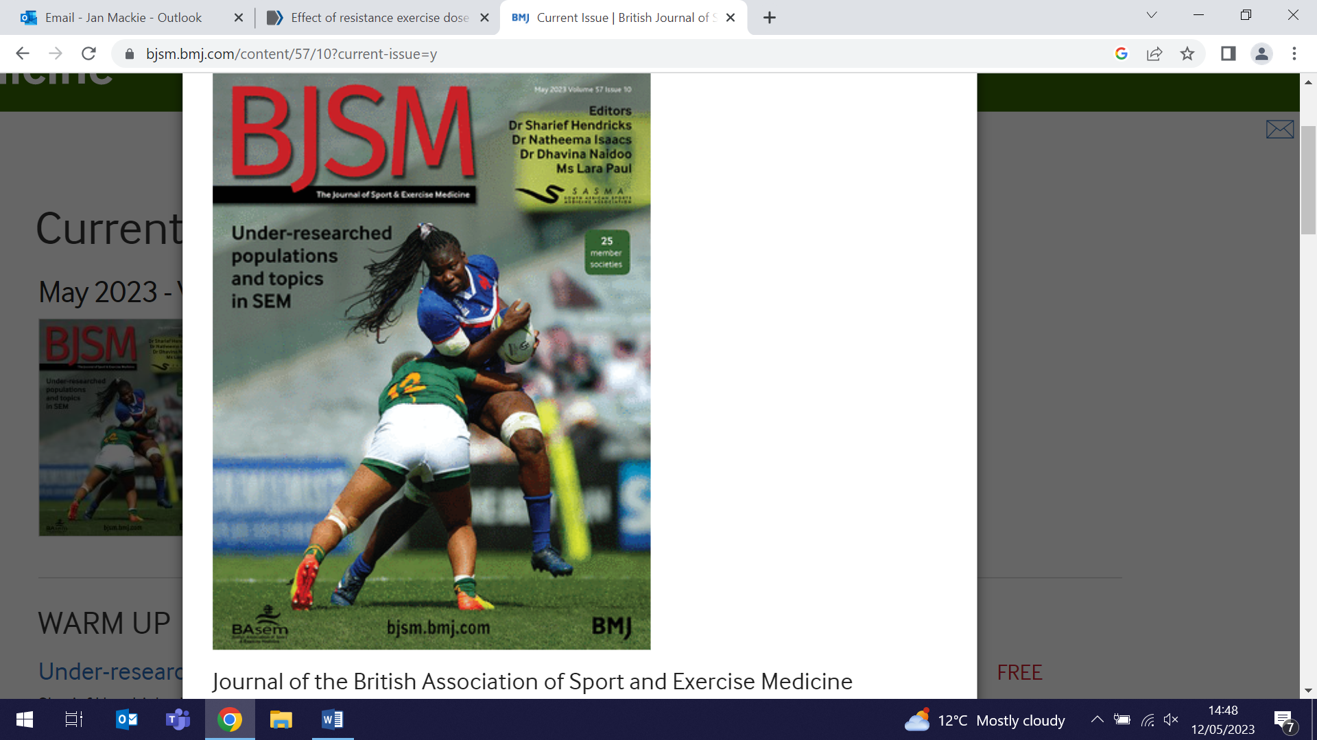 | Exercise therapy, particularly using resistance exercise, is the main conservative treatment for tendinopathy. A review and meta-analysis study has examined the effect on patient improvement of different resistance exercise dose components, including intensity, volume, and frequency. Interventions involving higher intensity resistance exercise with the addition of external loads showed greater efficacy compared with body mass only exercise. Greater efficacy was seen with interventions performed less frequently, potentially allowing for adequate recovery, compared with higher frequencies of once or more daily. No consistent results or patterns were identified from analyses of resistance exercise volume. Researchers conclude that clinicians prescribing resistance exercise therapy for tendinopathy should consider including higher intensities of resistance exercise, and allowing adequate recovery between sessions.
Nitrous Oxide guidelines and forthcoming government legislation
11 May (Alvar Paris. Centre for Prevention, Detection and Diagnosis

Management guidelines for diagnosis and treatment of nitrous oxide induced subacute combined degeneration of the cord, recently published in Practical Neurology, were presented by Alvar Paris at the joint annual 2023 meeting of the Association of British Neurologists and Institute of Clinical Neurosciences in Belfast. Neurologists’ opinions were also sought regarding proposed new government plans to introduce legislation to control nitrous oxide under the Misuse of Drugs Act 1971, by making it a class C drug. Audience members were invited to register their interest in signing a letter to the Home Secretary, setting out concerns that this may push users away from seeking help and lead to more harm. | 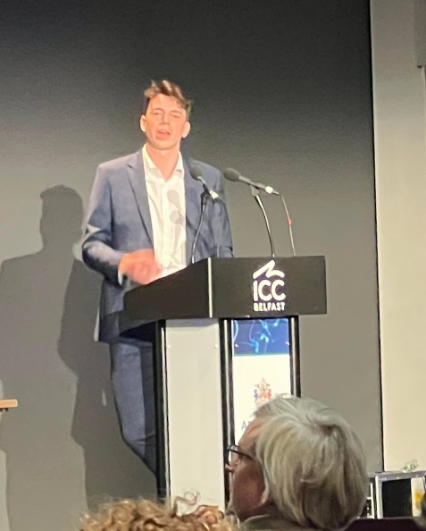
Covid-19 impact on Tanzanian maternal and child health services
12 May (Giuliano Russo. Centre for Public Health and Policy)

 | Drawing on interviews and focus group discussions with key informants, patients, and health providers, a cross sectional case study in three districts of Tanzania finds that prioritization of covid-19 services led to reorganisation of health facilities, reallocation of staff, rescheduled antenatal and postnatal clinics, and reduced time for health education and child monitoring. Evidence showed lower uptake of antenatal, postnatal, family planning, and immunization services, as well as fewer institutional deliveries.
New: TRIPLE C reporting principles
13 May (Sara Paparini. Centre for Public Health and Policy)

An online Delphi panel of 51 experts from 50 diverse disciplines and sectors across 12 countries has produced guidance for case study evaluations exploring the influence of context on the processes and outcomes of complex interventions. The panel reached over 80% consensus on 16 items for the reporting principles, covering title, abstract, definitions of terms, philosophical assumptions, research question(s), rationale, how context and complexity relates to the intervention, ethical approval, empirical methods, findings, use of theory, generalisability and transferability, researcher perspective and influence, conclusions and recommendations, and funding and conflicts of interest. The resulting Triple C (Case study, Context, Complex interventions) reporting principles are designed to be enabling rather than prescriptive, and to make case study evaluation reporting on context and complex health interventions more comprehensive, accessible and useable. | 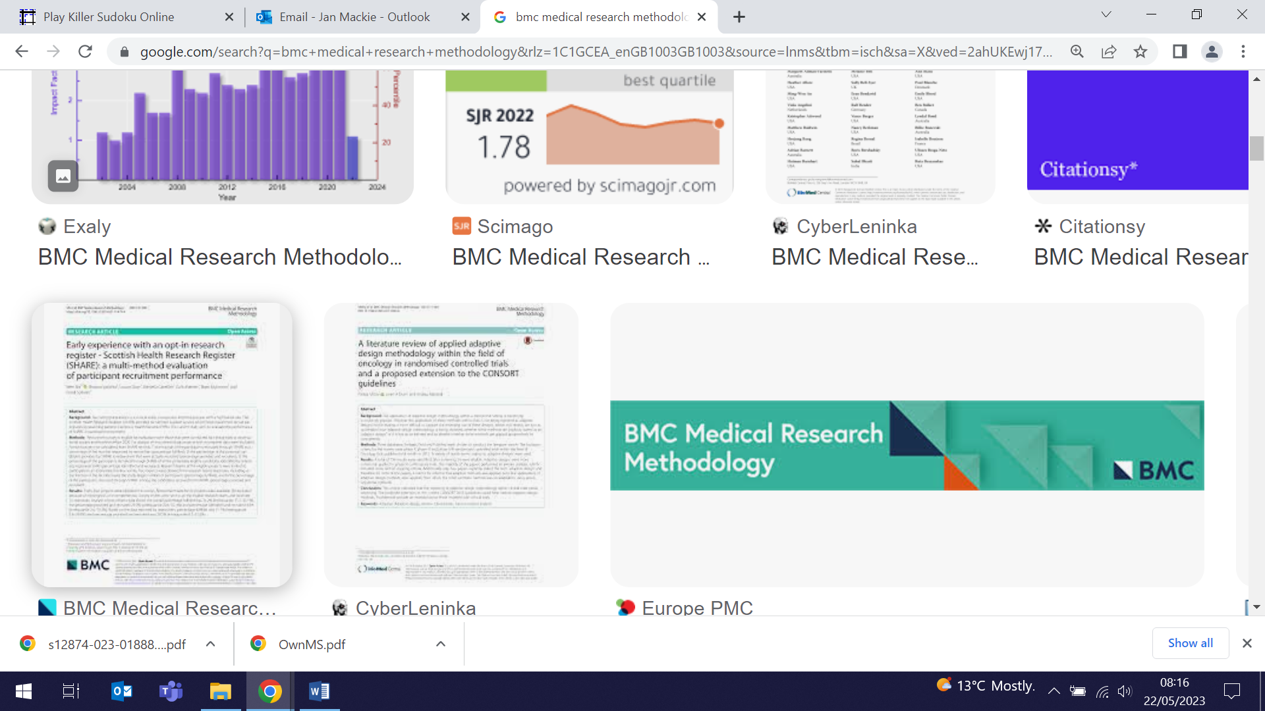  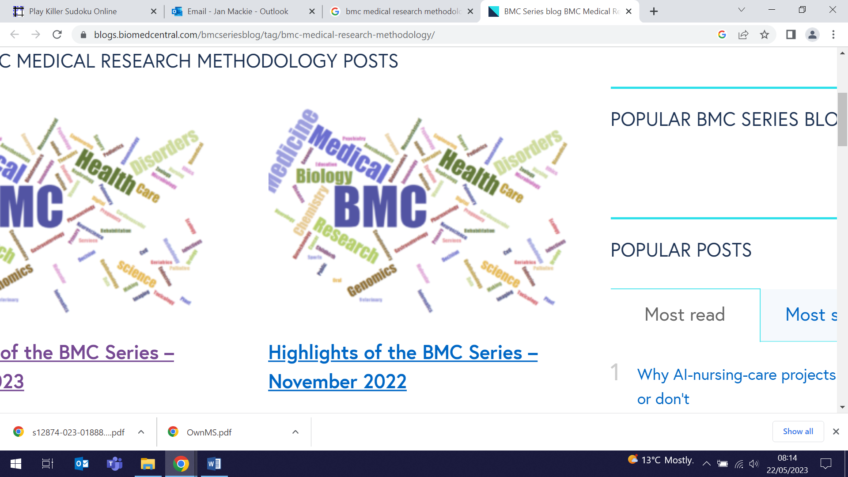
Breast cancer screening on the Trisha show
13 May (Stephen Duffy. Centre for Prevention, Detection and Diagnosis)

 | Stephen Duffy appeared as a guest of Trisha Goddard show (TalkTV) on 13 May, talking with her about breast screening, and problems inherent in the NHS Breast Screening Programme. The discussion covered issues including accessibility and barriers to screening, differences in attendance between women from different ethnic and socio-economic groups, and concepts of risk
Alzheimer's disease and aphasia: Comprehending acoustically degraded speech
15 May (Charles Marshall. Centre for Prevention, Detection and Diagnosis)

Accurate decoding of speech degraded by challenging listening conditions is investigated in a study of patients with Alzheimer’s disease or 3 syndromes of progressive aphasia. Noise vocoding was used to examine recognition of spoken 3-digit numbers, and to ascertain the threshold number of noise-vocoding channels required for 50% intelligibility by participants. Associations of the threshold with regional grey matter volume (defined by voxel-based morphometry of brain images) were also assessed. Mean intelligibility threshold was significantly higher for all patient groups than healthy controls, and for patients with Alzheimer's disease and logopenic variant primary progressive aphasia v semantic variant primary progressive aphasia. In ROC analysis, vocoded intelligibility threshold discriminated very well between Alzheimer's disease and non-fluent and logopenic variant primary progressive aphasia patients v healthy controls. Findings suggest that comprehension of acoustically altered speech captures an auditory brain process relevant to daily hearing and communication in major dementia syndromes, with novel diagnostic and therapeutic implications. | 
Specialist dementia nursing models and impacts
16 May (Claudia Cooper. Centre for Psychiatry and Mental Health)

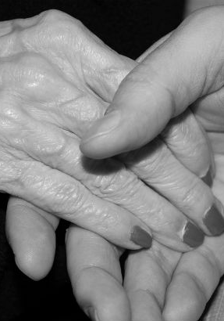 | A new review finds that existing recommendations for people living with dementia to have access to specialist nurses are not supported by defined specialist dementia nursing models and role-related competencies. While nurses with an advanced knowledge of dementia and specialist nursing interventions are highly valued by people with dementia and their families, researchers found no RCT evidence evaluating whether specialist nursing delivers better clinical outcomes, relative to other models of care. Consistent evidence was found from just one community and one inpatient study that specialist nursing services can reduce hospital bed usage. Further research on the specialist nursing skills and the impact of specialist nursing interventions is needed to usefully inform workforce development strategies and clinical practice.
Salt content in pizzas
17 May. (Research and Action on Salt and Obesity Unit team. Centre for Public Health and Policy)

To coincide with salt awareness week, a report on the nutritional quality of pizzas in both retail and out of home sectors has been released by the CPHP Action on Salt team. High salt intake is the major contributing factor for raised blood pressure, which is responsible for 60% of strokes and 50% of heart disease. The report shows that pizzas contribute 1847 tonnes of salt to UK adult diets each year, and that half of pizzas sold contain the entire daily adult salt allowance or more. Takeaway pizzas contain more than double the amount of salt found in those bought in supermarkets. Reducing the salt content of Dominos pizzas to the current salt dietary targets would potentially remove approximately over 450 tonnes of salt from UK diets. Action on Salt call on the Chancellor to expand the successful Soft Drinks Industry Levy to cover excessively salty food. | 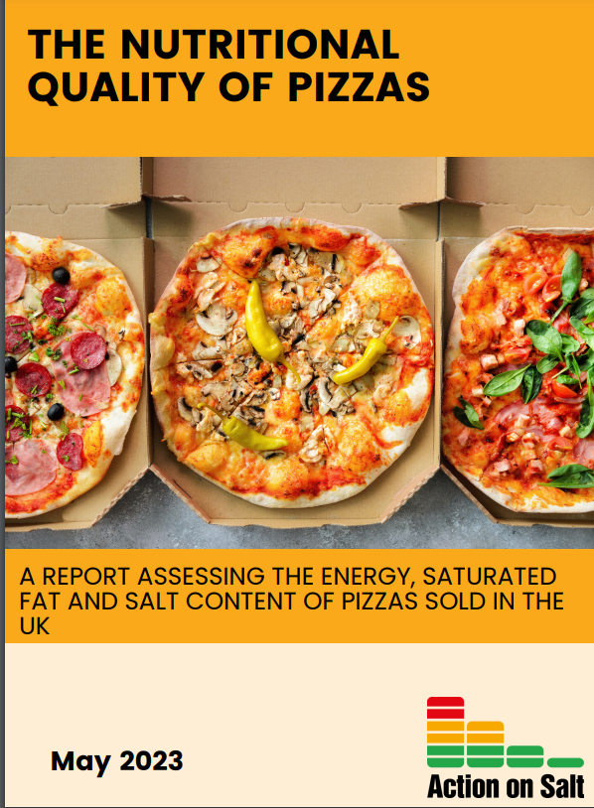
ADAMS Genetic Association study in MS patients from diverse ancestries
17 May (Ben Jacobs, Luisa Schalk, Katila George, Thamanna Begum, Alastair Noyce, Ruth Dobson. Centre for Prevention, Detection and Diagnosis)

 | The genetic Association study in individuals from Diverse Ancestral backgrounds with Multiple Sclerosis (ADAMS) is gathering genetic and phenotypic data on a large cohort of ancestrally-diverse adults with MS living in the UK. Demographic and phenotypic data from participants recruited via clinical sites, the UK MS Register, or online is being collected using a baseline questionnaire with healthcare record linkage, and genotyped saliva tests. Of the initial cohort 71.2% are female, median age is 44.9 years at recruitment, >60% are non-white British, 23.5% identify as Asian or Asian British, 16.2% as Black, African, Caribbean or Black British, and 20.9% as having mixed or other backgrounds. Recruitment will continue for 10 years, but researchers aim to perform initial genetic analyses of susceptibility and severity in the next 3 years, with a view to replicating the findings from European-ancestry studies.
Patient enablement and help-seeking for blood cancer symptoms
18 May (Jessica Russell, Georgia Black. Centre for Prevention, Detection and Diagnosis)

A study based on a cross-sectional survey of 434 adults examines the role of patient enablement on help-seeking for people experiencing potential blood cancer symptoms. Existing patient enablement items were included in the new Blood Cancer Awareness Measure. Of the 224 respondents who reported experiencing at least one potential blood cancer symptom, 112 had sought medical help. Contrary to expectations, higher patient enablement scores were associated with being less likely to seek help, and with being more comfortable to re-consult if symptoms didn't go away or got worse, after a test result suggested there was nothing to worry about although symptoms persisted, or to request further tests, scans or investigations. Enablement did however appear to play an important role in likelihood of re-consulting when symptoms persist, get worse or need further investigation. | 
Interventions for aggressive behaviour in adults with intellectual disability
May 18 (Liz Steed. Centre for Primary Care)

 | Interventions for aggressive challenging behaviour among adults with intellectual disability are explored in a review study aiming to understanding what mechanisms contribute to successful intervention. Three overarching domains were identified: working with the person displaying the behaviour, relationships and team focused approaches, and sustaining and embedding facilitating factors at team and systems levels. Mechanisms underlying successful application of interventions included improving understanding, addressing unmet need, developing positive skills, enhancing carer compassion, and boosting staff self-efficacy and motivation. The study concludes that interventions should be personalised, and that effective communication and trusting relationships among service users, carers, professionals, and staff teams are essential to facilitate effective intervention delivery.
Multi-ancestry meta-analysis and fine-mapping in Alzheimer's disease
18 May (Jeff Kim. Centre for Prevention, Detection and Diagnosis)

In the largest multi-ancestry genome-wide association study (GWAS) meta-analysis of Alzheimer’s disease and related dementias (ADD) to date, researchers have devised a novel method of creating a composite polygenic risk score (PRS) model that is a promising approach for assessing ADD risk across ancestrally heterogeneous and/or ancestry-derived mixed cohorts. Using GWAS summary statistics from European, East Asian, and African American populations, and an additional GWAS from a Caribbean Hispanic population, the study identified 2 independent novel disease-associated loci on chromosome 3, and compared the generalizability of multi-ancestry- and single-ancestry-derived PRS in a three-way ancestry-derived mixed Colombian population. The findings highlight the importance of multi-ancestry representation in uncovering and understanding putative factors that contribute to risk of Alzheimer’s disease and related dementias. | 
Why Do We Diagnose Monoclonal B-cell Lymphocytosis?
18 May (Stephen Hibbs, Esca van Blarikom. Centre for Primary Care)

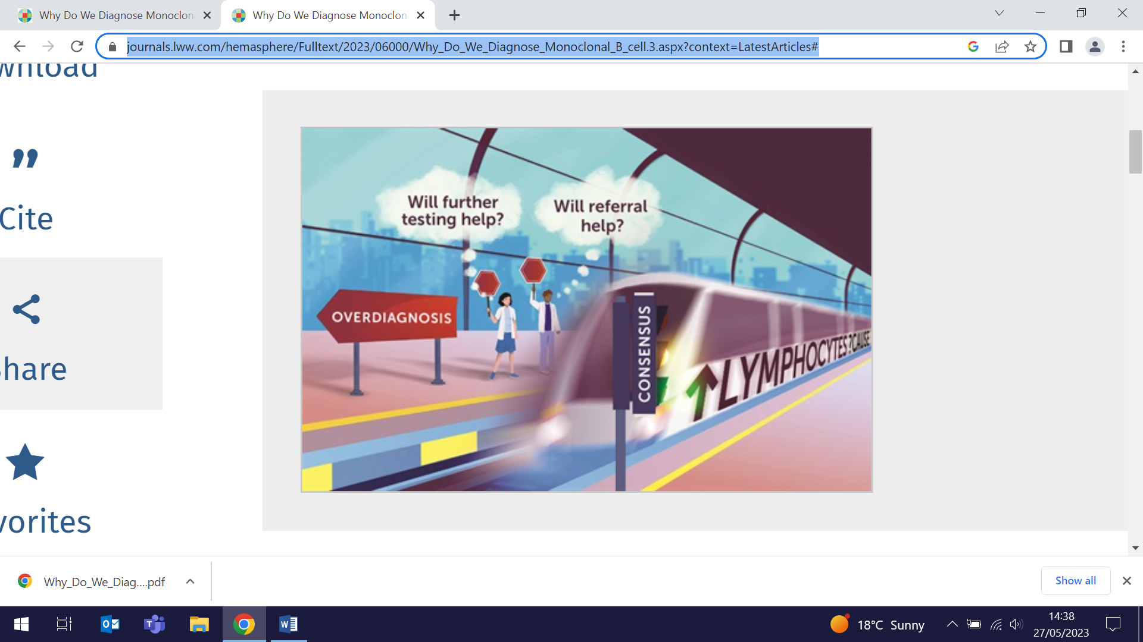 | Posing the question: What will change for my patient by knowing she has monoclonal B-cell lymphocytosis (MBL), a Hematopic case study grapples with the conundrum of whether an underlying disorder should be diagnosed if it provides no new treatment options. MBL is associated with a small increase in the risk of infections and solid tumours, and reduced response to vaccinations, but the diagnosis does not mitigate these risks. With the diagnosis the patient becomes a haematology patient-in-waiting, somewhere between well and unwell. This can produce real effects of anxiety and depression, observed in other disorders to be higher in those on expectant management than those receiving active treatment. In this personal case study, the authors note that their conclusion was that “If this lymphocytosis indicates something that needs our intervention, then it will declare itself in her symptoms if and when they arise.”
PRELUDE1 study protocol: liver fibrosis testing via diabetes annual review
19 May (Stacey Jennings. Centre for Psychiatry and Mental Health)

People with type 2 diabetes (T2D) have a 60%-80% lifetime prevalence of chronic liver disease, and fibrosis is the major determinant of liver disease morbidity, but no routine screening programme exists. A 12-month prospective cohort study of >5000 participants from 10 General Practices in East London and Bristol will determine undiagnosed significant liver fibrosis rates in a T2D population. The research will assess the feasibility of two-tier liver fibrosis screening using the FIB-4 score at the diabetes annual review, and subsequent transient elastography testing delivered either in the community or secondary care settings. A substudy will examine acceptability of the fibrosis screening pathway. | 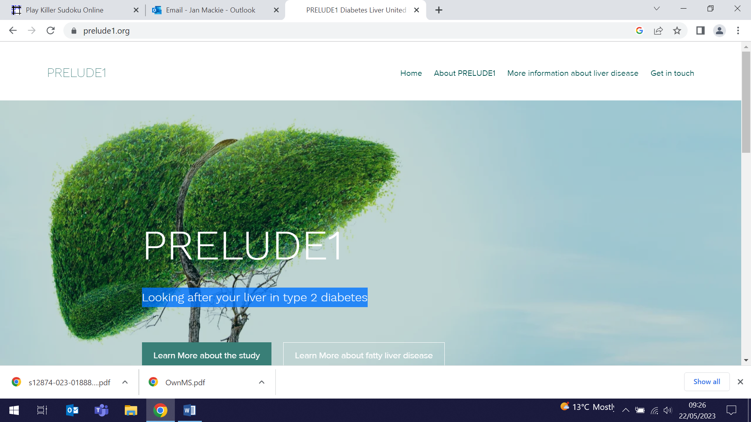
Vitamin D to prevent TB infection in South African school children
19 May (Neil Walker, David Jolliffe, Chris Griffiths, Richard Hooper. Centres for Evaluation and Methods/Public Health and Policy/Primary Care)

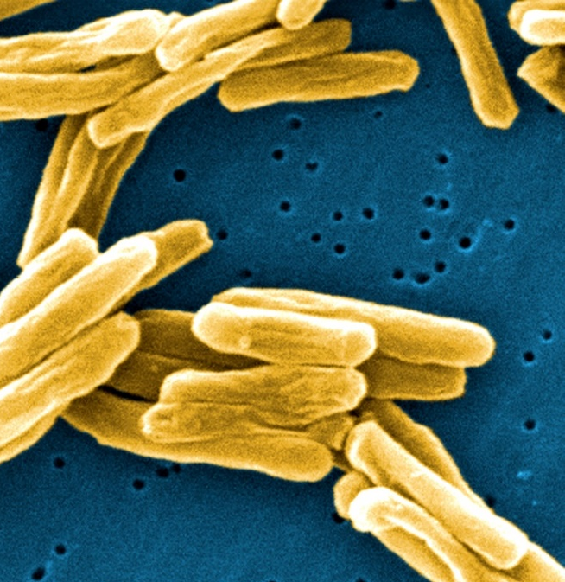 | A randomised placebo-controlled trial of oral vitamin D supplementation in 1682 school children in Cape Town has investigated reported independent associations between vitamin D deficiency and increased susceptibility to Mycobacterium tuberculosis infection. The study outcome was based on a positive QuantiFERON-TB Gold (QFT-Gold) assay, which detects CD4+ T cell IFN-γ responses to TB antigens. Results show that, after 3 years of supplementation, serum 25-hydroxyvitamin D concentrations were elevated, but the intervention did not reduce risk of QFT Plus conversion.
Monoclonal Antibodies for patients with MS, pre- and post-pregnancy
21 May (Ruth Dobson. Centre for Prevention, Detection and Diagnosis)

An updated clinical guide on the use of monoclonal antibodies in women with multiple sclerosis extends advice beyond pregnancy for those of childbearing age, considering pre-conception counselling, and management during pregnancy and post-partum. The review notes that discussing treatment options and family planning with women of childbearing age is essential before commencing disease modifying treatment, to make the most suitable choice for each individual patient. | 
Data support sex-specific preventive strategies for cardiovascular disease
22 May (John Robson. Centre for Primary Care)

 | Using data on incident cardiovascular events among 363313 participants in the UK Biobank, a new study examines sex-based differences in associations of vascular risk factors with incident myocardial infarction and ischaemic stroke. Results suggest that older age, hypertension, and smoking are stronger drivers of cardiovascular disease in women, while lipid metrics are stronger risk determinants for men. Authors say their findings highlight the importance of sex-specific preventive strategies and suggest priority targets for intervention in men and women.
Principal’s Visit (23 May)

The WIPH meeting with QMUL Principal Colin Bailey on Tuesday 23 May was attended by over 170 of our WIPH staff. Following a presentation by our Director, the Principal spoke to us about our how our work contributes to the QMUL strategy, and particularly noted our excellence in publication outputs, research impact, and funding. Outcomes from the constructive Q&A session included a commitment to support a proposal for PhD through publication. The success of the event set the stage for a jovial cream tea to follow. | 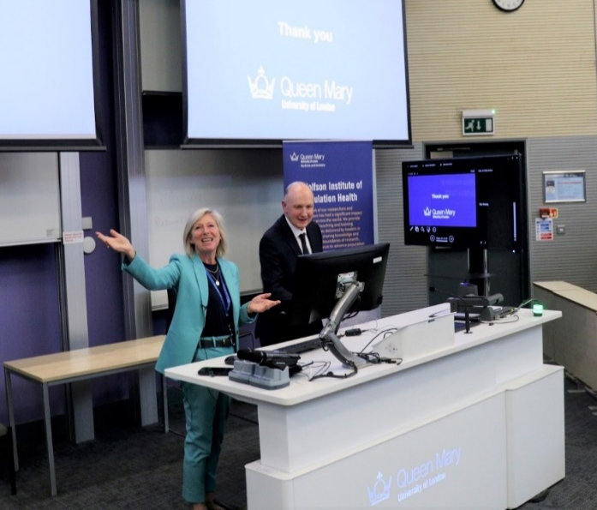
Group-based intervention to reduce opioid use for chronic pain
23 May (Dawn Carnes, Steph Taylor, Sian Newton. Centres for Public Health and Policy/Primary Care/Evaluation and Methods)

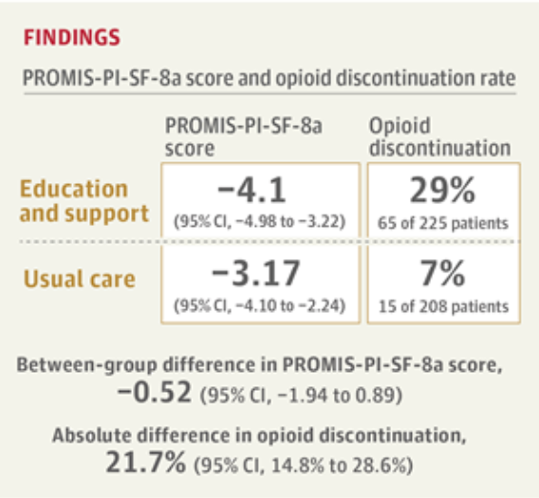 | To determine whether an intervention of group meetings, education, individual support, and skill-based learning can reduce opioid use and improve pain interference with daily activities, researchers conducted a multicentre RCT in 608 participants with chronic pain from primary care settings in the UK. At 12-months follow-up, 29% of people in the intervention group (v 7% in usual care) discontinued opioids, but no statistically significant differences were found in pain interference with daily life activities between the 2 groups.
Early depressive symptoms and disability accrual in Multiple Sclerosis
24 May (Ben Jacobs, Ruth Dobson. Centre for Prevention, Detection and Diagnosis)

Using data from 862 subjects in the UK MS Register, researchers investigated whether early depressive or anxiety symptoms predict subsequent physical disability worsening in people with Multiple Sclerosis. Study results suggest that early depressive symptoms in MS are associated with subsequent disability accrual, but are likely the result of disability rather than its cause. | 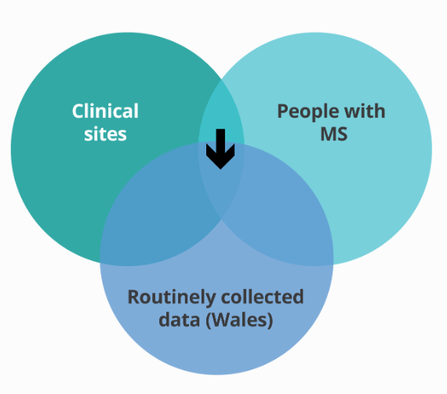
Call for the release of commercial baby food & drink guidelines
24 May (Action on Sugar Team. Centre for Public Health and Policy)

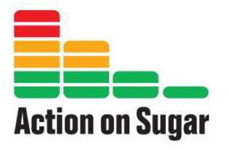  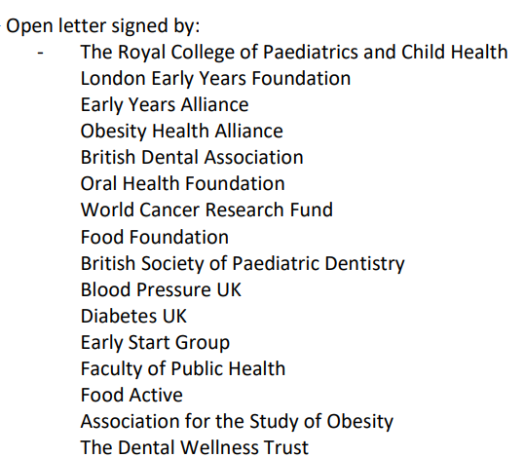 | With 16 NGOs and 3 leading baby food companies, Action on Sugar have written an open letter to Health Secretary Steve Barclay calling for the release of Commercial Baby Food and Drink Guidelines. The main contributor of sugars for infants aged 4-9 months comes from shop bought baby foods, particularly fruit- and cereal-based foods. Recommendations suggest that free sugars should provide ≤5% of daily energy intake for infants (≈14g), but by 18m they are reportedly consuming nearly the adult maximum (30g/day). While many brands are reducing sugars, products with unsuitably high levels are still marketed as suitable for infants. In 2020 Public Health England ran a consultation on these draft guidelines, aiming to publish by 2023, and the Royal College of Paediatrics and Child Health also recently called for the implementation of these guidelines.
TB screening yield in four European programmes
25 May (Dominik Zenner. Centre for Public Health and Policy)

To inform the feasibility of a European approach to control planning for TB, an analysis of data from over 2 million migrant TB screens in Italy, the Netherlands, Sweden and the UK investigates the differences in screening yield. The study found that key determinants of TB yield included close contact, increasing age, incidence in Country of Origin (CoO), and specific migrant groups including asylum seekers and refugees. In asylum seekers the elevated TB risk remained similar above CoO incidence thresholds of 100 per 100,000, which may reflect higher transmission and reactivation risk of migration routes, with implications for selecting populations for TB screening. | 
QMUL Research and Innovation Award Successes
25 May (Sammy Quaife CPDD, Sara Paparini CPHP, Research Action on Salt and Obesity CPHP, Mark Freestone CPMH)

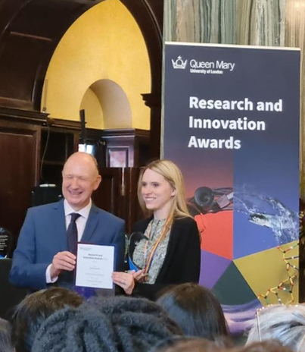 | WIPH researchers triumphed at the inaugural QMUL Research and Innovation Awards on 25 May. Sammy Quaife was awarded Outstanding Early Career Researcher, and the SHARE Collaborative (Sara Paparini, Social Science Lead) was joint winner for Research Impact: Culture, Civic Community and Policy. WIPH staff received three highly commended prizes: for Excellent Interdisciplinary Research, Mark Freestone and colleagues in the Prevention of Gambling Harms Multi-Disciplinary Hub, and the SHARE Collaborative, and for Research Impact: Culture, Civic Community and Policy, the Research Action on Salt and Obesity team. Well done all.
Framework to reduce health inequalities through general practice
25 May (John Ford. Centre for Primary Care)

A review of interventions influencing health and care inequalities in general practice has produced an action framework to guide health professionals and decision makers. The review found that robust evidence on the effect of general practice on health inequalities is scarce, but that general practice should be informed by five key principles: involving coordinated services across the system (connected), accounting for differences within patient groups (intersectional), making allowances for different patient needs and preferences (flexible), integrating patient worldviews and cultural references (inclusive), and engaging communities with service design and delivery (community-centred). | 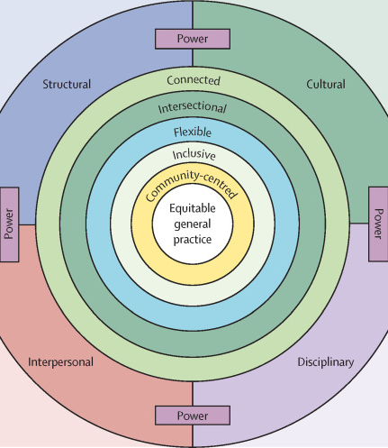
Our Stories Told By Us
25 May (Rebecca Mbewe. Centre for Public Health and Policy)

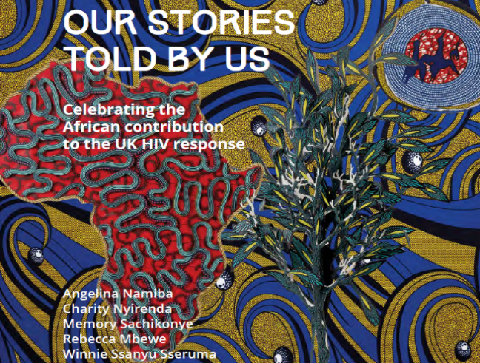 | Rebecca Mbewe, qualitative researcher working in the Global Public Health Unit’s SHARE Collaborative, has co-written a book celebrating the African contribution to the UK HIV response. Written with four other African women living with HIV, the book is a collation of their journeys and includes the voices of many other people living with HIV, as well as the authors’ allies. Our Stories Told By Us was launched on 25 May.
MS Brain Health Awards: Winning Individual Healthcare Professional
25 May (Ruth Dobson. Centre for Prevention, Detection and Diagnosis)

Ruth Dobson has received the Individual Healthcare Professional Award from MS Brain Health, an initiative that emerged from the publication of the evidence-based international consensus report: Brain health: time matters in multiple sclerosis. Ruth was selected for the award for applying the MS Brain Health recommendations in her clinical practice and research activities to improve patient outcomes, including exceptional leadership of the UK MS Pregnancy Register, ensuring that pregnant women with MS receive optimal care during and after childbirth. Congratulations to Ruth on this well-deserved and prestigious honour. | 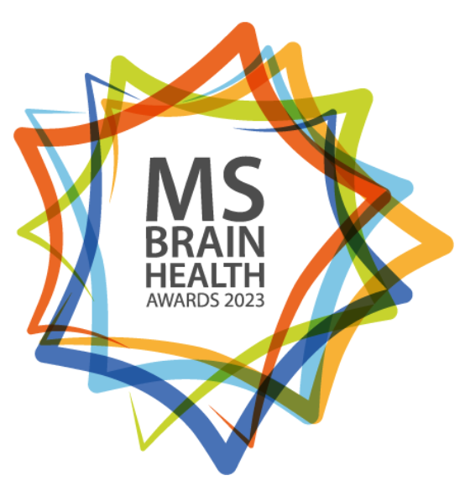
Pathogenesis: BBC Radio 4 Book of the Week
29 May (Jonathan Kennedy. Centre for Public Health and Policy)

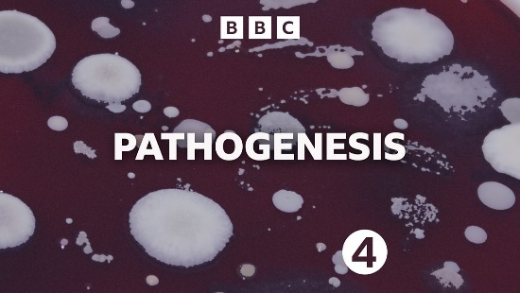 | Jon Kennedy’s hugely successful book, Pathogenesis, has been selected for serialisation by BBC Radio 4 as their Book of the Week, starting at 09:45 on 29 May. The book has had splendid reviews across all major media outlets, and Jon has been appearing at a range of literary and other festivals across the country (including the Chalke Valley History Festival on 26 June).
Knowing the risks of NOS
30 May (Devan Mair, Alastair Noyce. Centre for Prevention, Detection and Diagnosis)

In the latest edition of Ae:ther, Devan Mair and Alastair Noyce explain the risks of recreational use of nitrous oxide, now the second most used drug among 16-24 yr olds, partially due to the ease of acquisition from corner shops and online. Increased use has caused a rise in nitrous oxide-related myeloneuropathy cases. Work at the Royal London Hospital developed the management pathway for treatment, now adopted as the national guideline. Despite advice from the Advisory Council on the Misuse of Drugs against prohibition of nitrous oxide, due to concerns of ostracising and criminalising young people, the government has decided to classify nitrous oxide as a Class C drug to be controlled under the Misuse of Drugs Act. | 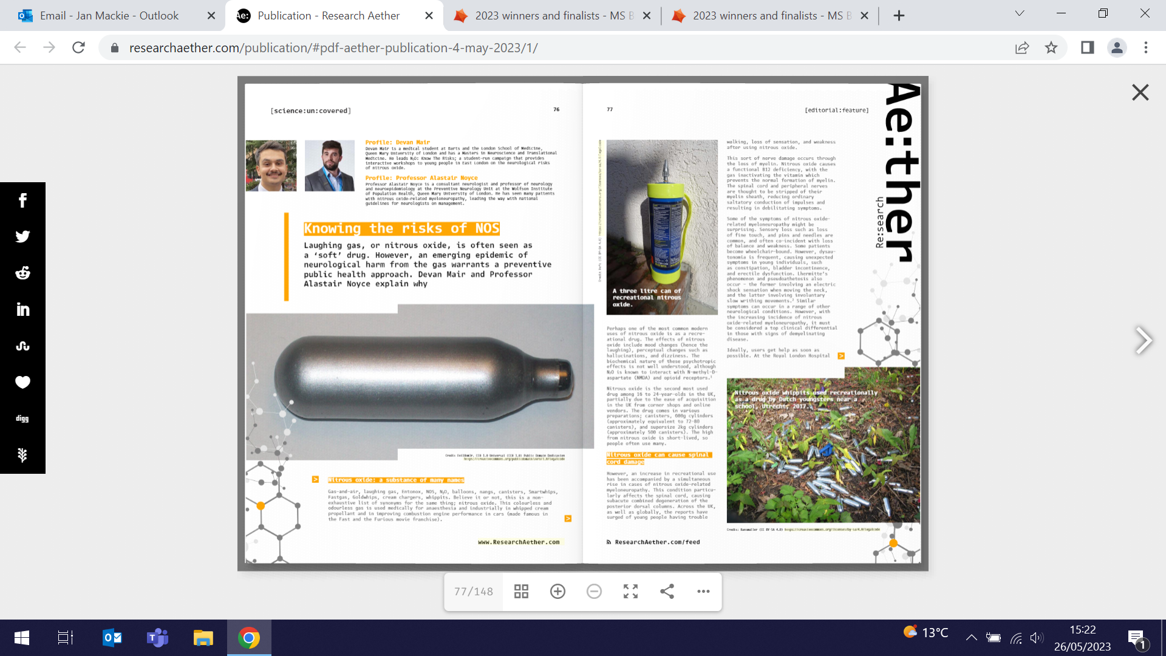
FORTHCOMING EVENTS AND NOTICES

Peopling the Palace Festival Event 6 June

A Public Studio Conversation on Neurological Disease Prevention, a unique workshop event to foster creative problem-solving and facilitate equitable knowledge sharing and idea exchange will be held from 2-4pm on 6 June at ArtsOne, Mile End Campus. Facilitator Lois Weaver will host an open dialogue featuring Ruth Dobson and Alison Thomson to tackle the complexities of neurological disease prevention, covering topics such as early intervention strategies, risk reduction measures, and ethical considerations surrounding testing. Tickets here. | 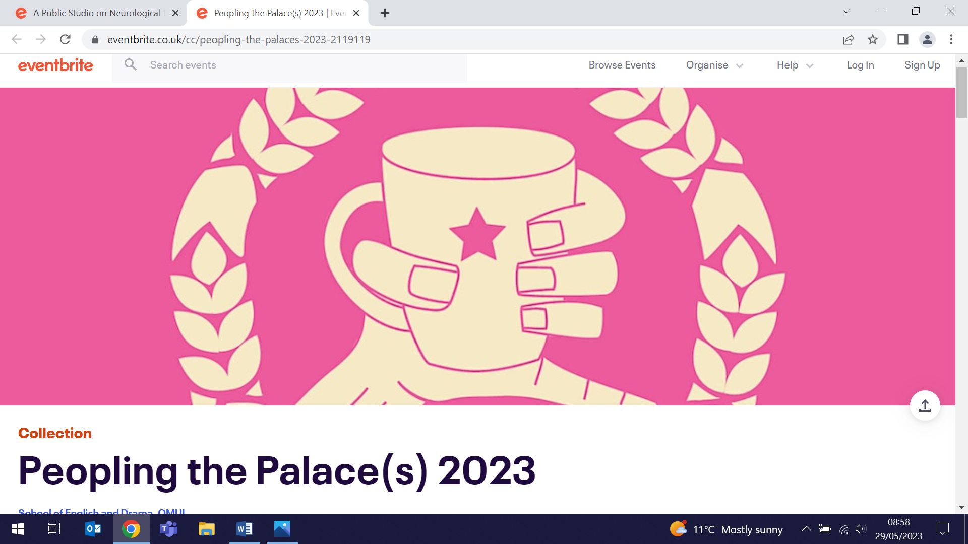
QMUL Festival of Communities 10-11 June

The Festival of Communities will be held on Saturday 10 June at Stepney Green Park and Sunday 11 June at the People’s Palace, QMUL Mile End Campus, offering a weekend of free family fun, exploring living and learning together in Tower Hamlets. Please drop in to visit our WIPH representatives, who will be manning the following stations with their teams, and offering a range of activities and showcasing some of our best work: Stefanie Bonfield (The Duck Screening Game (Let's get quacking!), Sabir Ahmed (QMUL Stop Smoking Service), Avinash Chandra (Demystifying Dementia), Aneet Gill (Research Wheel of Fortune), Elisavet Moschopoulou (The SURECAN Walking Retreat), Rebecca Muit (Hidden Work: Can we see what is hidden?), Deepali Patel (Origami Express & Henna Pop Up), Sonia Pombo (Health Eating in Children), Mehru Raza (Genes & Health Community Collage), Ratna Sohanpal (Assistive Technology for independent living), Alison Thomson (Mindful Medicine: Exploring Ethics in Medical Research), and Nikki Vickaryous (Brain Games). | 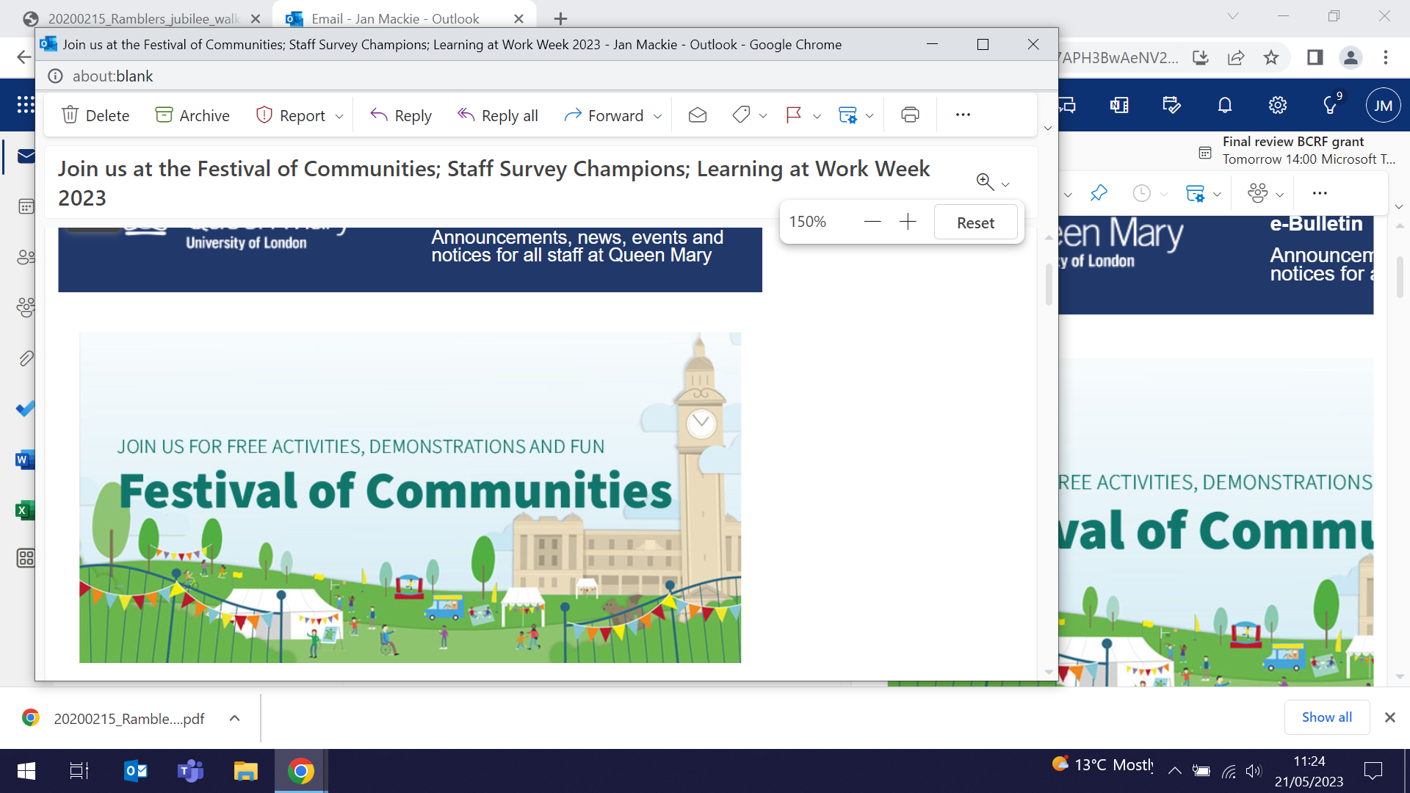  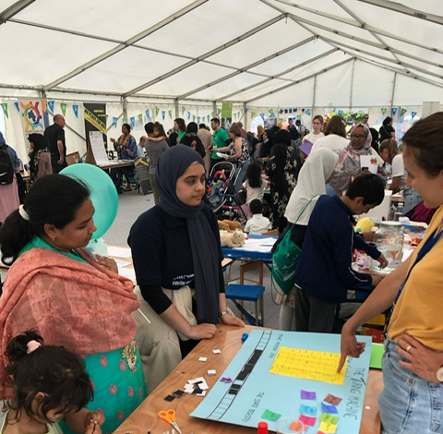
Many thanks to all who so enthusiastically contribute. Please send any news items for the next newsletter to j.a.mackie@qmul.ac.uk

