WOLFSON INSTITUTE OF POPULATION HEALTH
NEWSLETTER
ISSUE 36: 21 JUNE 2023

In this issue of our Wolfson Institute of Population Health Newsletter, we celebrate the achievements and work of staff and students at the end of May and through the first half of June.

FROM OUR DIRECTOR
Dear Colleagues

It’s a very busy time of year for many of us as we supervise and assess exams and dissertations. Thanks to everyone who contributes to the excellent education offerings delivered across our Institute. We are also entering conference season, so many are heading off across the UK and further afield to present their work and meet up with colleagues. Wishing all of you success in your travels and developing collaborations.

Our WIPH Showcase is fast approaching. Do please all join us on Wednesday 28 June in the Derek Willoughby Lecture Theatre at 10.30, for a day which promises to be fascinating and fun, and a great opportunity to hear about all our brilliant work. We will also be presenting WIPH Awards for the first time. Afterwards, we are looking forward to some great networking at our BBQ reception on the lawn at Charterhouse Square.  Looking forward to seeing everyone there.  With warm wishes - Fiona | 
MEET WIPH

Meet - James Scales (Research Fellow, Centre for Primary Care)

How would you describe your roles and responsibilities?

I am a Research Fellow funded by the Asthma&Lung UK Centre for Applied Research. I lead the IONA study, a short-term air pollution exposure study exploring how non-exhaust air pollution impacts people living with asthma.

What aspects of your role do you enjoy the most?

I enjoy recruiting people to the IONA study. If you have asthma, please get in touch !

What would be your second choice as a profession?

Research is actually my third career following an abortive career as a tennis player, and a successful career as a Royal Marine Commando.

What do you enjoy doing outside work?  I enjoy playing tennis, alpine climbing, and long distance adventures, such as kayaking across Scotland, and cycling to the Swiss Alps. As a fully paid up corduroy wearing East Londoner, I can also be found day drinking during weekend brunches on Broadway market.  Something about you that most people don’t know?  Following significant battles with mental health, I am a campaigner and fundraiser for men’s mental health. If you need help, call The Calm Zone. They are banging. | 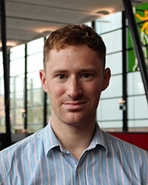
FROM OUR LEADERSHIP TEAMS

Research News
From Tor Kemp (Research Manager)

Live Virtual Forums | The Primary Care Setting: How It Can Help Deliver Your Research
Following a successful event in February around pathways to research in the primary care setting, Clinical Research Network has created an e-learning version of the resources on NIHR Learn. To complement self-directed learning they are offering learners an opportunity to meet with NIHR members, to consolidate their learning and further explore research opportunities in the primary care setting. Book to attend one of these sessions using this form. Current available dates: 12 and 27 July.

Funding | Commonwealth Fund Harkness Fellowships 2024/25 | Deadline 1 November 2023
The Commonwealth Fund's Harkness Fellowships for 2024-25 provide a unique leadership development opportunity for mid-career research professionals who are committed to advancing health care policy and practice. Co-funded in the UK by the NIHR and The Health Foundation, the Harkness Fellowships in Health Care Policy and Practice fund successful applicants to spend a year in the United States, conducting internationally comparative research with mentorship from leading U.S. experts.

Funding | James and Henry Cooper & William Garlick Coventon Scholarship 2023 | Deadline 28 July 2023
The Voluntary Hospital of St Bartholomew wishes to award a scholarship for a medical practitioner to undertake research in medicine, surgery or allied sciences to the value of £5,000. Scholarships may be awarded for research aimed at gaining preliminary data before applying to another funder, for a small research project, or to finalise an existing project. Applicants must either be PhD/MD students enrolled with the FMD and/or employees of Barts NHS Trust who have NOT previously completed a PhD/MD. Please contact Tor Kemp for more information.

Jobs | Associate Lecturer (Teaching) in Applied Health Research | Deadline 2 July 2023
The Associate Lecturer will be responsible for developing the research capacity building activities of the National Institute for Health Research Applied Research Collaboration (ARC) North Thames Academy, based in the Department of Applied Health Research within the UCL Institute of Epidemiology and Health Care (www.ucl.ac.uk/iehc)

EDI News
(Evangelos Katsampouris – Equality Diversity and Inclusion Lead)

The WIPH EDI Group invites all students and staff to join an MS Teams seminar on Responding to Bullying and Harassment on June 26 from 15:00-16:00.

If you are keen to become involved in the WIPH EDI Group, or to raise and discuss an EDI-related issue, please send us an email at: wiph-edi-request@qmul.ac.uk.

GENERAL INSTITUTE NEWS

Predominance of young Asian men in UK clinical case series of Nitrous Oxide users
30 May (Devan Mair, Alvar Paris, Alastair Noyce. Centre for Prevention, Detection and Diagnosis)

The largest clinical case series to date of patients presenting with probable N2O-induced myeloneuropathy in London, Birmingham, and Manchester hospitals shows a predominance (57%) of young men of Asian ethnicity. Authors say this may indicate genetic susceptibility or dietary or nutritional predispositions to neurological damage from N2O exposure, but may also indicate social circumstances predicating use. Of 119 cases, average age was 22 (youngest 14) and 3/4 patients were male (2/3 in London). Examinations revealed gait ataxia in 80 patients, with legs more commonly affected than arms. Weekly consumption averaged 318 canisters, ranging from 1 canister to 35 cylinders (≈2800 canisters). Researchers note that ease of access to canisters and larger cylinders has led to an apparent rise in myeloneuropathy cases in several UK areas. ‘Manufacturers and sellers should be held accountable for the apparent increase in harm through policy implementation and/or legislation.’ | 
Protect-C trial featured in Yorkshire Cancer Research Newsletter
30 May (Ranjit Manchanda. Centre for Prevention, Detection and Diagnosis)

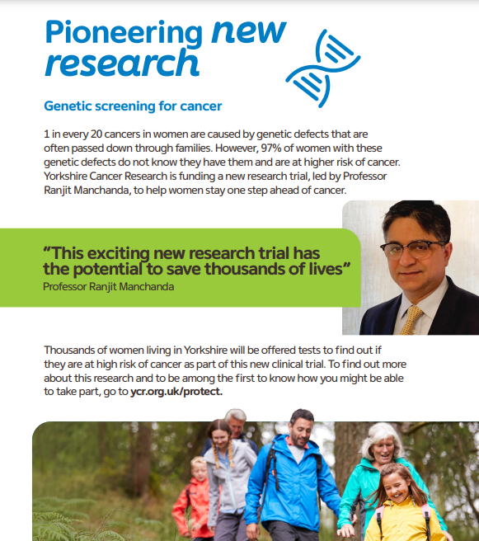 | The PROTECT-C trial, investigating the risks, benefits and feasibility of introducing population-based genetic cancer screening for all women, has been featured in the Yorkshire Cancer Research (YCR) Spring newsletter. YCR is funding the £3.8million trial, the findings from which could transform the way women and their families find out if they are at high cancer risk, giving them a choice and opportunity to take steps to prevent cancer. Study lead Ranjit Manchanda said: This approach can prevent thousands more cancers than any current clinical strategy, saving the lives of many women.
Expert Opinion in the Guardian: Public Health benefits of vaping
30 May (Peter Hajek. Centre for Policy and Public Health)

In a Guardian report that Government may be considering plain packaging and banning flavoured versions of vapes to deter young people from becoming addicted to nicotine, Peter Hajek put the case for vaping as a smoking cessation tool. He said that the public health benefits of vaping v smoking represent ‘the best chance we ever had of getting rid of cancer, and lung and heart disease caused by smoking’. Noting that daily vaping among children who have never smoked is rare, and that the main effect of vaping has been to deflect young nicotine seekers from smoking, he said that smoking among young people in the UK has been declining significantly faster than in Australia, where vaping regulation is stricter. | 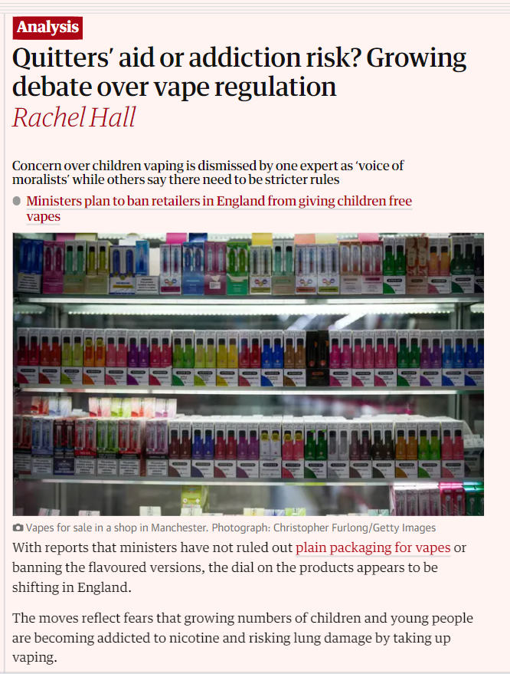
Improving the diagnostic process for possible bladder and kidney cancer
30 May (Fiona Walter. Centre for Prevention, Detection and Diagnosis)

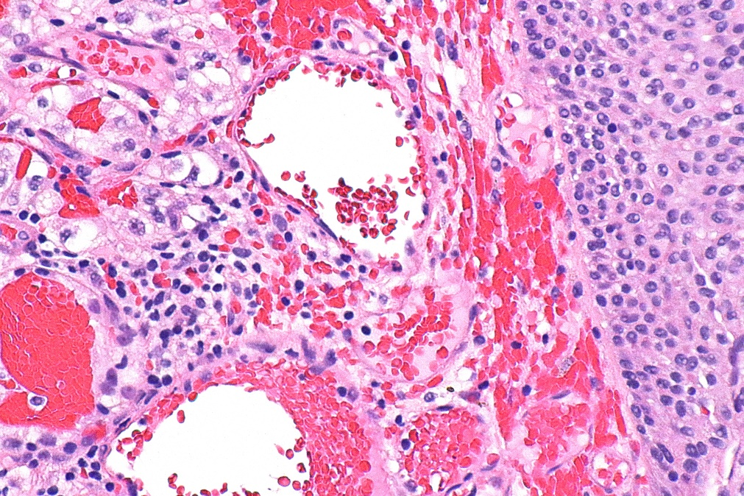 | To identify potential missed diagnostic opportunities for patients with bladder and kidney cancer, a study of 940 participants from 9 general practices in E. England identified patients with possible bladder and kidney cancer, and reviewed primary care records for data on symptoms, tests, referrals, and diagnosis. Findings showed that 28.5% received a referral, 48.5% had a final diagnosis of UTI, and 3.5% were diagnosed with prostate, bladder, or upper urothelial tract cancers. Only 1/3 of patients with recurrent UTIs were referred. Barriers during the diagnostic process included inadequate clinical examination, female patients given repeated antibiotics without clinical reviews, and suboptimal communication of test results to patients. Older women with recurrent or persistent UTIs may be at increased risk of missed diagnostic opportunities for bladder and kidney cancer.
Co-Creation of Breast Cancer Risk Communication Tools in India
30 May (Ranjit Manchanda. Centre for Prevention, Detection and Diagnosis)

Low awareness of breast cancer risk factors leads to diagnostic delays and potentially poorer survival, and in India, with a reported 179,790 cases in 2020, it is critical that this issue is addressed. In a new study, a multidisciplinary team developed and evaluated easy-to-follow transmedia prototypes to communicate breast cancer risk. Qualitative interviews conducted in regional languages assessed views of stakeholders on these prototypes, and found that participants favoured storytelling techniques (animation and comic strips/infographics) to explain complex issues such as genetic risk and testing. | 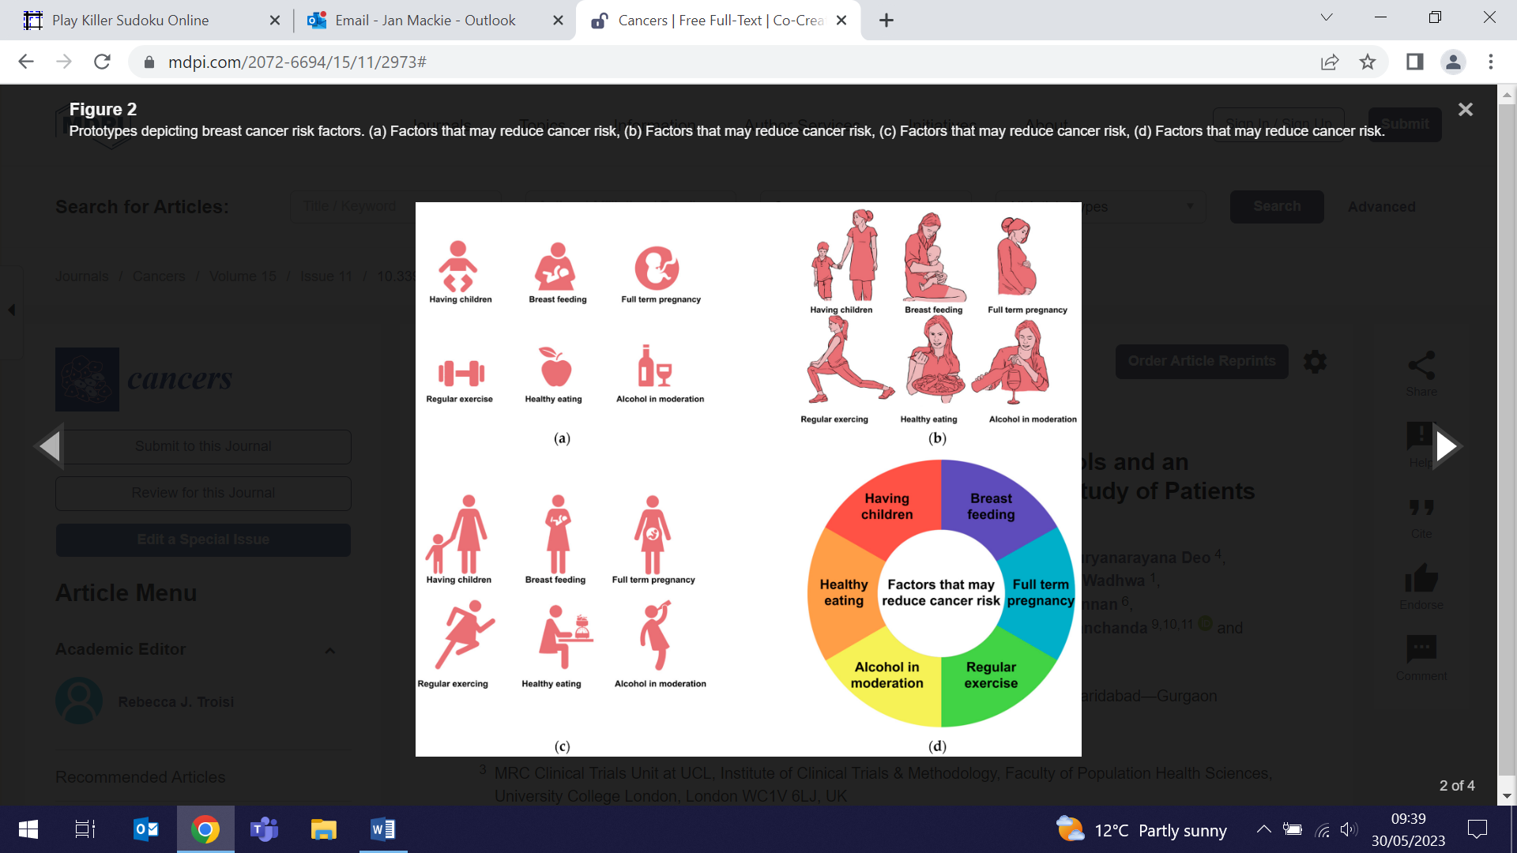
Symptom appraisal and help seeking in black males with possible prostate cancer
30 May (Fiona Walter. Centre for Prevention, Detection and Diagnosis)

 | A study of help seeking behaviour in men with symptoms of prostate cancer compares pre-consultation experiences after the onset of symptoms of possible prostate cancer among Black and White males. Interviews with males who had recently seen their GP with urinary symptoms, erectile dysfunction, or haematuria showed that patients often interpreted symptoms as unimportant, with most delays occurring due to the absence of reasons to seek help. In Black male patients this often stemmed from poor awareness of prostate cancer, possibly due to their reluctance to seek health information and discuss health issues with others in their social network. Researchers identify cognitive biases, cultural stigmas, and everyday interpersonal interactions as important areas for targeting strategies to reduce delays and improve early presentation in males with possible prostate cancer, particularly black males.
Painting the place where procedures cause pain
30 May (Stephen Hibbs. Centre for Primary Care)

In a Lancet Haematology piece, Stephen Hibbs reflects that in all the hospitals he has trained in the haematology procedure rooms, used for interventions that can cause substantial pain and anxiety, have had no natural light, walls are bare, and on occasion they have doubled up as store rooms. Posing the question: What do unwelcoming and bleak rooms communicate to the patients who come into them for procedures? he describes a project he initiated at Barts, where an artist was engaged to paint a mural across the procedure room. The transformation is presented from the perspectives of the doctor, the artist, someone from the arts and health charity that managed it, and a patient. The images here tell their own story. | 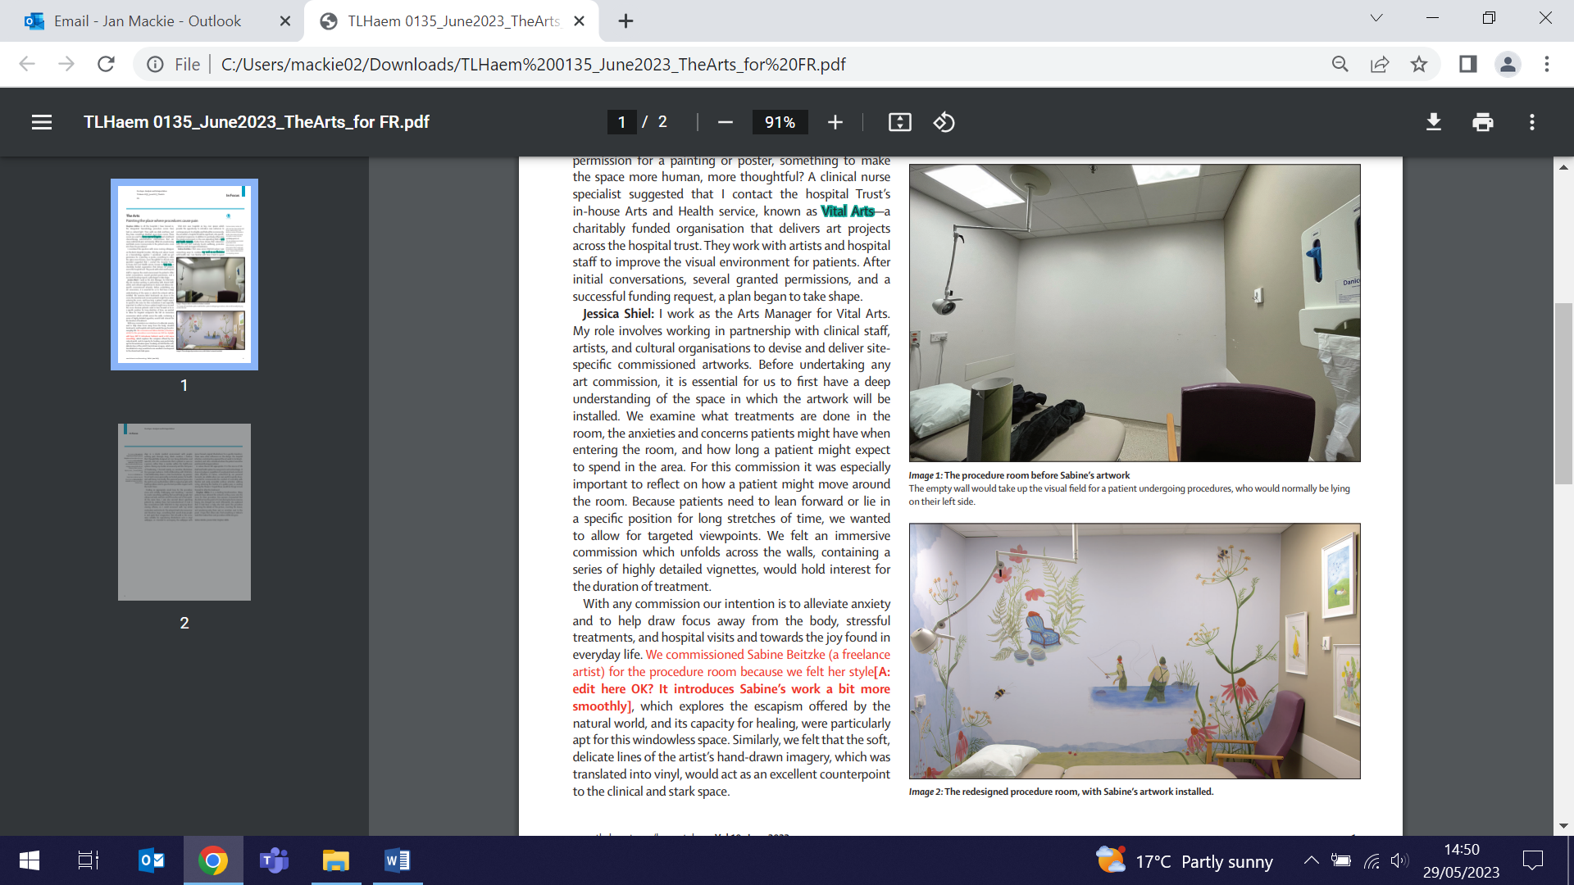
Genetic background of female reproductive disorders
30 May (Matina Iliodromiti. Centre for Public Health and Policy)

 | Summarising current knowledge, a systematic review explores associations between the most frequent female reproductive endocrine disorders associated with subfertility and their genetic background. From 55 studies, authors identified 384 genes associated with one or more of the disorders. The highest number of genes was found to be associated with polycystic ovary syndrome (n=209), followed by hypogonadotropic hypogonadism (n=88), and premature ovarian failure (n=87). Four genes, including FSHR, LHβ, LEPR and SF1 were associated with multiple reproductive disorders, implying common pathways in the development of those diseases.
SALIENT Project Launch
1 June (Lola Oyebode. Centre for Public Health and Policy)

A £5.4million grant from the UKRI Economic and Social Research Council has been awarded for the delivery phase of the SALIENT (food System triaALs for Impact on Environment Nutrition and healTh) trial. Lola Oyebode is a co-investigator in the consortium of eight universities working on the project. SALIENT will work to design and evaluate interventions that support healthier diets and reduce the environmental impacts of our food system. The delivery phase will work with partners in local government, food charities, community support teams and the food industry to deliver these interventions in real life settings. |   
HIV pre-exposure prophylaxis for cisgender and transgender women
1 June (Sara Paparini. Centre for Public Health and Policy)

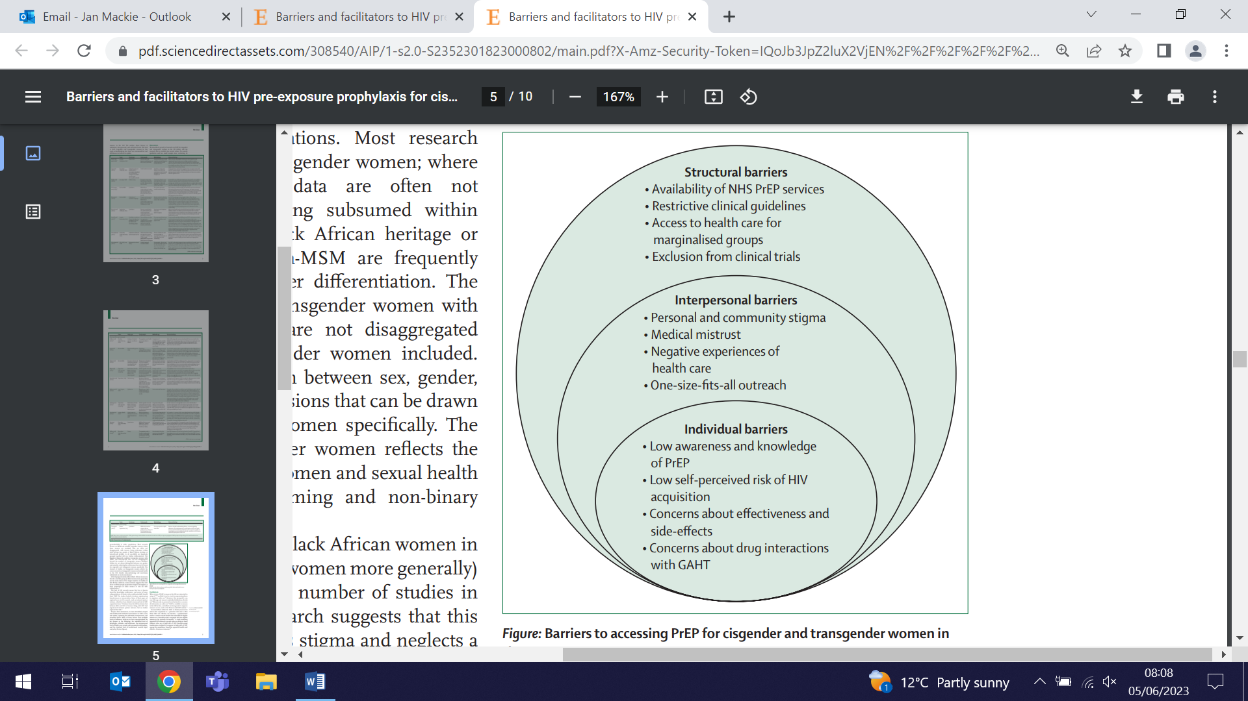 | A review exploring the barriers and facilitators to oral HIV pre-exposure prophylaxis (PrEP) access for cisgender and transgender women in the UK identifies barriers including poor awareness and acceptability; stigma, race, and ethnicity; restricted access to PrEP; and exclusion from clinical trials. Results revealed hidden subpopulations including non-Black African women, transgender women, sex workers, migrant women, women experiencing intimate partner violence, incarcerated women, and women who inject drugs, who could potentially benefit from PrEP. PrEP knowledge, preferences, and access for these women is largely unknown. Authors conclude that without a better understanding of the needs and preferences of the full spectrum of women who could benefit from PrEP, the UK will not reach zero transmissions by 2030.
BBC Radio 4: Warning on criminalising possession of nitrous oxide
2 June (Alastair Noyce. Centre for Prevention, Detection and Diagnosis)

Following research findings showing that young Asian men are predominant among those presenting with nitrous oxide related myeloneuropathy, Al Noyce spoke to the BBC Radio 4’s Today programme. Maximising his allocated interview time, he focused attention on problems inherent in forthcoming government legislation to criminalise possession of N2O. Warning that the threat of criminal charges could lead to delayed hospital attendance among those most in need of medical help, he delivered a clear message: ‘Many of us feel that the legislation should be targeted at the sellers’. | 
Important features for electronic safety-netting tools in UK general practice
5 June (Georgia Black. Centre for Prevention, Detection and Diagnosis)

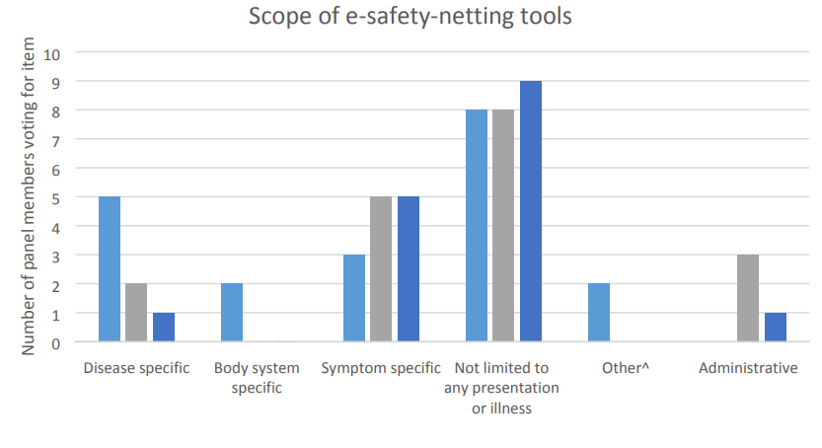  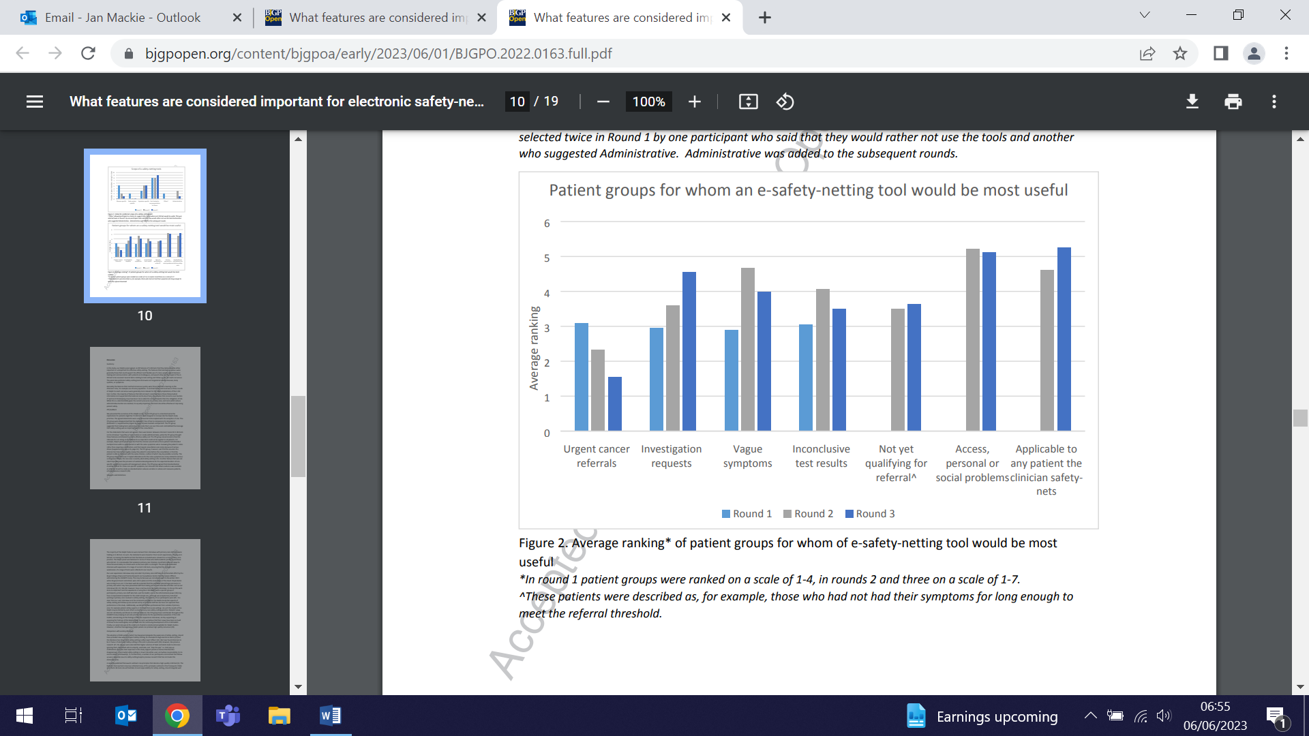 | A study to determine the most important features of electronic safety netting (E-SN) tools in UK primary care finds that successful adoption of these tools requires an evidence base for their effectiveness. From interviews with primary care staff who had trialled the EMIS E-SN toolkit for suspected cancer, three rounds of Delphi survey showed that tools not specific to a particular disease and which had features that promoted their flexible, efficient and integrated use were important, but only 28 out of 44 features reached consensus. The impact of these tools on patient safety needs to be assessed.
NHS-QMUL Violence Reduction Academy Partnership
8 June (Heather McMullen, Sania Shakoor, Mark Freestone. Centres for Public Health and Policy/Psychiatry and Mental Health)

A new Violence Reduction Academy to help tackle interpersonal violence in London has been launched, aiming to bring together practitioners and experts from different sectors to improve wellbeing in our communities and provide a health-orientated partnership approach to reducing violence in society. The NHS-QMUL initiative will build an evidence base, mapping existing interventions in health and social care and evaluating their success in reducing harm. This evidence will enable the academy to share best practice for reducing violence, and support the health system to implement initiatives across the capital. The three academic joint leads on the project are Heather McMullen, Sania Shakoor and Mark Freestone. | 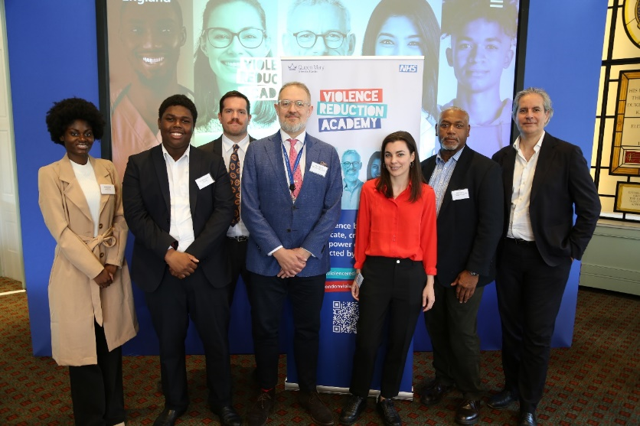  
NEJM Clinical Decisions feature: Management of possible MS
8 June (Ruth Dobson. Centre for Prevention, Detection and Diagnosis)

   | In an invited NEJM clinical decisions feature, Ruth Dobson provides one of two options for managing a proposed clinical case, defending her approach to recommend “monitoring only at this time”. Readers are invited to form community opinion by voting on the options, though neither option can be considered correct or incorrect. The hypothetical patient is a young adult presenting with a symptomatic, gadolinium-enhancing optic-nerve lesion and a single periventricular lesion. Ruth notes that disease-modifying therapy (DMT) may not reduce the risk of the development of clinically definite MS in low-risk patients, and studies examining initiation of DMT after a first demyelinating event are ongoing. As the patient’s final diagnosis may not be MS, she does not meet current MS diagnostic criteria, and active watchful waiting is likely to be the best approach in this case, as long as this decision is made in partnership with the patient.
Doctors' declaration of interests in medical organisations
8 June (Victoria Tzortziou Brown. Centre for Primary Care)

The processes and tools to enable consistent declaration and management of doctors’ conflicts of interests (COIs) are unclear. To better understand the degree of variation, researchers map policies across 31 organisations which set or influence professional standards, or engage doctors in healthcare commissioning and provision settings. Findings show that of 31 policies, 14 stated a duty to report concerns relating to COI, 18 advised that COI would be published, and 3 stated that any disclosures would remain confidential. Wide variation exists in what interests should be declared, when, and how. Authors propose that using the term ‘declaration of interest’ instead of ‘conflict of interest’ would encourage disclosure, and that agreed criteria about when a declared interest constitutes a conflict would assist in the interpretation of such declarations. |   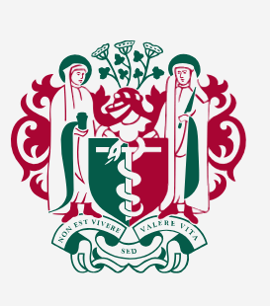
Validating a Chichewe translation of the Mental Health Literacy questionnaire
8 June (Sandra Jumbe. Centre for Evaluation and Methods)

 | Mental health literacy (MHL), an understanding of mental disorders and how these may be supported, is linked to better help seeking behaviour and management of mental illness. A study translating a self-reporting MHL questionnaire into Chichewa language for young adults in rural settings in Malawi evaluates how well this version correlates with the original version. Assessing the Chichewa translation for four factors: (1) Knowledge of mental health problems, (2) Erroneous beliefs/stereotypes, (3) First aid skills and help seeking behaviour, and (4) Self-help strategies, results showed that all but item 2 of the Chichewa version fit very well with related factors of the original English MHLq. Researchers conclude that more psychometric testing with a larger sample is needed to further validate the questionnaire. A validated Chichewa MHLq will provide mental health professionals and researchers in Malawi with a more culturally and linguistically acceptable tool for assessing mental health literacy.
Psychosis and multimorbidity: could syndemic theory resolve disputed evidence?
9 June (Georgina Hosang, Kam Bhui. Centre for Psychiatry and Mental Health)

A broad range of factors are associated with the development of psychosis and multimorbidity. Most research and clinical interventions focus on specific aetiologies, but prevention and intervention efforts along these lines have not been effective for all people with psychosis, especially marginalised groups including ethnic minorities. Syndemic theory is described as population-level clustering or co-occurrence of health conditions, in the context of shared aetiologies that interact and can act synergistically. These influences appear to act within specific places of high disadvantage. A new paper assesses the applicability of syndemic theory to ethnic inequalities in people living with psychosis and facing multiple disadvantages and poor health outcomes. It discusses practical and theoretical adaptations required to apply the theory to psychosis, ethnic inequality, and multimorbidity, with implications for research, policy, and practice. Authors hope the approach may offer new ways of conducting research, and for prevention and better care for people with complex lives. | 
Proton beam therapy for breast cancer patients?
9 June (Jo Haviland. Centre for Evaluation and Methods)

 | An article in a BMJ occasional series, highlighting areas of practice where management lacks convincing supporting evidence, examines the use of proton beam therapy (PBT) as an alternative to standard xray radiotherapy for breast cancer patients. No high certainty evidence exists on the clinical benefits of PBT in these patients in relation to either cardiac late effects and/or cosmetic outcomes. Authors note that three ongoing RCTs are currently recruiting to address whether PBT can reduce risk of long term serious heart damage without increasing other short term side effects, such as skin changes, compared with xray radiotherapy. These RCTs should provide high certainty around the population of patients in whom PBT will provide the greatest benefits in terms of reduced risks of late cardiac side effects.
QMUL Festival of Communities
10 and 11 June

A huge Well Done! to our twelve WIPH teams, who represented our Institute so brilliantly at the 2023 QMUL Festival of Communities. The event attracted over 7000 visitors, and our WIPH presence was again noted as the strongest from any QM Institute. Our thanks to you all for giving up your time on the weekend to interact with our local communities and showcase our work. | 
London’s Air Ambulance Helipad Abseil
11 June (Tracy Connelly. Director’s Office)

 | Massive congratulations to our Deputy Institute Manager, Tracy Connelly, for completing London’s Air Ambulance Helipad Abseil to raise funds to support the London's Air Ambulance Charity. The abseil was postponed from 2022, so Tracy had to keep her nerve for a good long time. She has raised £1200 to date, with every £ going to help London's Air Ambulance Charity to continue their work to save lives in London. Fabulous Achievement Tracy! Link here for anyone who would like to donate.
WIPH Graduate Studies Day
13 June

Our postgraduate research students presented an array of outstanding research at the 2023 WIPH Graduate Studies Day. The panel discussion included topics on PhD/Life balance, dissemination of research and stakeholder engagement, writing up, what to expect in your PhD viva, and what to do Post PhD. Ben Jacobs (Multiple Sclerosis genetics in diverse ancestries) and Stef Bonfield (Exploring public opinions of tests for cancer in areas of higher deprivation: a qualitative interview study) have been selected to repeat their presentations at the forthcoming WIPH Showcase. | 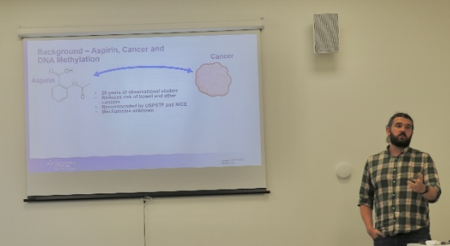  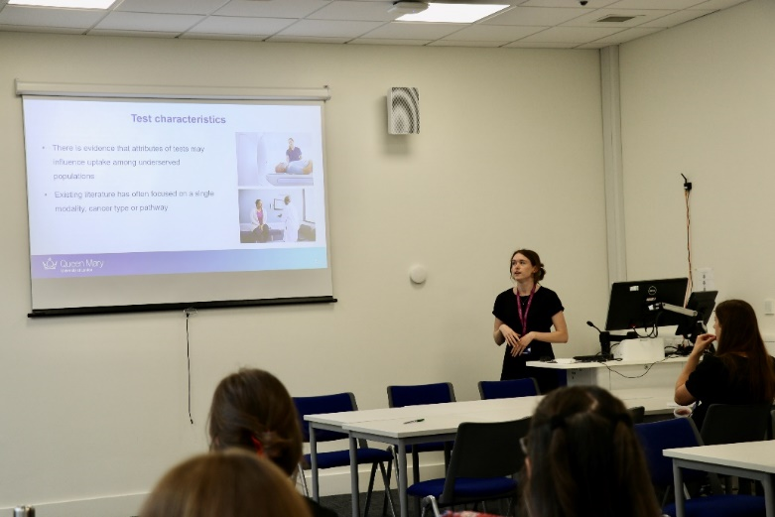
Addressing the Polypharmacy Paradox
13 June (Deborah Swinglehurst. Centre for Primary Care)

  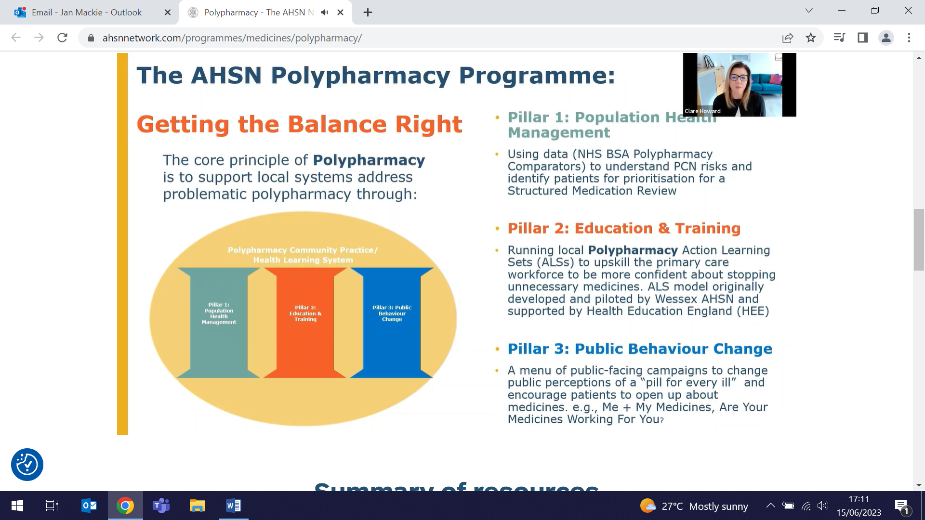 | Deborah Swinglehurst gave a presentation entitled Addressing the Polypharmacy Paradox at the inaugural meeting of the Buckinghamshire, Oxfordshire and Berkshire West Community of Practice on Polypharmacy (BOB) on 13 June. This new initiative within the Oxford Academic Health Science Network (AHSN) is creating clinical, multistakeholder communities of practice across England to implement the findings of the national overprescribing report. The Oxford community already has over 90 committed professionals engaged in this work.
Bonn Climate Change Conference
13 June (Natasha O’Sullivan, Heather McMullen. Centre for Public Health and Policy)

Global Health Unit members Natasha O'Sullivan and Heather McMullen organised and hosted an event, 'Achieving Sexual and Reproductive Rights and Climate Justice', on 13 June at the Bonn Climate Change Conference. The event was held in collaboration with the Danish Family Planning Association and the Asian-Pacific Resource & Research Centre for Women. Natasha spoke about a messaging guide being launched by the Sexual and Reproductive Health and Rights (SRHR) & Climate Justice Coalition, which will offer advice on how to think, speak about, and frame this topic. Other panellists discussed the intersections between SRHR and the Climate Crisis, SRHR within Climate Policy, and examples of good and bad practice and programming. | 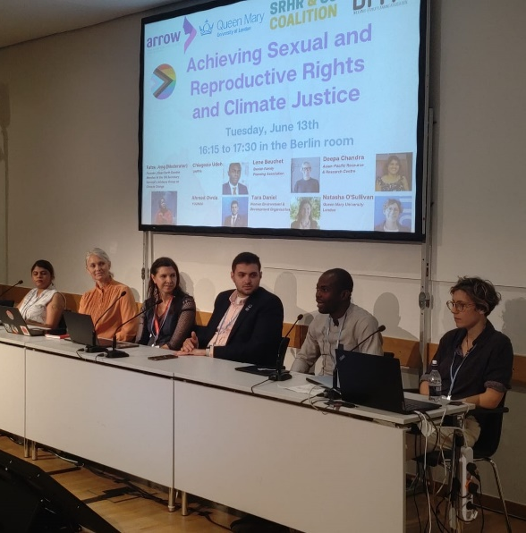  
RCOG World Congress 2023
13 June (Ranjit Manchanda. Centre for Prevention, Detection and Diagnosis)

 | Ranjit Manchanda delivered an invited talk on Preventing Gynaecological Cancer at the RCOG World Congress 2023 in London on 13 June. Following his presentation, he also participated as a panel member in a Stump the Panel session, in which 3 cases with only snippets of gradually delivered information were presented to the panellists, who could pose questions to try to determine the case diagnosis.
Cost analysis of SARS-CoV-2 testing in Mozambique
13 June (Giuliano Russo. Centre for Public Health and Policy)

Estimating the direct provider's costs of SARS-CoV-2 diagnosis in symptomatic patients in Mozambique, a study compares two nasopharyngeal antigen rapid diagnostic tests (Ag-RDTs) (Panbio and Standard Q) with three nasal Ag-RDTs (Panbio, COVIOS and LumiraDx), and reverse transcription PCR (RT-PCR). Diagnosis cost using Ag-RDTs was three times lower than RT-PCR testing. Medical supplies expenditures were the main driver of the final cost (>50%), followed by personnel and overhead costs (mean 15% for each). Researchers conclude that low and middle income countries can include cost-efficient Ag-RDTs in their screening strategies. Additional analyses are recommended as the costs of testing can be influenced by the sample referral system. | 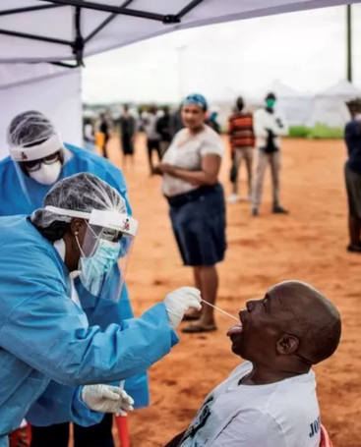
Evaluation of an AI model to assess future breast cancer risk
13 June (Celeste Damiani, Emily Lane, Jack Cuzick, Adam Brentall. Centres for Evaluation and Methods/Prevention, Detection and Diagnosis)

 | A matched case-control study of screen-detected (n=2044) or interval (n=696) breast cancer cases, using the OPTIMAM Mammography Image Database from the National Health Service Breast Screening Programme in the UK, has found that a breast cancer artificial intelligence system was a stronger predictor for risk stratification over 3-6yrs than mammographic density, and could help determine screening intervals. The performance for interval and screen-detected cancer was similar, but performance was higher for advanced (stage II or higher) breast cancer compared with earlier stage disease. The model (Mirai) has not been previously externally validated in an English screening population or by using multiple mammograms over time, and has also not been assessed for disease staging and grading, which is needed to help determine if the cancers identified early are likely to be fatal without additional interventions.
Acceptability of the faecal immunochemical test in primary care
14 June (Fiona Walter. Centre for Prevention, Detection and Diagnosis)

Little evidence exists on patient views on the faecal immunochemical test (FIT) used in UK primary care to triage symptomatic patients with different levels of colorectal cancer risk. An interview study conducted in 2020 analyses transcribed recordings with 44 patients, 8 of whom received a positive FIT result. Participants’ familiarity with similar tests and perceived risk of cancer influenced test experience and acceptability. Test explanation by healthcare professionals was often limited, and many participants did not receive a result. For those with a negative result and persisting symptoms, there was uncertainty about any next steps. Authors suggest possible ways to improve the FIT experience, particularly regarding communication about the test and its results. | 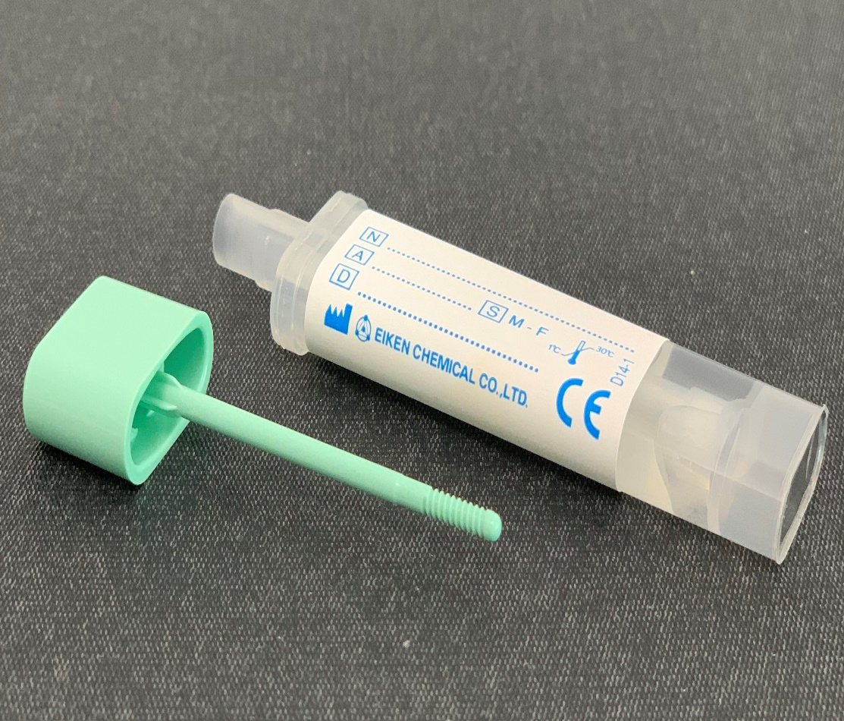
Non-malignant CT detected findings in the SUMMIT lung cancer screening cohort
15 June (Sammy Quaife. Centre for Prevention, Detection and Diagnosis)

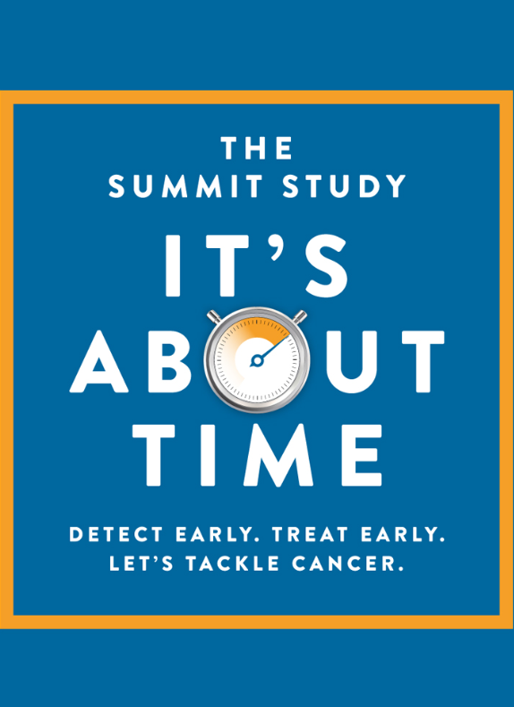 | Incidental findings are frequently identified on CT scans for lung cancer screening CT scans, but their clinical significance and how such findings should be reported is uncertain. A standardised reporting and management protocol for incidental findings on the baseline LDCT was developed for the SUMMIT study. Results from the study show that in over 11000 SUMMIT participants who underwent low dose CT scans, the most common incidental findings were coronary artery calcification (64.2%) and emphysema (33.4%). In accordance with the study’s protocol, 1 in 20 participants required review for clinically relevant findings in primary care, and the number potentially requiring review in secondary care was 1 in 25. Authors suggest that the reporting protocol allows systematic assessment and standardises onward management.
Motor Dysfunction in Individuals at Risk of Parkinson's
15 June (Cristina Simonet, Aneet Gill, Jon Bestwick, Alastair Noyce. Centre for Prevention, Detection and Diagnosis)

Using data from participants in the PREDICT-PD study, which aims to stratify individuals according to their risk of future Parkinson’s disease, researchers have examined motor assessments at baseline and after an average of 6yrs follow up, to compare motor decline according to risk scores. Results show that at 6yrs the higher-risk group had a greater motor decline compared with the lower-risk group (30% vs. 12.5%, P = 0.031). Two baseline high risk participants were given a Parkinson’s diagnosis during follow-up, with motor signs emerging between 2-5yrs before diagnosis. Authors conclude that the PREDICT-PD algorithm could also identify individuals whose motor examinations experience a decline over time. | 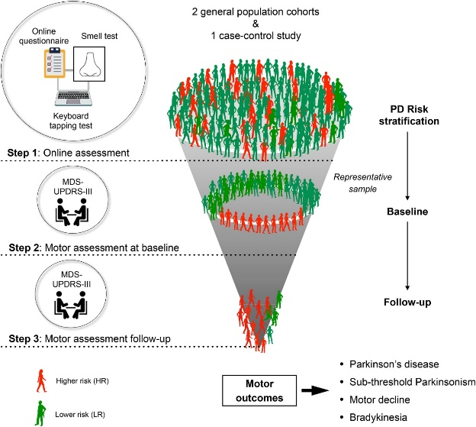
Synaptic Terminal Density Early in the Course of Schizophrenia
15 June (Ellis Onwordi. Centre for Psychiatry and Mental Health)

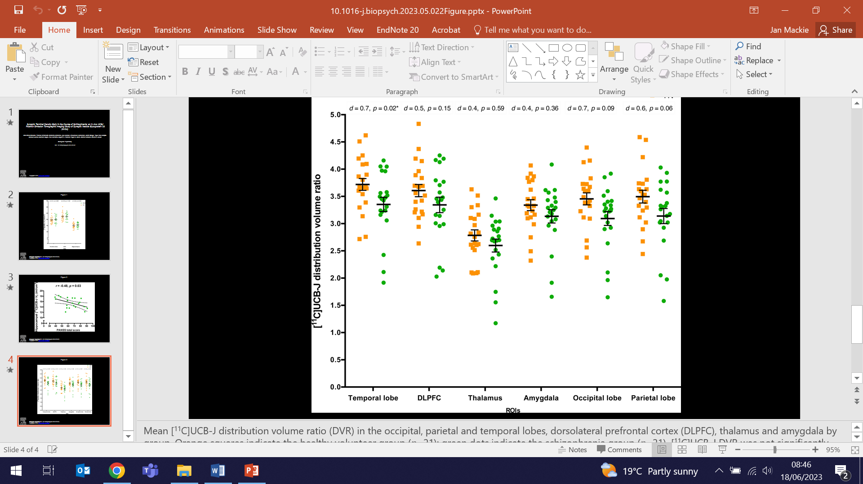 | Patients with chronic schizophrenia have lower uptake of synaptic terminal density marker UCB-J. To determine if this marker is present early in the illness, researchers compared the volume of distribution and distribution volume ratio of UCB-J in antipsychotic-naïve/free patients with schizophrenia and in healthy controls. Results showed no significant effects of group in most regions of interest, other than lower distribution volume ratio in the temporal lobe and lower volume of distribution in the anterior cingulate cortex in patients v controls. These findings indicate that large differences in synaptic terminal density are not present early in schizophrenia, which may indicate that synaptic density changes during the course of schizophrenia.
The histamine system and cognitive function
16 June (Ellis Onwordi. Centre for Psychiatry and Mental Health)

Post-mortem evidence shows that in patients with psychotic disorders the expression of a histamine-3 receptor (HR3) is altered, which may underlie cognitive impairment associated with schizophrenia. An in vivo H3R receptor PET imaging study comparing brain uptake of an H3R selective tracer found no statistically significant difference in uptake between patients with schizophrenia and controls, however, dorsolateral prefrontal cortex tracer uptake was strongly correlated with cognition in controls only. Researchers suggest that H3R in the dorsolateral prefrontal cortex may play a role in executive function, and that this is disrupted in schizophrenia in the absence of major alterations in H3R availability as assessed using a selective radiotracer for H3R. The result provides further evidence for the role of H3R in cognitive impairment associated with schizophrenia. | 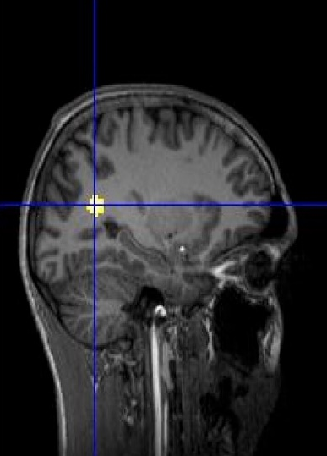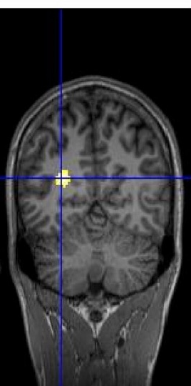  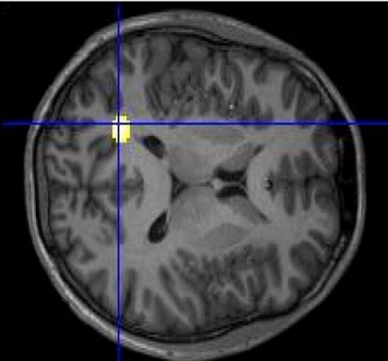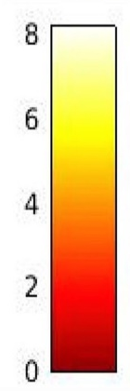
Protocol for PIAMS study on point of care testing for influenza
16 June (Charis Xuan Xie. Centre for Evaluation and Methods)

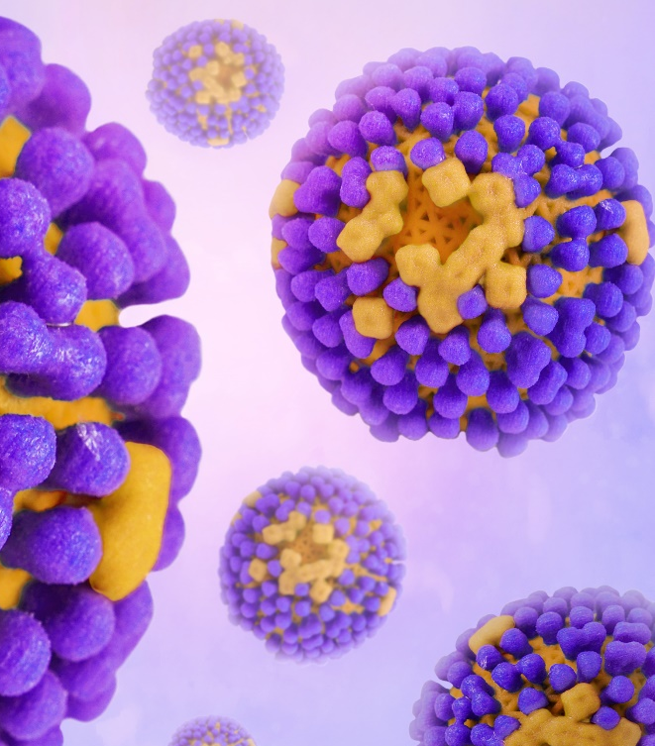 | Researchers have published the protocol for the Impact of point-of-care testing for influenza on antimicrobial stewardship (PIAMS) in UK primary care study, being conducted in 10 practices in England. A confirmed clinical diagnosis, particularly early in the disease, could inform better antimicrobial stewardship, but problems exist in integrating point of care testing into the clinical workflow. Up to 1000 primary care patients with respiratory symptoms will be tested with a rapid molecular POCT analyser. The study will generate data on the impact of POCT testing for influenza in primary care, and will help to inform about the feasibility of incorporating POCT into primary care workflows.
Adolescent mental health during the pandemic in a Colombian post-armed conflict area
16 June (Vicky Bird, Stefan Priebe, Francois van Loggerenberg. Centre for Psychiatry and Mental Health)

A study in a post-conflict area (Tolima) of Colombia analyses self-administered questionnaires to assess anxiety symptoms, depressive symptomatology, probable post-traumatic stress disorder, and resilience during the COVID-19 pandemic among 657 adolescents. Prevalence was 18% for moderate-severe anxiety, 30% for moderate to severe depressive symptomatology, and 22.3% for post-traumatic stress disorder, suggesting that around 2/3 school-attending adolescents living in this area in Colombia experienced at least one mental health problem during the pandemic. Authors call for open discussion of mental health in schools, curriculum changes, and school staff training, to help reduce stigma and encourage self-care and help seeking behaviours. | 
Survival associated with extent of radical hysterectomy in early-stage cervical cancer
17 June (Ranjit Manchanda. Centre for Prevention, Detection and Diagnosis)

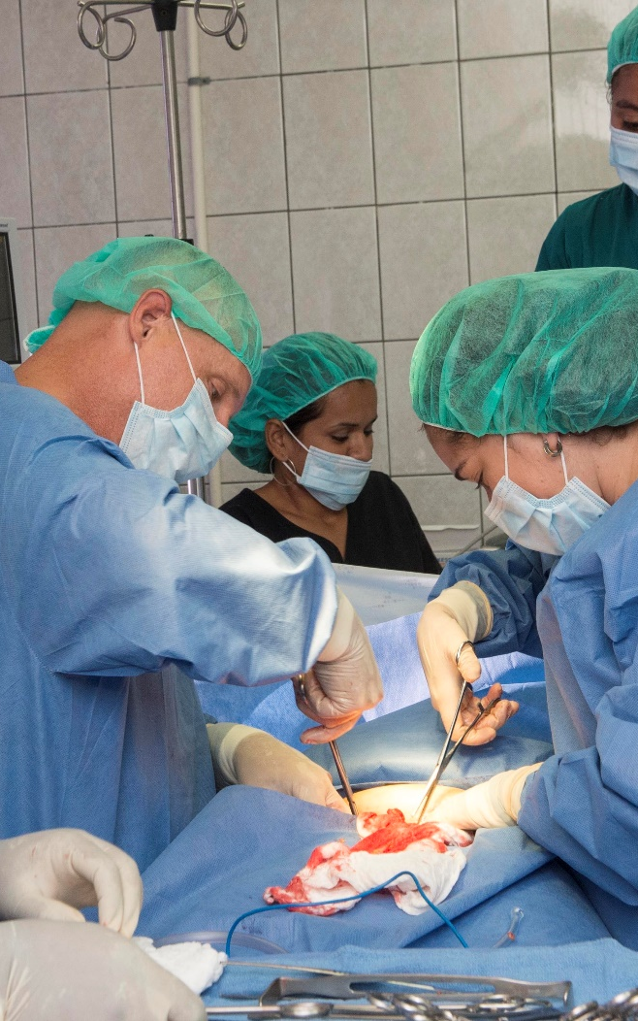 | A sub-analysis of 1257 patients from the Surveillance in Cervical CANcer (SCCAN) cohort examines whether radicality of hysterectomy (which is determined by known pre-operative tumour characteristics) in patients with early stage cervical cancer has an impact on 5-yr disease free survival. Study subjects had not received neo-adjuvant chemotherapy, and had undergone open type B/C1/C2 radical hysterectomy for stage IB1/IIA1 cervical cancer with negative lymph nodes and free surgical margins. Results showed no survival difference with more radical hysterectomy for tumours ≤20mm, but for tumours of 21-40mm, more radical hysterectomy was associated with improved 5-year disease free survival. No difference was found in pattern of recurrence according to extent of radicality. Non-nerve sparing radical hysterectomy was associated with better 5-year disease free survival than nerve-sparing radical hysterectomy.
Impact of pharmacists in general practice
17 June (Georgios Dimitrios Karampatakis. Centre for Primary Care)

An international literature review of 75 published studies explores the employment and integration models of general practice-based pharmacists, and their activities and impact. Integration of pharmacists into general practices has occurred in several countries, with medication reviews the most common task globally. Impact of general practice based pharmacists was identified through measures such as activity volume, contact with patients, perceptions/experiences, and patient outcomes. Outcomes from pharmacist activities were all positive, but were of varying statistical significance. The findings may help policy makers decide how best to implement and fund these services, and how to identify and measure the impact of general practice-based pharmacists. | 
Practitioner v self-referral to stop smoking services in the Lung Screen Uptake Trial
18 June (Evangelos Katsampouris, Stephen Duffy, Sammy Quaife. Centre for Prevention, Detection and Diagnosis)

 | In a single blinded RCT of 642 smokers from the UK Lung Screen Uptake Trial, participants were assigned to either self-referral or referral made on their behalf to local stop smoking services in England. Results showed that 49.8% of those offered a practitioner-made referral gave permission for their details to be shared with stop smoking services. In the group offered a self-referral contact card, 88.5% accepted. Greater quit confidence, quit attempts, and Black ethnicity were associated with increased acceptance within the practitioner-referral group. Although in this trial self-referral was more frequently accepted, prior evidence suggests practitioner-referrals increase quit attempts, suggesting practitioner-referrals should be the first-line strategy in lung cancer screening, with self-referral offered as a viable alternative.
Case study: Temporal structuring in hyperacute stroke services
19 June (Georgia Black. Centre for Prevention, Detection and Diagnosis)

A case study in hyperacute stroke wards explores how temporal structuring, determined by practices and social norms, affects quality and timing of care. From interviews with ward staff and non-participant observations, researchers generated five themes around the concept of temporal care. They conclude that temporal consistency stems from service design, including staffing, targets, and patient pathway design, as well as cultural attitudes to working patterns. In this case study they find that improvements to consistency of care will be limited without changes to structures, such as rotas and ward rounds, and to social norms around weekend work for certain professional groups. | 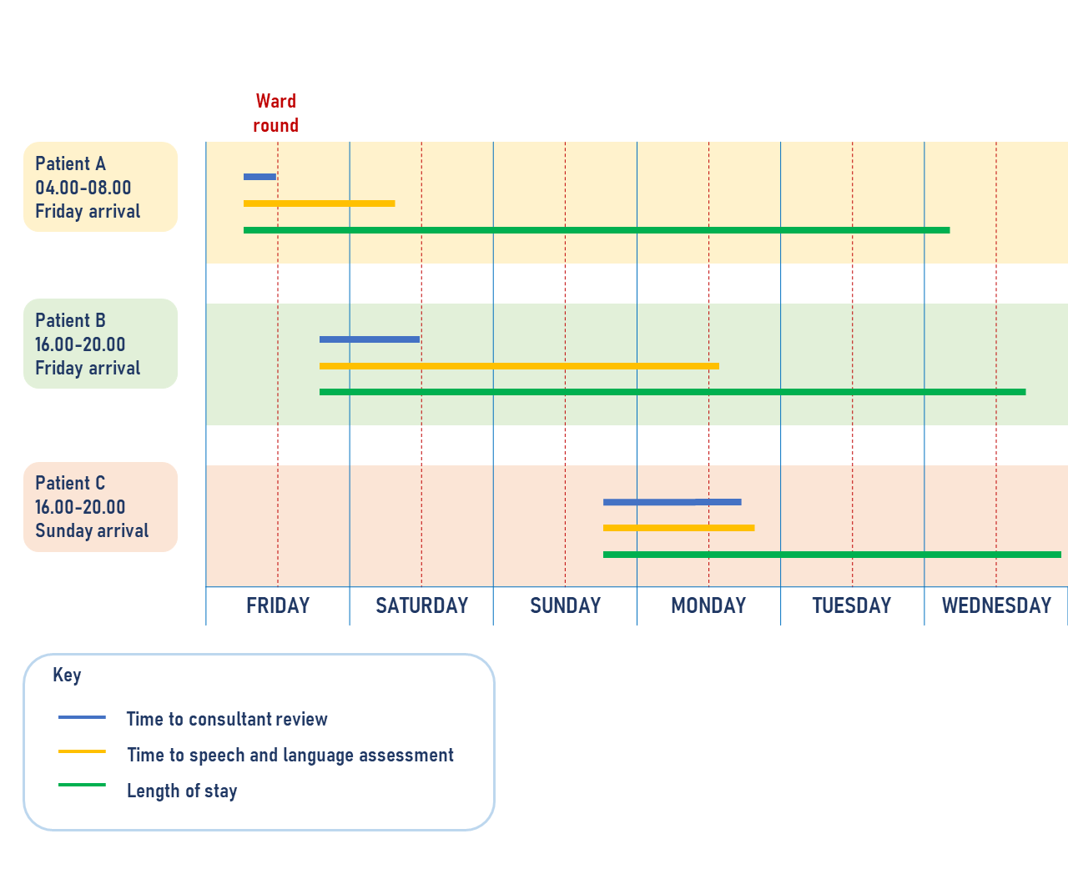
Ancient plague provides clues on the origin of Britons
19 June (Jon Kennedy. Centre for Public Health and Policy)

In a Guardian article, Jon Kennedy reflects on the recent discovery of Yersinia pestis, the bacteria that causes plague, in the dental pulp of three people who died in England around 4000 years ago. The discovery pushes back the earliest evidence of plague in England by several millennia, and proves that the prehistoric plague across Europe and Asia did reach England. He concludes that ‘the white British population are certainly not the indigenous people of the British Isles. They are the descendants of immigrants who arrived on boats. And it is likely that they were only able to settle here because the humble Yersinia pestis bacterium cleared the way for them.’ | 
King's Fund Conference: Accelerating progress on cardiovascular disease
20 June (John Robson and Stuart Rison. Centre for Primary Care)

 | Two WIPH CEG representatives took part in the King’s Fund Conference on Accelerating progress on cardiovascular disease on 20 June. John Robson delivered a talk on ‘The Clinical Effectiveness approach’ in the session on Engaging clinicians to deliver targeted action on primary and secondary prevention to reduce the risk factors for CVD, and Stuart Rison was one of three panellists in the closing session, ‘How do we accelerate progress on CVD?’
CORRECTION: In the 11 May issue of the newsletter the story: Short tenure of primary care physicians in Brazil dated 27 April was misaffiliated. The correct author for the story on this study was Giuliano Russo, Centre for Public Health and Policy. The version on record has been corrected.

FORTHCOMING EVENTS AND NOTICES

European Society of Gynaecological Oncology Webinar
23 June (Ranjit Manchanda)

Ranjit Manchanda will chair a live 90 minute interactive panel discussion webinar entitled Challenging clinical cases in ovarian cancer management on Friday 23 June at 13:00. This free educational initiative by the ESGO Multidisciplinary Tumour Board on ovarian cancer will include a short presentation of clinical cases and practical tips and recommendations. Register here to join online. | 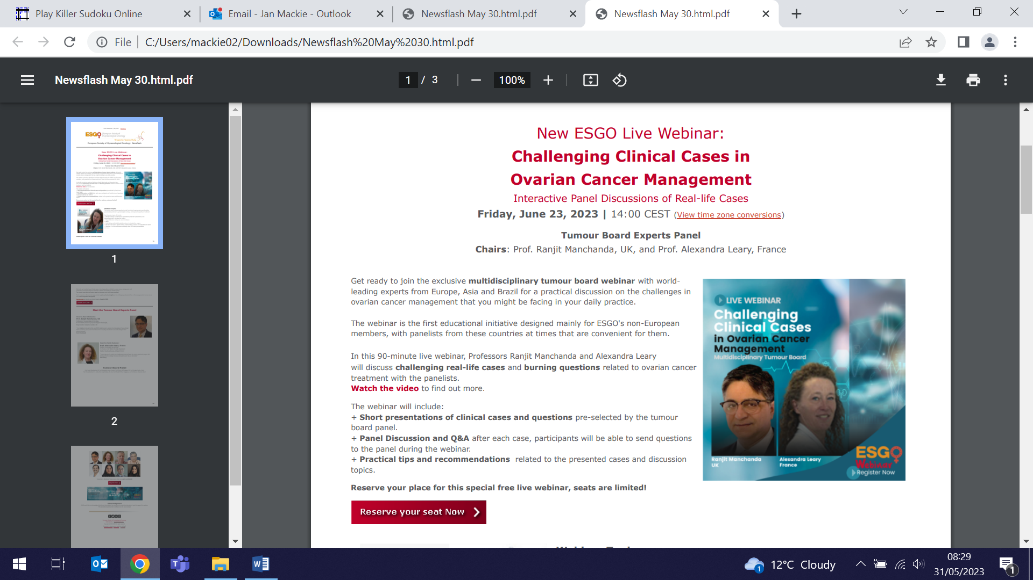
Free Webinar: A scalable liquid biopsy for HPV-related cervical cancer
29 June (Belinda Nedjai)

Belinda Nedjai will co-moderate this free Global Implications webinar at 4pm on Thursday 29 June, presenting on a non-invasive first-void urine sample collection as an alternative to clinician collected samples for population screening for HPV-related cancers. This alternative sampling system has potential to reduce the cost of care and better support diversity, equity and inclusion in healthcare. Click here to join. | 
Many thanks to all who so enthusiastically contribute. Please send any news items for the next newsletter to j.a.mackie@qmul.ac.uk

