WOLFSON INSTITUTE OF POPULATION HEALTH
NEWSLETTER
ISSUE 46: 28 NOVEMBER 2023

In this issue of our Wolfson Institute of Population Health Newsletter, we celebrate the achievements and work of staff and students through November.

FROM OUR DIRECTOR OF EDUCATION, MARK FREESTONE
Dear Colleagues

It has been a real pleasure to meet so many new faces - and meet up with some well-remembered ones - as Jon, Trevor, Fiona and I begin to roll out the Institute’s Education Strategy with consultations in each Centre. I have been deeply impressed and humbled by both the breadth & depth of expertise we have across our Centres, but also in people’s willingness to put forward suggestions for new education opportunities, be those modules, CPD, or even short courses. We are very grateful to all of you who have taken on the mantle of developing learning experiences already, and I look forward to hearing from everyone in due course.

I am sure we all look on Tracy Connelly’s departure from the Institute with mixed emotions: Tracy was a huge presence in WIPM even before our merger into WIPH, and the source of unforgettable Friday afternoon morale-boosting missives that could equally detail daredevil stunts, gardening, or Tracy’s bold charitable endeavours. Or all three. In WIPH we miss the Friday updates, but her initiatives to improve and rationalise our working environment and strengthen our EDI work (among her many tasks) have had a huge impact. However, Tracy inevitably moves on to bigger and bolder things as Institute Manager in Dentistry, and we wish her all the very best. Good luck, Tracy!

As we reach the end of the teaching semester, those of us involved with education delivery have a chance to draw breath, finish up our marking and reflect on what seems like an exceptionally hectic two months. It is said that as soon as you think that you have something perfected is the moment it is already in decline, so I will simply say that I think the positivity, responsiveness and ‘can do’ attitude of both our academic and professional education staff has been a great credit to the Institute this year, and we look forward to moving forward with our Education Strategy as well as the new semester’s challenges.  Looking forward to seeing you all again soon,  Mark | 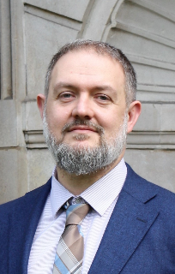
MEET WIPH: Jonnie Aeron-Thomas
(Operations Manager) CCSPED

How would you describe your roles and responsibilities?
As the Operations Manager (Delivery) for the CRUK Cancer Prevention Trials Unit (CPTU), my role revolves around supporting operations management across our portfolio. This entails early project support, resource planning and post-awards management. I am also currently involved in setting up BEST4, a new and exciting RCT that involves population targeted screening using a capsule sponge test to detect early signs of oesophageal cancer.

What has been your greatest professional achievement?
During my time as a Stroke Research Manager at King’s College Hospital NHS Foundation Trust in 2021/22, I spearheaded the highest recruiting stroke research centre in the Clinical Research Network nationally. Our recruitment success was driven by two King’s Sponsored studies I took pride in helping to set up and manage.

What aspects of your role do you enjoy the most?
I find enjoyment in the value of our work and the varied nature of my responsibilities. The role demands versatility, and I appreciate the opportunities to continuously learn and contribute. Working on early project support is particularly fulfilling, I like the point where imagining what’s possible meets what’s feasible.

What would be your second choice as a profession?
If I ventured into another career, I would aspire to become an investigative journalist. I am drawn to impactful storytelling, and admire reporters who hold power to account and expose corruption. More than just exposing wrongdoing, it is also an important aspect of social justice.

What do you enjoy doing outside work?  I enjoy walks with Marcel, my staff-whippet cross (who my wife scolds me for pampering). I also enjoy running, and completed my first marathon last year in Edinburgh for the Anthony Nolan charity, that does fantastic work helping people with blood cancer. When I’m not exercising, I like reading and listening to podcasts. I am also slowly but surely psyching myself up to learn the guitar - unfortunately, there are no musical genes in my family.  Something most people don’t know?  My wife and I like to follow the waves for our vacations. The next surf spots on our bucket list are Senegal, Philippines, and Sri Lanka. | 
GENERAL INSTITUTE NEWS

Multi-infection screening for migrant patients in UK primary care
4 November (Dominik Zenner. Centre for Public Health and Policy)

An interview study of infectious disease screening conducted among UK primary care clinical/admin staff finds that there is no standardised approach and many practices have no screening system, so migrant patients do not always receive evidence-based care. Respondents reported poor implementation of existing screening initiatives (eg regional TB screening), citing overly complex pathways that require extensive clinical/admin time and lack financial/expert support. Feedback on a digitalised integrated clinical decision-making tool ‘Health Catch UP!’ to support multi-infection screening for migrant patients was positive, with respondents saying it would systematically integrate data, support clinical decision-making, increase knowledge, reduce missed screening opportunities, and normalise primary care-based infectious disease screening for migrants.
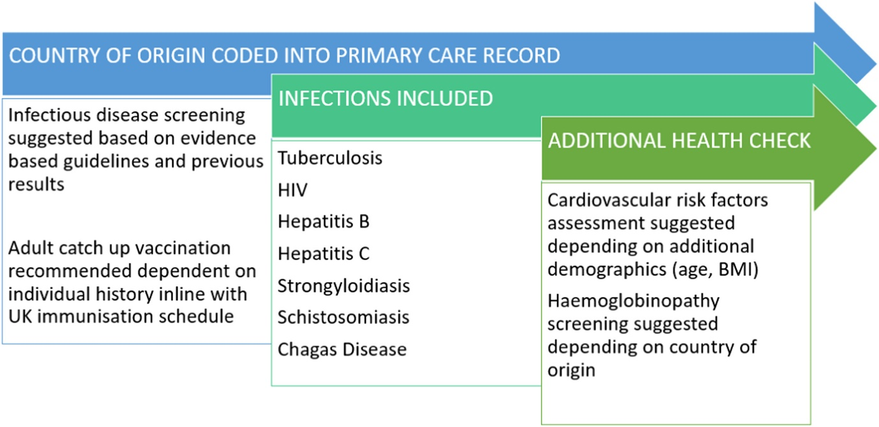
Annual Cluster Randomised Trials & Stepped Wedge Designs Meeting
8-9 November (Richard Hooper, Beth Stuart. Centre for Evaluation and Methods)

The 9th meeting on Current Developments in Cluster Randomised Trials (CRTs) and Stepped Wedge Designs (SWDs), organized annually by the Pragmatic Clinical Trials Unit, took place on 8-9 November, online and in-person at Mile End. With more than 80 attendees, the event brought together researchers involved in design and analysis of CRTs and SWDs, and included 30 abstract presentations, invited speakers, and an interactive workshop featuring Performing Medicine, exploring researchers’ views on risk bias in CRTs, based on the results of a qualitative interview study. | 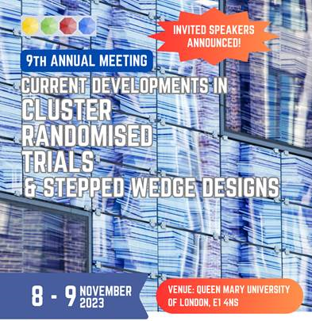
IMP²ART: Developing multilevel programme theory for asthma self-management
13 November (Liz Steed, Steph Taylor. Centre for Primary Care)

IMP²ART (IMPlementing IMProved Asthma self-management as RouTine) is a UK RCT to evaluate a whole systems approach to improve implementation of supported asthma self-management in primary care. A paper on the development of the study implementation strategy focuses on the integration of multiple level theories, synthesising the integrated Promoting Action on Research Implementation in Health Services (iPARIHS) and Capability, Opportunity, Motivation and Behaviour (COM-B) frameworks. The evolved framework will bring together important implementation and behaviour change elements to form the basis for the study process evaluation, and may benefit others targeting implementation in primary care.

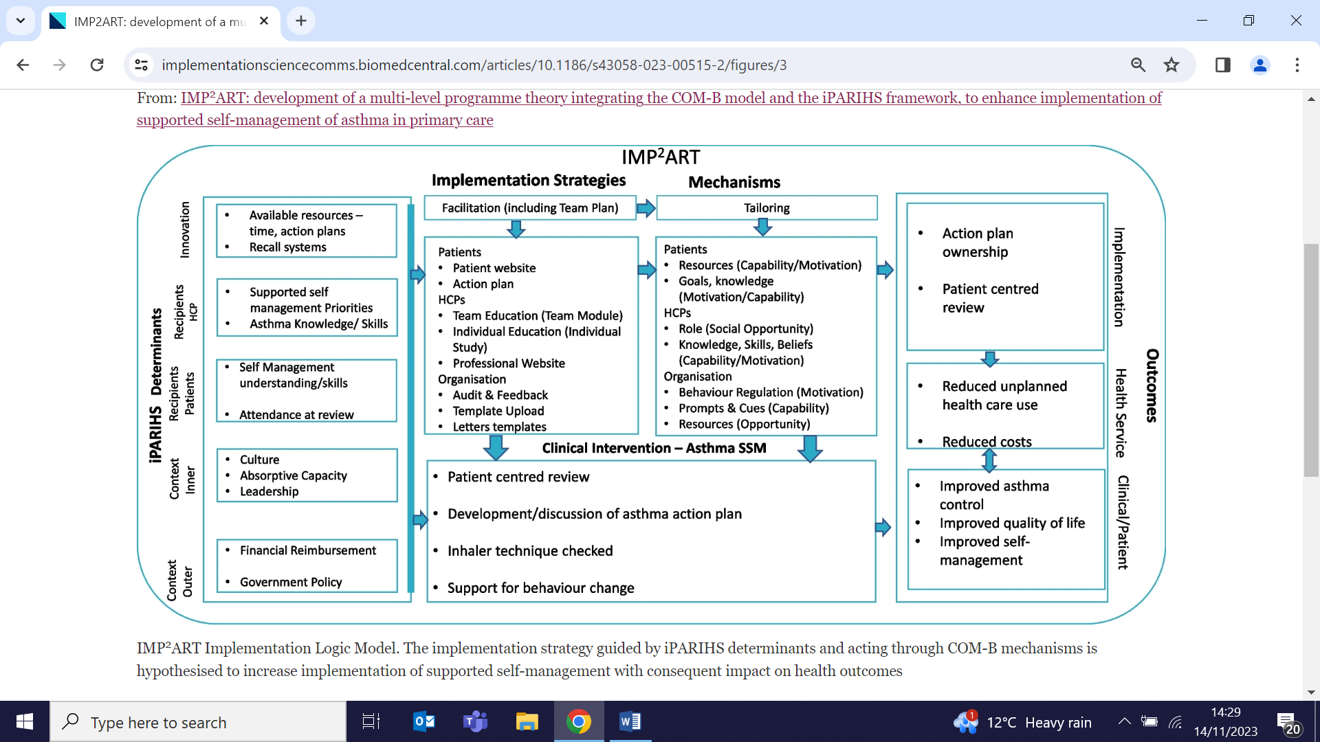
HIV pre-exposure prophylaxis: Psychosocial impact on gay men in England
14 November (Rosalie Hayes. Centre for Public Health and Policy)

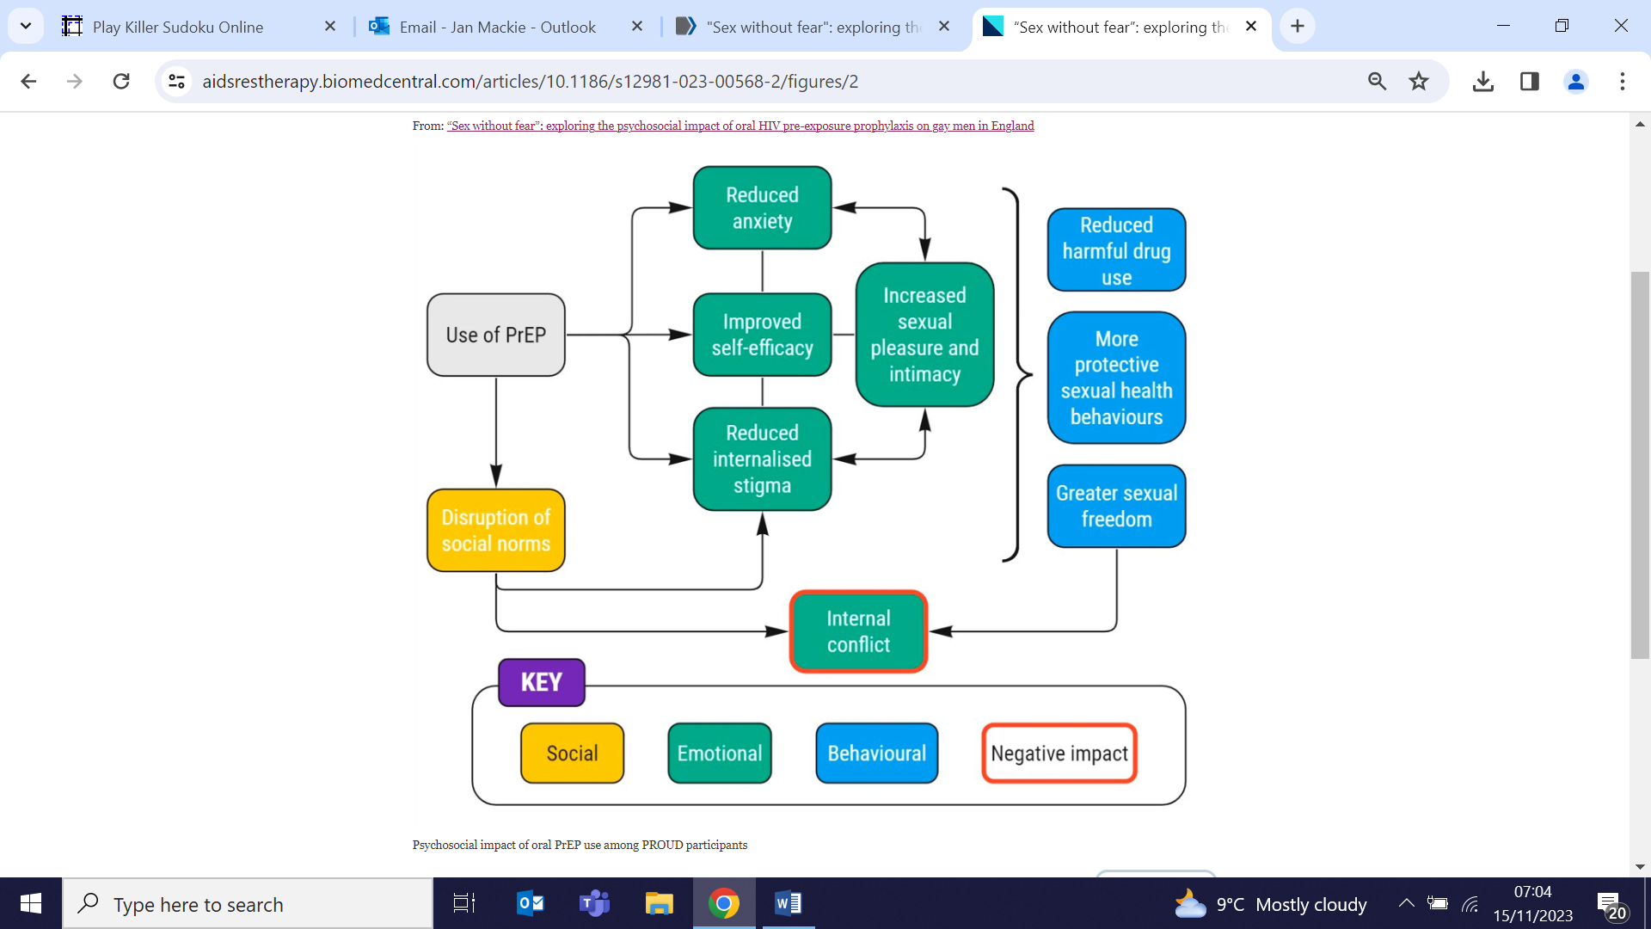 | Researchers exploring the impact of oral HIV Pre-Exposure Prophylaxis (PrEP) use on gay men in England say their findings support calls to consider the psychosocial impact of PrEP in prescribing guidelines. The interview study found that PrEP improved users' wellbeing by reducing HIV-related anxiety and internalised stigma, and increased HIV prevention self-efficacy, sexual pleasure, and intimacy. While these psychological changes may influence behaviour in the form of greater sexual freedom, reduced harmful drug use, and more protective sexual health behaviours, PrEP may create internal conflict for some, due to its disruption of social norms around condom use and its perceived influence on their sexual behaviour leading to reduced condom self-efficacy.
10-point plan for a UK Cancer Strategy
14 November (Fiona Walter. Centre for Cancer Screening, Prevention and Early Diagnosis)

A policy review paper calls for a UK Cancer Strategy to address gaps left by the integration of the National Cancer Control Plan into a ‘Major Conditions Strategy’ in England and Wales, and the closure of the National Cancer Research Institute, which authors call a major misstep at a time when the NHS is facing multiple challenges. Highlighting poor UK performance in cancer care compared with other countries (all UK nations in the bottom half of cancer league tables), and the expectation that by 2040 the UK will have to care for 30% more new cancer patients annually, authors have created their own 10-point plan as a blueprint for a new cancer strategy that will tackle record cancer treatment waiting times, workforce shortages, and the lingering impact of the COVID-19 pandemic. | 
Call to extend industry levies to reduce sugar content in food and drinks
14 November (Action on Sugar Team. Centre for Public Health and Policy)

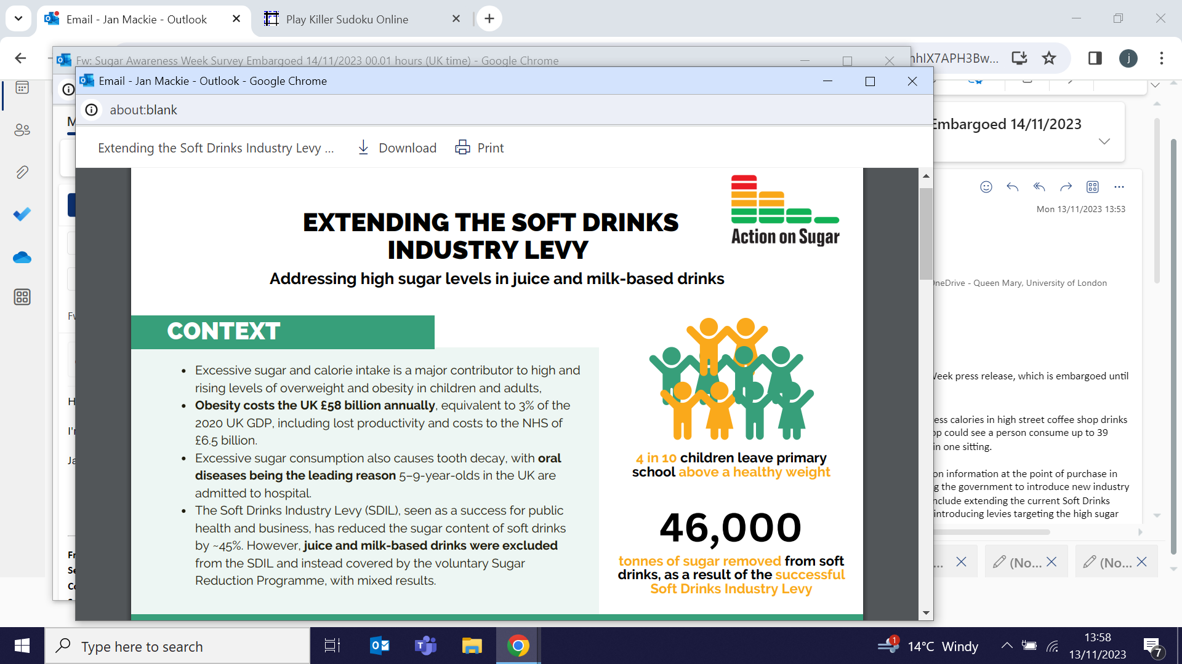 | Action on Sugar calls on the UK Government to extend industry levies to encourage manufacturers to reduce excessive amounts of sugar in their products. The call accompanies an analysis showing that over 1/3 of drinks and sweet products sold in major high street coffee shops exceed the daily recommended adult intake of sugar, and that some combinations of one food product and one drink from these outlets contain 5x the maximum daily limit. The research found that 782 sweet food and drink products in leading high street coffee shops were insufficiently labelled, and that over half would be marked 'red' if nutrition information was transparent. The proposal could include extending the current Soft Drinks Industry Levy to cover all juice and milk-based drinks, and introducing new levies to target the high sugar content in sweet foods. Revenue generated through levies could be invested in children’s health.
New WHO Therapeutic Patient Education guidelines
14 November (Steph Taylor, Chris Griffiths. Centre for Primary Care)

The WHO Regional Office for Europe has published a new guide for policy-makers, health professionals, and education and training bodies on therapeutic patient education (TPE): Improving patient education: a new guide for policy-makers and health professionals to support self-management of chronic conditions. This first guideline update for 20+yrs draws heavily on published 2014 work from the Centre for Primary Care (ref 4 in the document), and covers commissioning, designing and delivering TPE services, and training programmes for health professionals. It also looks at the evidence and theory underpinning patient education, outlines key components for delivering a high-quality service and identifies implementation opportunities and barriers. | 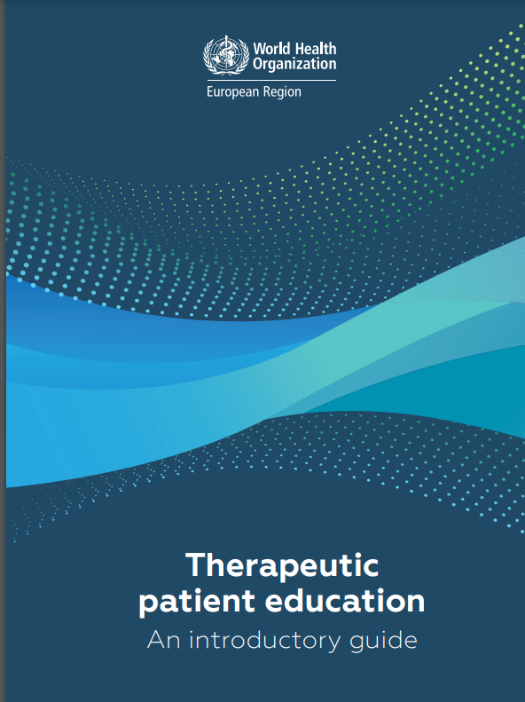
Effects of four risk factors on years of life lost to cancer
15 November (Judith Offman, Peter Sasieni. Centre for Cancer Screening, Prevention and Early Diagnosis)

  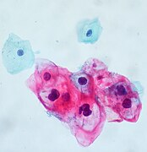 | The impact of alcohol, smoking, excess weight, and human papillomavirus (HPV) infection on cancer mortality and years of life lost (YLLs) has been calculated across 7 countries in new study. Researchers found that in 2020 in the UK, US, Brazil, Russia, India, China and South Africa, YLLs attributable to these preventable risk factors were 5.9 million for alcohol, 20.8 million for smoking, 3.1 million to excess body weight, and 4 million to HPV. Smoking tobacco was by far the biggest driver of preventable cancer deaths, causing 1.3 million deaths (over 2/3 of preventable cancer deaths). Risk factors were associated with different cancer types in different countries, probably due to between-country differences such as cervical screening services or use of chewing tobacco in addition to smoking tobacco.
Polypharmacy among older Pakistani patients in East London
15 November (Najia Sultan, Deborah Swinglehurst. Centre for Primary Care)

An interview study conducted among first generation Pakistani patients aged 50+ from GP Practices in East London who were prescribed 10 or more regular medications finds that patients make sense of and manage treatments in culturally specific ways. Doctor-patient relationships and family networks held particular significance. Participants described their emotional bonds with their medicines, identifying them as 'forces for good'-substances which allowed them to maintain their health through the intercession of God. Researchers hope their findings will help enable the integration of culturally sensitive approaches to prescribing. | 
ADRUK Annual Conference: ‘Public data for resilience and inclusion’
15-16 November (Rohini Mathur, Nicola Firman, Marta Wilk. Centre for Primary Care)

Three CPC researchers presented at the Administrative Data Research UK (ADRUK) 2024 conference in Birmingham. Nicola Firman spoke about her study linking e-health records with National Child Measurement Programme data, which found that younger children are 4.6x more likely to be living with obesity if they cohabit with an older child with obesity. Marta Wilk shared estimates of household and population sizes, showing that health records produced similar results to Census 2021 for population sizes (with some overestimation for people aged 30-50) and that there was a good agreement for small and middle size households, with health records overestimating the number of big households. Rohini Mathur delivered a keynote address on the role of research to support renewal, recovery and resilience, referencing CEG work linking administrative data with e-health records to understand the wider determinants of health. | 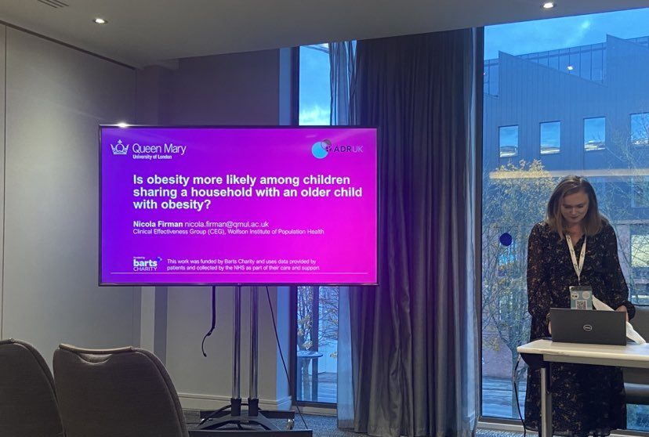  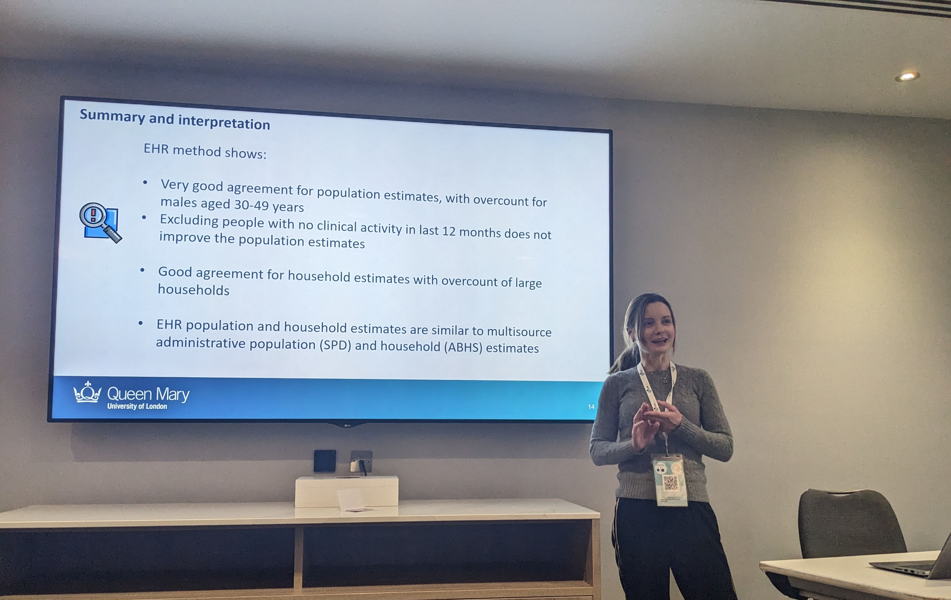  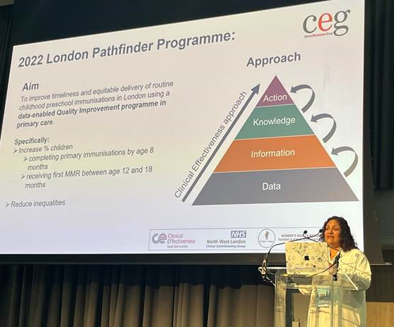
Medicines, pharmacy and prescribing initiative of the year award
16 November (John Robson, Chris Carvalho. Centre for Primary Care)

 | The Clinical Effectiveness Group, together with a collaborative team from Barts Health NHS Trust, N. East London Integrated Care Board, and UCL Partners, has won the Health Services Journal (HSJ) Medicines, Pharmacy and Prescribing Initiative of the Year Award for a programme to prevent heart attacks and strokes in north east London. The team developed a novel pathway to identify people at risk of heart attack and stroke and ensure they are prescribed suitable medications, with specialist pharmacists using CEG software tools to identify and prioritise at-risk patients. The approach increased prescription rates for anticoagulant medication in at-risk patients from 88 to 94% (above the national 90% target). Judges noted the programme’s ‘impressive commitment to sustainability, scalability and reducing inequalities’.
Factors influencing psychosocial outcomes of lung cancer screening
16 November (Sammy Quaife. Centre for Cancer Screening, Prevention and Early Diagnosis)

Following early data suggesting that lung cancer screening psychosocial impacts are influenced by programme factors, results from a review study suggest that targeted interventions can improve smoking related or decisional psychosocial outcomes (eg. smoking cessation interventions increase readiness/motivation to quit), but impacts of interventions on other psychological outcomes were varied. Limited evidence reported association between service delivery components and psychological outcomes, and results suggested moderation by individual aspects (eg. expectation of results, baseline anxiety). Researchers found that opportunities for discussion were key in reducing psychological harm. | 
DIALOG+ in primary care for patients with long-term physical conditions
16 November (Francois van Loggerenberg. Centre for Psychiatry and Mental Health)

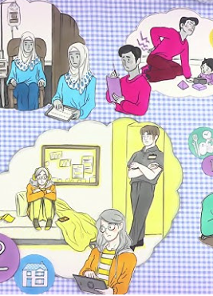 | The first study to examine the DIALOG+ intervention for patients with long-term physical conditions in primary care settings finds the intervention to be highly feasible in 3 participating sites across Bosnia & Herzegovina, Colombia, and Uganda. DIALOG+ is a low-cost, patient-centred and solution-focused intervention, which is used in routine patient-clinician meetings and has been shown to improve outcomes in mental health care. In each country, more than 75% of anticipated participants were recruited, with retention rates over 90% and completion of the intervention exceeding 92%. Patients had significantly higher quality of life and fewer anxiety and depression symptoms at post-intervention follow-up, with moderate to large effect sizes.
How can we save Planet Earth?
16 November (Chris Griffiths. Centre for Primary Care)

In the run up to his attendance at COP28 (30 Nov- 12 Dec), Chris Griffiths has been interviewed as part of a QMUL video series, ‘How can we save planet earth?’. In the video, Chris focuses on the effects of air pollution in cities on the health and development of children. He also discusses how he has used his research to help influence policy to improve air pollution, including the London ULEZ, and the scope of his research to benefit cities beyond London, to improve air quality across the world. | 
Cross-NIHR Collaboration on Multiple Long-term Conditions
16 November (Steph Taylor. Centre for Primary Care)

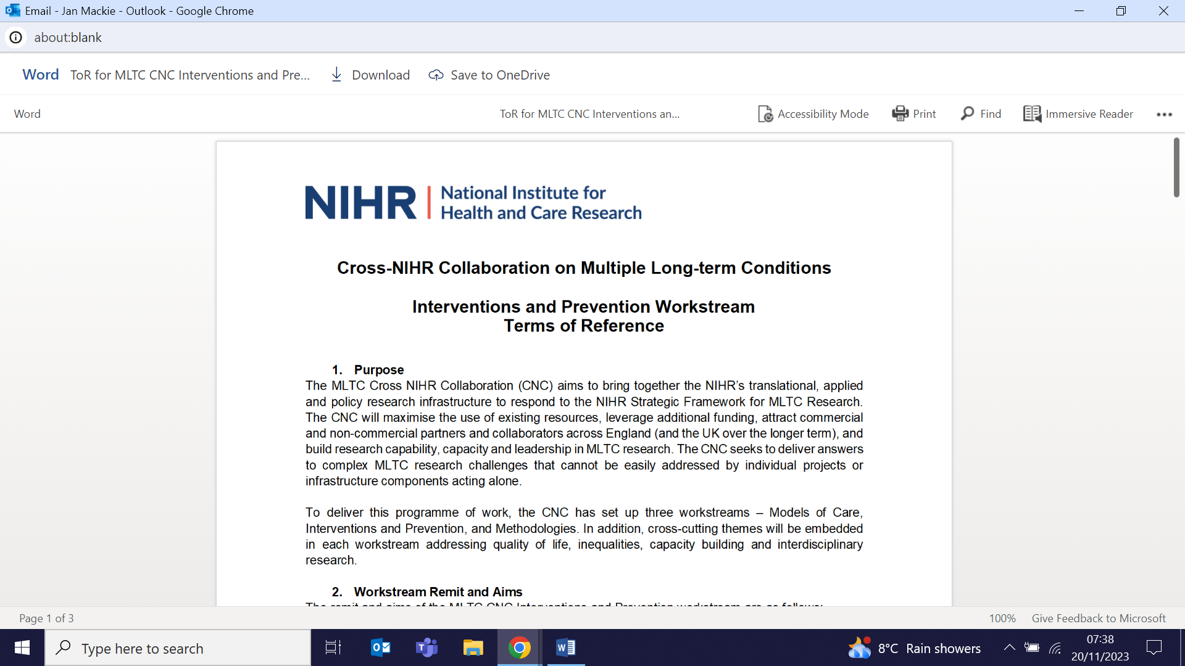  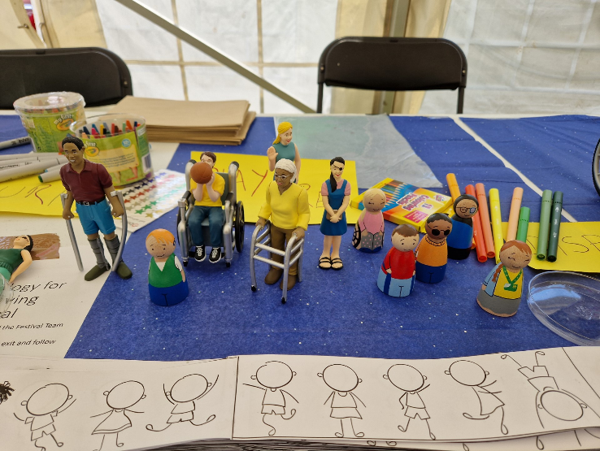 | Steph Taylor has been invited to join the Cross-NIHR Collaboration on Multiple Long-term Conditions (MLTC) Intervention and Prevention Workstream. The Collaboration is a 5yr £195million funded project to respond to the NIHR Strategic Framework for MLTC Research. With 14 million people in England living with MLTC, it is a significant challenge for the health and care service. Three workstreams have been set up: Models of Care, Methodologies, and Interventions and Prevention, with cross-cutting themes embedded in each to address quality of life, inequalities, capacity building and interdisciplinary research.
Ovarian cancer symptoms in pre-clinical invasive epithelial ovarian cancer
17 November (Ranjit Manchanda. Centre for Cancer Screening, Prevention and Early Diagnosis)

An analysis of symptoms in women with pre-clinical invasive epithelial ovarian cancer (iEOC) in the UK Collaborative Trial of Ovarian Cancer Screening (UKCTOCS) compares women with pre-clinical (screen-detected) v clinically diagnosed cancer. Results show that for high grade serous ovarian cancer, the symptom profile was different between women with preclinical and clinical disease. Women with preclinical early stage high grade serous ovarian cancer reported more gastrointestinal and systemic symptoms, with key symptoms including change in bowel habits, dyspepsia and tiredness. Authors say their findings provide evidence that alert symptoms for early tubo-ovarian cancer should be reconsidered, and call for a more nuanced complex of key symptoms to be evaluated and refined in a prospective trial.

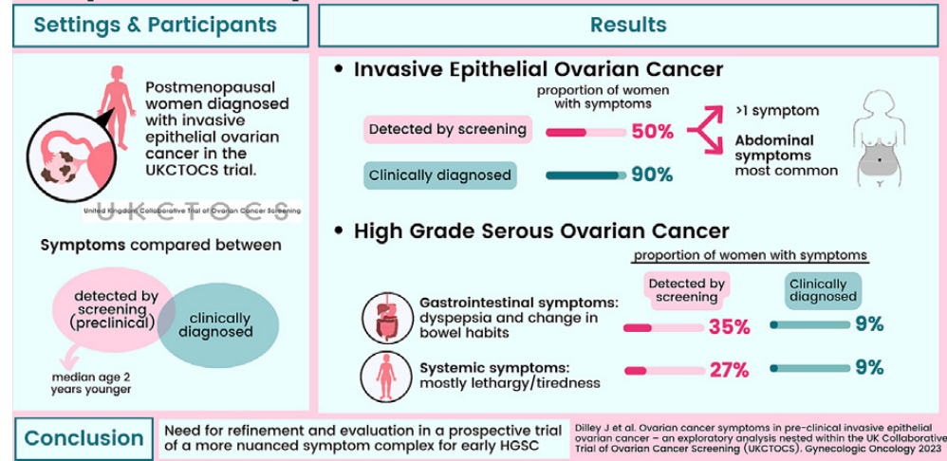
ISPD QMUL Centre for Public Engagement Large Grant Award
17 November (Sara Paparini. Centre for Public Health and Policy)

A QMUL CPE Large Grant Award to Sara Paparini will enable work to engage in research co-design with a community group of older men of Black Caribbean heritage, living and working in North London. The Meaningful participation in action-oriented research: the Black Men’s Health North London group project is an output from an existing WIPH Global Public Health Unit project. The group will co-design advocacy tools and develop a strategy for better engagement with local NHS and Integrated Care service providers to build bridges and improve health outcomes for the community in the specific areas of concern identified during this project. | 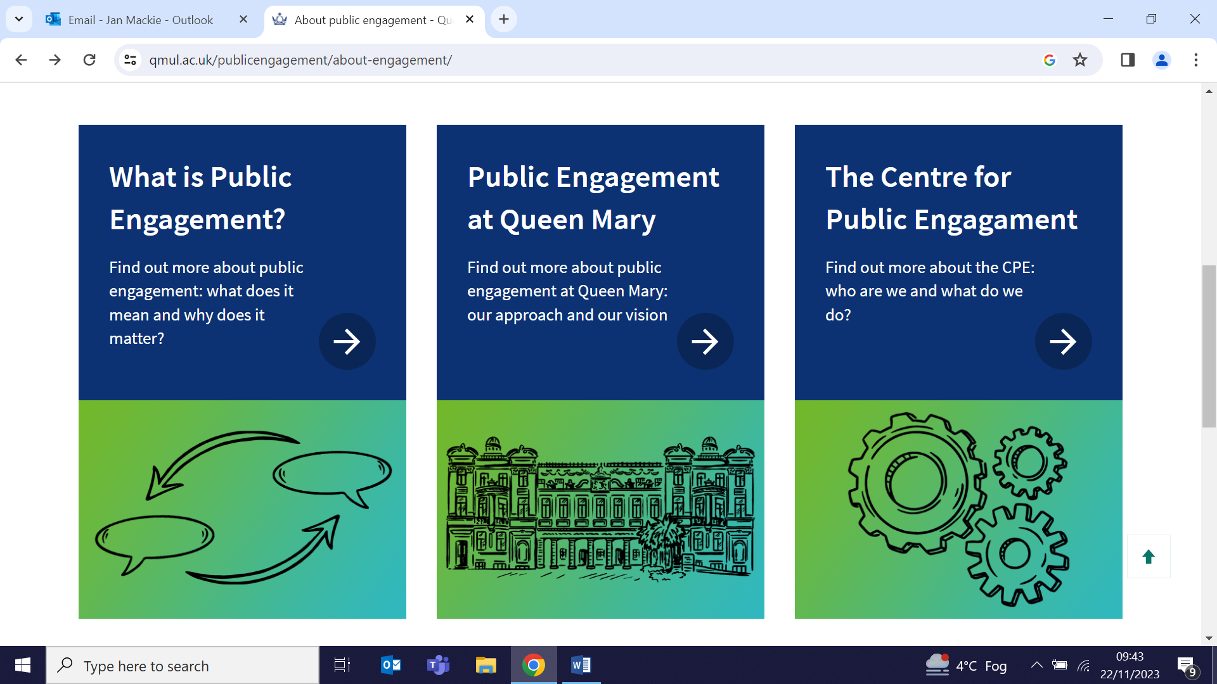
Early/Mid-career International Needs Survey
20 November (Georgina Hosang. Centre for Psychiatry and Mental Health)

  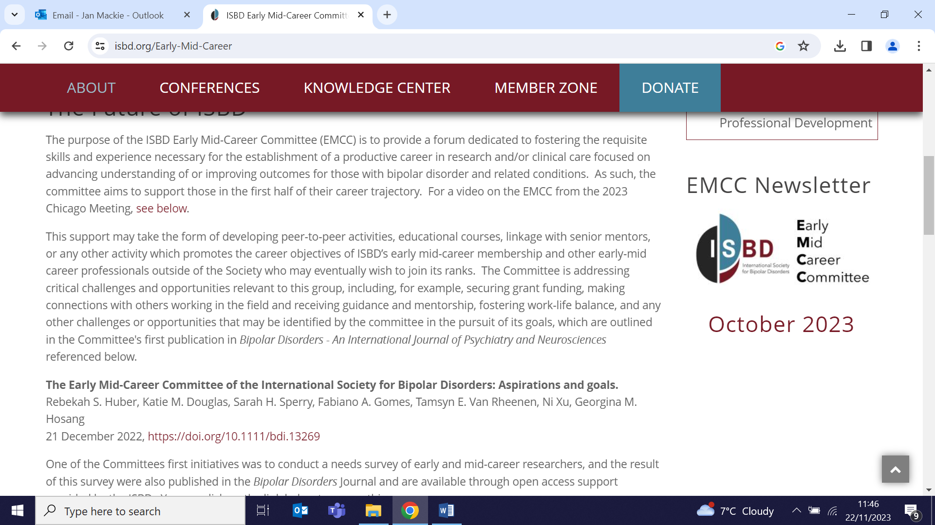 | A commentary co-authored by Georgina Hosang, co-chair of the Early and Mid-Career Committee at the International Society for Bipolar Disorders, maps future plans to increase resources in response to the most recent ISBD international needs survey. The global survey, addressing the needs of early and mid-career Bipolar Disorder professionals, revealed notable gaps in knowledge about identifying postdoctoral opportunities and faculty vacancies, and about securing research funding.
Predicting cytoreduction surgery success for recurrent ovarian cancer
20 November (Oleg Blyuss, Ranjit Manchanda. Centre for Cancer Screening, Prevention and Diagnosis)

Of women in clinical remission following initial treatment for epithelial ovarian cancer, 80% with advanced-stage disease develop recurrence, but standard treatment for this is unclear. Using published studies, researchers examining the overall survival for secondary, tertiary, or quaternary cytoreduction surgery for recurrence find pooled death rates of 45%, 51% and 66%, and mean overall survival of 16-91, 24-99, and 39-135 months respectively for the 3 options. Authors conclude that maximal effort higher order cytoreductive surgery, resulting in complete cytoreduction, can improve survival. | 
Webinar: Accessing CPRD data via QM Multi Study Licence
20 November (Fiona Walter, Jianhua Wu, Rohini Mathur, Harriet Larvin, Mary Thomas. Centres for Primary Care/Cancer Screening, Prevention and Early Diagnosis)

Around 130 attendees from across Queen Mary and Barts Health joined this webinar on 20 November. The Multi Study Licence team presented research examples that use data from Clinical Practice Research Datalink (CPRD) and outlined how staff can access CPRD data at a reduced cost using the University’s new Multi Study Licence. The recording and slides are now available.

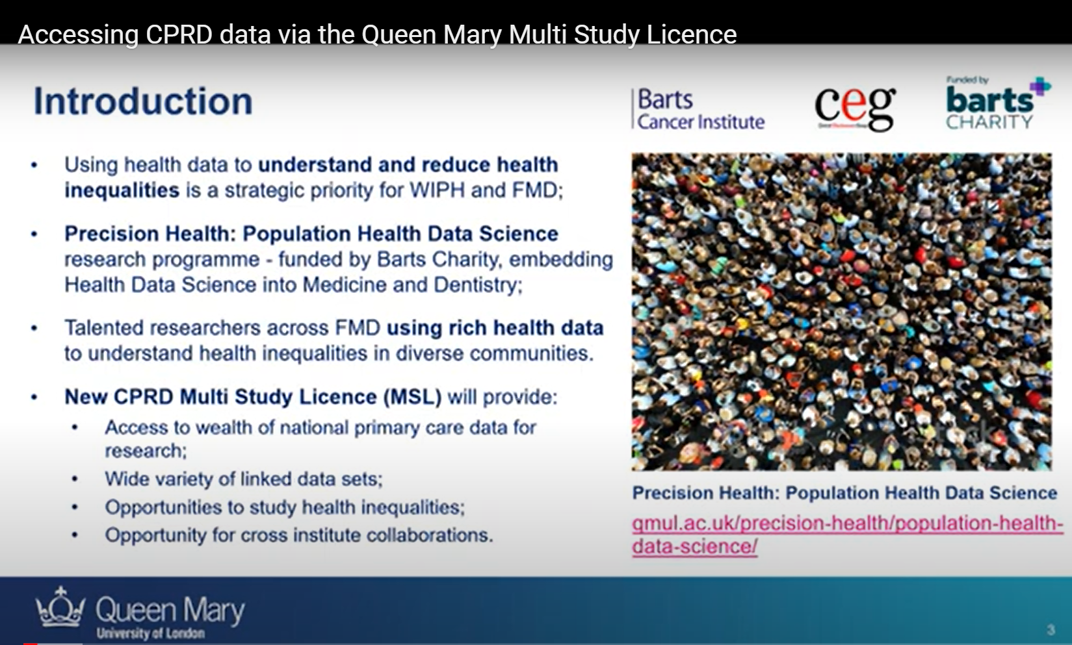
Willingness to pay for prostate cancer screening among Iranian men
21 November (Hiro Farabi. Centre for Evaluation and Methods)

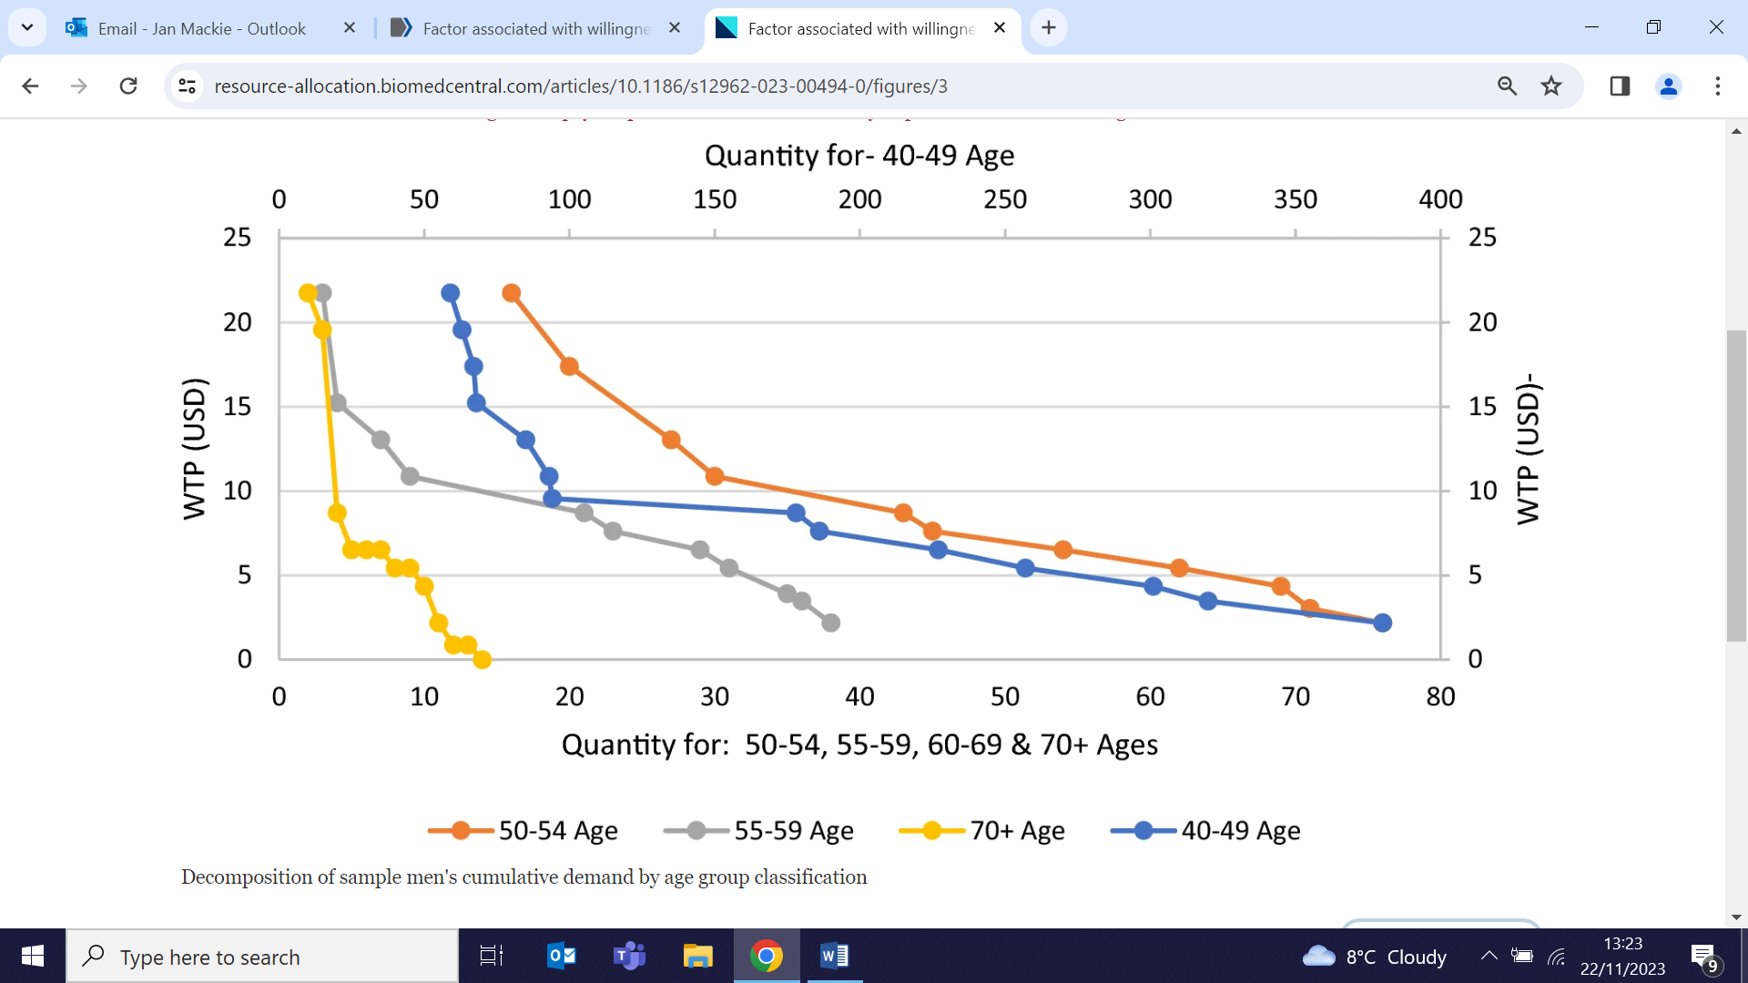 | An online survey of willingness to pay (WTP) for prostate cancer screening among 771 Iranian men aged 40+ finds that WTP decreased when complementary information was provided in addition to basic information, but that age, education, and monthly household expenditure positively influenced the decision to pay. Health status, expectations of remaining life and history of prostate problems positively affect WTP, but insurance coverage had a negative impact. Researchers note that participants had an exaggerated idea of the risk of prostate cancer. Common reasons not to pay included seeing screening as a public good (43%), financial constraints (35%), and having insurance (20%).
Particulate matter exposure for children with asthma in sub-Saharan Africa
21 November (Chris Griffiths, Centre for Primary Care)

To identify reduction strategies for exposure to particulate matter (PM) for school children with asthma in urban areas in sub-Saharan Africa, researchers monitored exposure in 297 children in 6 cities (Blantyre, Durban, Harare, Kumasi, Lagos and Moshi). From 1109 days of valid data, only 20% of monitored days were lower than the current WHO 24hr PM exposure health guideline of 15 μg/m³ and that children in Blantyre had the highest exposure (median 41·8 μg/m³). Children had significantly higher PM exposures at school than at home in Kumasi, Lagos, and Moshi, while children in the other 3 cities had significantly higher exposures at home and while commuting than at school. Results suggest that the most effective changes would be to pave school grounds, increase use of clean fuel for cooking and light in homes, and discourage smoking in homes. | 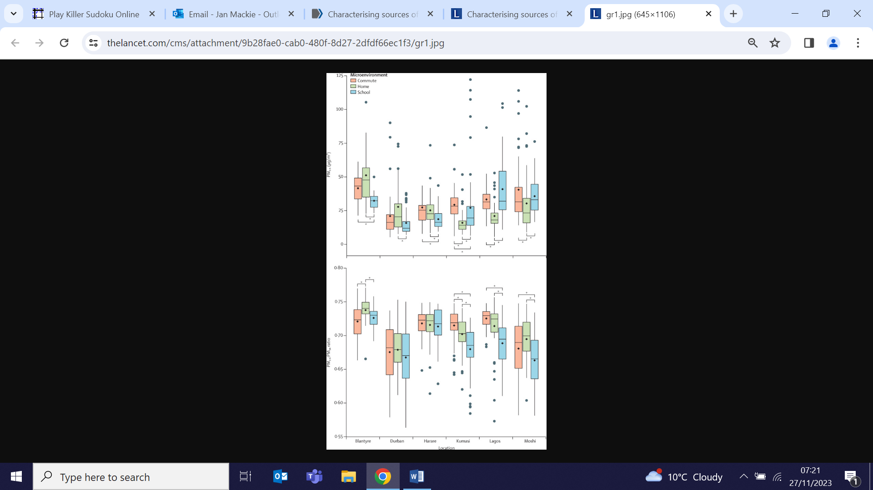
Gender Justice and the impact of climate change on women and girls
24 November (Heather McMullen. Centre for Public Health and Policy)

To coincide with the UN Day for the Elimination of Violence Against Women and Girls, QMUL have released a video interview with Heather McMullen as part of the ‘How can we save planet earth?’ series, hosted by Professor Tim Bale. Heather discusses her research on the impact of climate change and how it disproportionately affects the sexual and reproductive health of women and girls. She also talks about her work the United Nations Population Fund (UNFPA) to gather evidence to show the many ways that the climate crisis affects gender and sexual and reproductive health. Heather will be presenting her research at COP28.


Assessing breast cancer risk using history of mammographic density
24 November (Emma Atakpa, Jack Cuzick, Adam Brentnall. Centres for Cancer Screening, Prevention and Early Diagnosis/Evaluation and Methods)

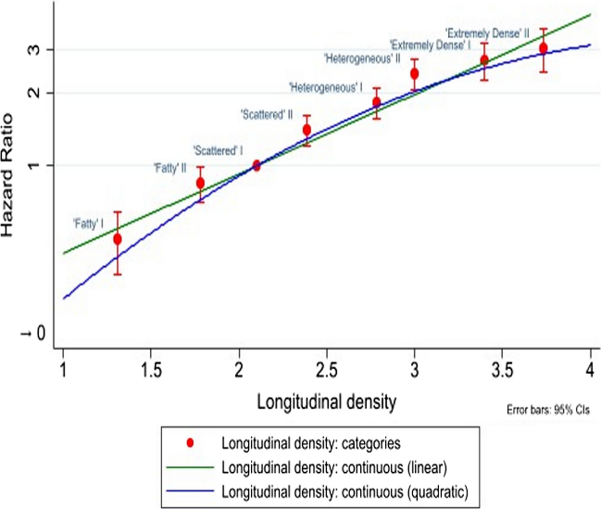 | A breast density measure using a woman’s entire history, developed to address variability in breast density measurement, is evaluated using data from 132,439 women with multiple screening mammograms from 1996-2013, in whom 2704 invasive breast cancers were diagnosed during follow-up. Compared with an age- and body mass index-only model, the gain in statistical information provided by the continuous longitudinal density measure was 23% greater than that provided by Breast Imaging Reporting and Data System (BI-RADS) density, increasing to 35% for follow-up after 3 mammograms. There was a 6-fold difference in observed risk between densest and fattiest 8-category longitudinal density v a 4-fold difference with BI-RADS density. Researchers conclude that longitudinal breast density may lead to more reliable and accurate estimates of individual breast cancer risk, and has potential to improve personal breast cancer risk estimation.
UK Public Health Science Conference
24 November (Sweedal Alberts, Abinayah Nadarajah, Amaani Ahmed, Jessica Budgett, Claudia Cooper, Megan Armstrong, Alastair Noyce. Centres for Psychiatry and Mental Health/Preventive Neurology)

WIPH researchers presented four abstracts at the Lancet’s national conference for new research in UK public health. CPMH ECRs Sweedal Alberts, Abinaya Nadarajah and Amaani Ahmed led a study supported by Jessica Budgett and Claudia Cooper exploring Indian attitudes to long term care, using data from the Longitudinal Ageing Study in India and qualitative analyses from MovingPictures. Claudia also co-authored abstracts presenting findings from the NIHR Home Health trial, on enabling health and maintaining independence for older people at home, and with Megan Armstrong on goals as a behaviour change intervention in people with mild cognitive impairment. Alastair Noyce co-authored an abstract on the effectiveness of interactive workshops to raise awareness of the neurological harms associated with nitrous oxide use. Sweedal and Abinaya also attended the ECR event held alongside the conference. | 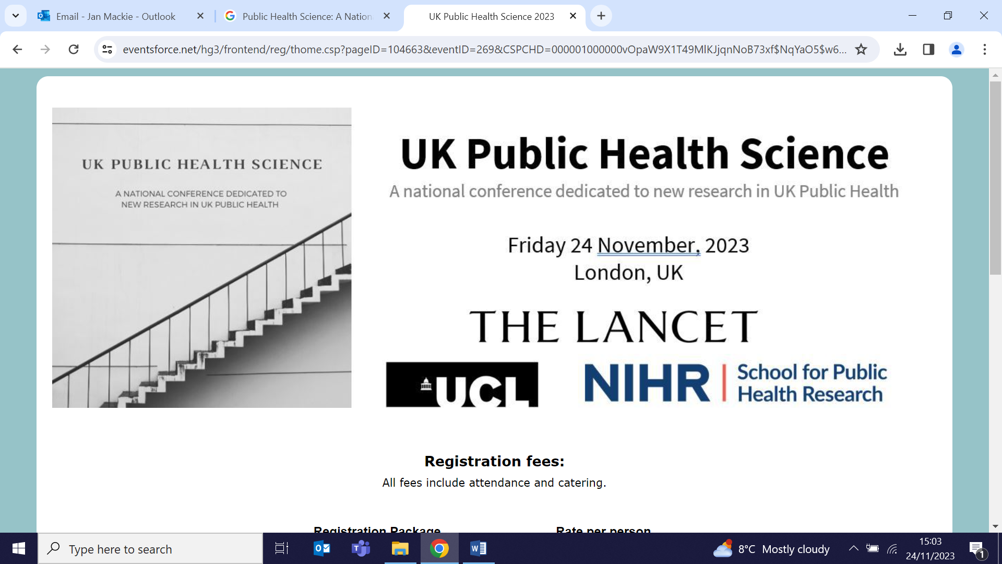
Movers and Shakers Podcast
25 November (Alastair Noyce. Centre for Preventive Neurology)

 | Alastair Noyce features as the invited expert in the latest episode of the Movers and Shakers podcast, hosted by Jeremy Paxman and colleagues who share a diagnosis of Parkinson’s Disease. Al speaks about the inadvertent and unwanted by-products of PD medications, discussing a range of side effects including motor and impulsivity disorders.
FORTHCOMING EVENTS

The annual Charterhouse campus Carols will be held 12 December around the Campus Christmas Tree. All are welcome. Mulled wine, hot chocolate and mince pies provided - Please bring your most enthusiastic voices! | 
Many thanks to all who so enthusiastically contribute. Please send any news items for the next newsletter to j.a.mackie@qmul.ac.uk

